Postoperative Critical Care: Resource Availability, Patient Risk and Other Factors Influencing Referral and Admission

Dr Danny J. N. Wong

MBBS, BSc, AKC, MRCP(UK), FRCA

A thesis submitted for the degree of

Doctor of Philosophy

University College London

2020

##### PAGE BREAK

# Declaration

I, Danny Jon Nian Wong, confirm that the work presented in this thesis is my own. Where work has been derived from other sources, I confirm that this has been indicated in the thesis (below).

* **Chapter 1** — Nil.
* **Chapter 2–4** — Study conception of the Second Sprint National Anaesthesia Project: EPIdemiology of Critical Care provision after Surgery (SNAP-2): S. Ramani Moonesinghe; Development of the protocols and study documents: SNAP-2 project team at the Royal College of Anaesthetists, including Steve K. Harris, Laura Farmer, Jose Lourtie and James Goodwin. Feedback on and oversight of SNAP-2 all study-related documents was provided by the study steering group, comprising Michael P. Grocott, Robert Sneyd, Sharon Drake, Stephen Brett, Anna Batchelor, Catherine Plowright, Suman Shrestha, Richard Shawyer, Shafi Ahmed, Mizan Khondoker and Mike Nathanson; The power analysis informing the sample size considerations for the patient cohort study was performed by Mizan Khondoker; Electronic database and web development for the patient cohort study: Net Solving Limited.
* **Chapter 5–7** — Collection of source data and data entry for the SNAP-2 organisational survey and patient cohort study: site investigators and collaborators at all participating hospitals.

##### PAGE BREAK

# Abstract

Although intended for benefit, surgery exposes patients to potential complications. Critical care is thought to protect against the development of these complications, and is recommended for patients at higher risk. However, previous literature suggests that high-risk patients do not consistently receive postoperative critical care.

In this PhD thesis, I investigate the supposed misallocation of critical care resources, and seek to answer the following research questions: 1. What is the availability of postoperative critical care? 2. How do clinicians estimate perioperative risk? 3. How accurate are current available risk prediction tools? 4. How do clinicians decide which patients to admit for postoperative critical care? 5. What factors influence their admission?

A survey of postoperative critical care availability was conducted in 309 hospitals across the United Kingdom, Australia and New Zealand (NZ). Then, in a subset of 274 of these hospitals, a cohort study enrolling 26,502 patients undergoing inpatient surgery was undertaken.

Postoperative critical care availability was found to differ between countries. UK hospitals reported fewer critical care beds per 100 hospital beds (median = 2.7) compared with Australia (median = 3.7) and NZ (median = 3.5). Enhanced care/high-acuity beds used to manage some high-risk patients were identified in around 31% of hospitals. The estimated numbers of critical care beds per 100,000 population were 9.3, 14.1, and 9.1 in the UK, Australia, and NZ, respectively. The estimated per capita high-acuity bed capacities per 100,000 population were 1.2, 3.8, and 6.4 in the UK, Australia, and NZ, respectively. The risk profile of inpatients undergoing inpatient surgery and the incidence of short-term mortality and morbidity outcomes were described. Less than 40% of predicted high-risk patients (defined as having a 5% or higher predicted 30-day mortality) in the cohort were admitted to critical care directly after surgery, regardless of risk model used.

Compared with objective risk tools, subjective clinical assessment performed similarly in terms of discrimination, but consistently overpredicted risk. The Area Under the Receiver Operating Characteristic curve (AUROC) for subjective clinical assessment was 0.89, compared to 0.91 for the Surgical Outcome Risk Tool (SORT), the best-performing objective risk tool. However, a model combining information from both objective tools and subjective assessment improved the accuracy and clinical applicability of risk predictions (combined model AUROC = 0.93; continuous Net Reclassification Index [NRI] = 0.347, p <0.001).

Associations were identified between patient risk factors (e.g. increased comorbidities, more complex surgery, higher surgical urgency) and the likelihood of being recommended postoperative critical care admission. Increased critical care bed availability had a small but significant association with critical care recommendation (adjusted odds ratio [OR] = 1.05 per empty critical care bed at the time of surgery), suggesting a subtle effect of exogenous influences on clinical decision-making.

These results will have value in informing policy around the delivery of postoperative care for high-risk patients undergoing surgery, both at a macroscopic level in planning services, and at a microscopic level in making clinical decisions for individual patients.

##### PAGE BREAK

# Impact Statement

The work presented in this thesis has achieved impact from the perspectives of academia, healthcare policy and clinical practice, as described below.

In terms of academia, this work has widened the research participation of practicing clinicians in almost all UK NHS hospitals, and a large number of public hospitals in Australia and New Zealand. Over 2,900 frontline clinical collaborators were involved, mobilising a strong network of research-interested clinicians who will continue contributing to research in the future. This collaboration spanned over 300 hospitals across the UK and Australasia, thus the results of this work will likely be widely disseminated and received with interest. Furthermore, the research infrastructure to conduct multicentre observational anaesthesia and perioperative medicine studies has been strengthened in Australia and New Zealand where this was previously underdeveloped. The success of this collaborative approach to sourcing data has led to the Royal College of Anaesthetists funding and commissioning a third Sprint National Anaesthesia Project, which will examine a new research topic proposed by the college’s members.

On a healthcare policy level, findings from the organisational survey (reported in *Chapter 3*) provide updated national estimates of the capacity to provide critical care for postoperative patients, and describes other hospital areas where high-risk patients are being looked after following their surgery. Published work on surgical cancellations using data from the patient cohort have been widely publicised by news media, highlighting the importance of sufficient critical care provision in the perioperative period to the general public. These results have been published and are being used to inform national guidance around the regulation of enhanced care and high-acuity hospital beds that care for patients who might be too unwell to occupy general ward-level beds, but do not necessarily require admission into intensive care or high-dependency units. The Faculty of Intensive Care Medicine and the Royal College of Physicians of London are currently finalising guidance on service development and delivery of enhanced care which has referenced the work delivered in this PhD.

From the perspective of the clinician making clinical decisions about individual patients, the work presented in *Chapters 4* to *7* firstly provides insight about the disparity between resource need and allocation; secondly, highlights ways in which better risk assessment can be conducted in order to identify patients who might benefit from critical care admission following surgery; and thirdly alerts clinicians to the possible unconscious biases which might influence their decision-making about critical care referral beyond patient risk factors. The clinical implications of the results from this thesis are that better allocation of scarce critical care resources might be achieved if clinicians undertake explicit risk assessment to identify the patients who are appropriate for critical care, and that augmenting subjective judgment with objective risk assessment tools would increase the accuracy of these risk assessments. It is anticipated that as computer-aided clinical decision aids become more ubiquitous, complementing objective prediction models with clinicians’ holistic assessments of their patients’ conditions will achieve better overall outcomes than relying on either alone.

Table of Contents

Declaration 2

Abstract 3

Impact Statement 5

Table of Contents 7

List of Tables 12

List of Figures 16

List of Abbreviations 21

Acknowledgements 25

1. Introduction — Surgery and its complications 26

1.1. The modern surgical pathway 31

1.2. Postoperative critical care 32

1.2.1. Definitions of critical care 33

1.2.2. Critical care as a complex intervention 35

1.2.3. A Donabedian framework: critical care as healthcare structure and process 37

1.2.4. The common language of critical care 38

1.2.5. Equipoise over the benefits of critical care 38

1.3. The right treatment for the right patient? 44

1.3.1. Hypothesis 1: Insufficient resource due to critical care bed scarcity and costs 46

1.3.2. Hypothesis 2: Difficulties in risk-prediction 50

1.4. Research questions and the structure of the rest of the thesis 58

2. Overview of The Second Sprint National Anaesthesia Project 61

2.1. Research governance considerations 63

2.1.1. Cohort study ethical considerations 63

2.2. Data security, handling, electronic Case Record Forms and data flow 65

2.3. Study delivery infrastructure 69

2.3.1. The Central Project Team 71

2.3.2. Study Steering Group 72

2.3.3. Research Networks and the Royal College of Anaesthetists 73

2.3.4. Australian and New Zealand Collaborators 74

2.4. Potential strengths and limitations of the SNAPs 75

2.5. A note on statistical analyses 75

2.6. Conclusion 76

3. Organisational Survey 77

3.1. Aims and objectives 78

3.2. Methods 78

3.2.1. Survey development and pilot 78

3.2.2. Survey content 79

3.2.3. Survey distribution 81

3.2.4. Statistical analyses 82

3.2.5. Sensitivity analysis 83

3.3. Results 84

3.3.1. Overview of responses 84

3.3.2. Hospital characteristics 84

3.3.3. Critical care beds 86

3.3.4. High-acuity care areas 92

3.3.5. General surgical wards 94

3.3.6. Sensitivity Analysis for Australian Hospital Sample 95

3.4. Discussion 97

3.4.1. Principal Findings 97

3.4.2. Strengths and weaknesses 97

3.4.3. Defining critical care 99

3.4.4. Other less clearly defined “high-acuity care” areas - Level 1.5 units? 100

3.4.5. The results in relation to existing literature 100

3.4.6. Unanswered questions and future extensions 102

3.4.7. Summary 103

4. SNAP-2: EPICCS Inpatient Surgery Cohort 104

4.1. Aims and objectives 104

4.2. Cohort inclusion and exclusion criteria 105

4.3. Cohort study data variables and Case Report Forms 105

4.3.1. Baseline risk factors 106

4.3.2. Outcome variables and duration of follow-up 107

4.4. Hospital-level critical care occupancy data 108

4.5. Cohort study analysis plan 109

4.6. Sample size considerations 109

4.7. Cohort study data quality checks 109

4.7.1. Incomplete case capture 110

4.7.2. Statistical modelling 111

4.7.3. Qualitative survey and discussion with local collaborators 112

4.7.4. Incomplete/missing data variables from individual patient records 112

4.8. Cohort study feasibility pilot 114

5. Descriptive Epidemiology of Postoperative Critical Care 115

5.1. Methods 117

5.1.1. Statistical analyses 117

5.1.2. Missing data variables 118

5.2. Results 118

5.2.1. Patient characteristics 118

5.2.2. Risk profile 129

5.2.3. Critical care admission 132

5.2.4. Postoperative outcomes 137

5.3. Discussion 148

5.3.1. Principal Findings 148

5.3.2. Comparison with other surgical cohorts in the literature 149

5.3.3. Low admission rates to critical care for high-risk patients 150

5.3.4. Summary 151

6. Predicting Risk in Inpatient Surgery 153

6.1. Methods 154

6.1.1. Data Variables 154

6.1.2. Statistical Analysis 155

6.2. Results 158

6.2.1. Patient cohort 158

6.2.2. External validation of existing risk prediction models 163

6.2.3. Subjective clinical assessment 164

6.2.4. Combining subjective and objective risk assessment 166

6.2.5. Sensitivity analyses 169

6.3. Discussion 179

6.3.1. Principal findings 179

6.3.2. Study limitations 179

6.3.3. Clinical implications and relation to existing literature 181

6.3.4. Summary 183

7. Propensity for Admission to Critical Care After Surgery 184

7.1. Methods 185

7.1.1. Statistical analysis 186

7.1.2. Data variables 188

7.1.3. Missing value treatment 190

7.2. Results 190

7.2.1. Part 1: Recommendation for critical care 191

7.2.2. Part 2: Eventual admission to critical care 203

7.3. Discussion 214

7.3.1. Key Findings 214

7.3.2. Interpretation 215

7.3.3. Study limitations 218

7.3.4. Clinical implications 219

7.3.5. Summary 220

8. Conclusions and future directions 221

8.1. Summary of the thesis 221

8.1.1. Epidemiology of inpatient surgery and critical care admission 221

8.1.2. What is the availability of critical care, including high-acuity care areas? 223

8.1.3. How do clinicians estimate postoperative risk, and how accurate are currently available prediction tools? 224

8.1.4. How do clinicians decide which patients to admit for postoperative critical care and what factors are influential? 225

8.2. Other decisions around the time of surgery — whether to cancel 226

8.3. Outstanding questions and future directions 227

8.4. Conclusion 230

9. Personal Reflections 231

9.1. Seeking help and sharing early 231

9.2. Understanding other’s motivations and personal incentives 232

9.3. Understanding myself 232

10. Appendices 234

10.1. Appendix 1: Organisational survey questions 234

10.2. Appendix 2: Patient study CRF 240

10.3. Appendix 3: Critical care occupancy CRF 250

10.4. Appendix 4: Sample size considerations for the patient cohort study 255

10.5. Appendix 5: Poisson Models for case ascertainment and capture 257

10.5.1. Data quality assurance 257

10.5.2. Missingness of data variables 260

10.6. Appendix 6: Patient-level data variables and proportion of missing values 262

10.7. Appendix 7: AXA-PPP procedure codes 276

10.8. Appendix 8: Computing environment used in the analyses 277

10.9. Appendix 9: Publications Associated With This Thesis 279

10.9.1. Chapter 2 & Chapter 4 279

10.9.2. Chapter 3 279

10.9.3. Chapter 5 279

10.9.4. Chapter 6 279

11. References 280

##### PAGE BREAK

# List of Tables

Table 1‑1: The Level 0-3 classification system used in the UK describes the patients’ needs first, then matches the levels of intervention/observation required in order to adequately care for the patient. Adapted from the Guidelines for the Provision of Intensive Care Services (GPICS) document (40). 33

Table 1‑2: The Level I-III Australia and New Zealand Intensive Care Society (ANZICS) classification system in Australia and New Zealand only refers to Intensive Care Units, and does not include HDUs which are separately defined (44,45). 34

Table 1‑3: The Levels of Care defined by the ESICM. HDUs are defined as providing a level of care not exceeding Level I (46). 35

Table 1‑4: Some features of critical care as described using a Donabedian Structure-Process-Outcome framework. 38

Table 1‑5: : A few examples of observational studies examining the effects of postoperative critical care admission on surgical outcome. 40

Table 1‑6: A summary of studies investigating the performance of subjective clinician assessment of mortality and morbidity risks in patients undergoing surgery. 53

Table 2‑1: Roles of the central project team. 72

Table 2‑2: Roles of the Australian and New Zealand project team. 75

Table 3‑1: Summary of hospital characteristics. 85

Table 3‑2: Summary of critical care unit characteristics. 87

Table 3‑3: Critical care and high-acuity care beds per capita. The sum of the number of critical care beds was divided by the sum of all hospital beds within each country, and multiplied by 100, to obtain the average ratio of critical care beds to hospital beds in each country. This ratio was then multiplied by OECD data on hospital beds per capita to obtain the per capita critical care bed numbers, rescaled to per 100,000 population. 88

Table 3‑4: Negative binomial regression model with the number of critical care beds as a proportion of the total number of hospital beds in each hospital as the dependent variable, regressed against the number of hospital beds, specific types of tertiary specialist services offered, whether the hospital has an high-acuity care area, whether the hospital has an Emergency Department, and the country where the hospital is located. Model intercept not shown. 91

Table 3‑5: Summary of high-acuity care area characteristics. 93

Table 3‑6: : Logistic regression model of whether high-acuity care areas are reported in a hospital as the dependent variable, regressed against hospital size (centred around the mean, and rescaled to a standard deviation scale), whether the hospital offers tertiary specialist services, the country where the hospital is located, the critical care bed to total hospital bed ratio, and whether the hospital has an Emergency Department. Model intercept not shown. 94

Table 3‑7: Summary of general ward staffing levels. 95

Table 3‑8: Characteristics of hospitals sampled within this study compared to overall characteristics of all hospitals in Australia. Abbreviations for state names: ACT = Australian Capital Territory; NSW = New South Wales; NT = Northern Territory; Qld = Queensland; SA = South Australia; Tas = Tasmania; Vic = Victoria; WA = Western Australia. 96

Table 4‑1: Postoperative Morbidity Survey (POMS) Domains, adapted from Grocott et al (148). 108

Table 5‑1: Baseline patient demographics stratified by country. For surgical specialty classifications: ‘GI’ includes colorectal, upper gastrointestinal tract, bariatric and hepato-pancreato-biliary surgery, and ‘Other’ includes solid organ transplants, ophthalmic, plastic, maxillofacial/dental, ear-nose-throat, endocrine and breast surgery, as well as interventional radiology, interventional cardiology and endoscopic procedures requiring anaesthetic support. 120

Table 5‑2: Breakdown of diabetic subtypes in patients with comorbid diabetes mellitus. 125

Table 5‑3: Breakdown of electrocardiogram (ECG) findings in patients who had ECGs available preoperatively. ‘bpm’ = beats per minute. 126

Table 5‑4: Breakdown anaesthetic modalities in surgical cases. The total percentage does not sum to 100% as patients could receive more than one anaesthetic modality during their surgery, e.g. General Anaesthesia plus Spinal Anaesthesia. 128

Table 5‑5: Proportion of patients in each mortality risk group according to P-POSSUM, SORT and SRS computed mortality. 130

Table 5‑6: Differences in baseline patient and surgical characteristics between patients who were admitted immediately to critical care and patients who were admitted to the ward after their surgery. 133

Table 5‑7: Day 7 Postoperative morbidity as defined by POMS. 141

Table 5‑8: Incidence of POMS-defined morbidity in patients remaining in hospital on Postoperative Day 7, stratified by country. 144

Table 5‑9: Incidence of POMS-defined morbidity in all patients in the cohort, regardless of their postoperative length of stay, stratified by country. 144

Table 5‑10: Incidence of POMS-defined morbidity stratified by immediate critical care admission vs. ward admission after surgery. 145

Table 5‑11: Mortality, stratified by critical care admission. 145

Table 5‑12: Failures to rescue. Mortality in patients subsequently admitted to critical care for treatment of complications, stratified by whether they were admitted to critical care immediately on the day of surgery. 146

Table 5‑13: 30-day mortality by risk strata as predicted using SORT, SRS and P-POSSUM. 147

Table 6‑1: Baseline patient demographics stratified by 30-day mortality. For surgical specialty classifications: ‘GI’ includes colorectal, upper gastrointestinal tract, bariatric and hepato-pancreato-biliary surgery, and ‘Other’ includes solid organ transplants, ophthalmic, plastic, maxillofacial/dental, ear-nose-throat, endocrine and breast surgery, as well as interventional radiology, interventional cardiology and endoscopic procedures requiring anaesthetic support. 160

Table 6‑2: Breakdown of information sources used by clinician in estimating 30-day mortality. Clinical teams could select one or more categories, percentages (in parentheses) therefore do not sum to 100%. 163

Table 6‑3: Performance metrics for Clinician Assessment versus: 1) SORT risk prediction, 2) a logistic regression model combining Clinician Assessment and SORT prediction, 3) SORT risk prediction with coefficients refitted to the current dataset (SORT-refitted), and 4) a logistic regression model combining Clinician Assessment and refitted SORT coefficients (Combined-refitted). Performance metrics were computed based on the subset of patients in whom clinician judgement alone was used to estimate risk (n = 21,325). The reported AUROC for the combined models (Combined and Combined-refitted) are the optimism-corrected value from bootstrapped internal validation. The final chosen model was Combined-refitted based on its superior performance. 166

Table 6‑4: Full coefficients for the risk prediction model combining subjective clinical assessment and objective risk tool information. 168

Table 6‑5: Sensitivity analyses. Characteristics of the patient subgroups used in all sensitivity analyses. The restricted cohort used in the first sensitivity analysis was older, had higher ASA-PS grades, higher proportions Xmajor or Complex surgery, higher incidences of comorbid disease and a higher mortality rate compared to the whole cohort of patients used in the main study analyses. The subgroup with clinical assessments made in conjunction with other tools was similar in characteristics to the whole cohort of patients used in the main analyses. The Australian and New Zealand cohort had a lower proportion of obstetric surgery (and consequently a higher proportion of males) and a higher proportion of minor/intermediate surgery, but a comparable percentage mortality. 170

Table 6‑6: AUROCs of the objective risk tools and subjective clinical assessment, compared between the UK and Australian/New Zealand data subsets. There was no significant difference in discrimination using any of the risk prediction tools or using subjective assessment when comparing their performance in the UK and Australian/New Zealand datasets. 178

Table 7‑1: Baseline patient demographics stratified by perceived requirement for critical care admission. For surgical specialty classifications: ‘GI’ includes colorectal, upper gastrointestinal tract, bariatric and hepato-pancreato-biliary surgery, and ‘Other’ includes solid organ transplants, ophthalmic, plastic, maxillofacial/dental, ear-nose-throat, endocrine and breast surgery, as well as interventional radiology, interventional cardiology and endoscopic procedures requiring anaesthetic support. 192

Table 7‑2: Patient-level variable associations with the likelihood of receiving a label of perceived requirement for critical care, expressed as adjusted Odds Ratios (OR) estimated with the final fixed-effects model. Patient age was modelled using a non-linear natural spline transformation, the ORs estimated for the age terms should not be interpreted directly and have therefore been omitted from the table. The effects for age can be interpreted graphically (Figure 7-3A). 195

Table 7‑3: Summary of the multilevel logistic regression models fitted in the first part of analysis in this chapter. MOR = Median Odds Ratio; AIC = Akaike’s Information Criterion. 200

Table 7‑4: Baseline demographics for patients who were perceived to require critical care admission included in the second analysis, stratified by whether they actually then were admitted to critical care after surgery. For surgical specialty classifications: ‘GI’ includes colorectal, upper gastrointestinal tract, bariatric and hepato-pancreato-biliary surgery, and ‘Other’ includes solid organ transplants, ophthalmic, plastic, maxillofacial/dental, ear-nose-throat, endocrine and breast surgery, as well as interventional radiology, interventional cardiology and endoscopic procedures requiring anaesthetic support. 204

Table 7‑5: Baseline demographics for patients did not have a perceived requirement for critical care admission, stratified by whether they were later admitted to critical care after surgery. For surgical specialty classifications: ‘GI’ includes colorectal, upper gastrointestinal tract, bariatric and hepato-pancreato-biliary surgery, and ‘Other’ includes solid organ transplants, ophthalmic, plastic, maxillofacial/dental, ear-nose-throat, endocrine and breast surgery, as well as interventional radiology, interventional cardiology and endoscopic procedures requiring anaesthetic support. 206

Table 7‑6: Summary of the multilevel logistic regression models fitted in the second part of analysis in this chapter. Final model chosen is in **bold**. MOR = Median Odds Ratio; AIC = Akaike’s Information Criterion. 211

Table 10‑1: Minimum sample sizes assuming morbidity rate = 15% to 30% (with 5% intervals) in the general ward, and 5%, 10%, 15% and 20% reduction in the group of patients referred to critical care. Calculations assume an allocation ratio 1:10 (critical care vs. ward), R-squared (multiple correlation between the exposure and other covariates) = 10 % and a dropout rate of 1%. Final sample size target chosen highlighted in **bold**. 256

##### PAGE BREAK

# List of Figures

Figure 1‑1: An idealised patient surgical pathway. 32

Figure 1‑2: A simplified graphical model for the factors which may affect surgical outcomes. Potential confounders are blue, outcomes are orange, and the critical care intervention is pink. 37

Figure 1‑3: Postoperative admission to critical care. The percentage of patients admitted to critical care postoperatively in the EuSOS study is associated with the critical care bed capacities in their respective countries. Data adapted from Pearse et al (2012), and Rhodes et al (2012). 48

Figure 1‑4: Enhanced care areas (Level 1+ units) in the surgical pathway. This is a modification of the pathway depicted in Figure 1-1, with the removal of the steps before surgical management is decided in the patient journey. 50

Figure 2‑1: Webtool and database screenshot. Patient cohort study data was collected and submitted via a secure online webtool to the study database hosted within the Royal College of Anaesthetists. (A) shows an overview of all cases from each site. (B) shows an example Case Record Form (CRF) for an individual patient included in the study. Each CRF was divided into sections with coloured bars at the top of each section indicating whether the sections were completed (green), incomplete (amber), erroneous (red), or empty and unsaved (blue). Within the site overview page of the webtool, users were able to identify CRFs with incomplete or erroneous fields at a glance by seeing the coloured bars on the right of each row. Identifiable and confidential information has been pixelated in this illustration. 66

Figure 2‑2: Study data flows. Patient identifiable data was collected and submitted via a secure online webtool to the study database hosted within the Royal College of Anaesthetists. 69

Figure 2‑3: UK study collaborator network. Local collaborators were located in each participating hospital, and consisted of Consultant and Trainee Anaesthetists, and local hospital Research & Development staff. Arrows indicate the lines and directions of communication. 70

Figure 2‑4: Australian and New Zealand study collaborator network. Similar to the UK, local collaborators were located in each participating hospital, and consisted of Consultant and Trainee Anaesthetists, and local hospital Research & Development staff. A central Australian and New Zealand team coordinated the study in both countries with close liaison with the UK Central Project Team. Arrows indicate the lines and directions of communication. 71

Figure 3‑1: Scatter plot of critical care beds vs. hospital size, with hospitals coloured by tertiary status. Lines of best fit as estimated using a negative binomial regression model illustrate the higher number of critical care beds in hospitals offering tertiary services, compared to hospitals not offering tertiary services. 89

Figure 3‑2: Forest plot of associations between specialist services delivered and the relative availability of critical care beds per 100 hospital beds, after adjusting for hospital size, presence of enhanced ward areas, presence of emergency department and country. 90

Figure 5‑1: Cases included and excluded from analysis. 118

Figure 5‑2: Age distribution of the patient cohort. (A) The histogram (grey bars) and density plot (black line) of the ages of patients who underwent surgery. Two peaks are seen with the first centred around 30 and the second centred around 70 years of age. (B) When the age distribution was stratified by sex the first peak was mainly due to a large number of young females, and likely to be obstetric, patients. (C) A confirmatory plot of the age distributions stratified by obstetric vs. non-obstetric procedures confirmed this. 122

Figure 5‑3: Relative frequencies of operative urgency and surgical complexity for patients who underwent surgery within the cohort. (A) The distribution of surgical urgency. (B) The distribution of surgical complexity. 123

Figure 5‑4: Levels of care received by patients prior to surgery. The majority of patients were not receiving critical care (defined as Level 2 or Level 3 care) preoperatively. 124

Figure 5‑5: Histograms for the preoperative blood test results of patients who had blood test investigations available before their operation. Hb = haemoglobin; WCC = White Cell Count; HbA1C = haemoglobin A1c. 127

Figure 5‑6: Surgical start times. 128

Figure 5‑7: Risk distribution of patients in the cohort. (A) The distribution of American Society of Anesthesiologists Physical Status (ASA-PS) grades. (B) Histograms showing the distribution of preoperative predicted mortality as computed by the Portsmouth-Physiology and Operative Severity Score for the enUmeration of Mortality (PPOSSUM), Surgical Risk Scale (SRS), and Surgical Outcome Risk Tool (SORT) risk assessment tools. (C) Pair-wise scatter plots showing the relationship between each risk tool prediction, with Pearson’s correlation coefficient, r, indicating the degree of agreement between each prediction tool. 129

Figure 5‑8: Risk distribution of patients in the cohort replotted as a jitter plot with a log(probability) scale and coloured by ASA-PS grade. ASA-PS = American Society of Anesthesiology Physical Status; P-POSSUM = Portsmouth-Physiology and Operative Severity Score for the enUmeration of Mortality; SRS = Surgical Risk Scale; SORT = Surgical Outcome Risk Tool. 131

Figure 5‑9: Histograms depicting the probability distributions of patients in the cohort by country and risk prediction tool. The risk profiles of each country appeared similar. Risk distributions depended upon the risk model used to calculate predicted mortality risk. PPOSSUM = Portsmouth-Physiology and Operative Severity Score for the enUmeration of Mortality; SRS = Surgical Risk Scale; SORT = Surgical Outcome Risk Tool. 132

Figure 5‑10: Variation in critical care admission by (A) Age; (B) ASA-PS Grade; (C) Surgical severity as defined by AXA-PPP procedure code; (D) NCEPOD urgency classification; (E) Surgical specialty. In (A) each point represents an individual patient, the positions of the points have been jittered to compensate for over plotting. In (B) to (E) stacked column charts have been standardised to 100% for each category to allow visual comparison between categories. 134

Figure 5‑11: Critical care admissions (blue) in patients of high- and low-predicted mortality risks in the overall cohort (A), and in each country (B). Mortality risks were computed using P-POSSUM, SORT and SRS. Although guidelines recommend that patients with predicted mortality of ≥5% should be admitted to critical care immediately after surgery, only approximately one-third were in this cohort. A substantial proportion of those admitted to critical care postoperatively were low-risk patients with <5% predicted mortality. 136

Figure 5‑12: Distribution of postoperative lengths of stay. Overall distribution (A), and stratified (B) by whether patients were admitted immediately to critical care after their surgery, or admitted to the general ward. 138

Figure 5‑13: Postoperative length of stay variation according to surgical specialty. 139

Figure 5‑14: Distributions of postoperative length of stay, for patients who remained in-hospital on postoperative day 7, according to surgical specialty and POMS-defined morbidity. Patients with lengths of stay of 60 days or more have been removed from this plot to avoid an artefactual rise in the distribution at the extremes of hospital lengths of stay. 143

Figure 5‑15: Kaplan-Meier curves of patient survival, stratified by immediate postoperative admission to critical care versus postoperative admission to the ward. Survival was lower in the sub-group that was admitted immediately to critical care after surgery (log-rank test p <0.001). 146

Figure 5‑16: Kaplan-Meier curves of patient survival, stratified by country. Unadjusted survival was higher in patients from Australia (log-rank test p = 0.017), which may be due to differences in case-mix or other confounding factors. 147

Figure 6‑1: STROBE flow diagram of patients included and excluded from this analysis. 159

Figure 6‑2: Calibration plots for SORT (A), P-POSSUM (B), SRS (C), and Receiver Operating Characteristic (ROC) curves for the three models (D). In the calibration plots (A-C), non-parametric smoothed best-fit curves (blue) are shown along with the point-estimates for predicted vs. observed mortality (black dots) and their 95% confidence intervals (black lines) within each decile of predicted mortality. External validation of all three models were performed on the entire patient dataset. 164

Figure 6‑3: Calibration plots and Receiver Operating Characteristic (ROC) curves for subjective Clinician Assessments (A, B) and the final chosen logistic regression model combining Clinician Assessments and component SORT variables (C, D), validated on the subset of patients in whom clinicians estimated risk based on clinical judgement alone (n = 12,802). For (A), a non-parametric smoothed best-fit curve (blue) is shown along with the point-estimates for predicted vs. observed mortality (black dots) and their 95% confidence intervals (black lines) within each range of clinician predicted mortality. For (C), the apparent (blue) and optimism-corrected (red) non-parametric smoothed calibration curves are shown, the latter was generated from 1,000 bootstrapped resamples of the dataset. 165

Figure 6‑4: Predicted risks from combined model, stratified by clinical assessments. The changes to risk predictions (y-axis) based on subjective clinical assessments (coloured lines) as SORT-predicted risks (x-axis) change was modelled, to illustrate the change in risk predictions if information from both are combined. 167

Figure 6‑5: Calibration plots for SORT (A), P-POSSUM (B), SRS (C) and clinical assessments (E), and Receiver Operating Characteristic (ROC) curves for the three models (D) and clinical assessments (F), validated in the sensitivity analysis patient subset with restricted inclusion criteria (n = 12,987). The Areas Under the ROC curves (AUROCs) for P-POSSUM, SRS, SORT and clinical assessments were 0.863, 0.811, 0.876 and 0.824 in this subgroup, respectively 174

Figure 6‑6: Calibration plot (A) and Receiver Operating Characteristic (ROC) curve (B) for clinical assessments, validated in the sensitivity analysis patient subgroup where clinical assessments were made in conjunction with one or more other risk prediction tools. The Area Under the ROC curve (AUROC) for clinical assessments was 0.922 in this subgroup. 175

Figure 6‑7: Calibration plots (A-F) and Receiver Operating Characteristic (ROC) curves (G-H) for the objective risk prediction tools in the Australasian and UK cohorts. 177

Figure 6‑8: Calibration plots (A-B) and Receiver Operating Characteristic (ROC) curves (C-D) for clinical assessments in the Australasian and UK cohorts. 178

Figure 7‑1: Cases included and excluded from analysis. 190

Figure 7‑2: Forest plot of adjusted odds ratios for factors associated with a perceived requirement for postoperative critical care in a fixed-effects logistic regression model. Increasing ASA-PS grades, higher surgical complexity and higher surgical urgency were associated with increased likelihoods of being perceived to require critical care. Compared to Gastrointestinal surgery, most other surgical specialties were less likely to result in perceived requirement for critical care, except Cardiothoracic surgery. For every empty critical care bed at the time of surgery, the Odds Ratio (OR) for perceived requirement was 1.05, adjusting for other patient risk factors. Age was modelled using a natural spline transformation and left out of the plot for this reason. PMHX = Past Medical History; Resp = Respiratory; Obs = Obstetric; Ortho = Orthopaedics; * p <0.05, ** p <0.01, *** p <0.001 197

Figure 7‑3: Plots of the marginal probabilities of perceived requirement for admission to postoperative critical care against patient age (A), and against the number of empty critical care beds around the time of surgery (B) in the fixed effects model. Similar marginal effects plots are also shown for the final multilevel model, again for age (C), and for grand-mean centred empty critical care beds (D). For these marginal effects plots, other categorical variables are held constant at their reference value, while other continuous variables are held constant at their mean values. 199

Figure 7‑4: Forest plot of adjusted odds ratios for factors associated with a perceived requirement for postoperative critical care in the final mixed-effects logistic regression model. Similar to the fixed-effects only model, increasing ASA-PS grades, higher surgical complexity and higher surgical urgency were associated with increased likelihoods of perceived requirement for critical care. Again, compared to Gastrointestinal surgery, most other surgical specialties were also less likely to result in perceived requirement for critical care, except Cardiothoracic surgery. For every standard deviation increase in empty critical care beds at the time of surgery, the Odds Ratio (OR) for perceived requirement was 1.09, adjusting for other patient risk factors and hospital-level factors. Hospitals with a higher percentage of critical care beds as a proportion of total hospital beds were more likely to have patients perceived to require critical care (adjusted OR = 1.12). Hospitals with Emergency Departments (EDs) were almost half as likely to have patients perceived to require critical care. Age was modelled using a natural spline transformation and left out of the plot for this reason. PMHX = Past Medical History; Resp = Respiratory; Obs = Obstetric; Ortho = Orthopaedics; * p <0.05, ** p <0.01, *** p <0.001. 202

Figure 7‑5: Forest plots of adjusted odds ratios for factors associated with admission to critical care in both patients who were perceived to require and perceived not to require critical care in the fixed-effects logistic regression models. For ease of interpretation, due to the large number of variables, variables with no significant effects for either subgroup of patients have been removed from the plot. Age was modelled using a natural spline transformation and left out of the plot for this reason. PMHX = Past Medical History; Obs = Obstetric; Ortho = Orthopaedics; * p <0.05, ** p <0.01, *** p <0.001. 209

Figure 7‑6: Plots of the marginal effects age on admission to postoperative critical care in patients who were perceived to require critical care (A), and in patients who were perceived to not require critical care recommendation (B). For these marginal effects plots, other categorical variables are held constant at their reference value, while other continuous variables are held constant at their mean values. 210

Figure 7‑7: Forest plots of adjusted odds ratios for factors associated with admission to postoperative critical care in the final multilevel logistic regression models. For ease of interpretation, due to the large number of variables modelled, variables with no significant effects for either subgroup of patients have been removed from the plot. Age was modelled using a natural spline transformation and left out of the plot for this reason. PMHX = Past Medical History; Obs = Obstetric; Ortho = Orthopaedics; * p <0.05, ** p <0.01, *** p <0.001. 213

Figure 10‑1: Total number of cases captured by hospital. 258

Figure 10‑2: Site codes, and number of cases of the 3 sites (in red) identified as significant outliers reporting fewer than expected cases. 260

##### PAGE BREAK

# List of Abbreviations

**ACS** — American College of Surgeons

**AIC** — Akaike’s Information Criterion

**ANZCA** — Australian and New Zealand College of Anaesthetists

**ANZCA CTN** — Australian and New Zealand College of Anaesthetists Clinical Trials Network

**ANZICS** — Australia and New Zealand Intensive Care Society

**ASA** — American Society of Anesthesiologists; In some parts of the text, ASA is also used as the abbreviation for the Australian Society of Anaesthetists.

**ASA-PS** — American Society of Anesthesiologists Physical Status

**AUROC** — Area Under the Receiver Operating Characteristic curve

**CAG** — Confidentiality Advisory Group of the Health Research Authority

**CCOT** — Critical Care Outreach Team

**CHI** — Community Health Index

**COPD** — Chronic Obstructive Pulmonary Disease

**CPET** — Cardiopulmonary Exercise Testing

**CRF** — Case Record Form

**CT** — Computed Tomography

**DASI** — Duke Activity Status Index

**ECG** — Electrocardiogram

**ED** — Emergency Department

**EPICCS** — EPIdemiology of Critical Care provision after Surgery

**ERAS** — Enhanced Recovery After Surgery

**ESICM** — European Society of Intensive Care Medicine

**EuSOS** — European Surgical Outcomes Study

**FICM** — The Faculty of Intensive Care Medicine

**GCS** — Glasgow Coma Score

**GI** — Gastrointestinal

**GIRFT** — Getting It Right First Time Programme

**GPAS** — Guidance for the Provision of Anaesthesia Services

**GPICS** — Guidelines for the Provision of Intensive Care Services

**HDU** — High Dependency Unit

**HES** — Hospital Episode Statistics

**HSC** — Health and Social Care

**HSRC** — Health Services Research Centre

**HRA** — Health Research Authority

**ICNARC** — The UK Intensive Care National Audit & Research Centre

**ICS** — The UK Intensive Care Society

**ICU** — Intensive Care Unit

**IQR** — Interquartile Range

**IRAS** — Integrated Research Application System

**ISOS** — International Surgical Outcomes Study

**LOS** — Length of Stay

**METS** — Metabolic Equivalents of Tasks

**MOR** — Median Odds Ratio

**MRI** — Magnetic Resonance Imaging

**NCEPOD** — The National Confidential Enquiry into Patient Outcome and Death

**NELA** — National Emergency Laparotomy Audit

**NHS** — The UK National Health Service

**NIAA** — National Institute of Academic Anaesthesia

**NIHR CRN** — The National Institute of Health Research Clinical Research Network

**NRI** — Net Reclassification Improvement statistic

**NSQIP** — National Surgical Quality Improvement Program

**NZ** — New Zealand

**OECD** — Organisation for Economic Co-operation and Development

**ONS** — Office of National Statistics

**OPCS** — Office of Population Censuses and Surveys Classification of Surgical Operations and Procedures

**OR** — Odds Ratio

**P-POSSUM** — Portsmouth modification of the Physiological and Operative Severity Score for the enUmeration of Mortality and morbidity

**PACU** — Post Anaesthesia Care Unit

**PBPP** — Scottish Public Benefit and Privacy Panel

**PI** — Principal Investigator in a participating site

**POMS** — Postoperative Morbidity Survey

**POSSUM** — Physiological and Operative Severity Score for the enUmeration of Mortality and morbidity

**QuARC** — Quality Audit and Research Coordinator

**RAFT** — Research & Audit Federation of Trainees

**RCoA** — The Royal College of Anaesthetists

**RCS(Eng)** — The Royal College of Surgeons of England

**REC** — Research Ethics Committee

**ROC** — Receiver Operating Characteristic

**RR** — Relative Ratio

**SNAP** — Sprint National Anaesthesia Project

**SNAP-2** — The Second Sprint National Anaesthesia Project

**SORT** — Surgical Outcome Risk Tool

**SRS** — Surgical Risk Scale

**UK** — The United Kingdom

**USA** — The United States of America

**WHO** — World Health Organization

##### PAGE BREAK

# Acknowledgements

Words cannot express the love and gratitude I feel towards my wife Esther and our sons Jonathan and Timothy. Without their patience and support, I would never have been able to undertake this important research.

I would also like to thank the following:

My supervisors Ramani Moonesinghe and Steve Harris for their patience, wise counsel and mentorship.

Members of the SNAP-2 project team and staff at the NIAA HSRC, in particular Laura Farmer, Jose Lourtie and James Goodwin for helping with so much of the logistics behind the scenes.

Amaki Sogbodjor, Arun Sahni, Chris Evans, David Gilhooly, Duncan Wagstaff, Ed Palmer, Helen McKenna, James Bedford, Jia Stevens, Matt Oliver and Olly Boney, my research friends who have been on the journey along with me.

My mum and dad, Fifi and Ellick, who taught me the value of hard work and perseverance.

My sisters, Vivian and Ivy, for listening to me moan on occasion.

All the patients whose data were contributed, and who we have the privilege to serve as clinicians and researchers.

*“Therefore do not worry about tomorrow, for tomorrow will worry about itself. Each day has enough trouble of its own.”* — Matthew 6:34

##### PAGE BREAK

# Introduction — Surgery and its complications

Surgery has historically been a treatment of last resort and patients facing the knife in the era before reliable anaesthetics and antisepsis were exposed to high risks of death (1). What would be considered extremely low-risk and common procedures today were previously fraught with danger when surgical techniques and perioperative care were still in their infancy.

Until the 19th century, all surgery was performed without any anaesthesia, and the surgeon’s objective was to perform their procedure as quickly as possible, whilst patients were tied up or inebriated with alcohol (2). Hand hygiene was non-existent and deaths from postoperative infections were common (3). Patients and surgeons would proceed with surgery only after all other treatment options were exhausted. And when surgery was reluctantly undertaken, historic accounts indicate that many patients would have had their wills written in advance and, in some cases, priests would be on hand to administer last rites in anticipation of death during the operation (1).

The feeling of dread when facing the prospect of surgery can be detected in the written accounts of people who underwent operations in earlier centuries. Recounting her experiences of being told that she would need to undergo a mastectomy, the novelist Frances “Fanny” Burney wrote in the 1800s:

*“all hope was over… I now saw it was inevitable, and abstained from any further effort… I was formally condemned to an operation.”* — Frances Burney (4).

Burney later described the surgery itself, which took place on 30 September 1811:

*“I mounted, therefore, unbidden, the Bed stead… [and saw it] was instantly surrounded by the 7 men and my nurse… when the dreadful steel was plunged into the breast – cutting through veins – arteries – flesh – nerves – I needed no injunctions not to restrain my cries. I began a scream that lasted unintermittingly during the whole time of the incision – and I almost marvel that it rings not in my Ears still! So excruciating was the agony. When the wound was made, and the instrument was withdrawn, the pain seemed undiminished, for the air that suddenly rushed into those delicate parts felt like a mass of minute but sharp and forked poniards, that were tearing the edges of the wound… I then felt the knife (rack)ling against the breast bone – scraping it! When all was done, and they lifted me up that I might be put to bed… I then saw my good Dr Larry, pale nearly as myself, his face streaked with blood, and his expression depicting grief, apprehension, and almost horrour.”* — Frances Burney (4).

However, even after surviving the ordeal of surgery, many patients in pre-modern times still had to contend with the repercussions of their procedures, which continued to plague them with long-term symptoms. As an example, the celebrated diarist Samuel Pepys underwent surgery to remove bladder stones which troubled him since his youth on 26 March 1658; but after his lithotomy[1] he continued to complain of chronic complications for the remainder of his life. There were up to 48 entries found within his diary which reference the bladder stone or his surgery, which provide evidence of the profound and lasting impact of the illness and treatment he received (6). His descriptions of the chronic complications he endured after the lithotomy were captured in numerous diary entries referring to the surgery,[2] signalling clearly that the operation was one of his life-defining events.

Fast forward to the 21st Century, bladder stone surgery today has transformed into significantly less-invasive laparoscopic and cystoscopic removal techniques, associated with far less risk to the patient (7); and as with the particular progress achieved in urinary stone removal surgery over time, much general development has also taken place elsewhere in other surgical specialties and perioperative care since the 17th Century. Surgery is now a much more common and vital treatment option for a whole spectrum of acute and chronic medical conditions, and will likely become increasingly prevalent as populations grow and age (8–11).

Estimates of UK surgical activity vary, with one recent study calculating between approximately 2,400 and 12,500 cases per year per 100,000 population (10). In a separate estimate, the Royal College of Anaesthetists reports that around 10 million patients undergo surgical procedures a year worldwide, based on a data published by Weiser *et al* (9,12). Therefore, identification of patients at high risk of complications arising from surgery and its sequelae, and attempting to mitigate their risks through clinical and systems interventions, has been a focus of research in perioperative medicine[3] (that is, the medical subspecialty concerned with the medical care of the patient before, during, and after surgery) (13–15).

The perioperative period is considered a dangerous time for a patient due to the iatrogenic physiological and anatomical trauma experienced by the patient. During surgery, patients are exposed to intraoperative physical trauma exerted by the surgeon’s scalpel, which may result in blood loss, altered vascular resistance and blood flow to vital organs, increased cardiac oxygen demands. Further downstream postoperatively, the patient undergoes a stress response to the surgical insult which manifests as systemic derangement and a range of metabolic effects resulting from tissue injury (16–18). Activation of the hypothalamic-pituitary-adrenal axis and the sympathetic nervous system following a surgical stimulus results in an upregulation of glucocorticoid, mineralocorticoid, catecholamine, growth hormone, vasopressin, glucagon and renin secretion, and a concurrent downregulation of insulin, sex hormone and thyroid hormone secretion (17,18). Inflammatory cytokines cascades that are important in mediating immunity also become activated following tissue damage, leading to an acute phase response. These responses are characterised by changes including increased vascular permeability, changes in patterns of hepatic protein synthesis, and neutrophil and lymphocyte proliferation. The overall result of these changes is a dysregulated physiology and altered homeostasis in patients around the time of surgery, which increases their susceptibility to adverse events.

In addition to the surgical insults resulting from tissue trauma, the anaesthesia that patients are subject to in order to facilitate surgery also carries its own risks and physiological changes. Many drugs used to induce general anaesthesia can cause vasodilatation and myocardial depression, resulting in hypotension and impaired coronary and cerebral perfusion and therefore impaired oxygen delivery to vital tissues (19). At the onset of general anaesthesia, patients quickly lose their respiratory drive, endogenous airway reflexes are ablated, and diaphragmatic activity ceases. These changes in respiratory function result in the lung bases collapsing (pulmonary atelectasis), a loss of pulmonary ventilation and changes in ventilation-perfusion matching within the lung (20). Therefore, at anaesthetic induction, the anaesthetist has to attend to the physiological changes to airway, breathing and circulation in order to prevent the harmful consequences of anaesthesia from affecting the patient. Interventions to the patient’s airway, in particular, are associated with a range of potential complications, such as the inability to intubate the trachea, which may result in an inability to provide adequate oxygenation to the patient with disastrous consequences. In the postoperative period, inhibited cough reflexes from surgical wound pain inhibit adequate re-expansion of atelectatic lungs and clearance of pulmonary secretions, which increase the likelihood of lower respiratory tract infections developing.

Taken together, one can consider the perioperative risks faced by the patient around the time of surgery as the sum of complications from direct surgical insult and from anaesthesia, on the background of the risks posed from the patient’s general state of health. At a cohort level, perioperative risks are frequently measured in terms of mortality or morbidity (complication) rates within a defined period after surgery. Mortality within 30 days of surgery in higher risk patient groups have been estimated at around 8% for hip fracture surgery patients (21), but can exceed 10% in patients undergoing emergency laparotomy (22), and can even be as high as 40% in some forms of emergency aortic surgery (13). Anaesthesia techniques have been developed to mitigate against mortality risks, and one of the priorities of safe perioperative care is to minimise potentially avoidable patient risks during the operation (the intraoperative period), in order to prevent direct anaesthetic-related complications[4]. Consequently, complications directly attributable to anaesthesia are on the decline, with estimates of anaesthesia-related mortality risk decreasing from approximately 1 death in 1,000 in the 1940s, to 1 in 10,000 in the 1970s, and improving to around 1 per million in the mid-2000s (27,28). However, the postoperative care received by patients during the surgical period is also thought to affect longer-term patient outcomes, through the early identification of complications and initiation of specific treatments directed at those complications as they arise (29). Thus, a number of processes exist to expedite patient recovery and reduce postoperative complications. These are commonly referred to as “pathways”, to describe the journey taken by patients from the moment of surgery contemplation, through to undergoing their surgery, and then the postoperative care they receive after surgery (30–32). An example of an idealised pathway is described in more detail below.

## The modern surgical pathway

Guidelines issued by the Royal College of Anaesthetists, recommend minimum standards which hospitals should achieve in the delivery of surgical and perioperative care to patients (33). Although there are variations to individual patient experiences, depending on local hospital infrastructure or surgical procedure, it is helpful to imagine a hypothetical journey most patients can expect to experience in the modern surgical pathway (Figure 1-1)[5].

Typically, once a patient has reached a decision to undergo surgery in partnership with their multidisciplinary team, preoperative preparations are made to facilitate this process (9,34). If the urgency of surgery permits, and if facilities are available locally, patients undergo preoperative clinical assessment which focuses on modifying existing risk factors where possible, to improve perioperative outcomes. They could be seen in a preoperative assessment clinic where they may undergo investigations to ascertain their fitness or identify physiological parameters which need correcting. Alterations to the patient’s existing medications or lifestyle modifications may be suggested, such as weight-loss or smoking cessation. Alternatively, in emergency surgery, preassessment may be performed by the anaesthetist in the hours immediately preceding surgery, and may focus on correcting deranged physiological values, considering modifications to perioperative management (including changes to anaesthetic and surgical techniques and decisions about postoperative recovery destinations), and counselling patients on risks and benefits.

A patient would then go on to have their surgery, and surgical and anaesthetic techniques would be individually tailored according to their needs. After surgery, he or she would undergo postoperative recovery either at home or in hospital: in the majority of surgical cases (an estimated 63%) (10), low-risk patients undergoing uncomplicated day-case procedures are discharged from hospital on the same day as their surgery; the remaining 37% of cases are inpatient surgery, where patients stay in hospital for at least one night after their procedure.

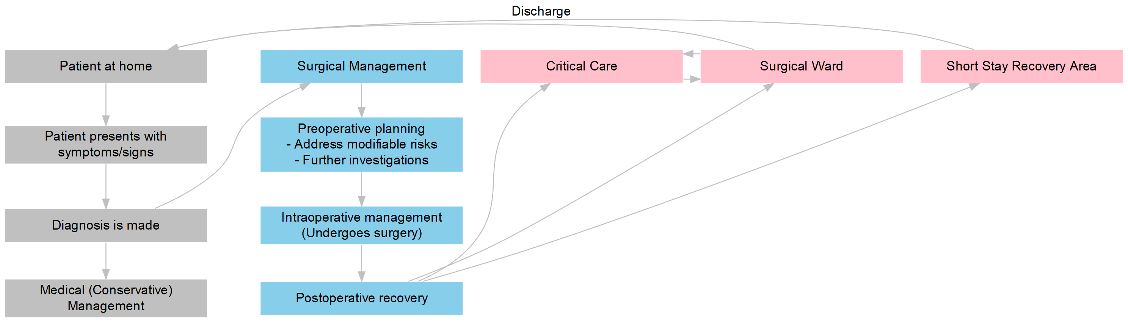

Figure 1‑1: An idealised patient surgical pathway.

## Postoperative critical care

Inpatient surgical recovery generally occurs on a general surgical ward, which is staffed by nurses and healthcare assistants who are accustomed to caring for patients after their surgery. On this ward, the medical management is typically coordinated by operating surgeons and their team of junior doctors. As patients may have different baseline co-morbidities and are subjected to surgical insults of varying magnitude depending on their underlying diagnosis and comorbidities, clinical teams may admit those deemed to be at increased risk of developing complications to a critical care unit after surgery—where it is thought that patients may have their perioperative risk reduced through higher levels of monitoring, more intensive nursing care, and more advanced medical therapies not typically available on the surgical ward.

In some countries, such as Australia and New Zealand (NZ), there are currently no national guidelines for deciding which patients are appropriate for admission postoperatively to critical care. However, in the UK, the National Confidential Enquiry into Patient Outcome and Death (NCEPOD), the Royal College of Surgeons of England and the Department of Health collectively recommend critical care admission when the preoperative estimated risk of mortality is ≥5% (35–37).

### Definitions of critical care

Formal definitions of critical care in the UK are defined in guideline documents published by the Intensive Care Society (ICS) and the Faculty of Intensive Care Medicine (FICM), and in the Critical Care Minimum Dataset maintained by NHS Digital (Table 1-1) (38–40). Levels 0 and 1 generally describe care provided on normal wards, while Levels 2 and 3 describe critical care delivered within high-dependency unit (HDU) and intensive care unit (ICU) respectively.

Table 1‑1: The Level 0-3 classification system used in the UK describes the patients’ needs first, then matches the levels of intervention/observation required in order to adequately care for the patient. Adapted from the Guidelines for the Provision of Intensive Care Services (GPICS) document (40).

|  |  |
| --- | --- |
| Levels (UK) | Description |
| 0 | Patients whose needs can be met through normal ward care in an acute hospital. |
| 1 | Patients at risk of their condition deteriorating, or those recently relocated from higher levels of care, whose needs can be met on an acute ward with additional advice and support from the Critical Care team. |
| 2 | Patients requiring more detailed observation or intervention including support for a single failing organ system or post-operative care and those ‘stepping down’ from higher levels of care. |
| 3 | Patients requiring advanced respiratory support alone, or basic respiratory support together with support of at least two organ systems. This level includes all complex patients requiring support for multi-organ failure. |

However, alternative definitions exist in health systems of other countries and regions, which may impede international comparisons (41–43).

For example, in contrast to the UK, Level I, II and III ICU definitions in Australia and NZ, refer not to patient dependency but instead to multiple organisational factors relating to work practice/caseload, staffing requirements, operational requirements, design, and monitoring and equipment standards (Table 1-2) (44). The major difference between the UK and the Australasian system is that the former defined standards based on the needs of the patient, while the latter defines the unit capabilities: in Australia and NZ, Level III ICUs are tertiary referral units for intensive care patients, while Level I and II ICUs are rural units serving smaller populations where there are limited specialist services available, and where travel to specialist services may cause delay (44); Level I-III ICUs in Australia and NZ are all able to provide a period of mechanical ventilation, and HDUs do not come under this classification system (45).

Table 1‑2: The Level I-III Australia and New Zealand Intensive Care Society (ANZICS) classification system in Australia and New Zealand only refers to Intensive Care Units, and does not include HDUs which are separately defined (44,45).

|  |  |
| --- | --- |
| Levels (Australasia) | Description |
| I | A unit capable of providing immediate resuscitation and short-term cardio-respiratory support for critically ill patients, and able to provide mechanical ventilation and simple invasive cardiovascular monitoring for a period of at least several hours. No minimum number of beds, but capacity based on demand. |
| II | A unit capable of providing mechanical ventilation, renal replacement therapy and invasive cardiovascular monitoring for an indefinite period. At least 6 staffed and equipped beds with more than 200 mechanically ventilated patients admitted per annum. |
| III | A tertiary referral unit for intensive care patients capable of providing comprehensive critical care including complex multi-system life support for an indefinite period. Level III units should have a demonstrated commitment to academic education and research. All patients admitted to the unit must be referred for management to the attending intensive care specialist. At least 8 staffed and equipped beds to discharge commitments consistent with a tertiary referral centre, divided into smaller areas of 8-15 beds. Normally more than 400 mechanically ventilated patients admitted per annum. Medical director with full-time commitment to ICU and who is a Fellow of the College of Intensive Care Medicine. Minimum standards for support staff, such as clerical and secretarial staff and equipment officers and other allied health professionals. |

European guidelines from the European Society of Intensive Care Medicine (ESICM) similarly describe three levels of care (Levels I, II and III), which again mirror the language of the UK and Australasian definitions but differ in their definitions (Table 1-3) (46). Within the European definitions, HDUs are classified as providing levels of care below Level I.

Table 1‑3: The Levels of Care defined by the ESICM. HDUs are defined as providing a level of care not exceeding Level I (46).

|  |  |
| --- | --- |
| Levels (European) | Description |
| I | Patients experiencing signs of organ dysfunction necessitating continuous monitoring and minor pharmacological or device-related support. These patients are at risk of developing one or more acute organ failures. Minimum 1 nurse to 3 patients. |
| II | Patients requiring monitoring and pharmacological and/or device-related support (e.g., hemodynamic support, respiratory assistance, renal replacement therapy) of only one acutely failing vital organ system with a life-threatening character. Minimum 1 nurse to 2 patients. |
| III | Patients with multiple (two or more) acute vital organ failure of an immediate life-threatening character. These patients depend on pharmacological as well as device-related organ support such as hemodynamic support, respiratory assistance, or renal replacement therapy. |

Given the international variation that exists in definitions of critical care, for the purposes of this PhD thesis, I shall define *postoperative critical care* as the package of treatments available on both the ICU (Level 3) and HDU (Level 2) *according to UK conventions* for patients admitted to those units for care after undergoing surgery.

### Critical care as a complex intervention

To understand the differences between critical care and general surgical ward care in the postoperative recovery pathway, critical care can be viewed through two perspectives.

In the first, critical care can be thought of as a type of Complex Intervention. This class of interventions are described as treatments *“that contain several interacting components”* (47). Other features of Complex Interventions highlighted by Craig *et al* include complexity of behaviours required by those delivering or receiving the intervention, complexity of groups or organisational levels targeted by the intervention, number and variability of outcomes, and a degree of flexibility or tailoring of the intervention to the patient (47).

Critical care fulfils the features of a Complex Intervention as it sits within a patient pathway with a number of components of care, and includes multiple different processes which can be flexibly tailored to individual patient need. The decision to deliver critical care is also contingent on a number of different factors, including the patient’s risk factors for developing complications, the clinician’s judgement of whether they think critical care would benefit the patient, and other contextual factors such as availability of beds and other competing interests (from other high-risk surgical patients or critically-ill non-surgical patients) for limited bed resources.

To see how the critical care Complex Intervention fits within the patient pathway, a graphical model (Figure 1-2) can be used.[6]

In Figure 1-2 a number of the factors (nodes) which could possibly affect the surgical outcomes of interest (i.e. postoperative complications and mortality, orange boxes) are depicted in relation to each other. Their relationships are linked by arrows which suggest the direction of effect of any node on another. In this model, critical care (pink box) could indicate whether a patient receives critical care (vs. normal surgical ward care), and therefore could be thought of as a differing treatment option that may influence the effects of various other upstream causal variables (blue boxes), including the magnitude of surgical insult and other measured or unmeasured confounders.

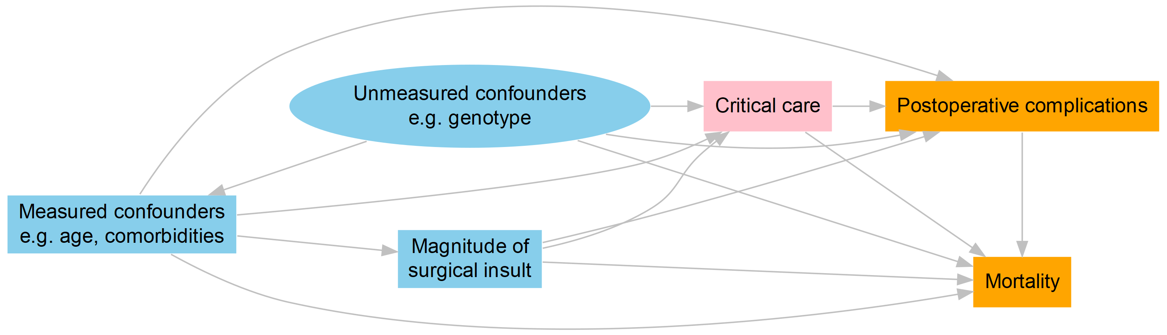

Figure 1‑2: A simplified graphical model for the factors which may affect surgical outcomes. Potential confounders are blue, outcomes are orange, and the critical care intervention is pink.

### A Donabedian framework: critical care as healthcare structure and process

Second, the Donabedian *Structure-Process-Outcomes* framework[7] could also be used to describe the differences between a critical care unit and a general surgical ward (50,51). Using this model, one might say that critical care units are specialised areas with higher nurse-to-patient/doctor-to-patient ratios and specialised equipment (*Structure*), that are able to deliver intensive or advanced medical therapies such as increased monitoring, mechanical ventilation or advanced drug infusions (*Process*), in order to improve patient recovery (reduce complications and mortality) following surgery (*Outcomes*). Table 1-4 summarises some key aspects of critical care delivery which differ from normal surgical ward care, using the UK consensus definitions (40).

Table 1‑4: Some features of critical care as described using a Donabedian Structure-Process-Outcome framework.

|  |  |  |
| --- | --- | --- |
| Structure | Process | Outcomes |
| 1. Specialised equipment for delivering organ support | 1. Consultant intensivist available 24/7, and able to attend within 30 minutes | 1. ICU complications, e.g. ventilator associated pneumonia |
| 2. Consultant:patient ratio ranging from 1:8 to 1:15 | 2. Daily (twice daily recommended) consultant ward rounds | 2. More severe morbidity, e.g. multi-organ dysfunction |
| 3. Recommended resident doctor:patient ratio no worse than 1:8 | 3. Daily multidisciplinary input from nursing, microbiology, pharmacy and physiotherapy | 3. Higher incidence of mortality than general ward |
| 4. Minimum 1:1 nurse:patient ratio for Level 3 patients | 4. Able to monitor vital signs hourly | 4. Greater loss of function at discharge than general ward patients |
| 5. Minimum 1:2 nurse:patient ratio for Level 2 patients | 5. Able to provide organ support, e.g. invasive or non-invasive ventilation, multiple intravenous vasoactive infusions, renal replacement therapy, etc. |  |
| 6. Minimum training standards, e.g. 50% of nurses must have a post-registration award in critical care nursing | 6. Able to care for patients under continuous sedation |  |

### The common language of critical care

Therefore, critical care, seen through the lenses of a complex intervention and the Donabedian conceptual framework, differs fundamentally from general ward care by the types of medical treatments and equipment, the increased intensity of nursing and medical (doctor) input, and levels of monitoring available to the patients postoperatively. While there are differences between countries in formal definitions for critical care, these aspects are consistent when critical care is compared across different countries (41).

### Equipoise over the benefits of critical care

Although critical care admission is generally regarded as essential for high-risk patients, it is not yet certain whether this complex intervention improves outcomes, or which patients would benefit from pre-emptive admission to critical care after surgery. There is an assumption that critical care is beneficial, and while trials on some specific critical care interventions, such as pre-emptive haemodynamic therapies have been shown to be beneficial (52,53), the efficacy of planned critical care admission overall to prevent postoperative complications has not itself been subject to randomised controlled trials.

While there is some evidence from observational studies favouring critical care admission in patients experiencing clinical deterioration on the ward, when prompt admission may result in improved mortality outcomes compared to delayed admission (54), the evidence for immediate postoperative admission is less clear (Table 1-5) (55–60).

An Instrumental Variable (IV) analysis conducted by Harris *et al* using multicentre data from the UK from 12,380 patients assessed the effects of prompt admission to critical care under the natural randomisation event (instrument) of critical care strain (54). They demonstrated that when critical care strain was low (2 or more empty critical care beds) patients were more likely to be admitted promptly to critical care from the ward than when strain was high (no empty beds available at the time of referral), and consequently the delays in admission seen during periods of high strain significantly increased 90-day mortality by 16.2% for those recommended for critical care admission.

Table 1‑5: : A few examples of observational studies examining the effects of postoperative critical care admission on surgical outcome.

|  |  |  |  |  |
| --- | --- | --- | --- | --- |
| Study | Sample Size (n) | Centres | Country | Details |
| Symons *et al* 2013 (55) | 367,796 | 145 | England, UK | Retrospective study. Data from patients admitted with high-risk emergency general surgery diagnoses were extracted from the Hospital Episode Statistics (HES) database. The effects of hospital-level structural factors on mortality were investigated using logistic regression modelling. Patients admitted to hospitals in the highest tertile of ICU bed numbers per 1000 hospital beds had lower mortality (adjusted OR = 0.84) than those in the lowest and middle tertiles. |
| Vester-Andersen *et al* 2014 (56) | 2,904 | 6 | Denmark | Prospective study. Major gastrointestinal surgery (laparotomy or laparoscopy) patients included in a multivariable logistic regression analysis comparing admission to ward care with immediate postoperative critical care admission, and with ward care followed by delayed admission to critical care. Overall 538 patients died (18.5%) within 30 days of surgery, with higher risk-adjusted mortality for patients admitted to critical care immediately after surgery (adjusted OR = 3.27). Delayed admission to critical care had a higher risk-adjusted mortality than immediate postoperative admission (adjusted OR = 5.45). |
| Gillies *et al* 2015 (57) | 16,147 | 207 | UK | Retrospective study. Data from patients admitted to UK critical care units after surgery was extracted and linked from the HES and Office for National Statistics, Intensive Care National Audit & Research Centre Case Mix Programme and Scottish Intensive Care Society Audit Group (SICSAG) databases. Multilevel logistic regression modelling was used to analyse the effects of regional-level factors on regional variations in mortality, adjusting for patient-level risk factors. Inter-region unadjusted variance in hospital mortality was identified (Median Odds Ratio [MOR] = 1.14), and persisted despite patient-level case mix adjustment (MOR 1.10). After critical care bed utilisation was included in model adjustment, MOR reduced to 1.03, and suggested that patients admitted to critical care units in hospitals with higher surgical critical care admissions per 100,000 were associated with lower mortality (adjusted OR 0.91). |
| Kahan *et al* 2017 (58) | 44,814 | 474 | 27 countries | Prospective study. Patients undergoing elective surgery with planned overnight hospital stay, excluding emergency, day-case surgery and radiological procedures. Multilevel logistic regression modelling adjusting for patient-level risk-factors, hospital-level and country-level effects was used to investigate the effects of critical care admission on 30-day inpatient mortality. Patients admitted to critical care immediately postoperatively had a higher risk-adjusted mortality (adjusted OR = 3.01). This association differed between countries with different income-levels (high-income countries adjusted OR = 2.50 vs. low- and middle-income adjusted OR = 4.68). Further sensitivity analysis including only high-risk patients did not significantly alter findings. |
| STARSurg collaborative 2019 (59) | 4,529 | 163 | UK & Ireland | Prospective study. Major gastrointestinal and liver surgery patients were included. Multilevel logistic regression modelling was used to investigate the effects of direct postoperative critical care admission on mortality. Patients admitted to critical care directly after surgery had higher 30-day mortality after risk-adjustment (adjusted OR = 2.32) compared to patients admitted to ward care. Patients admitted initially to the ward, later requiring rescue critical care admission had higher risk-adjusted mortality than those admitted to critical care immediately post-surgery (adjusted OR = 8.65). |
| Thevathasan *et al* 2019 (60) | 7,060 | 1 | USA | Retrospective study. Data from patients undergoing surgery requiring general anaesthesia were extracted from hospital electronic records and analysed using propensity score matching methods. Patients with the lowest tertile of propensity for postoperative critical care admission were found to have increased postoperative lengths of stay (adjusted Incidence Rate Ratio [IRR] = 1.69) and hospital costs (adjusted IRR = 1.92). Postoperative critical care admission was associated with decreased lengths of stay (adjusted IRR = 0.90) and hospital costs (adjusted IRR 0.92). |

In the post-surgical population, an association between rates of critical care utilisation and improved regional variation mortality outcomes has previously been shown in a retrospective study by Gillies and colleagues, who extracted data from large UK registries and used multilevel regression analysis to determine if there were regional differences in outcome for surgical patients admitted to critical care (57). Their study of 16,147 patients admitted to 207 critical care units detected regional-level variation in hospital mortality which was explained by critical care bed utilisation within the hospitals (Median Odds Ratio reducing from 1.14 in a null model to 1.03 in a model accounting for surgical critical care admissions per 100,000 procedures), and that higher critical care utilisation was associated with a significant reduction in patient mortality.

Applying increased monitoring and higher-intensity nursing care to patients immediately following their surgery is intuitively more favourable compared to less intensive ward level care, and may prevent complications that necessitate rescue admission to critical care at a later stage of the hospital stay. Admission to critical care when patients have already experienced complications is associated with higher mortality when compared with patients who were immediately admitted postoperatively (61). Yet other observational studies have suggested that patients who are admitted for critical care management do not necessarily receive a survival benefit (58).

Kahan *et al* reported a planned analysis of ISOS data which analysed outcomes from 44,814 patients undergoing surgery in 474 hospitals in 27 countries using mix-effects logistic regression models to evaluate the association between immediate postoperative critical care admission and in-hospital mortality (58). After adjusting for patient-risk, they found that the mortality was higher in patients admitted to critical care (adjusted OR = 3.01).

A prospective observational study by the Student Audit and Research in Surgery (STARSurg) collaborative including 4,529 patients undergoing major gastrointestinal and liver surgery in 163 centres in the UK and Ireland found that patients admitted to critical care directly after surgery had higher 30-day mortality after risk-adjustment (adjusted OR = 2.32) compared to patients admitted to ward care using multilevel logistic regression modelling (59). But patients in their cohort who subsequently deteriorated on the ward and later required rescue critical care admission had still higher risk-adjusted mortality (adjusted OR = 8.65).

A recent study by Thevathasan *et al* using data from a single tertiary centre in the USA suggests that there might be a heterogenous treatment effect associated with immediate postoperative critical care admission (60). They performed a propensity score-matched study in patients who underwent surgery with general anaesthesia, matching 3,530 patients who were admitted to critical care postoperatively to 3,530 patients who were admitted postoperatively to a surgical ward on a propensity score for postoperative critical care unit admission. They further stratified their cohort into tertiles of propensity score, and found differences in the effect of critical care admission on hospital lengths of stay, and healthcare costs which varied by tertile of propensity score. In patients with the lowest propensity for critical care admission, admission to critical care was associated with increased length of stay and healthcare costs. Conversely, in patients with the highest propensity for critical care, admission to critical care was associated with shorter lengths of stay and healthcare costs.

Given the lack of strong evidence that pre-emptive admission to critical care immediately following surgery is beneficial, some might argue that high-risk patients would do just as well recovering on general surgical wards or high-acuity care wards postoperatively, and only later getting transferred to critical care (reactive admission) when they deteriorate or exhibit early signs of complications. An intuitive way of looking at this is that avoiding critical care when it is not needed avoids exposing patients to the potential deleterious effects of the intervention — in a commentary by Taccone *et al*, it has even been argued that critical care:

*“could paradoxically be more harmful than beneficial for elective surgical patients because of potential side effects, such as increased risk of nosocomial infections, reduced access to early mobilization, oversedation, sleep deprivation, stress, and delirium.”* — Taccone *et al* (2017) (62)

Taccone and colleagues further argue that a postoperative “intermediate care” ward may be sufficient for most surgical patients, avoiding exposure to the side effects of critical care (62). The idea that high-risk surgical patients could be managed in alternative settings outside of traditional critical care has also been mooted by Sobol and Wunsch in a 2011 review article (63), where they cite a study in which patients were admitted to a lower intensity “Post Anaesthesia Care Unit” (PACU) instead with no increased incidence of postoperative morbidity and mortality (64). These areas of “intermediate”, “enhanced” or “high-acuity” care will be touched on further in this chapter.

## The right treatment for the right patient?

Due to the equipoise over benefit, relative scarcity of critical care beds, and the differences in local practices and case-mix, deciding which patients to admit to critical care immediately after surgery is not straightforward. A number of strategies exist to help triage patients for admission (65), which often involve some form of risk assessment to identify the patients at highest risk of complications from their surgery. Risk stratification works on the assumption that high-risk patients are most likely to benefit from critical care interventions. Pre-emptive critical care admission may be able to prevent high-risk patients from developing anticipated complications, which become more difficult to treat once they happen, and may result in irreversible decline leading to mortality (an event known as “failure to rescue”) (66).

An alternative strategy is to protocolise admissions to critical care for certain procedure types, based on their anticipated care needs following surgery, regardless of their risk profile. This strategy has become a standard of care in certain surgical specialties in the UK, for example in cardiothoracic surgery, critical care facilities are ring-fenced for postoperative cardiac surgery patients (67,68). Similarly in Israel, consensus guidelines recommend all postoperative vascular surgery or major general surgery patients with severe underlying systemic disease be admitted to critical care (63,69).

A third strategy is the identification of patients who would most likely benefit from critical care (70), and preferentially admitting patients with maximum expected benefit over patients with little or no benefit expected (63,71).

Although UK recommendations advise clinicians to admit patients to postoperative critical care if their risk is high (35,36), a number of observational studies have suggested that a large proportion of patients who go on to die after their surgery were not directly admitted to critical care postoperatively,[8] and instead spend the initial hours and days recovering from surgery on the general surgical ward (14,15,61).

In the European Surgical Outcomes Study (EuSOS), a study of 46,539 patients undergoing surgery over a 7-day period in 28 European countries, 73% of the patients who died were not admitted to critical care at any stage after their operation (14). In the International Surgical Outcomes Study (ISOS), a global study of 44,814 patients undergoing elective inpatient surgery in 27 countries across 6 continents,[9] 28% of the patients who died were not admitted to critical care at any stage during their admission (15). In a retrospective cohort study of 572,598 Scottish patients undergoing surgery using linked registry data, Gillies *et al* found that only 4.8% of the highest-risk patients in their cohort were admitted directly to critical care postoperatively, and that subsequent (indirect) critical care admission was associated with increased mortality in this group even after adjustment for potential confounders (61).

Two hypotheses exist to explain why high-risk patients are not being admitted directly to critical care following their operations, which will be briefly examined below, and which will shape the questions that this thesis will set out to answer (72–74).

### Hypothesis 1: Insufficient resource due to critical care bed scarcity and costs

Critical care is regarded a scarce resource and an expensive intervention due to the reliance on highly-trained staff and increased numbers of nurses and doctors per patient (Figure 1-1), therefore it is subject to rationing at multiple levels, from the macro- (at state and government level) to the micro-level (at the patient bedside) (75). Advanced organ support technologies available within critical care units further increases the financial burden of delivering care on these units as equipment are costly to run and maintain. In the UK, the daily cost of critical care ranges from £838 to £2,075 (76), depending on the intensity of organ support requirements and types of pathology treated, with an average of £1,328 per day estimated by Ridley and Morris in 2004 (approximately £2,002, after adjustment for inflation[10] to 2018 prices) (77). These costs are comparable in other developed nations, for example, in the United States of America (USA) daily costs of critical care were estimated in 2005 at between US$2,698 to US$3,518 (approximately £2,052 to £2,675 using 2018 exchange rates), and in other European countries in 2007 from €1,168 to €2,025 (approximately £1,004 to £1,740 using 2018 exchange rates) (78,79). In contrast, the cost of an average general hospital ward is estimated at £294 per day in the UK (2004 estimate adjusted for inflation) (77).

In a study of critical care services across countries in North America and Europe using administrative data, Wunsch *et al* identified a correlation between the per capita healthcare expenditure and per capita ICU bed numbers in the 8 countries they studied (41). This implied that the differences in critical care costs may induce regional differences in the availability of critical care beds at the population-level, which are related to how health services are financed and delivered in different countries. They further showed that there was an inverse correlation between the availability of ICU bed capacities and reported frequency of sepsis diagnoses, and between the hospital mortality of patients in these countries. Their second finding provides some evidence to support the assertion that variations in critical care bed availability are associated with variations in prioritisation of patients for admission to critical care and/or affect the outcomes of patients.

The UK has an estimated 3.5 to 6.6 critical care beds per 100,000 population, which represents 1.2% to 2.8% of total inpatient hospital beds (41,43,57,80). These numbers are comparatively lower than the European average of 11.5 to 14.9 critical care beds per 100,000 population (41,43), and North American critical care bed capacities reported in the literature (Canada: 13.5 and USA: 20.0 per 100,000 population) (41,80). Consequently, it may be that the UK does not have adequate capacity to pre-emptively admit all high-risk patients to critical care following surgery, or that clinicians are deciding not to admit patients to critical care who might benefit from the intervention because of the scarcity of beds.

Evidence from EuSOS suggests that the proportion of patients admitted postoperatively to critical care varied widely between countries (14). As an exploratory analysis for this thesis, I extracted published data from papers authored by Pearse *et al* (14) and Rhodes *et al* (43), and modelled the proportions of critical care admissions reported by each country in the former (dependent variable) against the critical care bed availabilities in each country as reported in the latter (independent variable) using linear regression.[11] This model suggested that a large proportion of the variability between countries might be explained by the variability in critical care bed numbers per 100,000 population (Figure 1-3). At least on a macro-level, patients undergoing surgery had differing probabilities for being admitted to critical care which were associated with the critical care bed availabilities in the countries where they were receiving treatment.

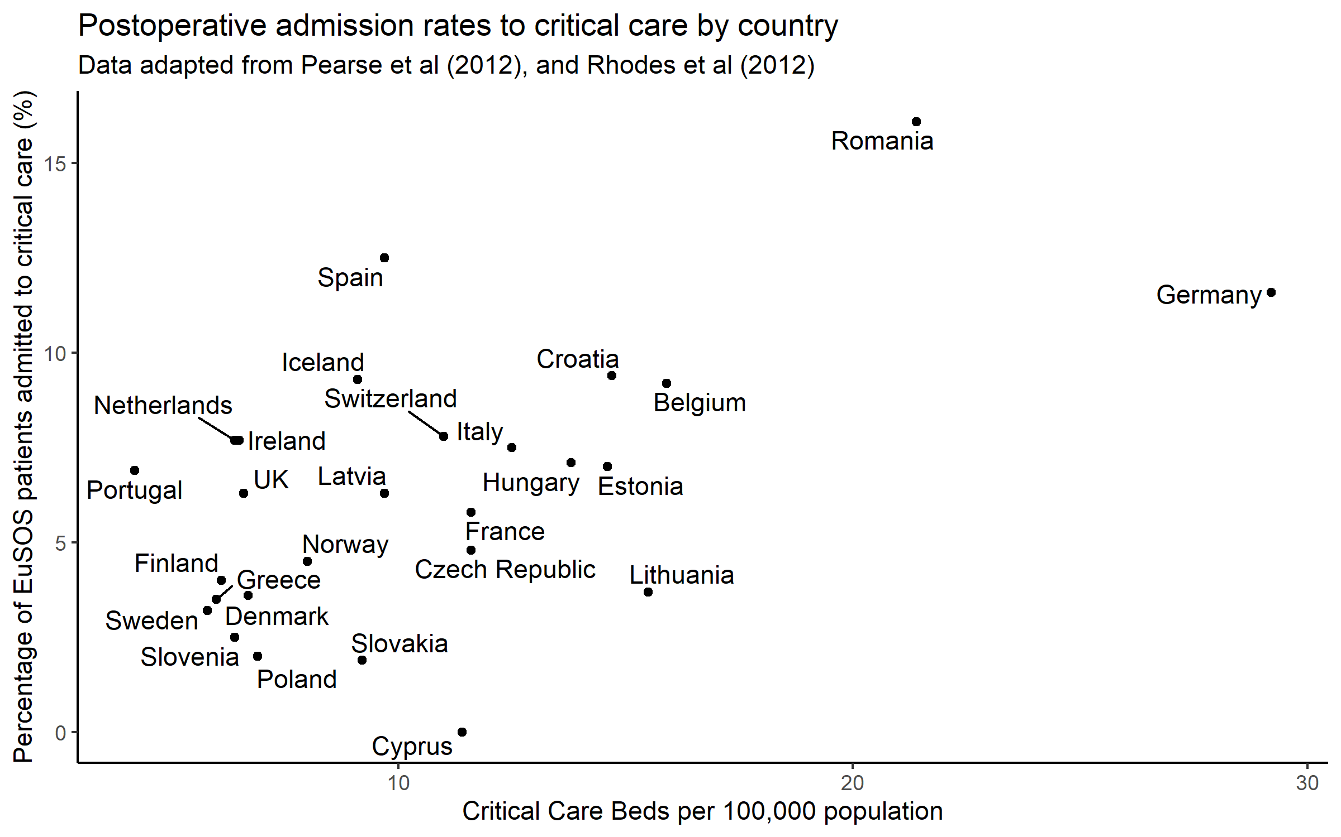

Figure 1‑3: Postoperative admission to critical care. The percentage of patients admitted to critical care postoperatively in the EuSOS study is associated with the critical care bed capacities in their respective countries. Data adapted from Pearse et al (2012), and Rhodes et al (2012).

While critical care is traditionally delivered in ICUs and HDUs in the UK, a subset of the interventions normally associated with critical care could be delivered in alternative “enhanced care” or “high-acuity” care settings elsewhere within the hospital. These other areas may have the resources to care for patients who require one or more interventions normally associated with critical care. For example, within the Emergency Department, resuscitation bays have the facilities to temporarily care for critically ill patients requiring intensive nursing/medical interventions. Another example would be the cardiologists’ Coronary Care Unit, which may have the ability to deliver 1:1 or 1:2 nursing, invasive blood pressure monitoring, continuous ECG telemetry and inotropic/vasopressor support. The use of such high-acuity care areas to deliver postoperative care has been reported in the UK’s *Critical Futures* project commissioned through by FICM (81) However, these high-acuity care beds are currently ill-defined in the literature, and little is known of their prevalence and make-up.

Their presence in hospitals are not the result of regulations issued by professional bodies. This therefore means there is the potential for variation in what medical interventions they can offer and how they are staffed, and there is no clear agreement on whether they should be defined as critical care units. For example, on these units, high-risk patients may be cared for by ward nurses in conjunction with support from Critical Care Outreach Teams (CCOT), or with anaesthetists and surgeons jointly managing the patients’ medical care.

In the first *Critical Futures* report, such facilities were referred to as “Level 1+” enhanced recovery services, without being labelled as critical care units *per se* (81). In this report, the authors presented survey results pointing to gaps in services in which high-acuity beds may have evolved to manage the postoperative recovery of high-risk surgical patients. They may be considered to provide sufficient support for postoperative recovery that high-risk patients then bypass ICU/HDU entirely during their hospital stay. Such a scheme could be considered a modification (Figure 1-4) of the earlier surgical pathway depicted in Figure 1-1. The lack of regulation surrounding the make-up and delivery of care in such enhanced care areas has prompted the formation of a working parties within FICM and the Royal College of Physicians of London to produce guidance on how high-acuity services can be further evolved to deliver care in this space. An open consultation is currently underway seeking feedback from stakeholders on a draft guidance document produced by this working group to regulate enhanced care and high-acuity beds (82,83).

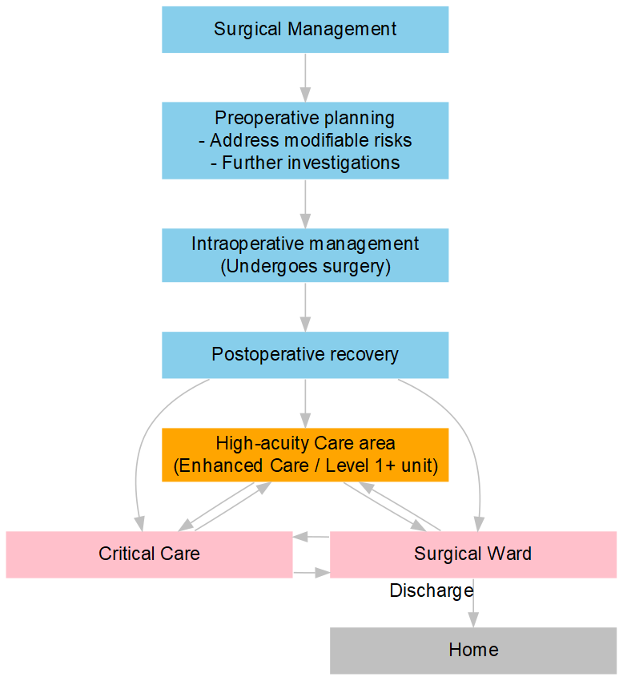

Figure 1‑4: Enhanced care areas (Level 1+ units) in the surgical pathway. This is a modification of the pathway depicted in Figure 1-1, with the removal of the steps before surgical management is decided in the patient journey.

### Hypothesis 2: Difficulties in risk-prediction

While the majority of patients undergoing surgery are low risk, individuals who have multimorbidity and/or are undergoing complex procedures are at higher risk of complications or death. Where a patient has been identified as high-risk, mitigation strategies such as adopting less invasive surgical approaches (or the avoidance of surgery altogether), and admission to postoperative critical care, might serve to improve patient survival. Discriminating between who is high risk from who is low risk is a difficult task, and various methods are employed, e.g. using subjective clinical assessment, additional physiological investigations or objective risk-stratification tools.

A large number of objective clinical scoring systems exist to help risk-stratify patients undergoing surgery (84), but their use is variable among clinicians and may be tempered by prior beliefs. Previous research has demonstrated that the majority of patients do not have mortality risks documented or quantified (85), even those undergoing surgical procedures which are known to be associated with a high risk of mortality (86) — in the UK, an estimated one third of elective major surgical patients, and one quarter of emergency abdominal surgery patients are thought to not have a risk assessment recorded before their surgery (87,88). Risk stratification tools are predominantly multivariable regression models which may use a large number of predictor variables, not all routinely available prior to surgery. These tools have also largely been derived using retrospective cohort data, sometimes with small datasets and unknown generalisability (external validity) to patient cohorts that might differ in time and place to the original derivation cohort.

What constitutes a high-risk patient may, in many instances, ultimately boil down to a subjective opinion of the surgeon and anaesthetist, based on the clinical information at hand. Clinicians may therefore be inaccurately predicting their patients’ risks of complications following surgery, and thus not adjusting their management accordingly. High-risk patients may be inappropriately identified as low-risk and recommended for postoperative admission to general surgical wards, and low-risk patients conversely recommended for critical care when they would not benefit. Perhaps the failure to admit high-risk patients appropriately to critical care after their surgery is in fact a failure of appropriately identifying the high-risk patient in advance.

It is unclear how good the subjective clinical assessment of patient risk is during the perioperative period. In a literature search to identify previous studies which examined this issue[12], a number of studies were identified that investigated the performance of subjective clinical assessment in predicting perioperative mortality or morbidity risk, or investigated the value of adding subjective variables to risk prediction in surgical risk assessment (study details summarised in Table 1-6) (89–103). While the majority of these were small, single centre studies, five of these studies recruited patients and clinicians from multiple centres (91,94,96,103,104).

Table 1‑6: A summary of studies investigating the performance of subjective clinician assessment of mortality and morbidity risks in patients undergoing surgery.

|  |  |  |  |  |
| --- | --- | --- | --- | --- |
| Study | Sample Size (n) | Centres | Country | Details |
| Pettigrew and Hill 1986 (89) | 218 | 1 | New Zealand | Prospective study. Surgeons graded patient risks of major complications or mortality just prior to performing elective major gastrointestinal surgery, recording risk on a visual analogue scale; this was compared against a structured clinical assessment tool based on 7 organ systems (respiratory, cardiovascular, etc.) which each had a 5 point scale (0 = “no risk”, 4 = “major risk”), and against other prognostic tools including plasma protein measurements and three other prognostic indices incorporating biochemical measurements. Subjective risk assessment by surgeons was less accurate than the structured clinical assessment tool and other tools incorporating plasma protein levels. No Receiver Operating Characteristic (ROC) curve analysis nor calibration analysis was conducted. |
| Pettigrew *et al* 1987 (90) | 113 | 1 | New Zealand | Prospective study. Patients undergoing elective gastrointestinal surgery were subjectively risk assessed by surgeons using a visual analogue scale once preoperatively and once immediately postoperatively, these risk assessments were compared against a subjective clinical assessment based on history and examination by a different clinician not performing the surgery, and against serum albumin levels. Visual analysis of ROC curves showed postoperative assessment by the surgeon was superior to preoperative assessment by the surgeon, subjective clinical assessment by another clinician, and serum albumin level. |
| Pons *et al* 1999 (91) | 1,309 | 7 | Spain | Prospective study. Mortality predictions based on surgeons’ subjective risk assessment (Area Under the ROC curve [AUROC] = 0.70) were compared against a regression model (AUROC = 0.76) in both elective and emergency open-heart cardiac surgery patients. Subjective risk assessment was graded in 5 categories as “low” to “extremely high”. Calibration of surgeons’ subjective risk assessment was poor. |
| Markus *et al* 2005 (92) | 1,077 | 1 | Germany | Prospective study. Patients undergoing elective and emergency major hepatobiliary or gastrointestinal surgery were given a subjective predicted risk of developing postoperative morbidity by surgeons on a scale of 0 to 100% (in steps of 10%). These predictions were made immediately following surgery and compared with predictions made using the Physiological and Operative Severity Score for the enUmeration of Mortality and morbidity (POSSUM). Surgeons’ subjective risk assessment was more closely correlated with actual morbidity outcomes than POSSUM as analysed using calibration curves. POSSUM-predicted morbidity overpredicted risks. ROC curve analysis was not performed. |
| Woodfield *et al* 2007 (93) | 1,013 | 1 | New Zealand | Prospective study. Patients undergoing abdominal surgery received a subjective surgeon assessment of risk of major complications and mortality graded using visual analogue scales immediately preoperatively and postoperatively. Preoperative and postoperative assessments were compared against each other. Preoperative prediction of mortality (AUROC = 0.74) and major complications (AUROC = 0.67) and were not significantly different to postoperative predictions (AUROC = 0.75 and 0.69 for mortality and major complications, respectively). Including preoperative surgical assessment in a multivariable logistic regression model incorporating a range of other objective variables (a modification of the Otago Audit Model) improved the accuracy of predictions by a small margin (AUROC = 0.78). |
| Cohen *et al* 2009 (94) | 28,751 | 170 | USA | Retrospective study. Data from patients undergoing colorectal surgery was extracted from the American College of Surgeons’ National Surgical Quality Improvement Program (ACS NSQIP) database. The effect of including subjective measures of risk in logistic regression models for predicting morbidity and mortality was assessed by constructing models with, and without, American Society of Anesthesiologists Physical Status (ASA-PS) and Functional Health Status (FHS) variables. ASA-PS is a 5-category scale (I to V) and FHS is a 3-category classification system (“independent”, “partially dependent” and “totally dependent”). A model with ASA-PS and FHS exhibited better calibration and discrimination (AUROC = 0.912) than models excluding either ASA-PS (AUROC = 0.909), or FHS (AUROC = 0.909), or both (AUROC = 0.905). |
| Karliczek *et al* 2009 (95) | 191 | 1 | Holland | Prospective study. Patients undergoing colorectal surgery requiring bowel anastomosis were subjectively assessed for risk of anastomotic leak by the surgeon using a visual analogue scale. Surgeons’ subjective prediction of anastomotic leak performed poorly as assessed using ROC curve analysis (AUROC not reported). |
| Bilimoria *et al* 2013 (96) | 1,414,006 | 393 | USA | Retrospective study. Data from patients undergoing a range of surgical procedures was extracted from the ACS NSQIP database, and a risk calculator was created using 8 regression models developed to predict outcomes for mortality, morbidity and 6 specific other complications. Subjective surgeon modification of risks computed by the models were incorporated using a Surgeon Adjustment Score (SAS, a categorical variable of 1, 2 or 3), and allowed model-computed scores to be increased by +0, +1 or +2 standard deviations of predicted risks for a particular surgical procedure. Inter-rater agreement of the SAS was tested in 80 surgeons using 10 simulated patient scenarios which varied in complexity and included additional comorbidities or factors not originally modelled in the regression models. Performance of the regression models were excellent (AUROC ranging from 0.80 to 0.94). Inter-rater agreement for SAS categorisation was good among surgeons for each scenario (80% to 100% agreement), however performance of SAS-modified risks was not assessed. |
| Pommerening *et al* 2015 (97) | 966 | 10 | USA | Prospective study. Trauma surgeons subjectively predicted immediately after major trauma patients arrived in hospital whether the patients were likely (binary yes/no) to require massive transfusion of blood products (defined as ≥10 units of red blood cells within 24hrs). Subjective trauma surgeon prediction performed acceptably for predicting massive transfusion (AUROC = 0.65), and massive transfusion or death (AUROC = 0.66). The Trauma Associated Severe Hemorrhage (TASH) score performed significantly better (AUROC = 0.72) at predicting massive transfusion but required seven independent variables, including some laboratory measurements. Therefore, due to absent data, almost half the cohort was excluded in the analysis comparing subjective assessment with TASH. |
| Cowger *et al* 2016 (98) | 10,802 | 202 | USA | Retrospective study. Data were extracted from patients undergoing assessment for suitability of insertion of a Left Ventricular Assist Device (LVAD) in the Interagency Registry for Mechanically Assisted Circulatory Support (INTERMACS). These patients were subjectively assigned Profiles (one of seven possible categories) to describe their clinical status based on haemodynamic stability, inotrope use and functional capacity. Three additional risk Modifiers were also assigned to patients including the need for temporary circulatory support, presence of arrhythmia, and frequent flyer status. The accuracy of Profiles and Modifiers to predict mortality outcome was assessed using survival analysis, and of the Modifiers assessed, frequent flyer status was the only one that predicted mortality. The study further assessed the heterogeneity in assignment of Profiles through a prospective web-based survey of clinicians based in each institution which presented five hypothetical patient scenarios. This survey demonstrated inconsistency in Profile assignment between respondents. |
| Buchlak *et al* 2017 (99) | 136 | 1 | USA | Prospective study. A multivariable logistic regression model was developed to predict postoperative complications in 136 patients undergoing complex spinal surgery (AUROC = 0.71). This model was then used to produce a risk prediction calculator and its implementation was assessed in an experiment involving 8 physicians. A hundred random patient scenarios were created using de-identified data and histories and presented to the physicians who were asked to predict whether the patients in the scenarios went on to develop complications (binary classification). Physicians were randomly presented the scenarios with and without the aid of the risk prediction calculator and also in differing orders of data-presentation. Predictions significantly improved in accuracy when physicians were aided by information from the risk prediction calculator. |
| Wang *et al* 2017 (100) | 242 | 1 | China | Retrospective study. Patients undergoing lumbar spinal surgery were risk assessed using the ACS NSQIP risk calculator described in the earlier study by Bilimoria *et al* above (96). The Surgeon Adjustment Score was used to modify risks upwards if patients exhibited additional risk factors including previous cardiac events and/or cerebrovascular disease. The ACS NSQIP risk calculator performed well for predicting renal failure (AUROC = 0.83), hospital readmission (AUROC = 0.84), and mortality (AUROC = 0.97), but only acceptably for predicting cardiac complications (AUROC = 0.65), any serious complications (AUROC = 0.67), any complication (AUROC = 0.68), and pneumonia (AUROC = 0.69). Its performance for other complications exhibited substantial variation (AUROC ranging from 0.31 to 0.60). Calibration was acceptable for all the outcome predictions (Hosmer-Lemeshow test p >0.05 for all). |
| Woodfield *et al* 2017 (101) | 1,295 predictions | 1 | UK | Prospective study. Conducted in three phases, a total of 859 patients had 1,295 risk predictions made. Phase I: patients undergoing major elective or acute abdominal surgery were risk assessed by the surgeon or their assistant for the risk of major complications on a visual analogue scale immediately preoperatively (AUROC = 0.78) and postoperatively (AUROC = 0.81), these were then compared to POSSUM (AUROC = 0.75). Phase II: visual analogue scales were modified with 6 additional subscales for different areas of clinical risk (functional status, cardiac and respiratory morbidity, severity of surgical pathology, complexity of surgery, urgency of surgery, and “other”), before a global risk assessment was made; prediction performance was similar to Phase I. Phase III: surgeons were given feedback on the accuracy of their predictions in Phases I and II, before then being asked to make predictions on subsequent fresh patients using the Phase II visual analogue scale tool; performance for this phase improved for both preoperative (AUROC = 0.90) and postoperative (AUROC = 0.92) predictions. |
| Kwan *et al* 2018 (102) | 275 predictions | 1 | Hong Kong | Retrospective study. Fifty-five Patients who underwent spinal surgery for metastatic spinal tumours were reviewed and their data were used to construct anonymised clinical scenarios. These scenarios were presented to five oncologists who made subjective predictions of patient survival, and these were compared against an objective modified Tokuhashi score prediction. Subjective survival prediction by oncologists had a higher agreement with actual patient survival (Cohen’s kappa = 0.52), than predictions made by modified Tokuhashi score (Cohen’s kappa = 0.31, p = 0.02). Subjective survival predictions also showed high inter-rater reliability between oncologists (Intra-Class Correlation [ICC] = 0.71), and high test-retest reliability over time (ICC = 0.69). |
| Wijeysundera *et al* 2018 (103) | 1,401 | 25 | Australia, UK, Canada and New Zealand | Prospective study. Patients undergoing elective major non-cardiac surgery with risk factors for cardiac complications were subjectively graded by anaesthetists on their functional capacity in terms of units of metabolic equivalents of tasks (METS) as poor (<4 METS), moderate (4-10 METS) or good (>10 METS). Their assessments were compared against objective tools including the Duke Activity Status Index (DASI) questionnaire, Cardiopulmonary Exercise Testing (CPET), and N-terminal pro-B Natriuretic Peptide (NT pro-BNP) levels, for predicting postoperative mortality or complications. Each variable was added to a baseline multivariable logistic regression model and the incremental value of each variable was assessed using AUROC and Net Reclassification Improvement. Subjectively assessed functional assessment of METS alone performed poorly for predicting a composite outcome of 30-day mortality or myocardial infarction (AUROC = 0.57) and for predicting 1-year mortality (AUROC = 0.55). Models incorporating DASI performed better than models which incorporated the other variables, for many of the outcomes tested. |

Within these studies, there was heterogeneity in the way subjective clinical assessment of risk was recorded, with some studies using visual analogue scales, some asking the clinician to provide a binary prediction of whether they anticipated a patient to meet with perioperative complications, and some asking for a prediction on an ordinal categorical scale. Furthermore, these studies were heterogenous in design, with some using retrospective case note vignettes presented to clinicians for subjective assessment outside of routine clinical care, and others prospectively seeking a subjective clinical risk assessment in patients preoperatively or immediately post-surgery. Overall, the findings of these studies were equivocal in ascertaining the value and accuracy of subjective clinical assessment in predicting perioperative risk.

Outside of the perioperative literature, subjective assessment of patients has also been studied in medical patients being assessed for admission to critical care, and clinician predictions have been found to be associated with “prognostic pessimism” in this scenario (70,105,106). Wildman *et al* compared the performance of an outcome prediction model for Chronic Obstructive Pulmonary Disease (COPD) patients presenting with an acute exacerbation against subjective clinical assessments of 180-day mortality in the COPD and Asthma Outcome Study (CAOS) (105,106). They demonstrated that clinical assessments were mis-calibrated, while maintaining reasonable discrimination, but that the calibration and discrimination of a multivariable regression model was significantly better. In other studies of acute medical patient admissions to hospital, subjective clinical assessments have been compared against physiological scoring systems for predicting length of stay and mortality (107,108). In these studies, subjective clinical assessments were found to have good discriminatory performance, and objective physiological variables did not improve predictions.

While the value of subjective clinical risk assessment has not been clearly demonstrated, and more objective risk prediction tools are widely available, implementation of these objective tools to support clinical assessment have been challenging (109). Furthermore, improving their uptake in clinical practice has required the concerted efforts of multiple agencies and national projects in the UK. In contrast, more complex and expensive investigations for risk-stratification, like cardiopulmonary exercise testing (CPET), have been growing in popularity (110), despite evidence that simple tools may have equivalent performance to CPET (103).

## Research questions and the structure of the rest of the thesis

In this chapter, I have introduced the concept of surgery as a period of increased physiological stress predisposing patients to adverse events. I have described the surgical pathways undertaken by patients in the UK and the potential to mitigate perioperative risks by admitting patients to critical care. Although guidelines exist in the UK which recommend that high-risk patients should be admitted to critical care postoperatively, I have briefly described the evidence that many high-risk patients do not receive planned postoperative critical care despite the recommendations. I visited three hypotheses which may explain this phenomenon, summarised as: firstly, insufficient resource for managing high-risk postoperative patients due to critical care bed scarcity and costs; secondly, difficulties in risk- and benefit-prediction and hence poor identification of high-risk patients or those patients who may benefit from critical care; and thirdly, equipoise over the perceived benefits of critical care on perioperative recovery. These hypotheses may provide an explanation to why there appears to be a mismatch between the clinical recommendations and the reality of patient care on the ground.

In this PhD thesis I will examine the first two of these hypotheses in detail — the availability of critical care beds, and the accuracy of risk assessment in the identification of patients appropriate for critical care. The data I will use to do this will come from the Second Sprint National Anaesthesia Project: EPIdemiology of Critical Care provision after Surgery (SNAP-2: EPICCS) study, a prospective observational cohort study I designed with the supervision of my thesis advisors, and which was conducted in 2017 across hospitals in the UK, Australia and New Zealand.

SNAP-2: EPICCS has been used to produce significant research outputs during the course of my PhD, two of which I have had published in peer-reviewed journals (111,112). The analyses within this thesis will include some of those previously published works.

SNAP-2: EPICCS was designed to answer the following research questions[13]:

1. What is the availability of critical care, including high-acuity care areas?
2. How do clinicians estimate postoperative risk?
3. How accurate are currently available risk prediction tools?
4. How do clinicians decide which patients to admit for postoperative critical care?
5. What factors influence patient admission to postoperative critical care?

In *Chapter 2*, an overview of SNAP-2: EPICCS will be presented. The project comprises a number of separate elements designed to obtain empirical patient- and hospital-level data to investigate the hypotheses and answer the research questions above.

I will then present the findings of 4 studies in *Chapters 3–7*, designed to answer the research questions presented.

In *Chapter 3*, I will report a study quantifying the availability of postoperative critical care beds, and other high-acuity beds which clinicians may use to manage high-risk perioperative patients. This study will provide updated estimates of critical care capacity, expressed as a proportion of hospital beds within institutions, and expressed as a number of beds per capita population. The estimates reported will be discussed in context of international numbers from best estimates from the literature reviewed in *Chapter 1*.

In *Chapter 4*, I will describe an inpatient surgical cohort which was raised for the main part of SNAP-2: EPICCS. In *Chapter 5*, I report the surgical epidemiology of patients undergoing surgery in the UK, Australia and New Zealand, and describe the risk profile of these patients. This study will use the preoperatively collected baseline risk variables, intraoperative-collected procedure variables, and the postoperatively collected outcomes data related to patients undergoing surgery, to characterise the population exposed to surgical interventions in the three countries. In *Chapter 6*, I will report a study examining the accuracy of risk prediction tools currently in use clinically, and compare their accuracy to subjective clinical assessment. The study reported in *Chapter 6* will go on to identify the tools which clinicians use to provide risk estimates in day-to-day clinical practice. In *Chapter 7*, I will report a study investigating the patient- and hospital-level factors which are associated with the likelihood of patients receiving a clinical recommendation for postoperative critical care, and also further examine the factors which then influence whether a patient actually goes on to receive critical care.

In *Chapter 8*, I will conclude with a summary of study findings reported in the preceding chapters and relate them to the research questions as outlined. A brief description of the impact of my research findings will be presented, and the future directions which this work can take will be discussed.

Finally, in Chapter 9, I will reflect on the personal lessons I have learned during this PhD.

##### PAGE BREAK

# Overview of The Second Sprint National Anaesthesia Project

In *Chapter 1*, the issue of misallocation of critical care resources for patients at high risk of mortality following surgery was raised, and some possible explanations of this observation were proposed. A number of research questions were raised which are being examined in this thesis. In this chapter, I outline a series of studies which together comprise the body of evidence I will use to answer these research questions. A summary of the aims and objectives of each study will be provided, and common elements to study delivery will be described in this chapter. Further details of the methodology of each study will be described in later chapters.

These studies together form a part of the Second Sprint National Anaesthesia Project: EPIdemiology of Critical Care provision after Surgery (SNAP-2: EPICCS), a prospective observational cohort study which enrolled patients in 2017 (72,111). The overall methodology of SNAP-2: EPICCS has previously been published (72,111), and will be summarised here. In brief, the SNAPs are short-term observational studies of patient-centred outcomes[14], which receive support and endorsement of the National Institute of Academic Anaesthesia Health Services Research Centre (NIAA HSRC) and its parent organisation, the Royal College of Anaesthesists (RCoA) (114). The SNAPs aim to encompass 100% participation of eligible National Health Service (NHS) hospitals, and have substantial support from frontline NHS anaesthetists in their delivery through a network of Quality Audit and Research Coordinators (QuARCs[15]). The work done in this PhD was performed as part of the second SNAP project. In addition to the UK sites which participated in the first SNAP, SNAP-2 sought the participation of sites in Australia and New Zealand to provide internationally generalisable data for inference.

In order to answer the questions described in the previous section, SNAP-2: EPICCS aimed to accomplish the following objectives:

1. Collect organisational data on the critical care facilities in hospitals providing inpatient surgical care, and describe the current provision of critical care for postoperative patients, including care provided in high-acuity and enhanced care ward areas, in the UK, Australia and New Zealand (mapped to Research Question 1).
2. Collect preoperative, intraoperative and postoperative data on all patients undergoing inpatient surgery for consecutive 7-day periods in UK NHS, Australian, and New Zealand public hospitals. Clinical teams would further be asked to provide a clinical estimate of patient risks of mortality prior to surgery, which would be compared to the estimates obtained using risk prediction tools and to real patient outcomes (mapped to Research Question 2).
3. Use the patient-level data collected to compute estimates of perioperative risk using previously validated risk-prediction tools, thus determining their calibration and discrimination for risk-prediction, as well as comment on the generalisability of these models in international populations (mapped to Research Question 3).
4. Model the likelihood of patient admission to postoperative critical care using multilevel regression and propensity score models on patient- and hospital-level variables as predictors, and explore the effects of critical care capacity at the time of surgery as an instrumental variable (mapped to Research Questions 4 and 5).

With these objectives in mind the project comprised 3 parts:

* **Part 1** — A cross-sectional survey (organisational survey) of critical care facilities in participating hospitals.
* **Part 2** — Recruitment of a cohort of patients undergoing inpatient surgery during 1 week of clinical activity in participating hospitals.
* **Part 3** — A cross-sectional survey of clinician perceptions to perioperative critical care (not included in this thesis).

For the purposes of this thesis, I use data from Parts 1 and 2. Part 3 is beyond the scope of the research questions that will be examined in this thesis, and therefore will be briefly described in the concluding chapter when discussing future research work to follow on from this PhD.

In the following sections, I will provide an overview of the general organisation, governance and management of the SNAP-2: EPICCS study infrastructure. Methodological details and results of the organisational survey (Part 1) will then be presented in *Chapter 3*. The details of the methods for the patient cohort study will be presented in *Chapter 4*, and results of the cohort study will be presented in the *Chapters 5* to *7*.

## Research governance considerations

The data collection for SNAP-2: EPICCS involved patients in each of the 4 devolved health authorities of the UK, and therefore was subject to research governance requirements for England, Scotland, Wales and Northern Ireland. The Organisational Survey did not collect any patient-level data, and therefore was not subject to ethics approval.

### Cohort study ethical considerations

For patients enrolled into the inpatient surgical cohort, patient consent was not sought, instead I obtained support from the Confidentiality Advisory Group (CAG) for exemption under Section 251 of the Health and Social Care Act 2001 as the legal basis to collect patient data without consent. It was important to the methodology of this study that all potential patient participants were included, in order to reduce the risk of selection bias affecting analyses. For example, emergency surgical patients or elderly patients with cognitive impairment may be too unwell to provide informed consent. However, these are the patients who may be most likely to see a benefit from postoperative critical care admission, hence, to exclude them from our study would introduce significant bias. Furthermore, this is an observational study where patients would not be subject to any additional interventions other than usual medical care. Data collected included some patient identifiable information (hospital number, date of birth, sex, postcode, place of residence) which were stored confidentially and pseudonymised on entering into a secure online database (data flows are discussed in greater detail below). Information about the study was prominently advertised using posters in patient areas of the hospitals participating in the study, and patients were given the opportunity to opt out of participating through either contacting the central project team, notifying their local caregivers, or discussing with the local investigators.

For England and Wales, Health Research Authority Research Ethics Committee (REC) support was applied for (South Central - Berkshire B Research Ethics Committee, REC reference: 16/SC/0349; IRAS project ID: 154486), and approval was granted on 29 July 2016. A further application to the CAG was also made (CAG reference: 16/CAG/0087), and final CAG support was granted on 16 September 2016.

For Scotland, Public Benefit and Privacy Panel for Health and Social Care support was applied for (NHSCR Ref: SR230; PBPP Ref: 1617-0126), and approval was granted on 19 December 2016. Individual NHS/HSC Site Specific Information (SSI) forms were submitted to individual NHS Scotland Health Boards and approvals were granted for each Health Board prior to study commencement.

For Wales, HRA approvals for England were transmitted to Health and Care Research Wales, which disseminated these to individual hospital sites, separate SSI forms were submitted for each Welsh Health Board participating in the study, approvals were then granted for each Health Board.

For Northern Ireland, SSI forms were submitted to each participating Health and Social Care Trust, and approvals were granted for each Trust individually.

For Australia and New Zealand, individual hospital institutional research ethics and governance approvals were obtained for conducting the study at each site.

The SNAP-2: EPICCS project was adopted onto the NIHR CRN[16] Portfolio (CPMS ID: 31913) in the UK.

After governance approvals were granted, one minor and two substantial amendments were made to the study protocol and documents in the UK, following issues identified in the pilot study conducted in January 2017. Individual institutional research and development department approvals were separately obtained for sites in Australia and New Zealand, after patient recruitment ended in the UK by collaborators situated at each hospital.

## Data security, handling, electronic Case Record Forms and data flow

For the Organisational Survey, data collection was primarily performed via online forms (FormAssembly, Veer West LLC, Bloomington, Indiana, USA), as no personally identifiable data was being collected.

In England, Scotland, Wales, Australia and New Zealand, data for the patient cohort were first collected on paper CRFs before being transcribed onto electronic CRFs via a dedicated, secure online webtool, with the data stored on a secure database (Figure 2-1). Completed paper CRFs were held in secure locations accessible by the local collaborators in accordance with GCP guidelines and local information and research governance frameworks.

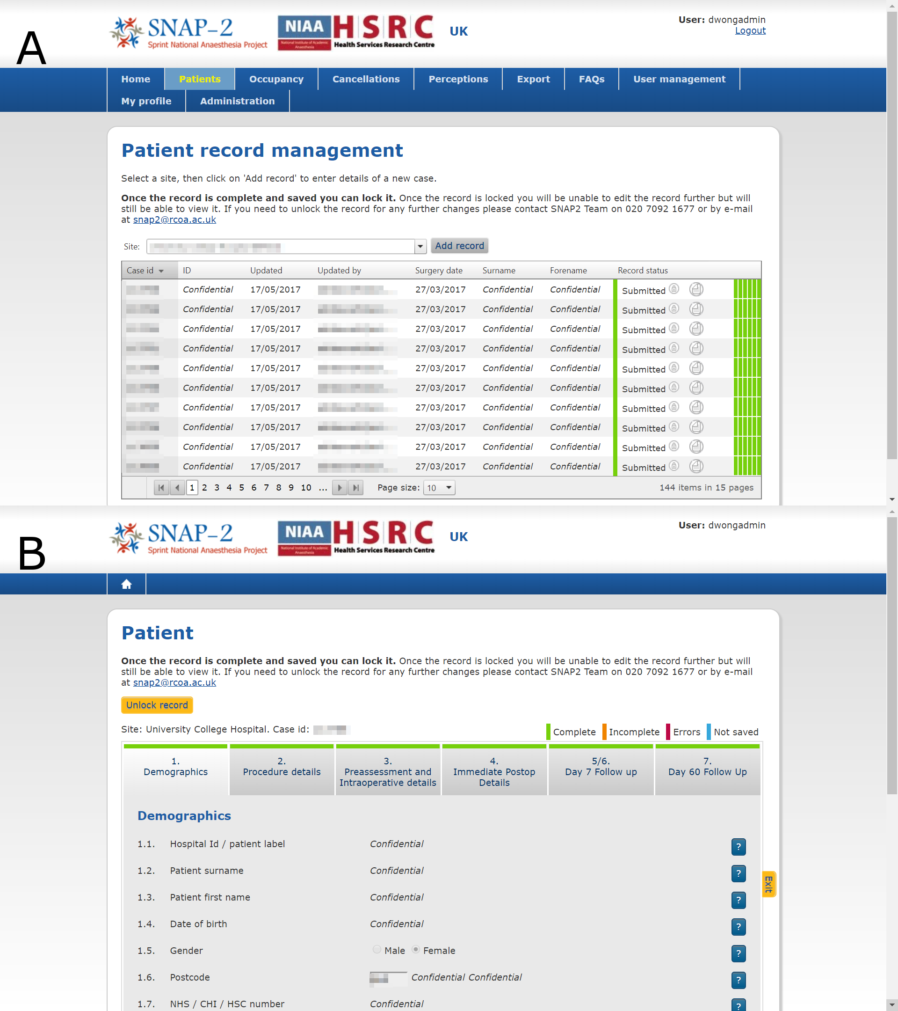

Figure 2‑1: Webtool and database screenshot. Patient cohort study data was collected and submitted via a secure online webtool to the study database hosted within the Royal College of Anaesthetists. (A) shows an overview of all cases from each site. (B) shows an example Case Record Form (CRF) for an individual patient included in the study. Each CRF was divided into sections with coloured bars at the top of each section indicating whether the sections were completed (green), incomplete (amber), erroneous (red), or empty and unsaved (blue). Within the site overview page of the webtool, users were able to identify CRFs with incomplete or erroneous fields at a glance by seeing the coloured bars on the right of each row. Identifiable and confidential information has been pixelated in this illustration.

The webtool and database were developed in partnership with Net Solving Ltd. (www.netsolving.com), an external software vendor, according to study specifications. During the design of the study, I met regularly with Net Solving Ltd. representatives to test the electronic CRFs before they were used in the study. Collaborators accessed the webtool via internet browsers at this web address: <https://snap2.snapresearch.org.uk/>. The database is hosted on servers managed by the Royal College of Anaesthetists outsourced to UK Fast Net Ltd. (<https://www.ukfast.co.uk/>).

Access to the webtool was limited to study collaborators with password-protected user accounts and encrypted server connections using Hypertext Transfer Protocol Secure (HTTPS). Data entry errors were minimised through field-level validation rules (e.g. only accepting integers ≥3 and ≤ 15 for Glasgow Coma Scale, correctly formatted dates for dates of birth, etc.), and section-level validation (sections with incomplete or erroneous fields were flagged up accordingly to the user). Records with complete data could be locked to prevent further alteration. Incomplete records could still be saved but incomplete fields would be highlighted to the user and the Central Project Team. Directly identifiable patient information such as names, dates of birth, postcodes and hospital identification numbers were recorded but only visible to users at each site, but were masked from the Central Project Team, who could only refer to records via their assigned study identification numbers (Case ID).

The webtool and database remained open to data entry from Tuesday 21 March 2017 to Monday 31 August 2017 in the UK, from Wednesday 21 June 2017 to Wednesday 25 October 2017 in Australia, and from Wednesday 30 August 2017 to Monday 4 December 2017 in New Zealand, to allow sites sufficient time to transfer data from their paper CRFs onto electronic CRFs.

In Northern Ireland, patient-level data was collected on paper CRFs, and then transcribed onto a validated Microsoft Excel spreadsheet template by the local investigators. Directly identifiable patient information was then removed from the spreadsheets and then electronically transmitted to the RCoA for aggregation. The data from Northern Ireland was then combined into a single table with the data from the rest of the UK before analysis. This additional step for Northern Ireland data was necessary as research governance restrictions prevented the transmission of patient identifiable information to bodies outside of their jurisdiction, and research governance approvals were not granted for participating sites to use the online webtool that sites in England, Scotland and Wales used.

The electronic patient datasets were appropriately exported without directly identifiable patient information for analysis; the RCoA served as the data controlling organisation for the study, with Ms Sharon Drake (Director of Clinical Quality and Research and Deputy Chief Executive, RCoA) as the designated responsible person.

As the data controller, the RCoA has policies which govern data processing, storage and disposal of all participant datasets, which are compliant with all applicable legal and regulatory requirements, including the Data Protection Act 1998 and any other statutory requirements. The RCoA is registered with the Information Commissioner’s Office (Data Protection Registration Number: Z7495398).

In order to facilitate future data-linkage with NHS Digital held national registry data for the subset of the patient cohort within England, a minimum amount of patient identifiable data will be extracted from the study database by the central investigation team, onto a password protected Excel spreadsheet, and emailed securely to the NHS Digital, to facilitate linkage to central held mortality data. Mortality will be tracked for all patients with a final censure date of 10 years after participant recruitment. Analyses relying on data-linkage fall outside the scope of this PhD thesis, but have been mentioned to inform the reader about the wider context to which this PhD research relates, as well as to illustrate the considered approach that has been taken with data privacy, governance and security throughout SNAP-2: EPICCS.

A diagram of the data flow is illustrated in Figure 2-2.

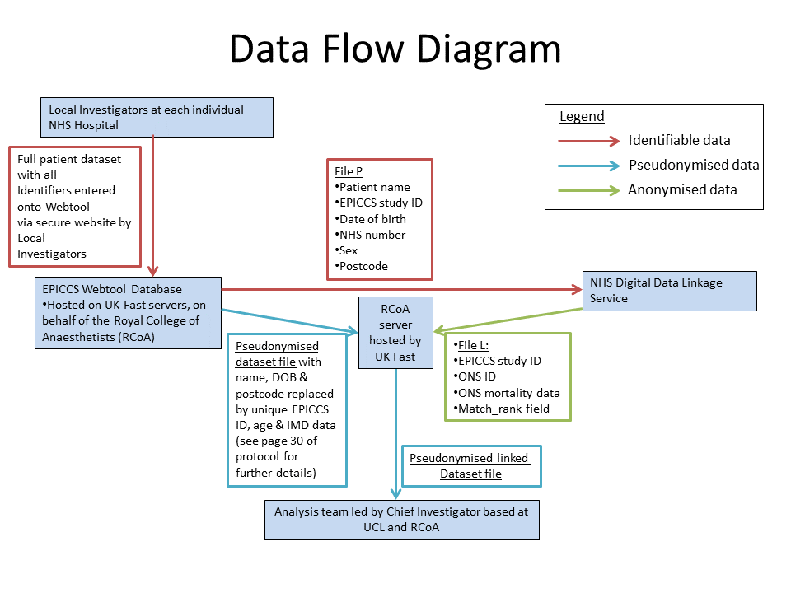

Figure 2‑2: Study data flows. Patient identifiable data was collected and submitted via a secure online webtool to the study database hosted within the Royal College of Anaesthetists.

## Study delivery infrastructure

SNAP-2: EPICCS had an ambitious scope and aimed for inclusive coverage of the majority of eligible NHS hospitals across the UK, and a representative sample of publicly funded Australian and New Zealand hospitals. Managing a project of this scale required a decentralised collaborative structure for delivery. Figure 2-3 illustrates the infrastructure that facilitated participant recruitment and data collection in the UK. Further details about the constituent members of the Central Project Team and Study Steering Group are described in the following sections.

Ethical and research governance approvals were led by me in the UK through the Health Research Authority (HRA) Integrated Research Application System (IRAS) research approvals process, and governance approval documents were then forwarded to collaborators in Australia and New Zealand. The study was conducted in UK NHS hospitals first, with patient recruitment completing in March 2017, before recruitment was commenced in Australia (recruitment completing in June 2017) and New Zealand (recruitment completing in September 2017). Conduct of the study in Australian and New Zealand hospitals was delegated to a team led by research collaborators who liaised closely with me and the Central Project Team in the UK, and utilised existing research network infrastructure in their countries which were similar to those used in the UK (Figure 2-4).

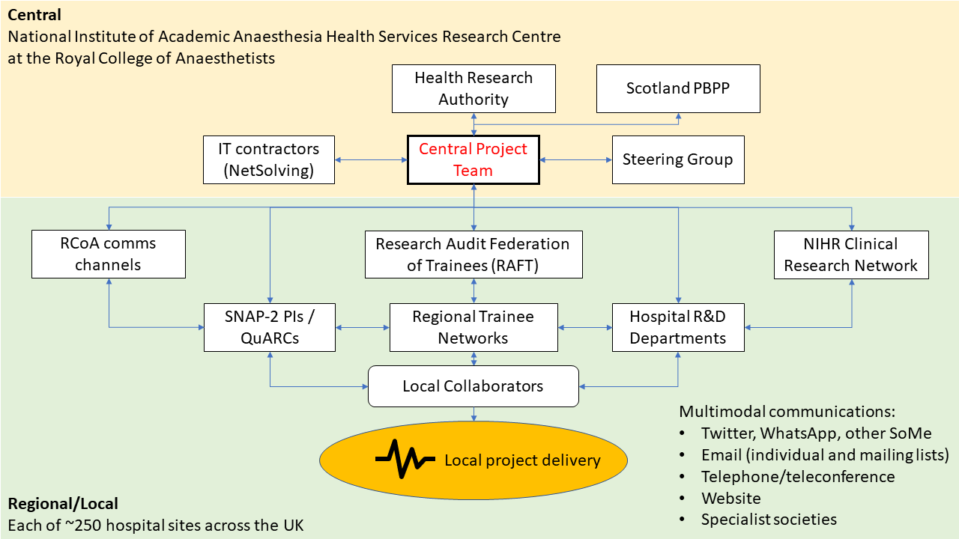

Figure 2‑3: UK study collaborator network. Local collaborators were located in each participating hospital, and consisted of Consultant and Trainee Anaesthetists, and local hospital Research & Development staff. Arrows indicate the lines and directions of communication.

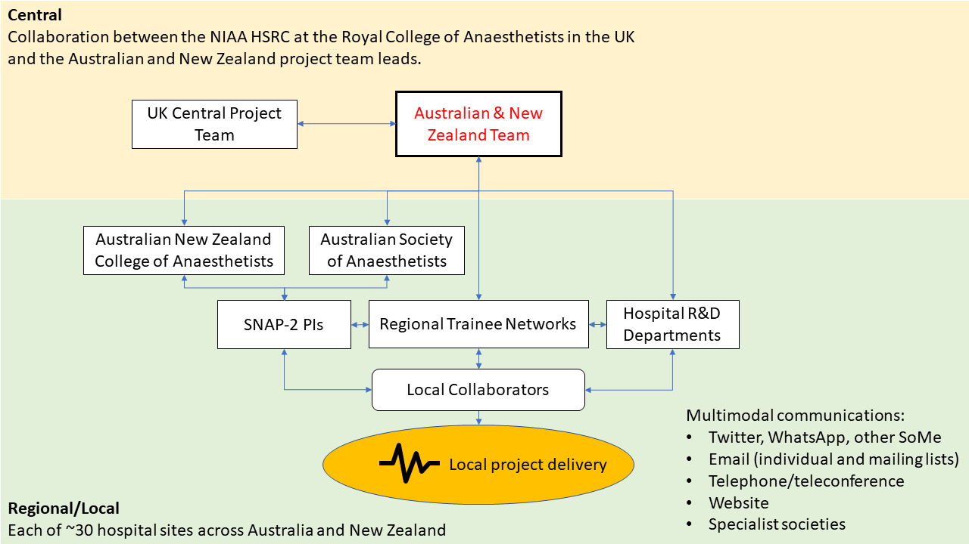

Figure 2‑4: Australian and New Zealand study collaborator network. Similar to the UK, local collaborators were located in each participating hospital, and consisted of Consultant and Trainee Anaesthetists, and local hospital Research & Development staff. A central Australian and New Zealand team coordinated the study in both countries with close liaison with the UK Central Project Team. Arrows indicate the lines and directions of communication.

### The Central Project Team

The core project team comprised of 6 people from the [NIAA Health Service Research Centre](https://www.niaa-hsrc.org.uk/HSRC_home) at the Royal College of Anaesthetists: myself (Dr Danny J. N. Wong, PhD Research Fellow), the Chief Investigator (Professor S. Ramani Moonesinghe, also my Primary PhD Supervisor), a statistical advisor (Dr Steve K. Harris, also my Secondary PhD Supervisor), and 3 administrative staff (Mr James Goodwin, Miss Laura Farmer, and Mr Jose Lourtie).

Individual roles are outlined in Table 2-1:

Table 2‑1: Roles of the central project team.

|  |  |
| --- | --- |
| Individual | Role |
| Prof SR. Moonesinghe | Chief investigator, obtained grant funding, conceived the study, led on protocol development. |
| Dr DJN. Wong | Co-investigator, co-authored protocol, day-to-day management of the study, Integrated Research Applications System and ethics applications, coordination with local site collaborators to deliver the study. |
| Dr SK. Harris | Co-investigator, contributed to protocol development, advice on statistical analysis. |
| Mr J. Goodwin, Miss L. Farmer, Mr J. Lourtie | Administrative support (e.g. recording all collaborators’ details, printing and distributing Case Record Forms, etc.), financial accounting, liaison with the Royal College of Anaesthetists membership network. |

### Study Steering Group

A steering group was convened, comprising experts from multiple bodies (including representatives from the Royal College of Anaesthetists, Royal College of Surgeons and external universities). These representatives were nominated by their parent organisations, which were formally invited to participate in the conduct of SNAP-2: EPICCS. The parent organisations were identified as potential stakeholders in the research, with established interests in the care of patients at and around the time of surgery.

The steering group reviewed all aspects of the conduct of the study, and provided external expert guidance on SNAP-2: EPICCS overall. It met quarterly (both face-to-face meetings and teleconferences) from September 2015 to March 2017 to discuss the planning and running of the study. After data collection completed, the steering group continued to meet on an *ad hoc* basis, depending on need. The steering group was chaired by Professor Mike Grocott, previous Director of the National Institute of Academic Anaesthesia Health Services Research Centre, and currently Professor of Anaesthesia and Critical Care Medicine at the University of Southampton.

Representatives from the following organisations sat on the steering group:

1. Royal College of Anaesthetists (RCoA): Professor Robert Sneyd (Council Member), Ms Sharon Drake (Director of Clinical Quality & Research)
2. Intensive Care Society (ICS): Professor Stephen Brett (Previous President)
3. Faculty of Intensive Care Medicine (FICM): Dr Anna Batchelor (Previous Dean)
4. Association of Anaesthetists of Great Britain and Ireland (AAGBI): Dr Mike Nathanson
5. Royal College of Surgeons of England (RCS[Eng]): Dr Shafi Ahmed
6. UK Critical Care Nursing Alliance: Ms Catherine Plowright
7. Royal College of Nursing (RCN) Critical Care Forum: Mr Suman Shrestha
8. Patient/Lay representation: Mr Richard Shawyer

The central project team reported monthly to the Board of the National Institute for Academic Anaesthesia’s Health Services Research Centre (NIAA HSRC) based at the Royal College of Anaesthetists.

Project team minutes were reviewed by the NIAA HSRC monthly and the steering group quarterly.

### Research Networks and the Royal College of Anaesthetists

The [Royal College of Anaesthetists (RCoA)](https://www.rcoa.ac.uk/) is the central body for Anaesthetists in the UK. Membership and fellowship of the college is compulsory for trainees and consultants, and therefore almost all anaesthetists in the UK receive the communications issued by the college, in the form of: a) the [Bulletin](https://www.rcoa.ac.uk/bulletin), a printed publication that is delivered to all members; b) college emails; c) communications through various sub-committees and working parties within the college, such as the College Tutors network. In effect, the College’s communications machinery can be mobilised to help encourage participation in big national studies of interests to all anaesthetists.

Together with the Chief Investigator, I wrote and published 2 articles for the RCoA Bulletin which were disseminated to all members of the RCoA outlining the study and motivations behind it, asking for member support (73,74). The first was published over a year before the study was due to launch and the second was published at the start of the month of patient recruitment.

The study utilised research collaborator groups that have been developed over the years by the NIAA HSRC. These groups of collaborators could be thought of as 3 overlapping networks, and allowed access into almost all the UK NHS hospitals where Consultant Anaesthetists, Trainees and National Institute of Health Research (NIHR) clinical research staff worked.

1. **The Quality Audit and Research Coordinators (QuARCs)** — Over 90% of the hospitals in the UK employ anaesthetic consultants who have volunteered to be [QuARCs](https://www.niaa-hsrc.org.uk/QUARCs?newsid=584). They serve as a single point of contact for the NIAA HSRC to reach into sites for conducting research. QuARCs have now been involved in a number of studies and therefore have built-up substantial experience in local data collection and developed relationships within their departments and with other departments to help facilitate research.
2. **Trainee Research Networks** — The UK now has a very sophisticated infrastructure of 14 trainee research networks, which cover virtually all regions, and sit beneath a national coordinating body called the [Research & Audit Federation of Trainees (RAFT)](http://www.raftrainees.com/). They promote a collaborative approach to research and offer junior anaesthetists and trainees the opportunity to contribute to research on the principle that the cumulative contribution of many individuals results in larger, more generalisable research outputs.
3. **The National Institute of Health Research Clinical Research Networks (NIHR CRN)** — The [NIHR CRN](https://www.nihr.ac.uk/about-us/how-we-are-managed/managing-centres/crn/) is a UK Department of Health funded organisation that exists to help support and fund common research assets (equipment and personnel). The NIAA HSRC is a partner organisation with the NIHR and therefore studies it coordinates are eligible for NIHR CRN support.
4. **Hospital Research & Development Departments and Research Support Staff** — A large multidisciplinary study requires many individuals working together from different hospital departments, including nurses, doctors and clinical research administrators from Anaesthesia, Intensive Care Medicine, Surgery and so on. Many clinicians work within their own departments of the hospital and may lack familiarity with other hospital departments. The study harnessed the expertise that existed within each hospitals’ R&D departments to enable cross-departmental working. Research administrators, research nurses and research support workers who are used to conducting studies, and used to completing the necessary regulatory and governance documentation were involved early in the study process. Contact was made with each hospitals’ R&D departments a few months before the study was due to launch, and QuARCs were also encouraged to liaise early with R&D departments.

### Australian and New Zealand Collaborators

Collaborators in Australia and New Zealand were guided by the UK Central Project Team with regards to study procedures, but were given autonomy to organise and coordinate the research networks within their countries to deliver the study. The members of the Australian and New Zealand project team and their roles are summarised in Table 2-2.

Table 2‑2: Roles of the Australian and New Zealand project team.

|  |  |
| --- | --- |
| Individual | Role |
| Prof PS. Myles | Senior lead investigator for Australia, member of the Australian and New Zealand College of Anaesthetists Clinical Trials Network (ANZCA CTN) Executive Board, provided supervisory support to Dr S. Popham, and liaised with ANZCA CTN members. |
| Dr S. Popham | Lead anaesthetic trainee investigator for Australia, chair of the Trainee Members Group of the Australian Society of Anaesthetists, liaised with site Principal Investigators and members of the Australian Society of Anaesthetists. |
| Ms S. Wallace | Administrative support for Australia (e.g. recording all collaborators’ details, printing and distributing Case Record Forms, recording and administering to site Research and Development Department approvals, etc.). |
| Dr HA. Lindsay & Dr D. Campbell | Senior co-lead investigators for New Zealand, provided supervisory support to Dr AM. Wilson and Dr LM. Barneto. |
| Dr AM. Wilson & Dr LM. Barneto | Co-lead anaesthetic trainee investigators for New Zealand, liaised and coordinated the New Zealand study with site Principal Investigators via the Supportive Anaesthesia Trainee aUdit & Research Network for NZ (SATURN) |

## Potential strengths and limitations of the SNAPs

The strengths of the SNAPs are the widespread participation of frontline clinical staff across the whole spectrum of available clinical work, with near complete capture of all clinical activity within the UK NHS, thus adding to the generalisability of findings. However, limitations of the SNAP approach are firstly, the cross-sectional nature of data capture, which necessitate that the timeframe of data sampling is relatively short, in order to minimise participant fatigue; secondly, reliance on clinical staff unused to research participation to perform data collection.

## A note on statistical analyses

For all statistical analyses in this thesis, R version 3.5.2 (2018-12-20) (R Foundation for Statistical Computing, Vienna, Austria) was used with a number of external packages enabled. A full list of the external packages used for analysis is included in *Appendix 7*.

## Conclusion

In this section, I have introduced a synopsis of the SNAP-2: EPICCS project which provide the data to approach the research questions laid out in this PhD research. The overall aims and objectives of SNAP-2: EPICCS and the component parts of the study have been presented. Details of research governance and study management have also been described.

SNAP-2: EPICCS comprised a wide-ranging research programme with a number of parts, of which two are relevant to the scope of this PhD thesis. In the subsequent chapters, I will present the relevant findings of analyses performed on data from Parts 1 and 2 of SNAP-2: EPICCS to answer the research questions presented in *Chapter 1*.

##### PAGE BREAK

# Organisational Survey

While surgery is a treatment for disease, complications from surgery are associated with significant morbidity and mortality (29,116). Critical care is a complex intervention thought to mitigate against the risks of surgery, via the higher nurse-to-patient ratio, medical input from specialist intensivists, and availability of specific organ support therapies. As the global burden of surgery increases, the numbers of patients at risk of perioperative complications rises correspondingly. Therefore, the capacity to prospectively admit high-risk patients to critical care following surgery becomes an increasing population concern.

In the UK in 2011, the National Confidential Enquiry into Patient Outcome and Death (NCEPOD) recommended critical care admission when the preoperative estimated risk of mortality is ≥5%, while the Royal College of Surgeons of England and the Department of Health recommended that those with mortality risks ≥10% should be admitted (35,36). The risk thresholds set by the Royal College of Surgeons of England were later updated in 2018 to match NCEPOD recommendations (37). However, in Australia and New Zealand (NZ), there are currently no national guidelines for risk stratifying postoperative critical care admissions.

However, despite these guidelines, multiple observational studies assert that critical care resources may not be reliably allocated to patients at highest risk of death (13–15). In some countries, a lack of critical care capacity is thought to contribute to this phenomenon (80). Recent commentary suggests that alternative facilities are consequently being used to provide enhanced care to patients outside of the traditional Intensive Care and High Dependency Units (ICU/HDUs) in some hospitals in the UK (81). These patient care areas may be able to provide a subset of the interventions and monitoring capabilities usually associated with critical care, and provide the necessary environment to manage the postoperative recovery of high-risk surgical patients.

Therefore, the overall aim of the first part of SNAP-2: EPICCS, was to describe the provision of critical care, enhanced care and usual ward care for surgical patients in England, Scotland, Wales and Northern Ireland. This part comprises an Organisational Survey performed to assess the available critical care facilities in UK hospitals completed by participant site investigators.

In this chapter the results of the survey will be presented. Further details of the statistical analysis underpinning these results will also be described. Parts of this chapter have now been peer-reviewed and published (112).

## Aims and objectives

The aim of the organisational survey was to describe the resources available in UK, Australian and New Zealand hospitals to deliver critical care to postoperative patients.

The objectives were to:

1. Describe the available ICU and HDU facilities in each responding hospital.
2. Describe hospital-level characteristics which may influence the capacity to deliver critical care in hospitals.
3. Describe the availability and provision of enhanced care ward beds which might potentially exist to augment critical care provision in some hospitals.

## Methods

### Survey development and pilot

Survey questions were constructed using a modified Delphi consensus method (117). A study steering group was convened with representatives from the RCoA, Faculty of Intensive Care Medicine (FICM), Intensive Care Society, Association of Anaesthetists of Great Britain and Ireland, Royal College of Surgeons (England), and lay representation from a patient expert and the RCoA’s Lay Committee (118). A full list of steering group members and their designations can be found in subsequent sections in this chapter. Draft survey questions were circulated among steering group members for anonymous feedback and evaluation (Round 1). The responses were anonymised and collated by an administrator (Miss Laura Farmer) acting as the Delphi process facilitator at the NIAA HSRC. Round 1 draft questions were then modified based on this feedback, and the questions then used to construct a pilot survey. The pilot survey was then re-circulated, along with anonymised feedback, to members of the steering group, and the survey was piloted in 8 hospitals. Following this pilot, a second cycle of anonymous feedback was then obtained on the survey questions and problems encountered with responding to the survey in the field (Round 2). The final survey was then constructed based on the responses from the Round 2.

The survey questionnaire was designed in the UK. To facilitate international comparisons, no further changes were made to the questionnaire before it was distributed in Australia and NZ, this was agreed by consensus between the UK Central Project Team and the collaborating Australian and New Zealand team. We considered the terminology and definitions used in each country to be equivalent in their local contexts.

### Survey content

The final survey can be found in the *Appendix 1*. Data were collected on hospital-level characteristics, including: general hospital and adult Intensive Care/High Dependency Unit (ICU/HDU) bed numbers, types of tertiary services delivered within the hospital[17], and the presence of an emergency department at the hospital. Also collected were data on Ward/Unit-level characteristics, including: staffing ratios and availability of critical care treatment modalities. Finally, where such pathways existed, data were collected on other high-acuity/enhanced ward areas where high risk adult patients would normally be admitted after surgery for increased levels of care[18]. Responses for total hospital bed numbers included the estimated total number of secondary care beds within the hospital, which may include mental health, obstetrics, and paediatric beds if those were present in the site.

In order to quantify beds allocated postoperatively to surgical patients, surgery was defined as all procedures taking place in an operating theatre or radiology suite for which inpatient (overnight) stay was planned, including both planned and emergency/urgent surgery. For questions related to general ward-level beds (those not providing critical care), respondents were asked to include beds for all surgical subspecialties, including neurosurgery, cardiothoracic surgery, gynaecological surgery, etc. However, for this survey total surgical beds excluded obstetric and paediatric surgery beds.

Details of each individual (physically separate) ICU/HDU was also collected, including: total number of funded critical care beds, maximum number of beds available for ventilated patients[19], whether the unit was an exclusively dedicated to ICU or HDU or a mixed unit with beds of both types, whether the unit was a specialised unit (e.g. a neurosurgical or cardiothoracic surgery unit), and if so whether patients from different specialties were permitted admission when needs arose.

Characteristics of individual high-acuity/enhanced care areas within the hospital, if present, were requested: bed numbers, the number of patients typically cared for by a single nurse in the area, and the clinician specialty of the consultant clinically responsible for patients admitted into these beds. The types of clinical interventions which patients are able to receive when admitted to these beds was collected: continuous monitoring, invasive blood pressure monitoring, vasoactive infusions, mechanical ventilation for patients with endotracheal tubes, non-invasive mechanical ventilation or continuous positive airway pressure, and epidural analgesia.

Finally, free-text responses were permitted for some sections of the survey, and respondent contact details were collected in order to facilitate communication when responses needed clarification.

### Survey distribution

The survey was conducted between Thursday 01 December 2016 and Friday 31 March 2017 in the UK, and between 01 December 2016 and 01 January 2018 in Australia and New Zealand. Lead collaborators in hospitals who participated in the previous Sprint National Anaesthesia Project (SNAP-1) (113), and the Royal College of Anaesthetists’ (RCoA) network of Quality Audit and Research Coordinators (QuARCs[20]) were approached to answer an electronic questionnaire in the UK. The SNAP-1 and QuARC collaborators consist of anaesthetists working in NHS hospitals throughout the UK. In Australia, the Australian Society of Anaesthetists (ASA) state representatives network and Australian and New Zealand College of Anaesthetists Clinical Trials Network (ANZCA CTN) were used to distribute the survey within their respective regions, and two cycles of reminders were sent via both networks. In NZ, correspondence was maintained with individual investigators at each site until data collection was completed. Further details about the research network infrastructure are described in later sections of this chapter.

Lead collaborators at each site were encouraged to answer survey questions based on their own knowledge of their hospitals’ structures and processes, and to approach senior hospital and nursing management teams for more difficult to obtain data. As the level of data reporting for the survey was at individual hospital site, each participant was only required to return a single response, however, where hospitals operated across more than one geographical site, individual responses were received for each separate location.

The survey was distributed electronically using online forms (FormAssembly, Veer West LLC, Bloomington, Indiana, USA) to all collaborators at sites in the UK, and electronically via e-mail to investigators at sites in Australia and NZ.

### Statistical analyses

Descriptive statistics for the characteristics of responding hospitals were computed. Details of critical care units and enhanced care areas were similarly described. Critical care bed ratios are calculated per 100 hospital beds for each participating site, based on the number of critical care and hospital beds reported by survey respondents. Critical care bed ratios per 100,000 population in the UK were estimated by combining population-level data from external datasets published by the Organisation for Economic Co-operation and Development (OECD) (119).

A comparison of characteristics of hospitals, critical care units and enhanced care units between each country was conducted. Univariate analysis was performed to compare characteristics of hospitals, critical care units and high-acuity care areas between each participating country, using appropriate statistical tests for continuous and categorical variables.

Hypothesising that critical care capacity would be related to tertiary services provided, I investigated the association between critical care bed provision at each site and variables thought to influence critical care bed capacity, using negative binomial regression, as appropriate for count data. The response variable of critical care beds per 100 hospital beds was regressed against the following covariates: number of hospital beds; tertiary services offered; country where the hospital was located; whether high-acuity care beds were present within the hospital; and whether the hospital had an emergency department. Relative ratios (RR) were calculated using the models to express the relative difference in critical care bed numbers associated with a particular variable, after adjusting for hospital size and other variables in the model. I further investigated the characteristics associated with the likelihood of hospitals having high-acuity care areas using logistic regression, the binary outcome variable of whether high-acuity care areas were present or absent was regressed against the following covariates: number of hospital beds; whether tertiary services were offered; country; the critical care:hospital bed ratio; and whether the hospital had an emergency department.

For both negative binomial and logistic regression modelling, models were constructed first from a null model (with no covariates), with individual covariates added in sequence based on their perceived importance. Models were compared using Akaike’s Information Criterion (AIC) (120). Final models were chosen based on their explanatory value and lowest AIC.

### Sensitivity analysis

Due to the lower national response rate from Australian sites compared to the UK and NZ, I conducted a *post hoc* sensitivity analysis comparing the hospital characteristics of the respondent sites with a published dataset of hospitals offering surgical services from the Australian Institute of Health and Welfare to determine if the survey sample was biased (121). The collected data from the Organisational Survey were matched by hospital name to this external published dataset which categorised hospitals by type.

## Results

### Overview of responses

Responses were received from 309 hospitals across the UK, Australia and NZ.

In the UK, 257 hospitals responded out of the 263 invited to participate (response rate 97.7%); these hospitals were nested within 141 English NHS Trusts, 13 Scottish NHS Boards, 6 Welsh Health Boards, and 4 Northern Irish Health and Social Care Trusts[21]. The UK sample therefore represented 94.8% of NHS secondary care organisations providing adult inpatient surgical services in the UK.

In Australia, 107 hospitals were invited to participate, with 35 sites responding (response rate 32.7%). In NZ, 18 hospitals were invited to participate, with 17 sites responding (response rate 94.4%).

### Hospital characteristics

The median reported hospital size in the survey sample was 429 beds (IQR = 280–626, Table 3-1). Australian (median 399 beds, IQR 256–600 beds) and NZ (median 315 beds, IQR 193–540 beds) hospitals were not significantly different in size to those in the UK (median 450 beds, IQR 290–650 beds).

The majority of responding hospitals were acute hospitals with emergency departments on-site (n = 256, 82.9%). 178 hospitals (57.6%) provided tertiary services. However, a higher proportion of hospitals in Australia (n = 27, 77.1%) and NZ (n = 14, 82.4%) in this study were tertiary institutions than those in the UK (n = 137, 53.3%).

Table 3‑1: Summary of hospital characteristics.

|  |  |  |  |  |  |
| --- | --- | --- | --- | --- | --- |
|  | Overall | UK | Australia | New Zealand | p |
| **n** | 309 | 257 | 35 | 17 |  |
| **Total hospital beds (median [IQR])** | 429 [280, 626] | 450 [290, 650] | 399 [256, 600] | 315 [193, 540] | 0.095 |
| **ED present (%)** | 256 (82.8) | 207 (80.5) | 33 (94.3) | 16 (94.1) | 0.058 |
| **Total critical care beds (median [IQR])** | 12 [8, 22] | 12 [8, 21] | 14 [8, 26] | 9 [6, 16] | 0.435 |
| **Total ventilated beds (median [IQR])** | 8 [6, 14] | 8 [6, 13] | 11 [5, 20] | 6 [4, 12] | 0.124 |
| **Proportion of critical care beds per 100 hospital beds (median [IQR])** | 2.84 [2.11, 4.39] | 2.67 [2.07, 4.31] | 3.74 [3.02, 4.93] | 3.50 [2.55, 4.12] | 0.014 |
| **Total general surgical ward beds (median [IQR])** | 120 [64, 189] | 121 [70, 189] | 90 [48, 156] | 87 [48, 195] | 0.309 |
| **Post-Anaesthesia Care Unit (PACU) present (%)** | 7 (2.3) | 6 (2.3) | 1 (2.9) | 0 (0.0) | 0.797 |
| **High-acuity care area present (%)** | 92 (29.8) | 72 (28.0) | 14 (40.0) | 6 (35.3) | 0.304 |
| **Tertiary services delivered (%)** | 178 (57.6) | 137 (53.3) | 27 (77.1) | 14 (82.4) | 0.003 |

### 

### Critical care beds

Most hospitals reported having on-site ICU/HDU facilities (n = 283, 91.6%), with a median ratio of 2.84 (IQR 2.11–4.39) critical care beds per 100 hospital beds. 460 separate critical care units were described within 283 hospitals across all 3 countries (Table 3-2). 315 of these units (68.5%) admitted patients from different specialties. However, 79 hospitals (17.2%) reported having at least one specialist critical care unit, and there were 145 such specialist units identified. Among these specialist units, 43 (28.3%) would admit patients from another specialty if necessary, with the remainder restricting admissions to patients from single specialties only (e.g. cardiothoracics, or neurosurgery).

Table 3‑2: Summary of critical care unit characteristics.

|  |  |  |  |  |  |
| --- | --- | --- | --- | --- | --- |
|  | Overall | UK | Australia | New Zealand | p |
| **n** | 460 | 397 | 40 | 23 |  |
| **Total critical care beds (median [IQR])** | 10 [6, 15] | 10 [7, 15] | 10 [7, 18] | 8 [6, 10] | 0.199 |
| **Total ventilated beds (median [IQR])** | 6 [0, 10] | 7 [0, 10] | 7 [4, 15] | 5 [3, 8] | 0.098 |
| **ICU/HDU/Mixed (%)** |  |  |  |  | 0.206 |
| ICU | 73 (15.9) | 61 (15.4) | 7 (17.5) | 5 (21.7) |  |
| HDU | 136 (29.6) | 125 (31.6) | 6 (15.0) | 5 (21.7) |  |
| Mixed | 250 (54.5) | 210 (53.0) | 27 (67.5) | 13 (56.5) |  |
| **Specialty unit (%)** |  |  |  |  | 0.304 |
| General/Mixed | 315 (68.6) | 263 (66.2) | 33 (82.5) | 19 (86.4) |  |
| Surgical | 30 (6.5) | 28 (7.1) | 1 (2.5) | 1 (4.5) |  |
| Medical | 27 (5.9) | 27 (6.8) | 0 (0.0) | 0 (0.0) |  |
| Cardiothoracic | 41 (8.9) | 35 (8.8) | 4 (10.0) | 2 (9.1) |  |
| Neurology/Neurosurgical | 19 (4.1) | 18 (4.5) | 1 (2.5) | 0 (0.0) |  |
| Other | 27 (5.9) | 26 (6.5) | 1 (2.5) | 0 (0.0) |  |
| **Will admit off-specialty (%)** | 43 (28.3) | 41 (30.6) | 1 (6.7) | 1 (33.3) | 0.146 |

The median number of critical care beds across all units was 10 (IQR 6–15). The estimated number of critical care beds and ventilated beds per capita calculated using the survey sample was highest in Australia (Table 3-3).

Table 3‑3: Critical care and high-acuity care beds per capita. The sum of the number of critical care beds was divided by the sum of all hospital beds within each country, and multiplied by 100, to obtain the average ratio of critical care beds to hospital beds in each country. This ratio was then multiplied by OECD data on hospital beds per capita to obtain the per capita critical care bed numbers, rescaled to per 100,000 population.

|  |  |  |  |  |  |  |
| --- | --- | --- | --- | --- | --- | --- |
| Country | Critical care beds per 100 hospital beds | Ventilated beds per 100 hospital beds | High-acuity care beds per 100 hospital beds | Critical care beds per 100,000 population | Ventilated beds per 100,000 population | High-acuity care beds per 100,000 population |
| **UK** | 3.59 | 2.17 | 0.47 | 9.33 | 5.64 | 1.23 |
| **Australia** | 3.70 | 2.77 | 0.99 | 14.05 | 10.54 | 3.77 |
| **New Zealand** | 3.39 | 2.20 | 2.36 | 9.14 | 5.93 | 6.38 |

Hospitals offering tertiary services had 1.62 times (relative ratio [RR]) as many critical care beds per 100 hospital beds than those which did not offer any tertiary services (95% CI: 1.42–1.86, p <0.001, Figure 3-1), after adjusting for other variables.

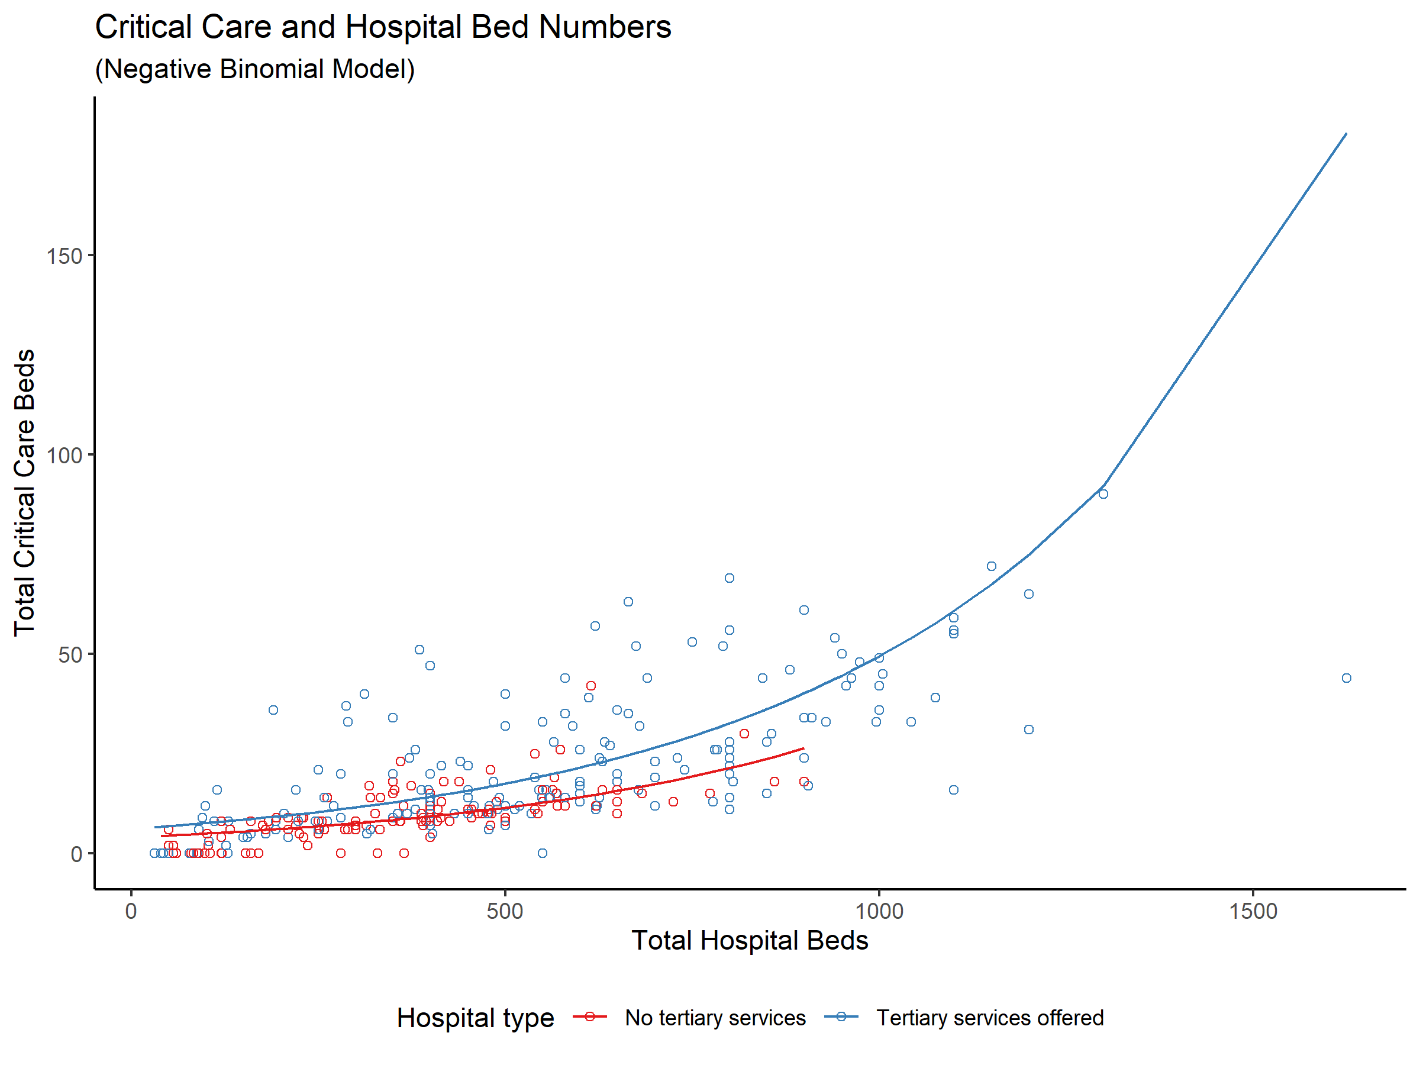

Figure 3‑1: Scatter plot of critical care beds vs. hospital size, with hospitals coloured by tertiary status. Lines of best fit as estimated using a negative binomial regression model illustrate the higher number of critical care beds in hospitals offering tertiary services, compared to hospitals not offering tertiary services.

The provision of cardiothoracic (RR 1.58, 95% CI 1.29–1.95, p <0.001), neurosurgery (RR 1.48, 95% CI 1.23–1.79, p <0.001) and extracorporeal membrane oxygenation (RR 1.40, 95% CI 1.11–1.77, p = 0.010) tertiary services were associated with increased proportions of critical care beds within hospitals (Figure 3-2, Table 3-4).

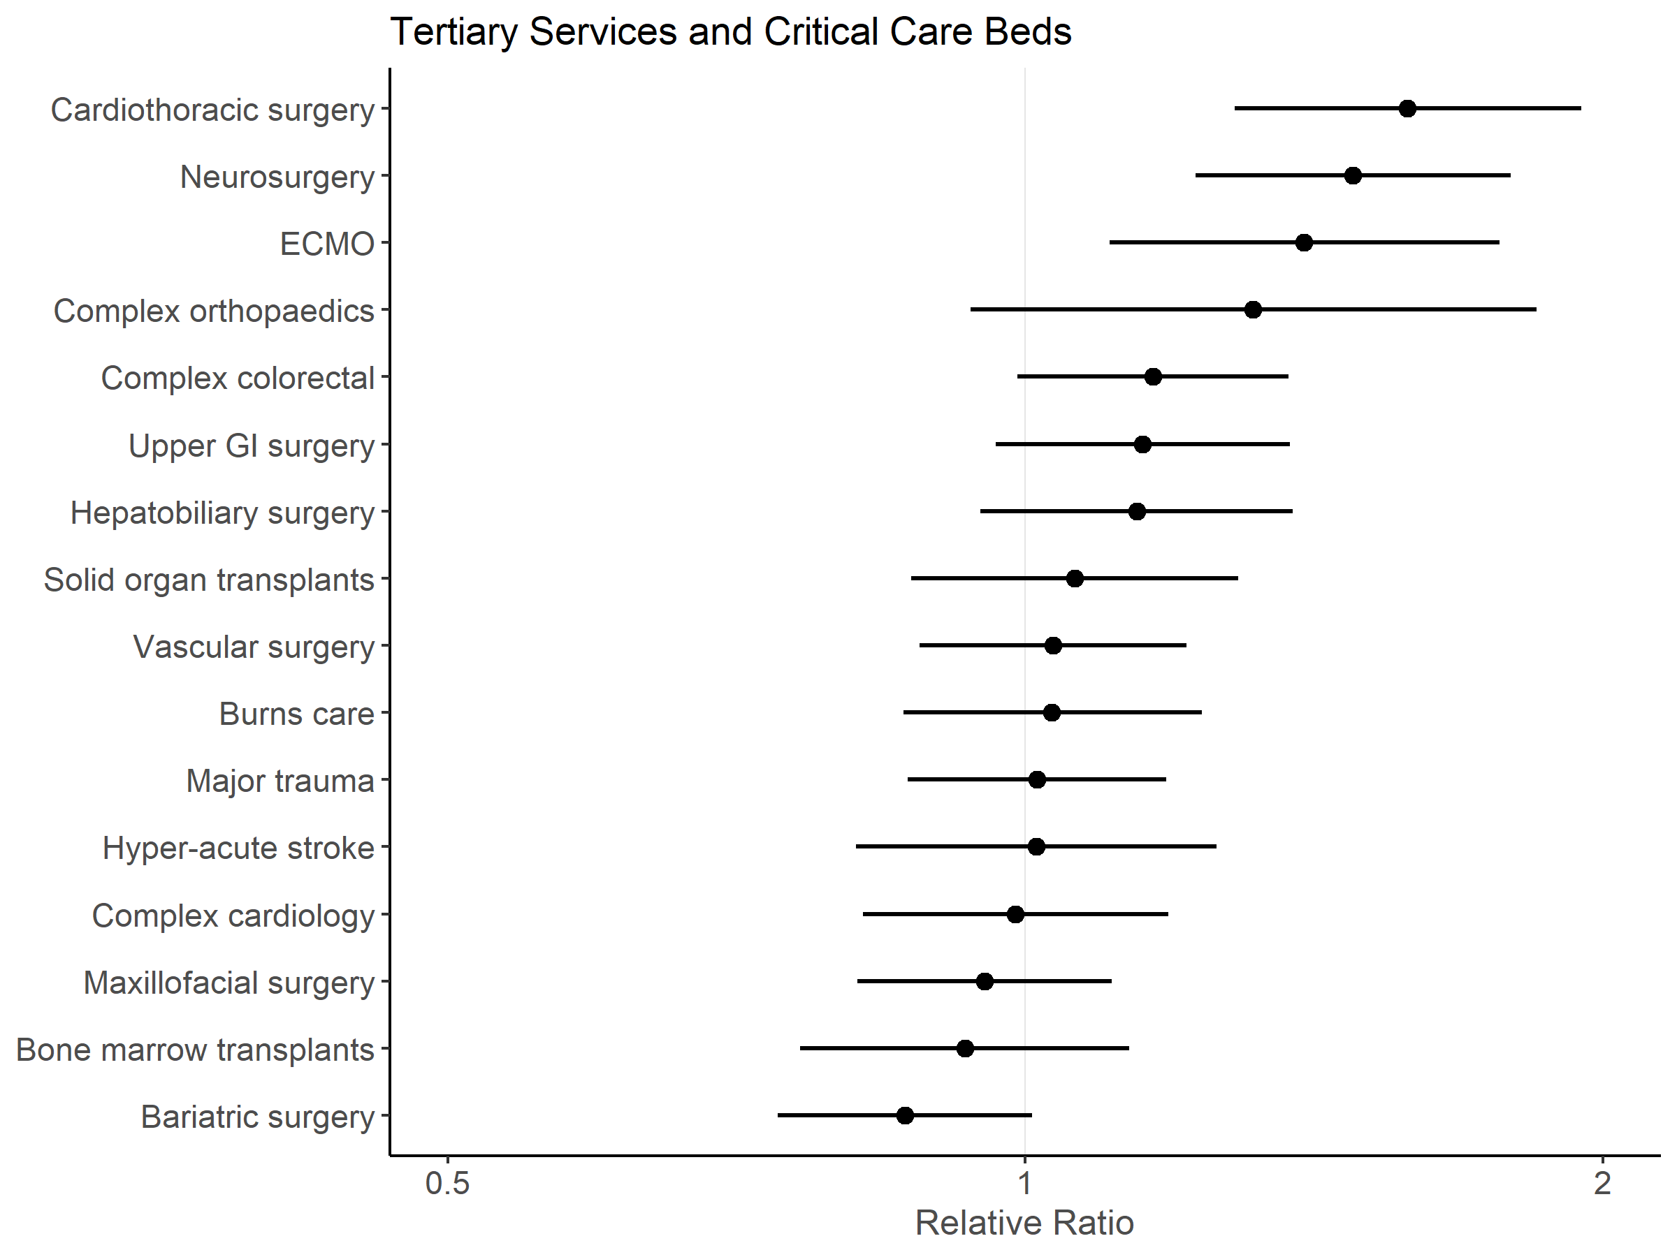

Figure 3‑2: Forest plot of associations between specialist services delivered and the relative availability of critical care beds per 100 hospital beds, after adjusting for hospital size, presence of enhanced ward areas, presence of emergency department and country.

UK hospitals had a smaller proportion of critical care beds per 100 hospital beds (median 2.67, IQR 2.07–4.31) compared to hospitals in Australia (median 3.74, IQR 3.02–4.93) and NZ (median 3.50, IQR 2.55–4.12). However, after adjusting for tertiary services delivered, and hospital size, the proportion of critical care beds to total hospital beds was lower in Australia (RR 0.60, 95% CI 0.49–0.75, p <0.001) and NZ (RR 0.64, 95% CI 0.49–0.85, p <0.001) than in the UK (Table 3-4 for model coefficients). Neither the presence of an emergency department, nor the presence of enhanced ward areas were associated with the proportion of critical care beds in any of the three countries.

Table 3‑4: Negative binomial regression model with the number of critical care beds as a proportion of the total number of hospital beds in each hospital as the dependent variable, regressed against the number of hospital beds, specific types of tertiary specialist services offered, whether the hospital has an high-acuity care area, whether the hospital has an Emergency Department, and the country where the hospital is located. Model intercept not shown.

|  |  |  |  |  |
| --- | --- | --- | --- | --- |
|  | Relative Count Ratio | 95% CI Lower Limit | 95% CI Upper Limit | p |
| **Hospital Beds** | 0.999 | 0.999 | 1.000 | <0.001 |
| **Bariatric surgery** | 0.865 | 0.743 | 1.008 | 0.059 |
| **Bone marrow transplants** | 0.930 | 0.764 | 1.133 | 0.470 |
| **Burns care** | 1.032 | 0.864 | 1.236 | 0.729 |
| **Cardiothoracic surgery** | 1.582 | 1.285 | 1.949 | <0.001 |
| **Complex colorectal** | 1.166 | 0.991 | 1.372 | 0.067 |
| **Complex cardiology** | 0.988 | 0.823 | 1.187 | 0.906 |
| **Extracorporeal Membrane Oxygenation** | 1.397 | 1.107 | 1.767 | 0.005 |
| **Hepatobiliary surgery** | 1.143 | 0.948 | 1.378 | 0.180 |
| **Hyper-acute stroke** | 1.014 | 0.868 | 1.185 | 0.864 |
| **Major trauma** | 1.013 | 0.816 | 1.257 | 0.909 |
| **Maxillofacial surgery** | 0.952 | 0.817 | 1.109 | 0.529 |
| **Neurosurgery** | 1.482 | 1.227 | 1.791 | <0.001 |
| **Solid organ transplants** | 1.061 | 0.872 | 1.291 | 0.566 |
| **Upper GI surgery** | 1.151 | 0.965 | 1.374 | 0.129 |
| **Vascular surgery** | 1.034 | 0.881 | 1.213 | 0.693 |
| **Complex orthopaedics** | 1.314 | 0.936 | 1.848 | 0.117 |
| **High-acuity Care Area present** | 0.937 | 0.831 | 1.056 | 0.285 |
| **Emergency Department present** | 1.160 | 0.955 | 1.410 | 0.133 |
| **Australia** | 0.605 | 0.487 | 0.751 | <0.001 |
| **New Zealand** | 0.644 | 0.489 | 0.847 | 0.002 |

### High-acuity care areas

Ninety-six (31.1%) hospitals reported having high-acuity care areas where high risk surgical patients could be admitted for postoperative management outside the operating theatre or critical care complexes: 72 hospitals in the UK (28.0% of hospitals); 14 in Australia (40.0%) and 6 in NZ (35.3%). A total of 147 such high-acuity care areas were identified (Table 3-5). These areas had a median 4 beds (IQR 3–8 beds), and a median nurse:patient ratio of 1:2 (IQR 1:2–1:4). Patient care was led by surgeons in 73 (49.7%) of these high-acuity care areas.

These areas were able to deliver a heterogeneous subset of interventions normally associated with critical care (Table 3-5), ranging from continuous observations and monitoring (n = 128, 87.1%), to Non-Invasive Ventilation (NIV) or Continuous Positive Airways Pressure (CPAP) support (n = 56, 38.1%).

Larger hospitals (adjusted Odds Ratio [OR] 1.97 for every standard deviation increase in hospital bed numbers, 95% CI 1.41–2.83, p <0.001) providing tertiary services (adjusted OR 2.42, 95% CI 1.24–4.84, p = 0.010) were more likely to report having high-acuity care areas. Hospitals with emergency departments (adjusted OR 0.27, 95% CI 0.11–0.63, p <0.001) were less likely to report having these types of beds. Full coefficients for the logistic regression model are available in Table 3-6.

After critical care and high-acuity bed numbers were considered together, the total potential per capita capacity for delivering at least some critical care to postoperative patients increases in all three countries (Table 3-3).

Table 3‑5: Summary of high-acuity care area characteristics.

|  |  |  |  |  |  |
| --- | --- | --- | --- | --- | --- |
|  | Overall | UK | Australia | New Zealand | p |
| **N** | 147 | 109 | 21 | 17 |  |
| **Total beds (median [IQR])** | 4 [3, 8] | 4 [3, 7] | 4 [4, 8] | 5 [4, 10] | 0.133 |
| **Patient:Nurse ratio (median [IQR])** | 2 [2, 4] | 2 [2, 4] | 2 [2, 4] | 2 [2, 3] | 0.983 |
| **Responsible consultant (%)** |  |  |  |  | 0.457 |
| Intensivist | 7 (4.8) | 7 (6.4) | 0 (0.0) | 0 (0.0) |  |
| Multi-specialty Joint Care | 34 (23.1) | 28 (25.7) | 3 (14.3) | 3 (17.6) |  |
| Perioperative Anaesthetist | 15 (10.2) | 13 (11.9) | 1 (4.8) | 1 (5.9) |  |
| Surgeon | 73 (49.7) | 50 (45.9) | 13 (61.9) | 10 (58.8) |  |
| Other | 18 (12.2) | 11 (10.1) | 4 (19.0) | 3 (17.6) |  |
| **Able to provide continuous observations/monitoring (%)** | 128 (87.1) | 94 (86.2) | 19 (90.5) | 15 (88.2) | 0.859 |
| **Able to provide invasive blood pressure monitoring (%)** | 83 (56.5) | 66 (60.6) | 10 (47.6) | 7 (41.2) | 0.220 |
| **Able to manage vasoactive infusions (%)** | 64 (43.5) | 46 (42.2) | 9 (42.9) | 9 (52.9) | 0.707 |
| **Able to provide invasive ventilation (%)** | 6 (4.1) | 6 (5.5) | 0 (0.0) | 0 (0.0) | 0.336 |
| **Able to provide non-invasive ventilation/continuous positive airway pressure (NIV/CPAP) (%)** | 56 (38.1) | 37 (33.9) | 12 (57.1) | 7 (41.2) | 0.129 |
| **Able to manage epidural catheters (%)** | 101 (68.7) | 74 (67.9) | 19 (90.5) | 8 (47.1) | 0.015 |

Table 3‑6: : Logistic regression model of whether high-acuity care areas are reported in a hospital as the dependent variable, regressed against hospital size (centred around the mean, and rescaled to a standard deviation scale), whether the hospital offers tertiary specialist services, the country where the hospital is located, the critical care bed to total hospital bed ratio, and whether the hospital has an Emergency Department. Model intercept not shown.

|  |  |  |  |  |
| --- | --- | --- | --- | --- |
|  | Odds Ratio | 95% CI Lower Limit | 95% CI Upper Limit | p-value |
| **Intercept** | 0.703 | 0.275 | 1.757 | 0.455 |
| **Hospital Beds (scaled)** | 1.973 | 1.409 | 2.827 | <0.001 |
| **Tertiary services offered** | 2.423 | 1.236 | 4.841 | 0.011 |
| **Australia** | 2.037 | 0.841 | 4.860 | 0.110 |
| **New Zealand** | 1.917 | 0.575 | 6.041 | 0.271 |
| **Critical care:Hospital bed ratio** | 0.943 | 0.842 | 1.048 | 0.293 |
| **Emergency Department present** | 0.269 | 0.113 | 0.629 | 0.003 |

### General surgical wards

Across all three countries, hospitals reported a median ratio of 28.3 surgical beds per 100 hospital beds (IQR 21.3–36.0). The average surgical ward was reported as having a median 26 beds (IQR 22–30 beds). The median nurse:patient ratio during the daytime was 1:6 (IQR 1:5–1:7, Table 5), and this ratio dropped to a median of 1:9 nurse:patients (IQR 1:7–1:11) at night.

General surgical ward nurses in the UK were responsible for more beds per nurse than in Australia or NZ, both in the day and at night (Table 3-7, p <0.001). The majority of UK (n = 252, 98.1%) and NZ (n = 16, 94.1%) hospitals reported staffing surgical wards with health care assistants to supplement the care delivered by nurses. In contrast, health care assistants were less commonly employed in Australia with only 18 hospitals (51.4%) reporting their deployment on surgical wards.

Table 3‑7: Summary of general ward staffing levels.

|  |  |  |  |  |  |
| --- | --- | --- | --- | --- | --- |
|  | Overall | UK | Australia | New Zealand | p |
| **n** | 309 | 257 | 35 | 17 |  |
| **Number of beds (median [IQR])** | 26 [22, 30] | 25 [22, 30] | 30 [24, 32] | 28 [25, 30] | 0.008 |
| **Number of nurses (day) (median [IQR])** | 4 [4, 6] | 4 [3, 5] | 8 [7, 9] | 6 [5, 8] | <0.001 |
| **Beds:Nurse ratio (day) (median [IQR])** | 5.71 [4.50, 7.00] | 6.00 [5.00, 7.50] | 3.75 [3.43, 4.00] | 4.45 [3.62, 5.00] | <0.001 |
| **Number of nurses (night) (median [IQR])** | 3 [2, 4] | 3 [2, 3] | 4 [4, 5] | 3 [3, 4] | <0.001 |
| **Beds:Nurse ratio (night) (median [IQR])** | 9.00 [7.00, 11.00] | 9.33 [7.33, 11.83] | 6.86 [6.00, 8.00] | 8.67 [7.22, 9.33] | <0.001 |
| **Health Care Assistants utilised (%)** | 286 (92.6) | 252 (98.1) | 18 (51.4) | 16 (94.1) | <0.001 |

### Sensitivity Analysis for Australian Hospital Sample

Due to the lower response rate in Australian hospitals invited to participate in the study, A sensitivity analysis was performed to examine the extent to which the Australian hospitals were subject to sampling bias. Openly-published data of hospitals offering surgical services from the Australian Institute of Health and Welfare were obtained which included data on the number of specialist services offered at the hospital, and a classification of hospital type (121). Children’s hospitals, small rural hospitals, and hospitals not offering surgery were excluded from this open dataset as they were not considered comparable to hospitals in the UK.

The characteristics (state regions, hospital groups and numbers of specialist services offered) of the hospitals in our study sample was compared against the characteristics for all hospitals in Australia.

The distribution of hospital types, regions and the number of specialist services offered within sites responding to the survey was examined and compared with the overall distribution of the same factors in all hospitals in Australia (Table 3-8).

Table 3‑8: Characteristics of hospitals sampled within this study compared to overall characteristics of all hospitals in Australia. Abbreviations for state names: ACT = Australian Capital Territory; NSW = New South Wales; NT = Northern Territory; Qld = Queensland; SA = South Australia; Tas = Tasmania; Vic = Victoria; WA = Western Australia.

|  |  |  |
| --- | --- | --- |
|  | Overall | Survey Respondents |
| **n** | 141 | 33 |
| **State (%)** |  |  |
| ACT | 2 (1.4) | 1 (3.1) |
| NSW | 48 (34.0) | 6 (18.8) |
| NT | 2 (1.4) | 1 (3.1) |
| Qld | 27 (19.1) | 6 (18.8) |
| SA | 13 (9.2) | 2 (6.2) |
| Tas | 3 (2.1) | 1 (3.1) |
| Vic | 31 (22.0) | 12 (37.5) |
| WA | 15 (10.6) | 3 (9.4) |
| **Group (%)** |  |  |
| Large metropolitan hospitals | 34 (24.1) | 5 (15.6) |
| Large regional hospitals | 26 (18.4) | 5 (15.6) |
| Major hospitals | 31 (22.0) | 17 (53.1) |
| Medium metropolitan hospitals | 29 (20.6) | 4 (12.5) |
| Unpeered | 21 (14.9) | 1 (3.1) |
| **Number of tertiary services available (median [IQR])** | 10 [6, 15] | 15 [11, 21] |

The survey sampled 17 hospitals which were classed as “Major Hospitals” (51.5%), although this category comprised 22.0% of all hospitals in Australia. The median number of specialist services offered by hospitals in the survey sample was also higher than the overall median for hospitals in Australia. Finally, the survey received a disproportionately high proportion of responses from the state of Victoria, and a lower proportion of responses from New South Wales.

Therefore, when interpreting the results of the survey, one needs to consider that the Australian data sample is weighted towards medium-to-large hospitals offering more specialist services.

## Discussion

### Principal Findings

In this chapter, I have presented a comprehensive overview of postoperative critical care facilities available for patients undergoing inpatient surgery in the UK, Australia and NZ. This survey describes the critical care provision in hospitals within these countries, and quantifies the availability of high-acuity care areas where postoperative patients may receive critical care therapies outside of the traditional ICU/HDU setting. Hospitals in NZ were generally smaller compared to the UK and Australia. The proportion of hospital beds which were dedicated to critical care was similar across the three countries, however the estimated per capita critical care capacity was highest in Australia. General surgery wards in Australia and NZ reported more favourable nurse:patient staffing ratios than the UK. High-acuity care areas delivering some critical care interventions were present in all three countries, and these were of similar size and nurse staffing ratios. The total potential per capita capacity for delivering at least some critical care to postoperative patients increases after these enhance care areas are considered.

### Strengths and weaknesses

This survey had nearly complete coverage of all UK and NZ public secondary care organisations that provide inpatient surgical care. The data collected is therefore likely to be an accurate representation of available postoperative facilities in both countries.

While NHS England collects data on critical care bed numbers, these are aggregated at Trust level, and not individual hospital site-level. In comparison, the Scottish Intensive Care Society Audit Group (SICSAG) publishes an annual audit report of critical care outcomes and facilities (126), while the national health authorities in Wales and Northern Ireland do not compile publicly accessible data of this nature for secondary analysis. The Australian New Zealand Intensive Care Society (ANZICS) publishes an annual report with information on the total number of adult intensive care units across Australia and NZ, which includes numbers of paediatric intensive care beds in their counts (127). These survey data are therefore comprehensive and robust, and contain information not routinely collected by national bodies in all three countries. A further key strength of this study is that it is the first empirical description of perioperative high-acuity care areas.

There are however also some weaknesses to this work.

First, the response rate in Australia was lower than in the UK and NZ. Australian sites also required a longer period to respond to the survey due to the low initial response rate. The sensitivity analysis conducted showed that the Australian hospitals sampled in the survey was weighted towards medium-to-large major hospitals which provide postgraduate anaesthesia specialty training, and capable of delivering higher numbers of specialist services (Table 3-8). The reasons for this were likely due to less well-developed research infrastructure for observational health services research in Australia compared to the UK, which has had significant infrastructure development as a legacy from the first Sprint National Anaesthesia Project.

Second, a higher proportion of NZ hospitals that responded were tertiary institutions. Larger tertiary institutions in Australia and NZ may have had increased motivation to participate in the survey, and survey dissemination via local networks may have favoured tertiary hospitals due to the nature of the networks used (the anaesthesia trainee research networks relied upon to distribute the survey are more likely to be found within larger tertiary hospitals).

Third, private sector hospitals were also not approached for the survey, and one is therefore unable to extrapolate the pathways which might exist in those institutions. Private healthcare providers provide a substantial proportion of elective surgical care, especially in Australia, where the spend on private healthcare as a proportion of total healthcare expenditure is higher compared to UK and NZ (UK: 21.9%, Australia: 31.9%, and NZ: 21.1% of healthcare spend) (128). These differences in the national samples must be considered when considering the comparative data presented about the three countries.

Finally, due to the difference in population distributions in Australia and NZ, these nations have a large number of geographically dispersed small rural hospitals, usually without critical care provision, and linked to central hubs of secondary/tertiary care; these differences from the UK make direct comparisons of health systems difficult.

### Defining critical care

Historically, critical care bed capacity per capita in the UK, Australia and NZ has been found to be low compared to many other developed health systems (43,80). However, research in this area is made difficult by the lack of international consensus in critical care definitions.

In the UK, Guidelines for the Provision of Intensive Care Services (GPICS) were recently published by the Faculty of Intensive Care Medicine and Intensive Care Society in 2015 (40), following on from earlier publications which aimed to describe ICU/HDU standards in the UK (39,129). In Australia and NZ, the College of Intensive Care Medicine (CICM) defines minimum standards for ICU and HDU in separate documents (44,45).

A Level 0-3 classification system has been adopted in the UK, and it is referred to extensively in GPICS. Level 3 indicates care for complex patients requiring support for multi-organ failure and with a minimum of 1:1 nurse:patient ratio, while Level 2 indicates care for patients with single organ support and a minimum 1:2 nurse:patient ratio. In contrast to the UK, Level I, II and III ICU definitions in Australia and NZ, refer not to patient dependency but instead to multiple organisational factors relating to work practice/caseload, staffing requirements, operational requirements, design, and monitoring and equipment standards (44). In Australia and NZ, Level III ICUs are tertiary referral units for intensive care patients, while Level I and II ICUs are rural units serving smaller populations where there are limited specialist services available, and where travel to specialist services may cause delay (44) Therefore Level I-III ICUs in Australia and NZ are all able to provide a period of mechanical ventilation, and HDUs do not come under this classification system (45).

### Other less clearly defined “high-acuity care” areas - Level 1.5 units?

Beyond the definitions above, there are other patient care areas within the hospital, which do not traditionally fall under the widely accepted umbrella of ICU/HDU critical care units. These other areas have the ability to care for patients who require one or more interventions associated with critical care. For example, within the Emergency Department, resuscitation bays have the facilities to temporarily care for critically ill patients requiring intensive nursing/medical interventions. Another example would be the cardiologists’ Coronary Care Unit, which may have the ability to deliver 1:1 or 1:2 nursing, invasive blood pressure monitoring, continuous ECG telemetry and inotropic/vasopressor support.

This survey sought to identify high-acuity/enhanced care areas capable of delivering higher levels of postoperative care compared to usual ward level care. I posit that these high-acuity beds may have evolved in the UK, Australia and NZ to compensate for the low critical care capacity for high-risk patients. These areas may be thought of as “Level 1.5” units, to borrow from the traditional UK classification system described above. Many hospitals in this survey reported the use of such facilities to deliver postoperative critical care to patients.

### The results in relation to existing literature

Using administrative panel data from multiple different sources, Adhikari *et al* estimated the per capita ratio of critical care beds in a number of countries, and further estimated the number of ICU beds per 100 hospital beds (80). They reported 1.2 ICU beds per 100 hospital beds for the UK, and 1.5 ICU beds per 100 hospital beds for NZ public hospitals, but did not provide estimates for Australia. They also further estimated per capita ICU bed ratios of 3.5, 5.6 and 4.7 per 100,000 population for UK, Australia and NZ respectively. In a separate study of European critical care capacity, Rhodes *et al* estimated 2.8 ICU beds per 100 hospital beds and 6.6 ICU/intermediate care beds per 100,000 population for the UK in 2012 (43).

The ANZICS Centre for Outcome and Resource Evaluation reported 9.0 ICU beds per 100,000 population in Australia and 5.3 ICU beds per 100,000 population in NZ (127). These numbers are similar to the estimates I calculated for ventilated critical care beds per 100,000 population for each country.

While the critical care capacity estimates from this study differ from these previous estimates, the survey findings seem to support the previous suggestions that Australia and NZ critical care bed ratios are generally higher than the UK. I propose that differences in our estimates may be due to: 1) variable definitions used for critical care; 2) differences in sampling methodology; 3) changes in total hospital bed numbers and critical care bed numbers in each country over time.

In the survey, respondents were asked to provide the numbers of critical care beds in their hospitals, including both ICU and HDU beds in the query. Local collaborator-reported bed numbers were used for both the numerator and the denominator to arrive at the calculated ratios. In contrast, Adhikari *et al* obtained estimates based on literature review, synthesising data from a number of different sources. Their primary sources were a 2005 paper published by Wunsch *et al* obtained from administrative datasets for the UK (41), and a 2006/2007 report by the Australian and New Zealand Intensive Care Society (ANZICS) (130,131). Rhodes *et al* estimated critical care bed numbers using aggregated country-level data dating from 2010, combining data from a number of different administrative sources—including the European Commission database (Eurostat), the World Health Organization (WHO), the Central Intelligence Agency (CIA) World Factbook and the OECD. The results from this survey therefore contribute a reliable, updated and empirical primary data source to the literature.

Using intermediate definitions for surgery, approximately 8,000 surgical procedures were performed per 100,000 population per year in the UK NHS between 2009 and 2014, with an estimated 3,810 per 100,000 per year requiring overnight stay (10). In comparison, 4,584 an estimated surgical admissions per 100,000 population per year occur in Australian public hospitals (132), and 4,669 surgical procedures per 100,000 population per year are performed in New Zealand (8,133). Therefore, combining the results from this study with the other data obtained from the literature, the availability of critical care beds in relation to volume of surgical activity performed in public hospitals can be approximated for each country (UK = 2.45, Australia = 3.06, New Zealand = 1.96 critical care beds per 1,000 surgical procedures). However, these estimates may be limited by differences in the definitions used when accounting for surgical volume between the different statistical sources.

### Unanswered questions and future extensions

What is clear from this analysis is the prevalence of high-acuity beds in many of hospitals throughout the three countries studied. I argue that these high-acuity beds are being used to augment the critical care capacity in hospitals where ICU/HDU beds may be insufficient to support clinical activity. However, it is not possible to comment on patient case-mix within these areas, or on the clinical effectiveness of treatment in these units. The high-acuity care areas likely represent a heterogenous group of bed types and further research is required to describe the detail of the structures and processes within these units, and the outcomes of patients admitted to them. We do not currently know if they provide good value care and whether they are a sufficient alternative to traditional ICU/HDU care for high risk patients. Rapid expansion in their numbers cannot currently be recommended without further evaluation.

Other important factors which might influence the capacity to deliver postoperative care to high-risk patients may also need further exploration. Particularly, the effects of hospital networking arrangements across large geographical regions was not explored in our study. Inter-hospital transfer is an established mechanism for diverting patients when critical care capacity may be inadequate in the transferring hospital, or when centralised tertiary services only available in the receiving hospital are required (134). There is evidence that patients transferred for non-clinical indications may have longer lengths of stay, but equivalent mortality outcomes, and therefore critical care capacities across regions may be important in resource planning beyond the immediate needs of a single hospital (135).

### Summary

There are notable differences between the UK, Australia and NZ in postoperative provision of care, both in terms of critical care capacity, and also staffing levels in general surgical wards, which have been highlighted in the results of this first part of SNAP-2: EPICCS. There are no significant differences in critical care bed numbers as a proportion of total beds at each hospital between the three countries, after adjusting for hospital size and tertiary care provision. High-acuity/enhanced care areas which accommodate high-risk surgical patients for postoperative management have been identified and described. Per capita postoperative critical care availability was lowest in the UK after accounting for these high-acuity care beds. It is postulated that high-acuity care areas may have developed organically to facilitate the provision of some aspects of critical care — in particular more favourable nurse:patient ratios — outside the ICU and HDU, in order to meet service demand. However, the utility of these high-acuity beds requires further evaluation.

##### PAGE BREAK

# SNAP-2: EPICCS Inpatient Surgery Cohort

To help answer research questions relating to patient risk and outcomes, as well as clinical decision-making around postoperative critical care referrals and admissions, a prospective observational cohort of patients undergoing inpatient surgery was established for SNAP-2: EPICCS. Data were collected by anaesthetists on all patients they anaesthetised who were undergoing inpatient surgery for seven-day periods in March (UK), June (Australia) and September 2017 (New Zealand). Baseline patient risk factor data, and questions about clinical decision-making and resource availability related to critical care referral and admission were also collected. This cohort was intended to be a representative sample of the whole population of patients undergoing surgery requiring overnight stay in the UK, Australia and New Zealand.

## Aims and objectives

This part of SNAP-2: EPICCS aimed to describe the epidemiology of perioperative risk and outcome, and critical care referral and admission after inpatient surgery in the three participating countries.

The objectives were to:

1. Characterise the inpatient surgical population using a comprehensive one-week sample of surgical activity in a large representative cross-section of public hospitals.
2. Describe the tools used by clinicians to estimate perioperative risk in these patients.
3. Evaluate the accuracy of previously-validated risk prediction tools in this cohort, and compare the performance of these tools against subjective clinical assessment of risk.
4. Explore the patient- and hospital-level factors which were associated with patients getting recommended for, and then eventually being admitted to, critical care.

## Cohort inclusion and exclusion criteria

All patients undergoing inpatient surgery (both elective and/or emergency) during the study week were enrolled onto the cohort study. Formal inclusion and exclusion criteria as published in the study protocol are described below (72).

* **Inclusion criteria** — Adult (≥18 years) patients undergoing surgery, or other interventions, that require the presence of an anaesthetist, and who are expected to require overnight stay in hospital. These would include all procedures taking place in an operating theatre, radiology suite, endoscopy suite or catheter laboratory for which inpatient (overnight) stay is planned, including both planned and emergency/urgent surgery of all types, caesarean section, surgery for complications of childbirth, endoscopy and interventional radiology procedures.
* **Exclusion criteria** — Patients who indicate they do not want to participate in the study, ambulatory surgery, non-surgical obstetrics, ASA-PS (American Society of Anesthesiologists Physical Status score) grade VI, non-interventional diagnostic imaging (e.g., CT or MRI scanning without interventions), emergency department or critical care interventions requiring anaesthesia or sedation but no interventional procedure.

Obstetric patients undergoing surgery and other interventional procedures requiring anaesthetic support such as endoscopy and interventional radiology procedures were included in this cohort as these patients are often overlooked in other perioperative cohort studies while they may still conceivably be competing for the same critical care resources following their procedures depending on baseline patient risks and/or whether there were any intraoperative complications. Furthermore, it was key to investigate the likelihood of critical care admission according to predicted mortality risks across all surgical specialties, to ascertain what other biases might influence referral and admission.

## Cohort study data variables and Case Report Forms

Case Report Forms (CRF) were completed for each patient who met the study inclusion and exclusion criteria on pen and paper, either by the perioperative anaesthetist caring for the patient or by other research staff, depending on the sections of the CRF to be completed. The data was then transcribed onto an electronic CRF hosted securely on the internet by staff at each participating site. The CRF underwent multiple rounds of review by members of the central project team, study steering group and Research Ethics Committee, before then undergoing a feasibility trial in a pilot study conducted in 2 hospital sites (University College Hospital, London; Derriford Hospital, Plymouth). The final version of the CRF is included in *Appendix 2*.

### Baseline risk factors

Demographic information was collected for each patient participant including identifiable information for the purposes of linking with data from other national registries, these include: patient names, dates of birth, sex, NHS numbers (alternatively CHI numbers in Scotland, and HSC numbers in Northern Ireland), and postcodes. Details of the patients’ surgical procedures, comorbidities, some details of medications and preoperative investigations (including latest blood test results if available), mode of anaesthesia, intraoperative findings, and postoperative destination were also recorded. The variables collected were those regarded as being influential in their associations with postoperative complications, as informed by evidence from the literature (27,29,35,36,66,136–141).

Also included in the patient dataset were specific variables used in following risk stratification models which have been validated for prediction of postoperative mortality in multicentre evaluations:

1. **ASA-PS (American Society of Anesthesiology Physical Status classification System)** (142) — ASA-PS is a 6-category classification system, ranging from grades I to VI, in which patients are graded according to their physical health, defined as: **I** a normal healthy patient; **II** a patient with mild systemic disease without substantive functional limitations; **III** a patient with severe systemic disease with substantive functional limitations; **IV** a patient with severe systemic disease that is a constant threat to life; **V** a moribund patient not expected to survive without the operation; **VI** a declared brain-death patient whose organs are being removed for donation. SNAP-2: EPICCS excluded ASA-PS VI patients.
2. **SRS (Surgical Risk Scale)** (143) — SRS is a perioperative risk scoring system derived from multivariable logistic regression in a cohort of 4,309 patients in a single UK centre, and validated in 2,780 patients from the same centre from a later time period. It incorporates predictor variables including NCEPOD urgency status (Elective, Scheduled, Urgent, Emergency surgery), magnitude of surgery (Minor, Intermediate, Major, Major-plus, Complex major, as defined by the British United Provident Association [BUPA] operative grade), and ASA-PS. Each variable is ascribed a score (1 to 4 for NCEPOD urgency status; 1 to 5 for BUPA operative grade; and 1 to 5 for ASA-PS I to V), and summed, generating a scale ranging from a minimum of 3 to a maximum of 14. The SRS score could then be converted to a probability scale using the following formula $ln[R∕(1-R)]=-9.81+0.84×SRS score$, where $R$ is the probability of mortality.
3. **P-POSSUM (Portsmouth predictor equation modification of the Physiological and Operative Severity Score for the enUmeration of Mortality and morbidity)** (144,145) — P-POSSUM is a modification of an earlier POSSUM risk score described by Copeland *et al* (144), and both use a range of physiological and operative variables to predict risk in a logistic regression formula. P-POSSUM was derived in a single-centre cohort of 2,500 patients and validated in 7,500 patients from a later time period. The physiological variables include age, cardiac history, respiratory history, blood pressure, pulse rate, Glasgow Coma Score (GCS), haemoglobin level, white cell count, serum urea concentration, serum sodium concentration, serum potassium concentration and electrocardiography findings. Operative variables include the severity of the procedure, number of procedures undertaken in the preceding 30 days, total intraoperative blood loss, presence of peritoneal soiling, presence of malignancy and urgency of surgery. A weighted score of 1, 2, 4 or 8 was assigned to each variable, depending on the extent to which they deviated from normal values, with higher weights ascribed to increasing risks. The physiological and operative scores were then converted to a probability scale using the formula $ln[R∕(1-R)]=-9.065+0.1692×Physiological score+0.1550×Operative score$, where $R$ is the probability of mortality.
4. **SORT (Surgical Outcome Risk Tool)** (146) — SORT is a perioperative risk score derived using multivariable logistic regression in a multicentre cohort of 11,219 patients and validated in 5,569 patients with 6 variables: age (categorised into <65, 65-79, and ≥80 years), ASA-PS grade (categorised into I–II, III, IV, or V), NCEPOD urgency status (Elective, Expedited, Urgent or Immediate), whether the patient was undergoing high risk surgery (defined as gastrointestinal, thoracic or vascular surgery), whether the surgery was classified as Xmajor or Complex, and whether the patient had a diagnosis of cancer.

### Outcome variables and duration of follow-up

Outcomes data for postoperative morbidity and mortality, and length of hospital stay were collected for each patient. The presence of postoperative morbidity as defined by the Postoperative Morbidity Survey (POMS). POMS was completed on all patients who were alive and remained in hospital on day 7 after surgery (147–149). The clinical sources used for POMS outcomes included a combination of direct patient observation, treatment and observation charts and biochemistry and pathology results (Table 4-1). POMS is a validated measure of postoperative morbidity and although other morbidity outcomes were considered, POMS was chosen for its high inter-rater agreement/reliability (148), and its correlation with longer-term patient survival (116). Furthermore, POMS allowed the morbidity to be reported as an overall binary composite score (presence or absence of any morbidity), or as organ-specific binary outcomes (presence or absence of morbidity in any single organ-system).

Table 4‑1: Postoperative Morbidity Survey (POMS) Domains, adapted from Grocott et al (148).

|  |  |  |
| --- | --- | --- |
| Morbidity Domain | Criteria | Source of Data |
| Pulmonary | New requirement for oxygen or respiratory support. | Patient observation or Treatment chart |
| Infectious | Currently on antibiotics or temperature >38°C in the last 24hr. | Treatment chart or Observation chart |
| Renal | Presence of oliguria <500 mL/24hr, increased serum creatinine (>30% from preoperative level) or urinary catheter in situ. | Fluid balance chart or Biochemistry result |
| Gastrointestinal | Unable to tolerate an enteral diet for any reason, including nausea, vomiting, and abdominal distension, or use of antiemetic. | Patient questioning, Fluid balance chart or Treatment chart |
| Cardiovascular | Diagnostic tests or therapy within the last 24 hr for any of the following: new myocardial infarction or ischaemia, hypotension (requiring pharmacological or fluid therapy >200 mL/hr), atrial or ventricular arrhythmias, cardiogenic pulmonary oedema, or thrombotic event requiring anticoagulation. | Treatment chart or Note review |
| Neurological | New focal neurological deficit, confusion, delirium, or coma. | Note review or Patient questioning |
| Haematological | Requirement for any of the following within the last 24 hr: packed erythrocytes, platelets, fresh-frozen plasma, or cryoprecipitate. | Treatment chart or Fluid balance chart |
| Wound | Wound dehiscence requiring surgical exploration or drainage of pus from the operation wound with or without isolation of organisms. | Note review or Pathology result |
| Pain | New postoperative pain significant enough to require parenteral opioids or regional analgesia. | Treatment chart or Patient questioning |

Other outcome variables collected were: inpatient mortality, length of hospital stay, and duration spent receiving critical care, with each censored at 60 days after surgery.

## Hospital-level critical care occupancy data

Concurrent to patient-level data collection, hospital-level data on availability of critical care beds was also collected at two time points (08:00 and 20:00hrs) during each day of patient recruitment in order to ascertain the capacity of critical care at each participating hospital site at the time closest to surgery. A copy of the CRF used to collect this data is found in *Appendix 3*. This data will facilitate investigation of the effects of critical care capacity on patient referral patterns to critical care.

## Cohort study analysis plan

The full study analysis plan for the patient cohort has been described in a published protocol paper (72). Three analyses have been designed, which will be reported within this PhD thesis. Further details of the statistical methods for these will be discussed in subsequent chapters. To summarise, the analyses are divided into following:

1. **Descriptive epidemiology of inpatient surgical critical care** — The characteristics of patients undergoing inpatient surgery in the UK are described, including the distribution of patient demographics, baseline risk factors, and outcomes, stratified by whether patients were admitted to critical care immediately following surgery.
2. **Predicting perioperative risk** — The performance of previously-validated risk prediction and stratification tools are evaluated in this cohort and compared against the performance of subjective clinical risk prediction. The frequency in which existing risk prediction tools are used in clinical practice are described.
3. **Determinants of critical care referral and admission** — The patient- and hospital-level factors associated with whether patients were referred for critical care and whether they eventually did receive postoperative critical care were investigated.

## Sample size considerations

A power analysis was performed by Dr Mizan Khondoker (consulting statistician) for establishing the sample size for the inpatient surgery cohort (*Appendix 4*). The sample size was based on detecting a benefit for critical care admission on patient outcomes, which is a separate analysis beyond the scope of this thesis. However, in 1 week in the UK, based on data from the SNAP-1 study (113), it was anticipated that SNAP-2: EPICCS would be able to recruit >12,000 patients.

## Cohort study data quality checks

Quality assurance of the data to be used in study analyses is important for confidence in the outputs that arise in the findings using data from the patient cohort. There were 2 major obstacles to data quality anticipated:

1. Incomplete case capture
2. Incomplete/missing data variables from individual patient records

Data quality checks were therefore designed to identify potentially incomplete case capture at participating sites and to assess for missing variables in individual patient records.

### Incomplete case capture

All SNAP-2: EPICCS sites were expected to recruit 100% of the patient cases which meet inclusion/exclusion criteria of Study 2. However, the denominator (number of cases which met the inclusion criteria) is not known for certain. Therefore, a method for estimating the case capture rate at each site was planned.

Study recruitment occurred during one week in March 2017, and incomplete case capture could mean lower than expected total number of cases during the study week, or lower than expected cases during any single day of the study at a particular site.

The “gold standard” of case ascertainment would be to compare the number of cases captured in the study to another registry or database where inpatient surgical procedures are recorded and considered to be complete. This is the approach adopted by National Clinical Audits in the UK (150). For example, the National Emergency Laparotomy Audit (NELA) obtains denominator data from Hospital Episode Statistics, which is an administrative dataset that records Office of Population Censuses and Surveys Classification of Surgical Operations and Procedures (OPCS) codes for all procedures (22). This method was not considered practicable for this PhD research as obtaining the denominator data from NHS Digital would have been too resource-intensive, due to regulatory work and subsequent data-linkage and preparation.

Therefore, in order to identify incomplete case capture, a number of approaches were used.

### Statistical modelling

Statistical models were constructed to estimate the expected number of cases that each site was supposed to submit to the study. The purpose of these models was to help guide subsequent manual review of the data.

Assuming that most sites submitting data to the study devoted their best efforts to recruit all possible cases to the study, Sites which were outliers in this distribution of cases captured could be identified if they fell beyond confidence intervals of the expected numbers recruited. In other words, if a statistical model were constructed with the dependent (response) variable being the number of cases expected, and independent (predictor) variables which could account for the case numbers were included in the model, then it would be possible to identify sites which recruited statistically significantly fewer cases than expected by this model.

Using Poisson regression for count data, a model was constructed which predicted the total number of cases expected during the study week at each site based on characteristics of the site, including the following predictor variables: total number of hospital beds at the site, whether the site has a critical care unit and whether the site offers any Tertiary Services. I further constructed a model which predicted the total number of cases expected on any given day of study recruitment with the assumption that different days of the week would have different surgical throughput based on logistical factors. For this second model, predictors were: the day of the week and the other variables from the first model.

Using the constructed model, the expected number of cases for each hospital in total for the week of the study recruitment, and then the expected number of cases for each hospital for any given day of the study recruitment were computed. The residual (number of actual cases captured minus the number of expected cases) was also then calculated. Sites which had residuals on either side of the 95% confidence interval (2 Standard Deviations) from a mean of zero (no difference) were identified. These outlier sites were then examined individually for reasons which might have explained deviation from expected case capture. The models then opened up a discussion with each local collaborator about why case ascertainment might have been below expected and discern if there was bias in their sampling.

### Qualitative survey and discussion with local collaborators

On each day of the study, Principal Investigators (PIs) at each site completed a questionnaire which assessed qualitatively how well their site managed to capture all possible cases which fulfilled the study inclusion/exclusion criteria. A single question was asked for each study day: “Apart from patients who opted out, what proportion of eligible patients do you think your site missed during data collection for the main study today?”

Possible responses to this question were categorical:

1. None. We captured every last one.
2. We might have missed a couple.
3. We definitely missed a few.
4. We missed a significant minority.
5. We missed more than half.

This provided a screening tool to identify particular problems with case capture, and to initiate a dialogue with PIs to clarify problems with case capture during the study.

Combining the regression models and the qualitative surveying method, sites which were potential outliers in terms of case capture were identified.

### Incomplete/missing data variables from individual patient records

Missing data variables is a common problem in large observational studies. Completeness of data variables was reviewed monthly from the start of data collection to the end of database closure. Data was entered onto the electronic CRF in sections:

1. Demographics
2. Procedure details
3. Preassessment and Intraoperative details
4. Immediate Postop Details
5. Day 7 Follow up
6. Day 60 Follow up

Each section was programmed with data validation rules to highlight missing variables within the section, to ensure that individual values did not fall outside plausible limits (e.g. the Glasgow Coma Scale can only take integer values between ≥3 and ≤15), and to ensure that impossible values could not be entered (e.g. dates of birth after dates of surgery). Once a section was complete the section would be marked as complete, and once all the sections were complete a record could be locked to prevent further amendments. Records with incomplete sections would be highlighted and visibly alerted to collaborators at each site using a colour-coded system.

Routine email reminders were sent to sites with low data completeness approximately every month, and then in the final month before database closure approximately weekly for the lowest performing sites. Sites with missing data variables on the paper CRFs were asked to conduct individual patient case note reviews in order to obtain the data retrospectively. However, some variables could not be obtained retrospectively in this manner as they asked about the opinions of the clinicians involved in patient care at the time of surgery, and these opinions may not have been documented in patient case notes. Before database closure, reminder emails were sent to all PIs and collaborators asking them to check over their data to resolve any errors and deficits in their data.

At database closure, 4 sites were granted 2-week extensions to upload patient data (Musgrove Park Hospital, Western General Hospital, Royal Orthopaedic Hospital, Queen Alexandra Hospital, and Hull Royal Infirmary).

Missingness in data variables was assessed in the following ways:

1. Missingness in individual variables were visually inspected using in exploratory plots and summary tables.
2. Individual sites were assessed on the proportion of their data which contained missing data variables.

## Cohort study feasibility pilot

The cohort study was piloted in two hospital sites between Tuesday 17 January 2017 to Monday 23 January 2017 at University College Hospital London and Derriford Hospital (Plymouth), with a truncated follow-up period to day 7 (POMS outcomes). The study pilot allowed for the logistics of study delivery to be modified and CRF design refinements to be made in anticipation of potential issues which may have arose during the final study in the rest of the UK. Following the pilot, amendments to the study protocol were made and approved according to research governance procedures. A planned sub-study, enrolling a subset of patients to an additional arm of data-collection looking at qualitative Patient Reported Outcome Measures (PROMs) at Day 3 after the surgery, was removed from the original study plans due to the resource-intensive nature of collecting this data. Further minor amendments to phrasing of questions in the CRFs were also made as a result of the pilot study to reduce the likelihood of ambiguous data capture and improve on clarity.

##### PAGE BREAK

# Descriptive Epidemiology of Postoperative Critical Care

In a seminal paper describing the risk profile of patients undergoing surgery in the UK, Pearse *et al* used the Intensive Care National Audit & Research Centre (ICNARC)[22] and CHKS[23] registry data from patients undergoing surgery in a five-year period between 1999 and 2004 (13). They reported a 1.9% mortality for hospital admissions involving a general surgical procedure (n = 78,378 of 4,117,727 hospital admissions). They also identified a subset of high-risk patients undergoing specific surgical procedures which were associated with high mortality rates within their dataset that accounted for 83.8% of deaths but for only 12.5% of procedures. Within this high-risk subset, less than 15% of patients were admitted to critical care despite the high mortality rate.

In the decade or so that has passed since Pearse and colleagues’ publication, there is an increasing recognition that the population in the developed world is ageing, and that the risk profile of patients presenting for surgery is changing. This point was highlighted in recent paper by Fowler *et al*, who undertook a time trend ecological analysis of Hospital Episode Statistics and Office for National Statistics data for England from 1999 to 2015, that found: 1) the population of patients presenting for surgery was older than the general population of England; 2) this age gap was increasing over time; and 3) the number and proportion of people aged ≥75 years undergoing surgery during this period was growing (11).

In parallel with the changes in the surgical population, perioperative care pathways are also evolving. There is greater recognition that most low-risk patients would benefit from shorter periods of physiological disruption through the adoption of Enhanced Recovery After Surgery (ERAS) pathways (30,32), which encourage early return of normal function (e.g. feeding and mobilisation); while high-risk surgical patients might have their risks mitigated by pre-optimisation before they present to surgery, improved intraoperative management, and higher intensity postoperative care after their procedures, in order to reduce postoperative complications. Indeed, as indicated in earlier chapters, the National Confidential Enquiry into Patient Outcome and Death (NCEPOD) issued guidance in 2011 recommending that all patients with a predicted mortality of ≥5% should be directly admitted to critical care after surgery, while the Royal College of Surgeons of England and the Department of Health initially recommended ≥10% predicted mortality threshold for postoperative admission that has since been revised to ≥5%, in line with the NCEPOD guidance (35–37).

Although the extent to which patients deemed as “high-risk” actually receive critical care admission after their surgery is thought to be lower than would be appropriate (13,14,56,58), the majority of studies in the literature do not establish the patients’ preoperatively predicted risks when defining which patients were high-risk. Instead, many of the studies looked retrospectively at the patients who died after surgery, and established what proportion of those who died received immediate admission to critical care in the period after surgery and before death.

Therefore, in this chapter, I shall examine the risk profile of patients presenting for surgery in the UK, Australia and New Zealand, and investigate the extent to which patients deemed as high-risk are appropriately admitted to critical care immediately after surgery, using the patient cohort from SNAP-2: EPICCS. The epidemiology of patients undergoing surgery shall be described, along with the predicted risks of these patients as defined by a number of widely available objective risk prediction tools. Finally, the risk distribution of the surgical cohort, and the proportion of these patients who were admitted to critical care will be presented.

## Methods

The inclusion and exclusion criteria, details of how the patient cohort was recruited, and other methodological details of the patient cohort component of SNAP-2: EPICCS have been described in *Chapter 2*.

### Statistical analyses

The descriptive epidemiology of the inpatient surgical cohort that was recruited for SNAP-2: EPICCS will be reported, including the incidence of baseline preoperative risk factors, types of surgery undertaken, and intraoperative surgical factors in the patients undergoing inpatient surgery in the UK, Australia and New Zealand recruited to the study.

Cases with missing data for the following variables are excluded from the analysis presented in this chapter: age, ASA-PS grade, NCEPOD surgical urgency, surgical procedure details (i.e. operation performed), patient malignancy status, 30-day mortality outcomes. The reason for this exclusion is that these are the minimum data required by many of the risk prediction tools to compute mortality risks at baseline.

Distributions of variables will be graphically displayed where appropriate, and measures of central tendency and variance will be reported as means and standard deviations, or medians and interquartile ranges, for normally-distributed and non-normally-distributed data respectively. The distribution of preoperatively recorded risk variables will be reported, and using these risk variables, predicted risks (as determined using P-POSSUM, SORT and SRS) will be computed. The distribution of predicted risks will also be reported.

The proportion of patients immediately admitted to critical care after surgery will also be reported, stratified by a number of baseline risk factors, including patient age, ASA-PS grade, surgical specialty, surgical complexity, and urgency of surgery. Finally, overall unadjusted outcomes of patients will be described for the whole cohort, and then further described according to country, and by whether patients were admitted to critical care or not. Outcomes that will be presented include: postoperative lengths of stay, lengths of stay in critical care, morbidity (at 7-days after surgery) and mortality (at 30- and 60-days) outcomes.

### Missing data variables

Data completeness was high, with less than 1% unexpected missing data for most baseline variables. As the study did not collect any additional blood test investigations beyond what patients would have received in their routine clinical care, some blood test values were not known at the time of surgery, but these were not considered missing data. Full summary statistics for each collected variable, along with missingness, are reported in *Appendix 5*.

## Results

### Patient characteristics

Patient data were collected from a total of 26,502 surgical episodes in 274 hospitals across the UK, Australia and New Zealand. After cases were excluded for missing data, the number of cases included for analysis was 26,216 (Figure 5-1).

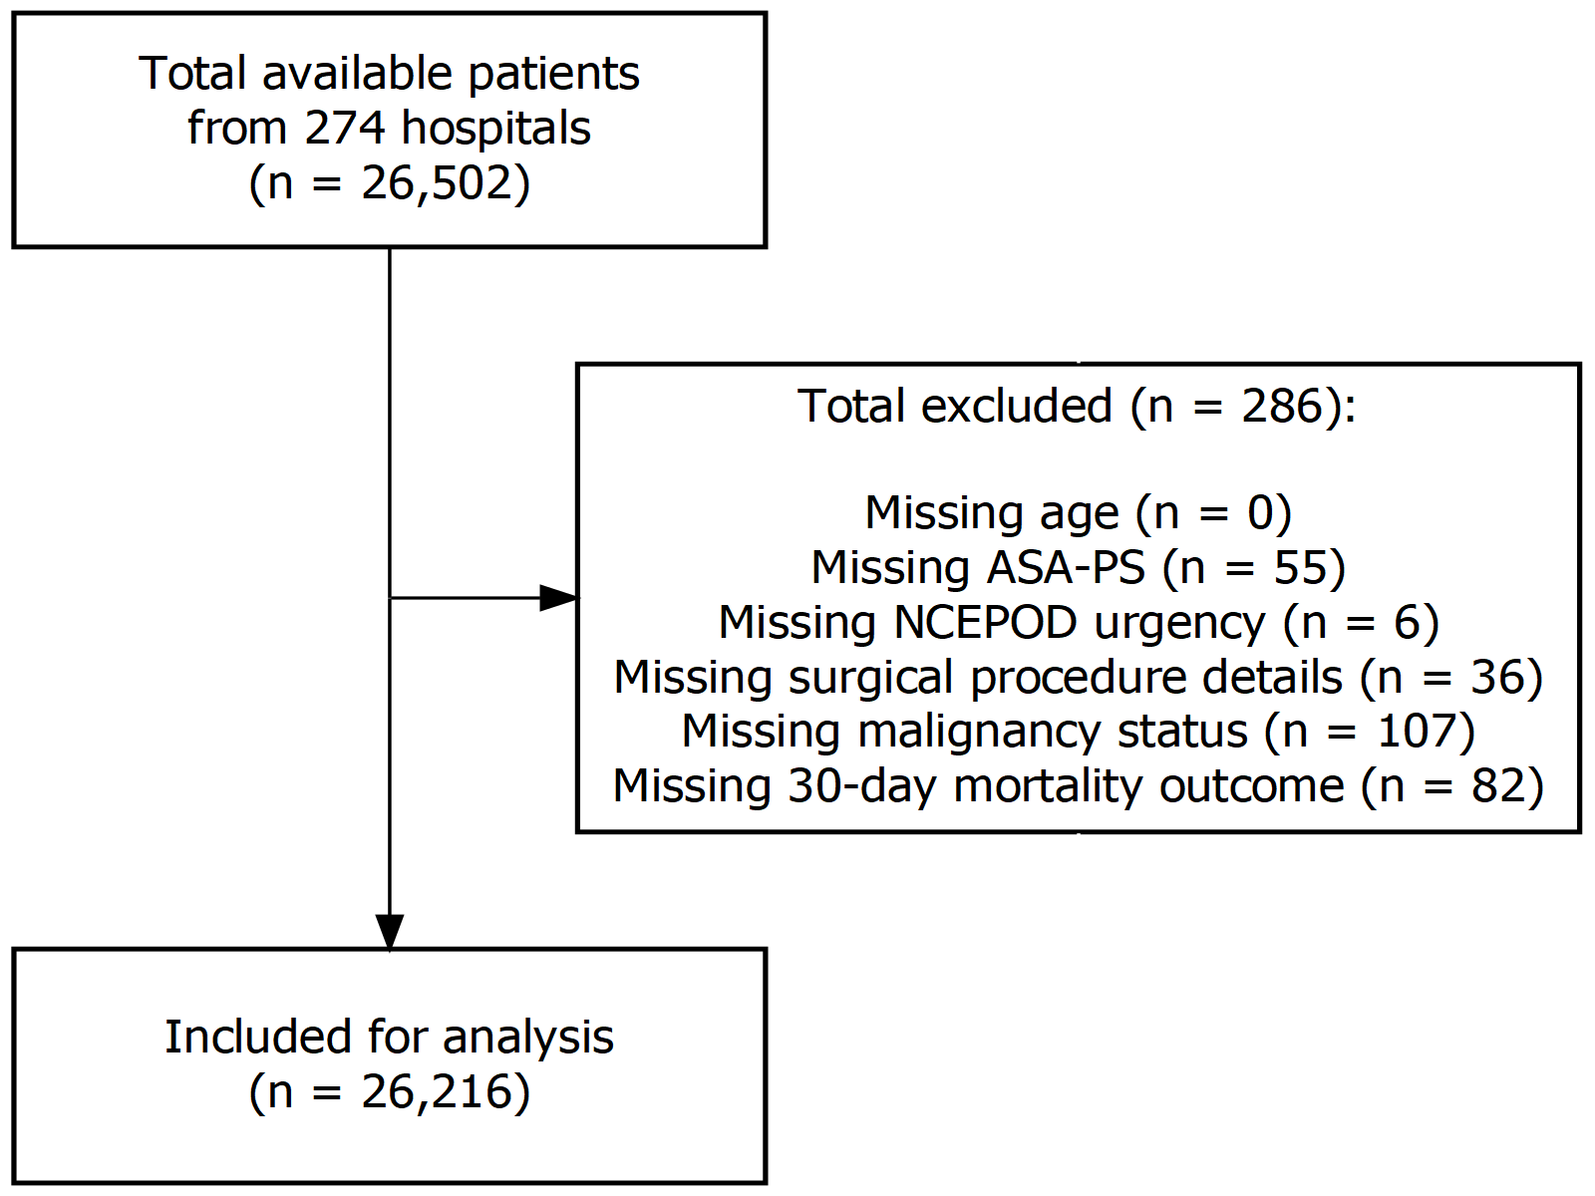

Figure 5‑1: Cases included and excluded from analysis.

The largest proportion (86.9%) of data was contributed by sites in the UK (n = 22,789, from 245 hospitals). Australia (n = 2,412, 9.2%) and New Zealand (n = 1,015, 3.9%) contributed a smaller proportion of data, due to fewer sites participating in either country (21 and 8 hospitals, respectively).

A wide range of surgical specialties were represented in the cohort. Table 5-1 summarises the baseline patient demographics for the cohort overall, stratified by country.

Table 5‑1: Baseline patient demographics stratified by country. For surgical specialty classifications: ‘GI’ includes colorectal, upper gastrointestinal tract, bariatric and hepato-pancreato-biliary surgery, and ‘Other’ includes solid organ transplants, ophthalmic, plastic, maxillofacial/dental, ear-nose-throat, endocrine and breast surgery, as well as interventional radiology, interventional cardiology and endoscopic procedures requiring anaesthetic support.

|  |  |  |  |  |  |
| --- | --- | --- | --- | --- | --- |
|  | Overall | Missing | Australia | New Zealand | UK |
| **n** | 26216 |  | 2412 | 1015 | 22789 |
| **Male (%)** | 10676 (40.7) | 0.0 | 1186 (49.2) | 451 (44.4) | 9039 (39.7) |
| **Age (median [IQR])** | 57 [37, 72] | 0.0 | 56 [38, 70] | 55 [36, 70] | 57 [37, 72] |
| **Operative Urgency (%)** |  | 0.0 |  |  |  |
| Elective | 13469 (51.4) |  | 1066 (44.2) | 436 (43.0) | 11967 (52.5) |
| Expedited | 3596 (13.7) |  | 530 (22.0) | 199 (19.6) | 2867 (12.6) |
| Urgent | 7802 (29.8) |  | 717 (29.7) | 320 (31.5) | 6765 (29.7) |
| Immediate | 1349 ( 5.1) |  | 99 ( 4.1) | 60 ( 5.9) | 1190 ( 5.2) |
| **ASA-PS Grade (%)** |  | 0.0 |  |  |  |
| I | 6439 (24.6) |  | 437 (18.1) | 208 (20.5) | 5794 (25.4) |
| II | 11672 (44.5) |  | 938 (38.9) | 436 (43.0) | 10298 (45.2) |
| III | 6696 (25.5) |  | 748 (31.0) | 293 (28.9) | 5655 (24.8) |
| IV | 1339 ( 5.1) |  | 279 (11.6) | 75 ( 7.4) | 985 ( 4.3) |
| V | 70 ( 0.3) |  | 10 ( 0.4) | 3 ( 0.3) | 57 ( 0.3) |
| **Surgical Severity (%)** |  | 0.0 |  |  |  |
| Minor | 2120 ( 8.1) |  | 275 (11.4) | 96 ( 9.5) | 1749 ( 7.7) |
| Intermediate | 4897 (18.7) |  | 608 (25.2) | 198 (19.5) | 4091 (18.0) |
| Major | 10507 (40.1) |  | 855 (35.4) | 411 (40.5) | 9241 (40.6) |
| Xmajor | 5287 (20.2) |  | 350 (14.5) | 142 (14.0) | 4795 (21.0) |
| Complex | 3405 (13.0) |  | 324 (13.4) | 168 (16.6) | 2913 (12.8) |
| **Surgical Specialty (%)** |  | 0.0 |  |  |  |
| GI | 4472 (17.1) |  | 385 (16.0) | 156 (15.4) | 3931 (17.3) |
| Gynaecology-Urology | 4309 (16.4) |  | 273 (11.3) | 150 (14.8) | 3886 (17.1) |
| Neuro-Spine | 1208 ( 4.6) |  | 140 ( 5.8) | 66 ( 6.5) | 1002 ( 4.4) |
| Obstetric | 3578 (13.7) |  | 180 ( 7.5) | 118 (11.6) | 3280 (14.4) |
| Orthopaedic | 6772 (25.8) |  | 479 (19.9) | 240 (23.7) | 6053 (26.6) |
| Cardiothoracic | 1033 ( 3.9) |  | 131 ( 5.4) | 63 ( 6.2) | 839 ( 3.7) |
| Vascular | 674 ( 2.6) |  | 98 ( 4.1) | 36 ( 3.6) | 540 ( 2.4) |
| Other | 4163 (15.9) |  | 726 (30.1) | 185 (18.2) | 3252 (14.3) |
| **Coronary Artery Disease (%)** | 3032 (11.6) | 0.0 | 365 (15.1) | 142 (14.0) | 2525 (11.1) |
| **Congestive Cardiac Failure (%)** | 897 ( 3.4) | 0.0 | 137 ( 5.7) | 71 ( 7.0) | 689 ( 3.0) |
| **Metastatic Cancer (%)** | 825 ( 3.1) | 0.0 | 111 ( 4.6) | 32 ( 3.2) | 682 ( 3.0) |
| **Dementia (%)** | 676 ( 2.6) | 0.0 | 49 ( 2.0) | 30 ( 3.0) | 597 ( 2.6) |
| **COPD (%)** | 1957 ( 7.5) | 0.0 | 234 ( 9.7) | 63 ( 6.2) | 1660 ( 7.3) |
| **Pulmonary Fibrosis (%)** | 180 ( 0.7) | 0.0 | 20 ( 0.8) | 6 ( 0.6) | 154 ( 0.7) |
| **Diabetes (%)** | 3532 (13.5) | 0.1 | 413 (17.1) | 145 (14.3) | 2974 (13.1) |
| **Liver Cirrhosis (%)** | 225 ( 0.9) | 0.0 | 36 ( 1.5) | 6 ( 0.6) | 183 ( 0.8) |
| **Renal Disease (%)** | 381 ( 1.5) | 0.0 | 69 ( 2.9) | 28 ( 2.8) | 284 ( 1.2) |

#### Age distribution

The overall age distribution of the patients in the cohort demonstrated a bimodal distribution with two peaks (Figure 5-2A). However, when stratified by sex, the first peak was clearly due to a large number of young females (Figure 5-2B), likely to be obstetric patients (Figure 5-2C). The median age of the whole cohort was 57 years (Interquartile Range, IQR = 37 to 72).

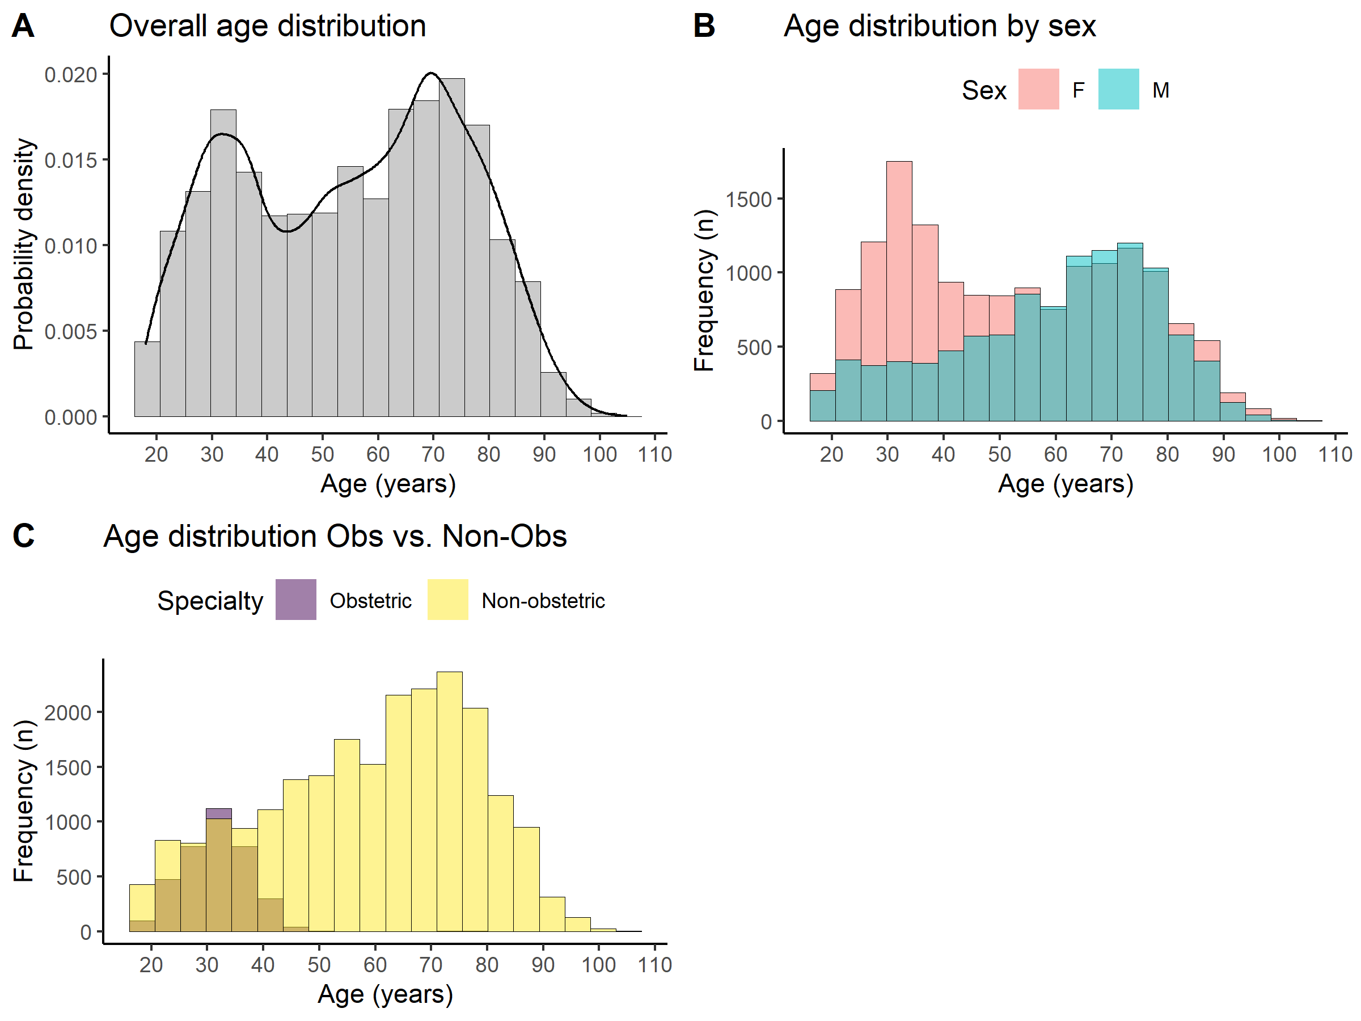

Figure 5‑2: Age distribution of the patient cohort. (A) The histogram (grey bars) and density plot (black line) of the ages of patients who underwent surgery. Two peaks are seen with the first centred around 30 and the second centred around 70 years of age. (B) When the age distribution was stratified by sex the first peak was mainly due to a large number of young females, and likely to be obstetric, patients. (C) A confirmatory plot of the age distributions stratified by obstetric vs. non-obstetric procedures confirmed this.

The majority of cases were elective surgery (n = 13,469 [51.4%]). Patients underwent procedures of varying complexity, with most patients undergoing Major surgery (n = 10,507 [40.1%]). AXA-PPP codes were used to classify surgical complexity.[24] Figure 5-3 illustrates the relative frequencies of operative urgency and surgical complexity within the cohort.

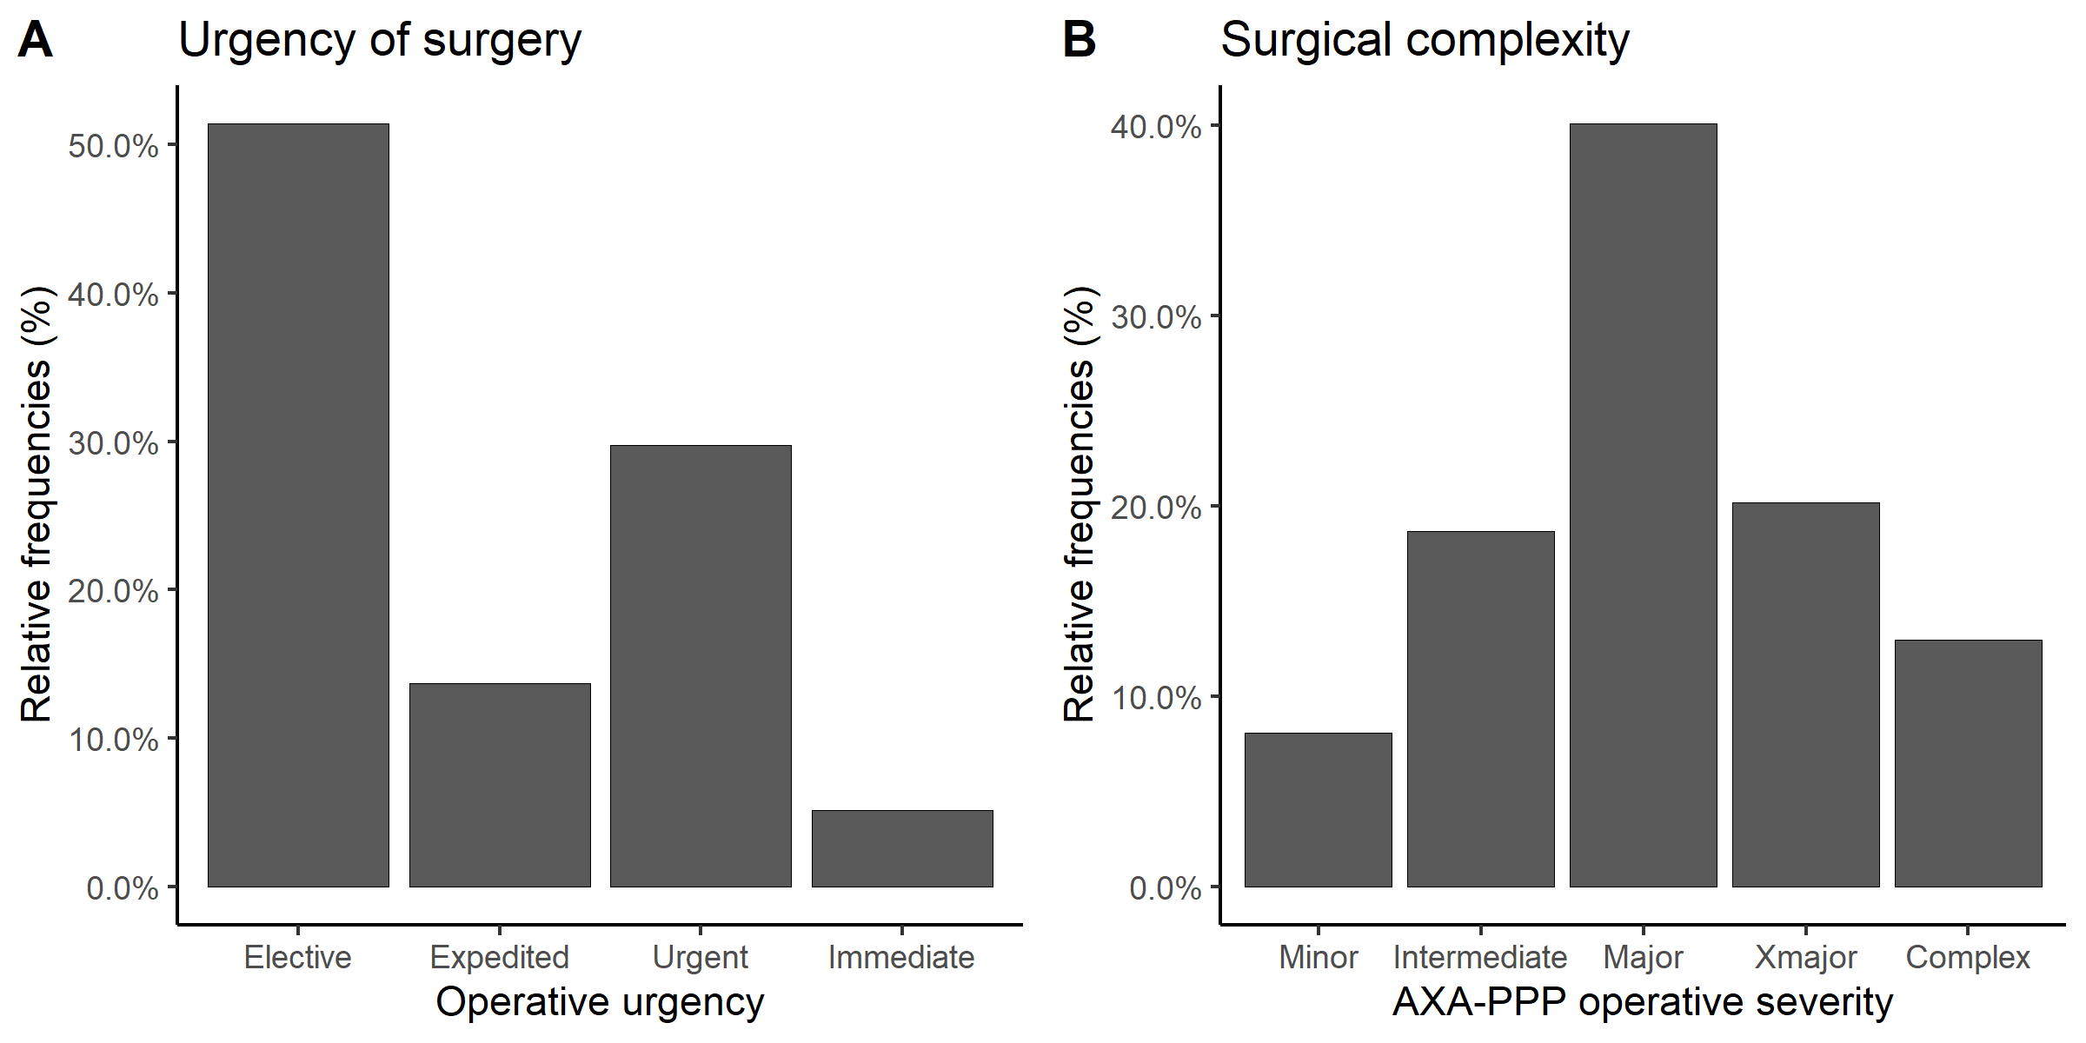

Figure 5‑3: Relative frequencies of operative urgency and surgical complexity for patients who underwent surgery within the cohort. (A) The distribution of surgical urgency. (B) The distribution of surgical complexity.

#### Preoperative origins and levels of care

The patients presenting for surgery were mostly admitted from home on the day of surgery (n = 14,048 [53.6%]), i.e. they did not occupy a hospital bed the night before their operation. For the 12,168 patients who were already inpatients at the time of surgery, the median preoperative length of hospital stay was 1 day (IQR = 1 to 2 days). A minority of patients were already inpatients for a week or longer (n = 1,359 [5.2%]) by the time they presented to surgery.

The levels of care (according to definitions of critical care published by the Intensive Care Society (ICS) and the Faculty of Intensive Care Medicine (FICM) (39,40)) received by patients prior to surgery were recorded within the dataset (Figure 5-4). Only a small number of the cohort were receiving critical care prior to their surgery — 471 patients (1.8%) were receiving Level 2 care, and 401 patients (1.5%) were receiving Level 3 care preoperatively.

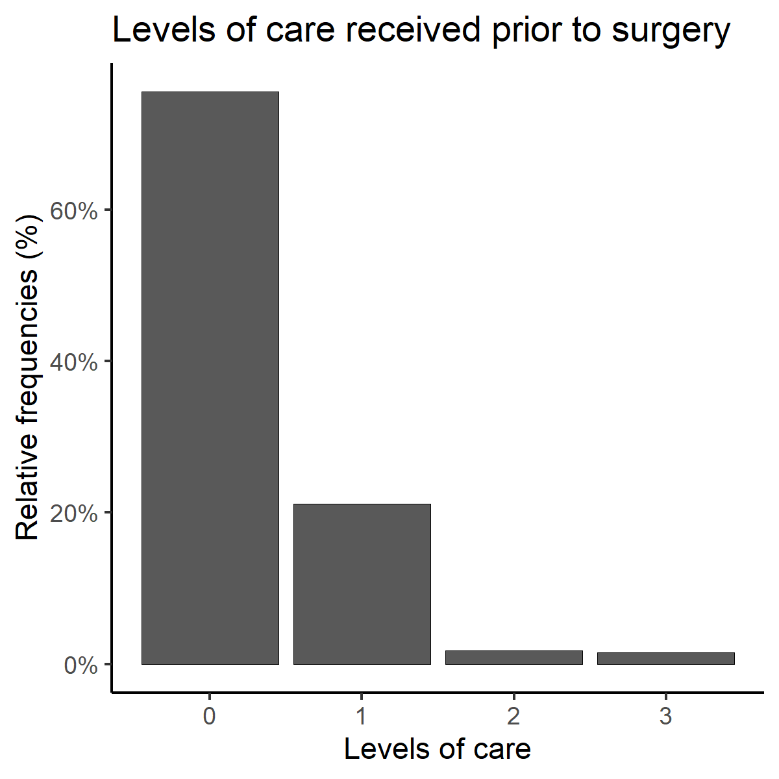

Figure 5‑4: Levels of care received by patients prior to surgery. The majority of patients were not receiving critical care (defined as Level 2 or Level 3 care) preoperatively.

#### Comorbidities

Information about patients’ past medical and drug history was also collected. Coronary artery disease was the most commonly reported, with 3,032 (11.6%) patients presenting to surgery with that comorbidity. When cardiovascular diseases were considered together, the number of patients who reported any cardiovascular comorbidity (i.e. reporting any one of coronary artery disease, congestive cardiac failure, or cerebrovascular disease including previous strokes and transient ischaemic attacks) was 4,225 (16.1%), almost one-sixth of the cohort.

Hypertension in the cohort was common, with a large proportion of patients were normally receiving antihypertensive drugs prior to surgery (n = 8,278 [31.6]%).

Other relevant cardiovascular medications which patients were receiving prior to surgery included anti-anginal drugs (n = 1,666 [6.4]%), diuretics (n = 2,473 [9.4]%), and warfarin or other treatment-dose anticoagulation medication (n = 2,533 [9.7]%).

More than a quarter of the patient cohort (n = 6,621 [25.3%]) reported either comorbid chronic obstructive pulmonary disease, pulmonary fibrosis, symptoms of breathlessness, or abnormal chest X-ray findings prior to surgery.

There were 825 (3.2%) patients with active malignancy, and a larger number (n = 3,215 [12.3%]) who had previous histories of cancer within the preceding 5 years.

Diabetes mellitus was a comorbidity for 3,532 (13.5%) patients. Table 5-2 summarises the incidence of different types of diabetes present in the subgroup of patients with diabetes.

Table 5‑2: Breakdown of diabetic subtypes in patients with comorbid diabetes mellitus.

|  |  |
| --- | --- |
|  | Overall |
| **N** | 3532 |
| **Diabetes (%)** |  |
| Type 1 | 301 (8.5) |
| Type 2 (diet controlled) | 734 (20.8) |
| Type 2 (insulin controlled) | 850 (24.1) |
| Type 2 (non-insulin glucose lowering drug controlled) | 1647 (46.6) |

The incidences of dementia (n = 676 [2.6%]), end-stage renal disease (n = 381 [1.5%]) and chronic liver disease (n = 225 [0.9%]) were low in the cohort.

#### Preoperative investigations

The cohort study was observational in nature and did not mandate any additional investigations above and beyond what patients would normally have received preoperatively.

The majority of patients (n = 15,161 [57.8%]) received electrocardiogram (ECG) recordings preoperatively, with the majority of these being normal sinus rhythm (Table 5-3).

Table 5‑3: Breakdown of electrocardiogram (ECG) findings in patients who had ECGs available preoperatively. ‘bpm’ = beats per minute.

|  |  |
| --- | --- |
|  | Overall |
| **N** | 15161 |
| **ECG (%)** |  |
| Normal sinus rhythm | 10802 (71.2) |
| Atrial fibrillation (60-90 bpm) | 822 (5.4) |
| Atrial fibrillation (>90 bpm) | 237 (1.6) |
| Q-waves | 294 (1.9) |
| >4 ectopics | 203 (1.3) |
| ST- or T-wave changes | 951 (6.3) |
| Other abnormal rhythms | 1852 (12.2) |

Blood test results for the following biochemistry and haematology investigations were recorded if available: serum creatinine, serum urea, plasma sodium, plasma potassium, haemoglobin concentration, white cell count, and HbA1C.[25] Results for at least one of these blood investigations were available for 23,718 patients (90.5%). The distribution of values for these tests, if available, are shown in Figure 5-5.

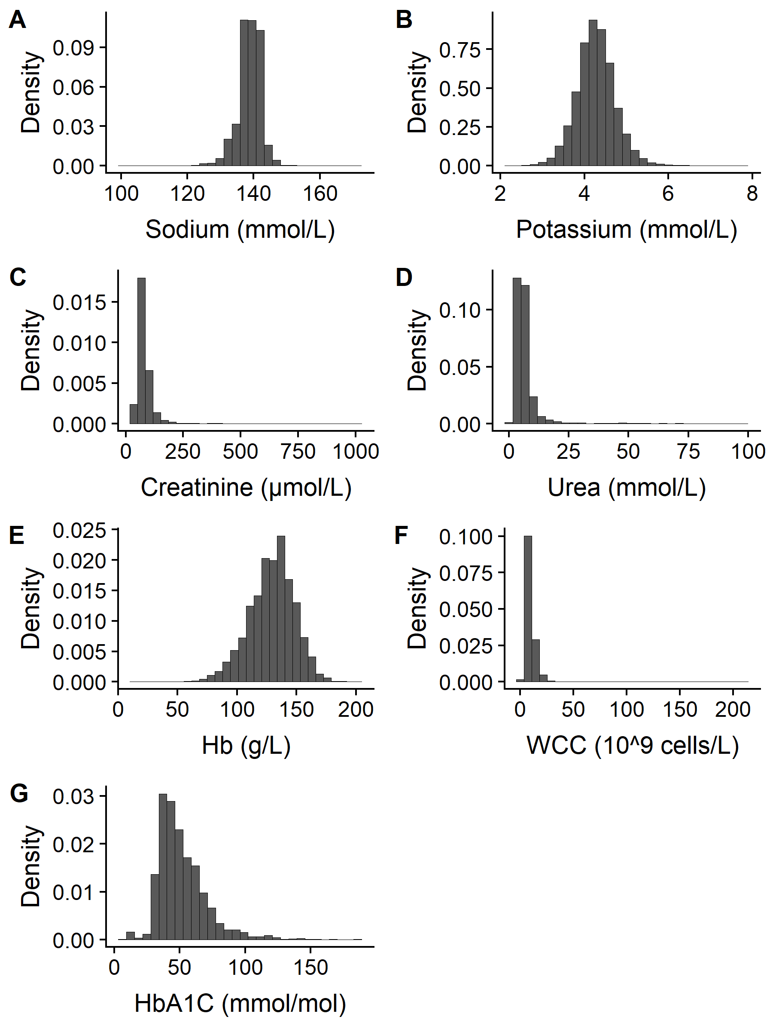

Figure 5‑5: Histograms for the preoperative blood test results of patients who had blood test investigations available before their operation. Hb = haemoglobin; WCC = White Cell Count; HbA1C = haemoglobin A1c.

#### Operative factors

The majority of surgery started during the daytime between 08:00hrs and 16:00hrs (n = 21,056 [80.3%], Figure 5-6), with a smaller proportion occurring in the evening between 16:00hrs to 20:00hrs (n = 3,079 [11.7%]), and the remainder occurring overnight between 20:00hrs and 08:00hrs (n = 1,661 [6.3%]).

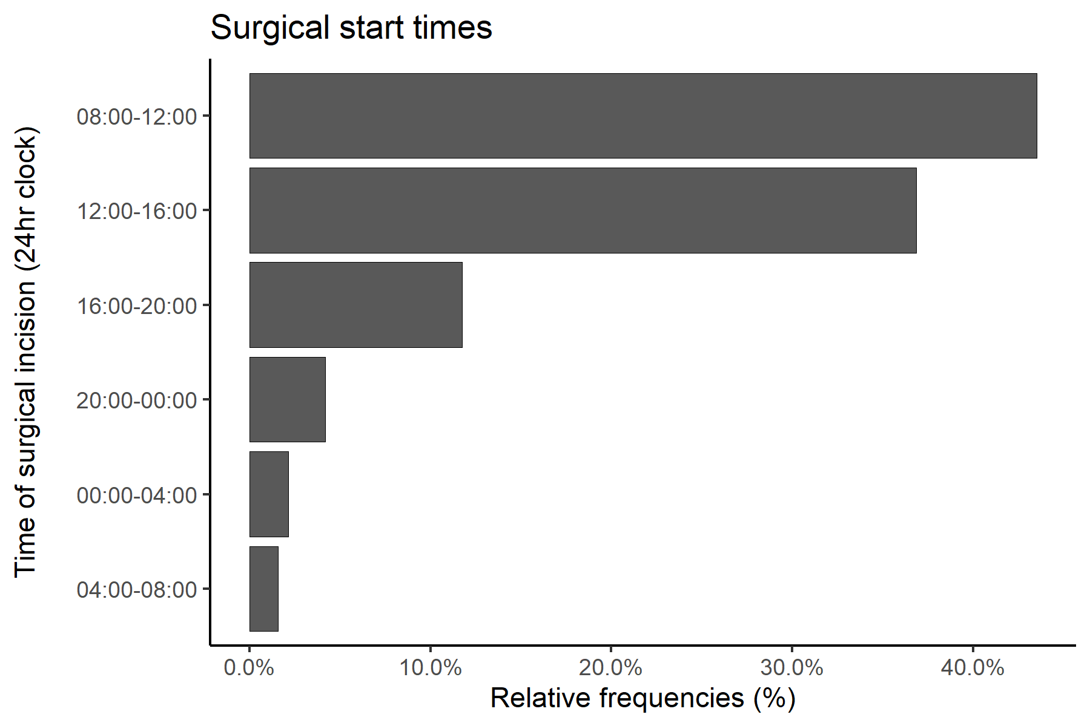

Figure 5‑6: Surgical start times.

The modalities of anaesthesia delivered during the operation were recorded for each case and the majority of patients received General Anaesthesia (n = 19,144 [73.0%]) either alone, or in conjunction with another mode of anaesthesia (Table 5-4). A large proportion of patients underwent central neuraxial blockade (i.e. either Spinal or Epidural Anaesthesia) without General Anaesthesia as the primary mode of anaesthesia (n = 5,634 [21.5%]), with a much smaller proportion undergoing peripheral nerve block (regional anaesthesia) without General Anaesthesia (n = 525 [2.0%])).

Table 5‑4: Breakdown anaesthetic modalities in surgical cases. The total percentage does not sum to 100% as patients could receive more than one anaesthetic modality during their surgery, e.g. General Anaesthesia plus Spinal Anaesthesia.

|  |  |
| --- | --- |
|  | Overall |
| **N** | 26216 |
| **General anaesthesia (%)** | 19144 (73.0) |
| **Deep sedation (%)** | 628 (2.4) |
| **Light sedation (%)** | 1454 (5.5) |
| **Epidural (%)** | 1325 (5.1) |
| **Spinal (%)** | 6401 (24.4) |
| **Combined spinal-epidural (%)** | 318 (1.2) |
| **Peripheral nerve/regional block (%)** | 2311 (8.8) |
| **Local anaesthetic infiltration (%)** | 2477 (9.4) |

### Risk profile

The baseline risk profile of patients presenting for surgery were assessed using ASA-PS grades (Figure 5-7A). The majority of patients were ASA I (n = 6,439 [24.6%]) or ASA II patients (n = 11,672 [44.5%]), traditionally considered to be lower risk based on their medical history. Patients classed as ASA III or higher (n = 8,105) comprised 30.9% of the cohort.

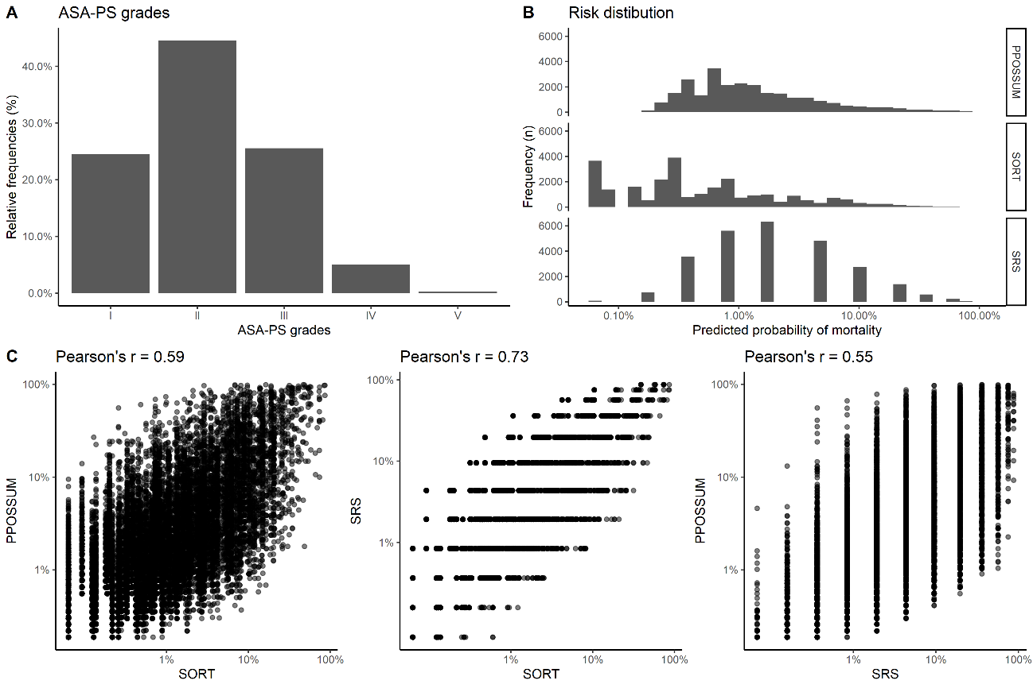

Figure 5‑7: Risk distribution of patients in the cohort. (A) The distribution of American Society of Anesthesiologists Physical Status (ASA-PS) grades. (B) Histograms showing the distribution of preoperative predicted mortality as computed by the Portsmouth-Physiology and Operative Severity Score for the enUmeration of Mortality (PPOSSUM), Surgical Risk Scale (SRS), and Surgical Outcome Risk Tool (SORT) risk assessment tools. (C) Pair-wise scatter plots showing the relationship between each risk tool prediction, with Pearson’s correlation coefficient, r, indicating the degree of agreement between each prediction tool.

The predicted risk of patients conditional on baseline risk factors were computed using the Portsmouth-Physiology and Operative Severity Score for the enUmeration of Mortality (P-POSSUM), Surgical Risk Scale (SRS), and Surgical Outcome Risk Tool (SORT), showing most patients in the cohort to be low risk (Figure 5-7B). Using these predicted risks, the proportion of patients who would have been considered *high-risk* (i.e. preoperative predicted mortality risk ≥5%) according to definitions published by NCEPOD (35) and the Royal College of Surgeons (37), were 14.9%, 10.1%, and 19.2%, based on P-POSSUM, SORT and SRS, respectively. Table 5-5 shows a further breakdown of the frequency of preoperative predicted risks based on these models by different risk ranges. There was variable agreement between the predicted risks using the different tools (Figure 5-7C), with Pearson correlation coefficients of 0.59 between P-POSSUM and SORT, 0.55 between P-POSSUM and SRS, and 0.73 between SRS and SORT.

Table 5‑5: Proportion of patients in each mortality risk group according to P-POSSUM, SORT and SRS computed mortality.

|  |  |  |  |
| --- | --- | --- | --- |
|  | P-POSSUM | SORT | SRS |
| **n** | 26216 | 26216 | 26216 |
| **Probability (%)** |  |  |  |
| **0 to 0.009** | 12870 (49.1) | 19053 (72.7) | 10012 (38.2) |
| **0.01 to 0.0249** | 6499 (24.8) | 2863 (10.9) | 6336 (24.2) |
| **0.025 to 0.049** | 2953 (11.3) | 1650 (6.3) | 4826 (18.4) |
| **0.05 to 0.09** | 1772 (6.8) | 1515 (5.8) | 2753 (10.5) |
| **0.1 to 0.49** | 1836 (7.0) | 1095 (4.2) | 1991 (7.6) |
| **0.5 to 1** | 286 (1.1) | 40 (0.2) | 298 (1.1) |

Due to the high frequency of patients concentrated at the lower spectrum of risk. Re-plotting the distribution of preoperative predicted risks from Figure 5-4B using a log(probability) scale allows for a clearer visualisation of the full spectrum of patient risks (Figure 5-8). The predicted risk of any individual patient would therefore differ depending on which risk prediction model was used to compute risk. The risk distributions of all three countries were comparable (Figure 5-9).

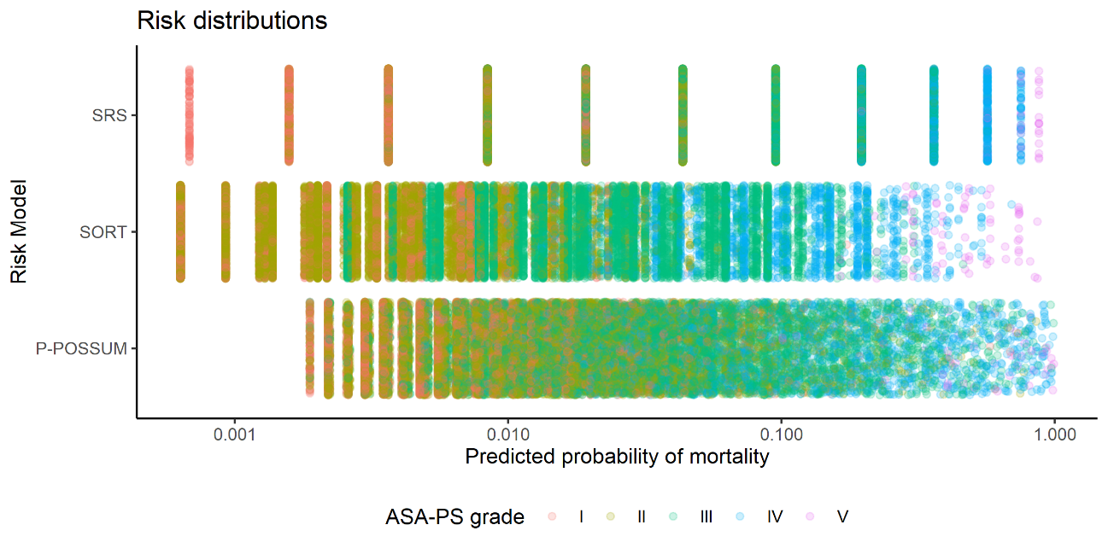

Figure 5‑8: Risk distribution of patients in the cohort replotted as a jitter plot with a log(probability) scale and coloured by ASA-PS grade. ASA-PS = American Society of Anesthesiology Physical Status; P-POSSUM = Portsmouth-Physiology and Operative Severity Score for the enUmeration of Mortality; SRS = Surgical Risk Scale; SORT = Surgical Outcome Risk Tool.

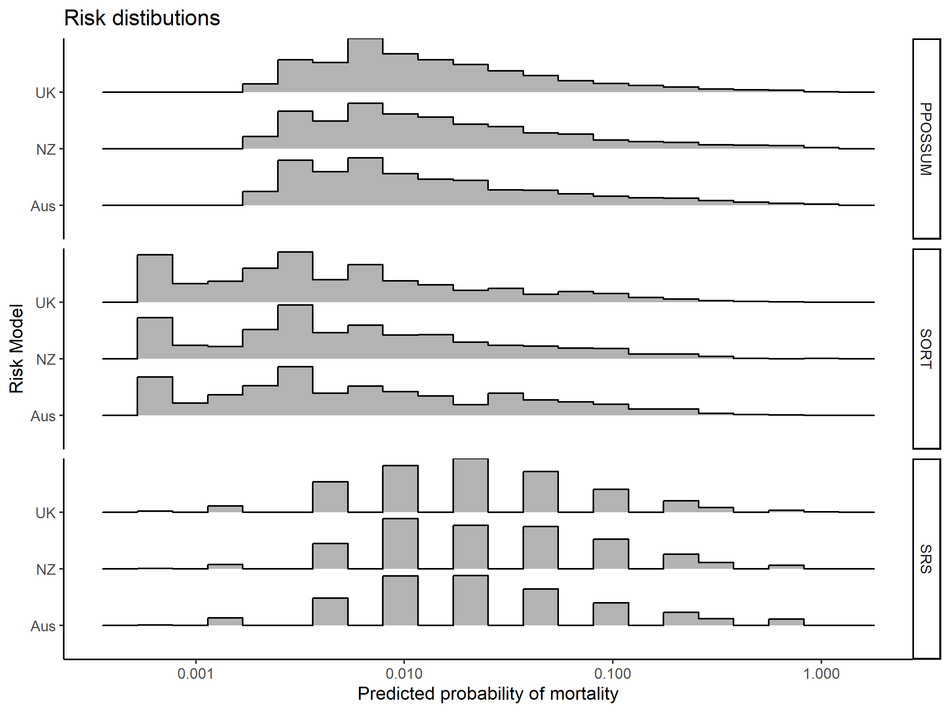

Figure 5‑9: Histograms depicting the probability distributions of patients in the cohort by country and risk prediction tool. The risk profiles of each country appeared similar. Risk distributions depended upon the risk model used to calculate predicted mortality risk. PPOSSUM = Portsmouth-Physiology and Operative Severity Score for the enUmeration of Mortality; SRS = Surgical Risk Scale; SORT = Surgical Outcome Risk Tool.

### Critical care admission

A total of 3,009 patients (11.5%) were admitted immediately to critical care after surgery. Of these, 2,704 (89.9%) were planned admissions, and 314 (10.4%) were unplanned admissions.

A number (n = 286) of patients were admitted to critical care on a later date after their surgery to manage complications, representing 1.1% of all patients undergoing surgery.

Patients who were admitted immediately to critical care postoperatively tended to be older, with a higher ASA-PS grade, undergoing surgery with greater associated severity, and with higher NCEPOD urgency categories (Table 5-6). The proportion of patients who were admitted immediately to critical care in the UK, New Zealand and Australia were 11.3%, 12.1% and 13.3%, respectively.

Table 5‑6: Differences in baseline patient and surgical characteristics between patients who were admitted immediately to critical care and patients who were admitted to the ward after their surgery.

|  |  |  |  |
| --- | --- | --- | --- |
|  | Admitted to Ward | Admitted to Critical care | p |
| **n** | 23124 | 3009 |  |
| **Age (mean (SD))** | 54.23 (20.11) | 62.28 (16.52) | <0.001 |
| **ASA-PS Grade (%)** |  |  | <0.001 |
| I | 6240 (27.0) | 176 (5.8) |  |
| II | 10861 (47.0) | 770 (25.6) |  |
| III | 5324 (23.0) | 1354 (45.0) |  |
| IV | 691 (3.0) | 647 (21.5) |  |
| V | 8 (0.0) | 62 (2.1) |  |
| **Surgical Severity (%)** |  |  | <0.001 |
| Minor | 1947 (8.4) | 152 (5.1) |  |
| Intermediate | 4598 (19.9) | 273 (9.1) |  |
| Major | 9701 (42.0) | 778 (25.9) |  |
| Xmajor | 4741 (20.5) | 538 (17.9) |  |
| Complex | 2137 (9.2) | 1268 (42.1) |  |
| **Operative Urgency (%)** |  |  | <0.001 |
| Elective | 12140 (52.5) | 1292 (42.9) |  |
| Expedited | 3070 (13.3) | 509 (16.9) |  |
| Urgent | 6886 (29.8) | 890 (29.6) |  |
| Immediate | 1028 (4.4) | 318 (10.6) |  |

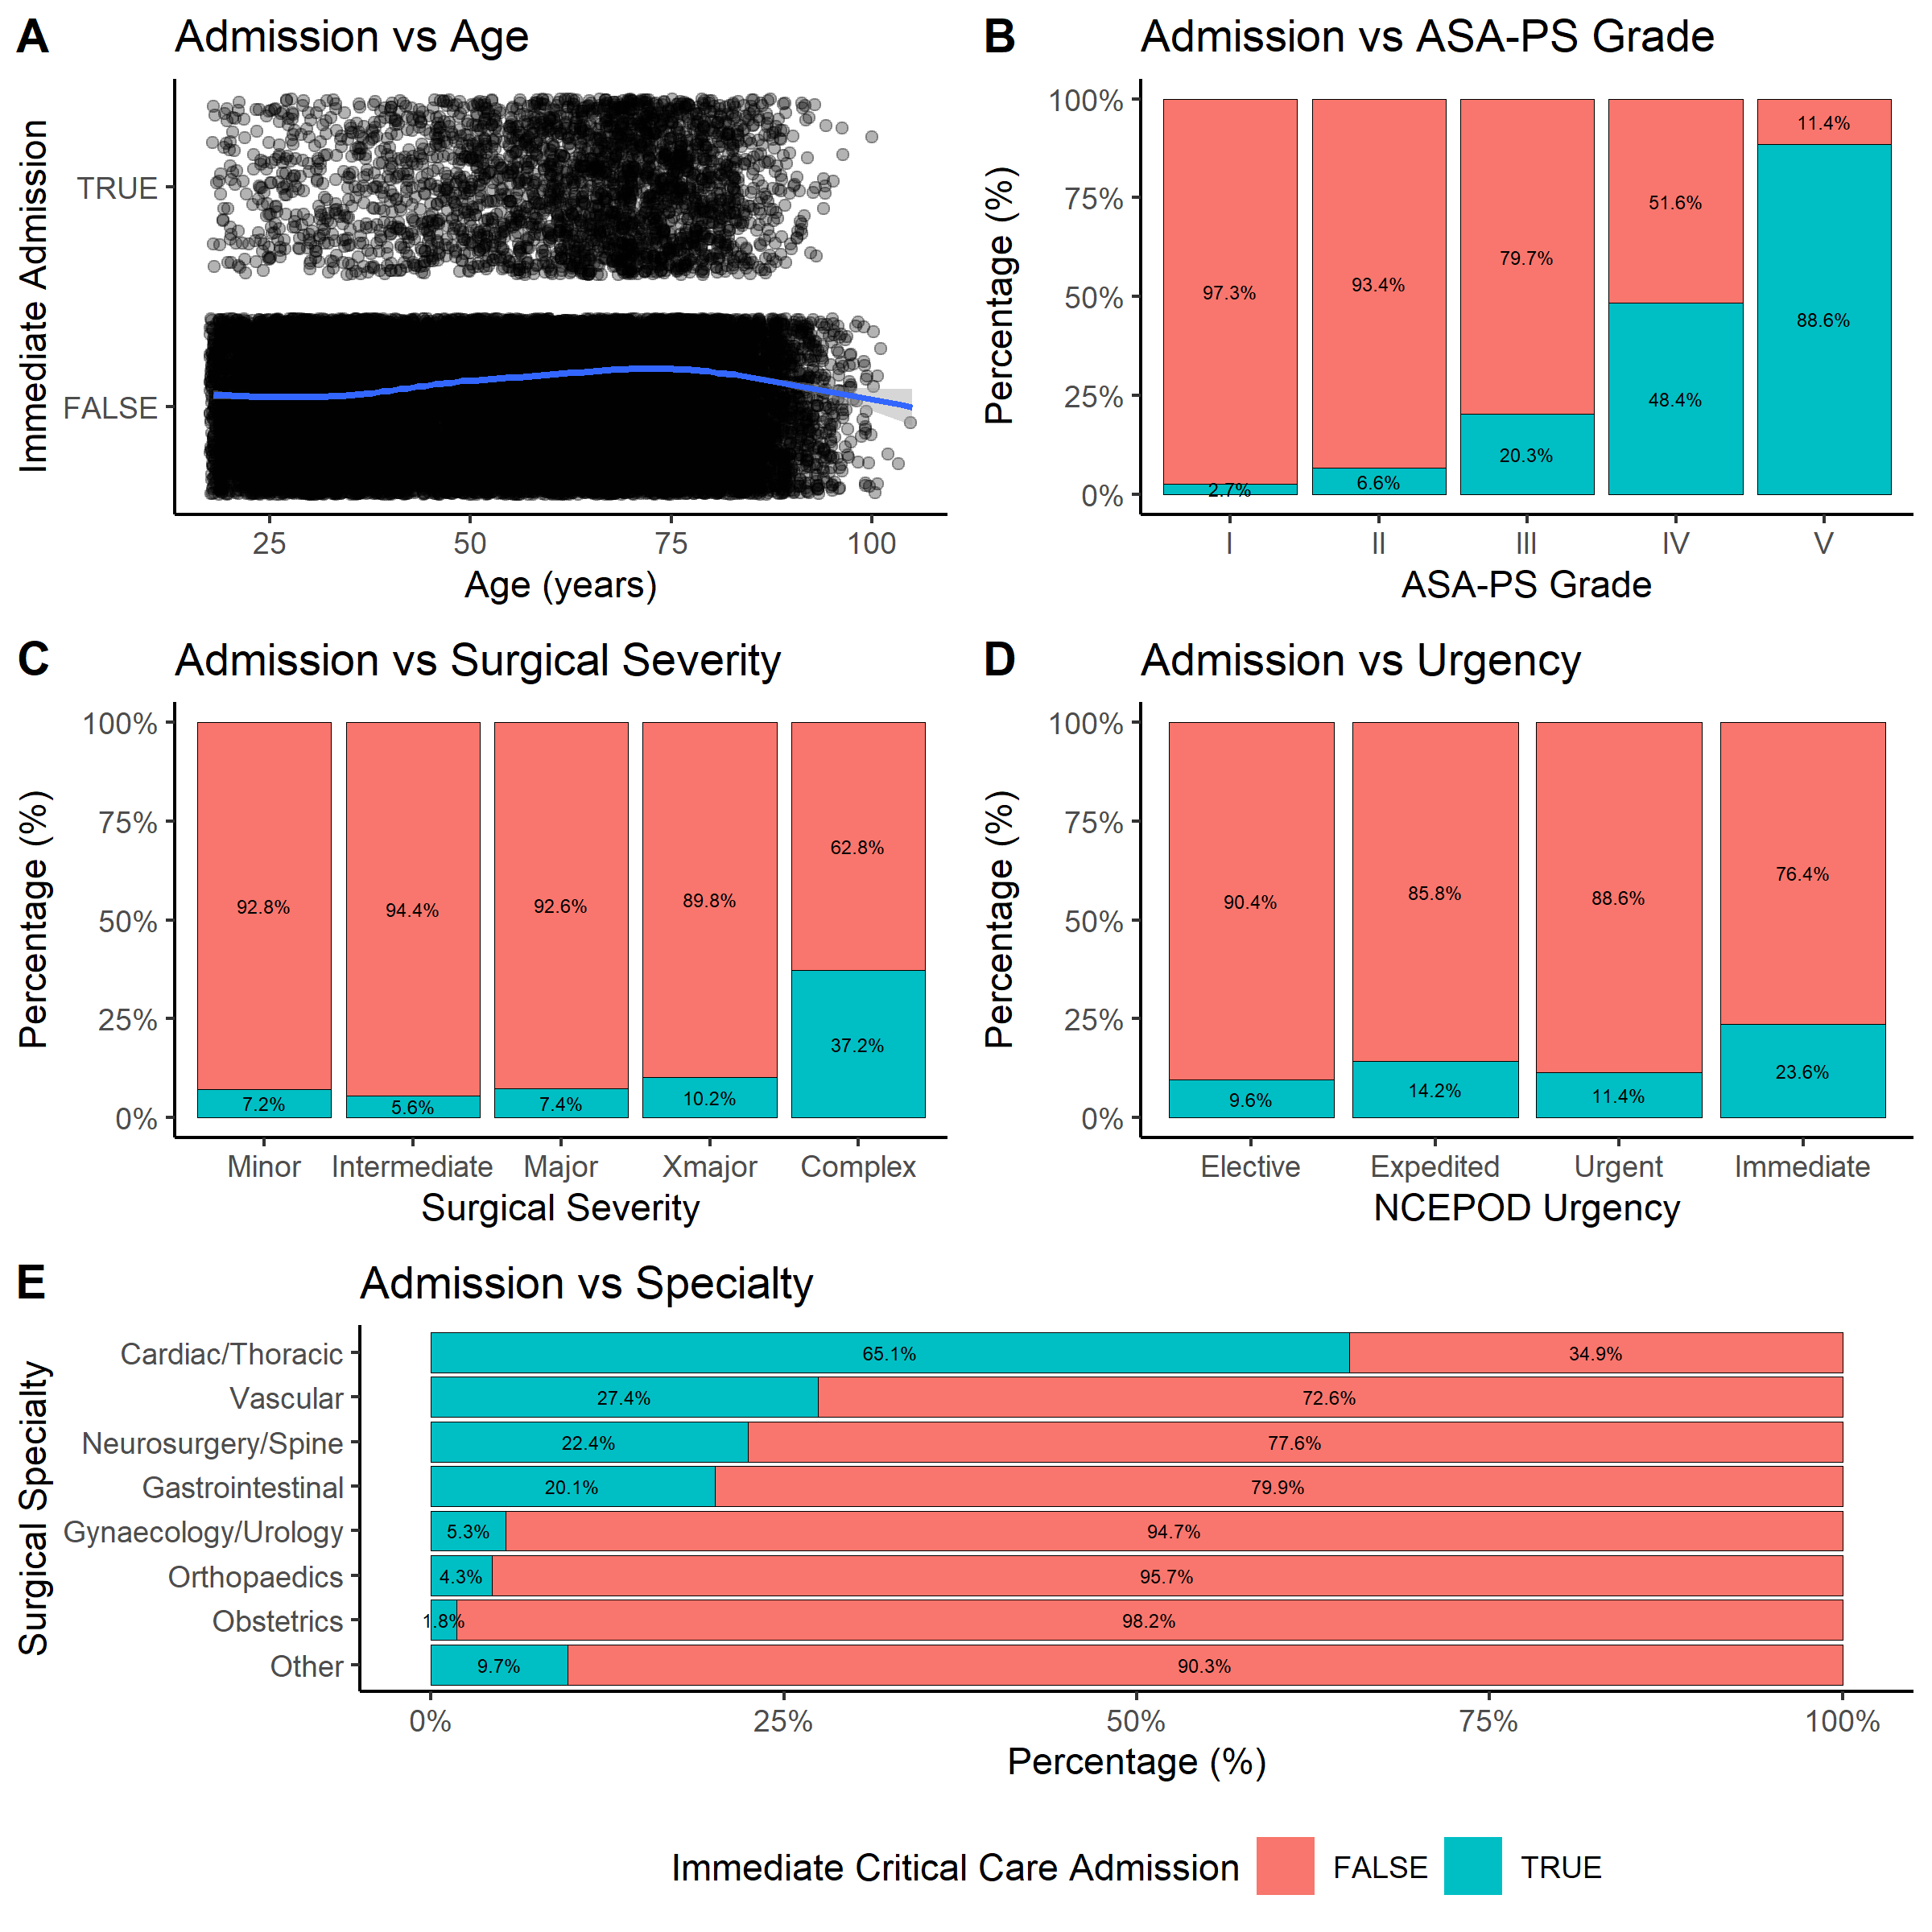

Figure 5‑10: Variation in critical care admission by (A) Age; (B) ASA-PS Grade; (C) Surgical severity as defined by AXA-PPP procedure code; (D) NCEPOD urgency classification; (E) Surgical specialty. In (A) each point represents an individual patient, the positions of the points have been jittered to compensate for over plotting. In (B) to (E) stacked column charts have been standardised to 100% for each category to allow visual comparison between categories.

Despite recommendations, high-risk patients (those with ≥5% predicted mortality) were not consistently being directly admitted to critical care following surgery (Figure 5-11). Although a larger proportion of high-risk than low-risk patients were admitted immediately to critical care, only about a third of high-risk patients were actually admitted. Of the 3894 patients with P-POSSUM predicted mortality of ≥5%, only 1354 (34.8%) were admitted to critical care immediately postoperatively. Similarly, only 35.6% (943 of 2650) of patients defined as high-risk using SORT, and 33.9% (1711 of 5042) of SRS-defined high-risk patients were directly admitted to critical care.

In contrast, a substantial proportion of those patients admitted directly to critical care (n = 3,009) were actually low-risk. This finding was true using predicted risks according to P-POSSUM (n = 1,655 [55.0%]), SORT (n = 2,066 [68.7%]) and SRS (n = 1,298 [43.1%]), although actual proportions varied by risk tool.

Although admission rates to critical care were higher in Australia and New Zealand than in the UK (Figure 5-11B), the finding that the majority of high-risk patients were not admitted directly to critical care postoperatively was consistent across the three countries.

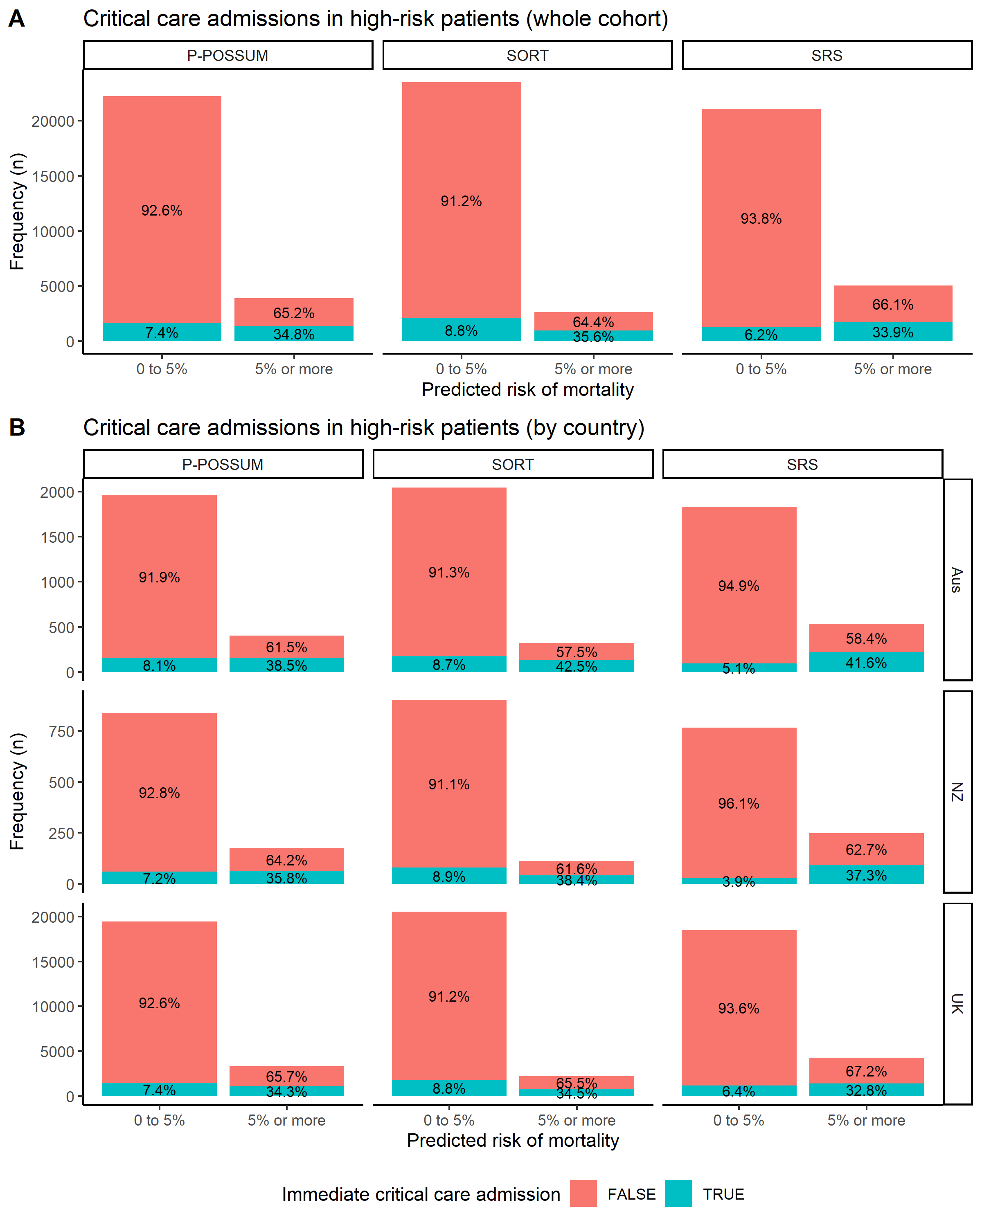

Figure 5‑11: Critical care admissions (blue) in patients of high- and low-predicted mortality risks in the overall cohort (A), and in each country (B). Mortality risks were computed using P-POSSUM, SORT and SRS. Although guidelines recommend that patients with predicted mortality of ≥5% should be admitted to critical care immediately after surgery, only approximately one-third were in this cohort. A substantial proportion of those admitted to critical care postoperatively were low-risk patients with <5% predicted mortality.

### Postoperative outcomes

A number of inpatient postoperative outcomes were tracked in the cohort.

#### Postoperative length of stay

The median postoperative length of stay was 2 days (IQR = 1 to 6 days)[26]. The postoperative length of stay was longer in patients who were admitted to critical care immediately after surgery (median = 7, IQR = 5 to 16 days) than for patients who were not immediately admitted postoperatively to critical care (median = 2, IQR = 1 to 5 days, p <0.001, Figure 5-12).

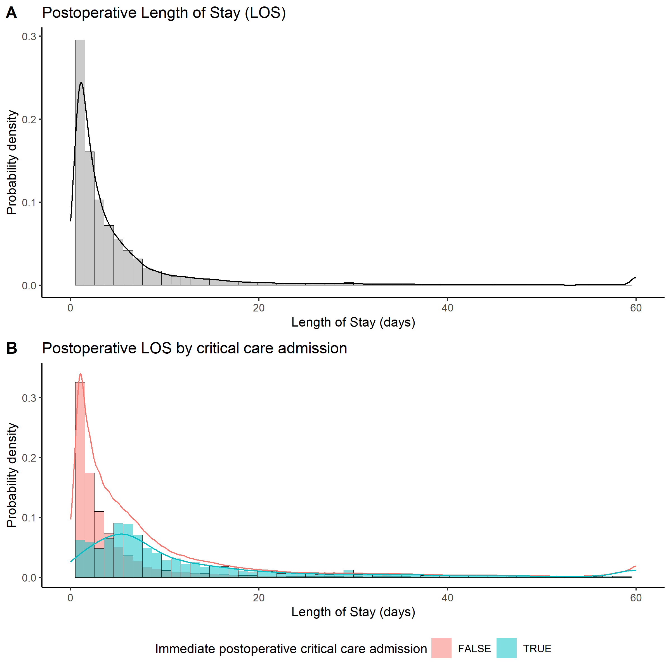

Figure 5‑12: Distribution of postoperative lengths of stay. Overall distribution (A), and stratified (B) by whether patients were admitted immediately to critical care after their surgery, or admitted to the general ward.

The postoperative lengths of stay differed according to the specialty of the surgery patients underwent (Figure 5-13). Median length of stay was highest in cardiothoracic patients (6 days, IQR = 4 to 9), and lowest in patients undergoing “other” surgery[27] (median = 1 day, IQR = 1 to 5).

The median length of stay was similar in the UK (median = 2 days, IQR = 1 to 6 days), Australia (median = 3 days, IQR = 1 to 6 days) and New Zealand (median = 3 days, IQR = 1 to 6 days).

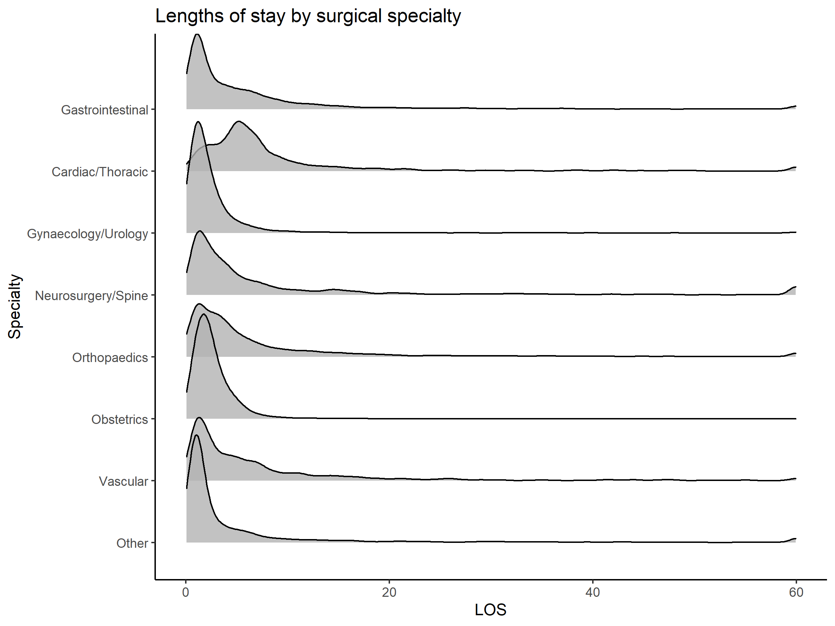

Figure 5‑13: Postoperative length of stay variation according to surgical specialty.

#### Late admissions to Critical Care

While 3,009 patients were admitted immediately to critical care after their surgery, 23,207 patients were not. Of the latter group, a small number (n = 156) required critical care admission at a later time point during their hospital stay.

Of the group who were admitted to critical care immediately postoperatively, 4.3% (n = 130) required critical care readmission at a later time.

#### Length of Critical Care Stay

The median duration spent in critical care for patients who were immediately admitted there postoperatively was 2 days (IQR = 1 to 5 days). In the minority of patients who were not initially admitted to critical care immediately following surgery, but later required critical care during their stay in hospital, the median duration spent in critical care was also 2 days (IQR = 1 to 5 days).

#### Morbidity

A total of 5,599 patients (21.4%) remained in hospital on Day 7 post-surgery. Of these, 3,655 patients (65.3%) were recorded as having POMS-defined morbidity on Day 7. Patients discharged before Day 7 were assumed to have no POMS-defined morbidity, therefore these 3,655 patients with POMS-defined morbidity represented 13.9% of all patients in the cohort. Table 5-7 summarises the numbers and proportions (expressed as the percentage of patients who remained in hospital on Day 7, and as a percentage of total patients in the cohort) with recorded POMS-defined morbidity on Day 7 post-surgery.

Table 5‑7: Day 7 Postoperative morbidity as defined by POMS.

|  |  |  |  |
| --- | --- | --- | --- |
|  | Number of patients with morbidity | % of inpatients on Day 7  ( n = 5,599) | % of whole cohort  (n = 26,216) |
| **Any POMS-defined morbidity present on Day 7** | 3655 | 65.5 | 14.0 |
| **Pulmonary: new oxygen requirement** | 760 | 13.6 | 2.9 |
| **Pulmonary: new ventilatory support** | 196 | 3.5 | 0.7 |
| **Infectious: temperature >38°C in last 24hrs** | 380 | 6.8 | 1.5 |
| **Infectious: currently on antibiotics** | 2112 | 37.8 | 8.1 |
| **Renal: <500ml urine output in last 24hrs** | 760 | 13.7 | 2.9 |
| **Renal: raised serum creatinine >30% from preoperative level** | 307 | 5.5 | 1.2 |
| **Renal: urinary catheter in situ** | 858 | 15.4 | 3.3 |
| **Cardiovascular: new myocardial infarction/ischaemia** | 53 | 0.9 | 0.2 |
| **Cardiovascular: hypotension requiring fluid >200ml/hr or pharmacological therapy** | 212 | 3.8 | 0.8 |
| **Cardiovascular: atrial or ventricular arrhythmias** | 203 | 3.6 | 0.8 |
| **Cardiovascular: cardiogenic pulmonary oedema** | 68 | 1.2 | 0.3 |
| **Cardiovascular: thrombotic event requiring anticoagulation** | 65 | 1.2 | 0.2 |
| **Gastrointestinal: unable to tolerate enteral diet** | 460 | 8.2 | 1.8 |
| **Gastrointestinal: use of antiemetics in last 24hrs** | 666 | 11.9 | 2.5 |
| **Neurological: new focal neurological deficit** | 129 | 2.3 | 0.5 |
| **Neurological: new confusion** | 336 | 6.0 | 1.3 |
| **Neurological: new delirium** | 216 | 3.9 | 0.8 |
| **Neurological: new coma associated with administration of sedation** | 106 | 1.9 | 0.4 |
| **Neurological: new coma without administration of sedation** | 35 | 0.6 | 0.1 |
| **Haematological: red cell transfusion requirement in last 24hrs** | 159 | 2.8 | 0.6 |
| **Haematological: fresh frozen plasma/platelet/cryoprecipitate transfusion in last 24hrs** | 28 | 0.5 | 0.1 |
| **Wound: dehiscence requiring surgical exploration** | 138 | 2.5 | 0.5 |
| **Wound: drainage of pus from operative wound** | 300 | 5.4 | 1.1 |
| **Pain: postoperative pain needing parenteral opioids** | 776 | 13.9 | 3.0 |
| **Pain: postoperative pain needing regional analgesia** | 146 | 2.6 | 0.6 |

Patients who remained inpatient on postoperative day 7 and recorded POMS-defined morbidity on that day, also recorded longer postoperative lengths of stay (median = 15 days) than patients who did not (median = 9 days, p <0.001, Figure 5-14). This finding was true regardless of specialty.

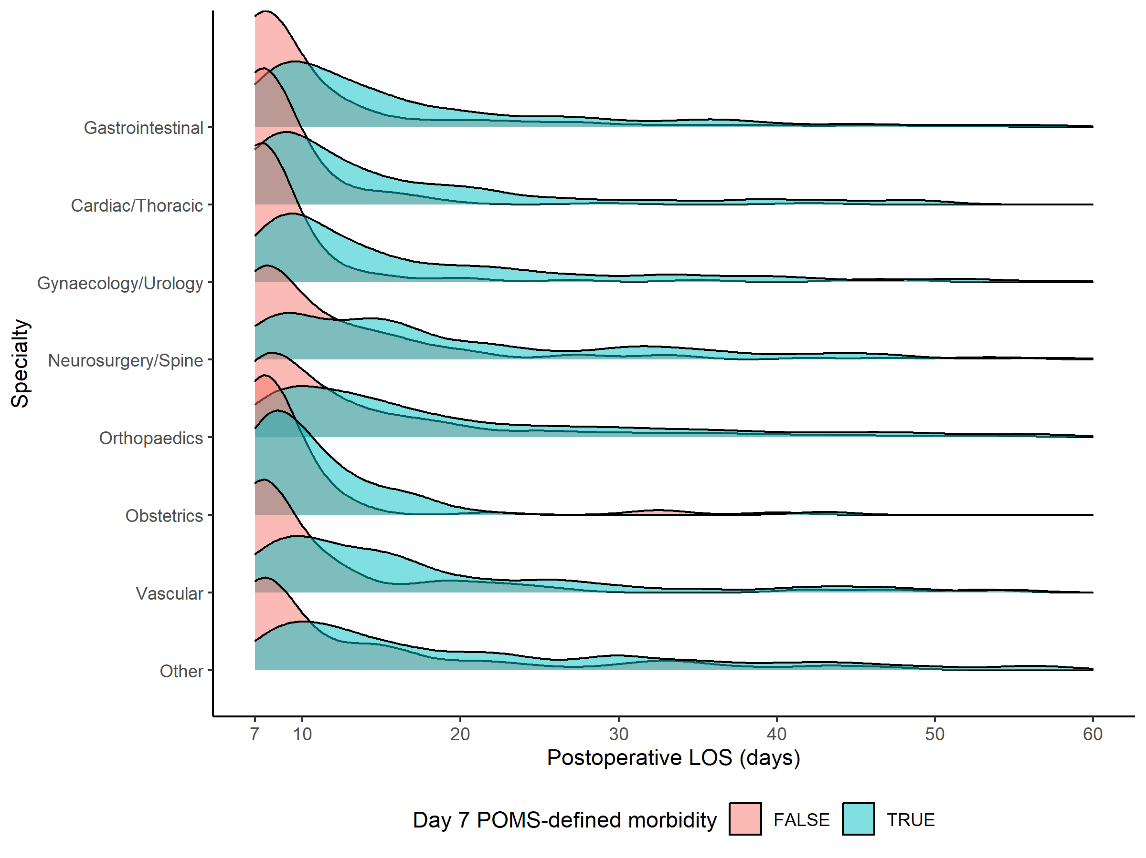

Figure 5‑14: Distributions of postoperative length of stay, for patients who remained in-hospital on postoperative day 7, according to surgical specialty and POMS-defined morbidity. Patients with lengths of stay of 60 days or more have been removed from this plot to avoid an artefactual rise in the distribution at the extremes of hospital lengths of stay.

Some domains of POMS-defined morbidity include less severe and relatively transient morbid states, such as the presence of a urinary catheter and the use of anti-emetics, which may not necessarily be considered complications arising from surgery, but rather conditions expected during normal surgical recovery. Therefore, the frequency of higher-grade (POMS-major) morbidity was calculated[28].

The incidence of POMS-major morbidity in the patients who remained in hospital on Day 7 was 56.4% (or 12.1% of the entire patient cohort, including those that were discharged before Day 7). Conversely, the incidence of POMS-minor morbidity in this group of patients was 36.9% (or 7.9% of the entire patient cohort). The unadjusted incidence of POMS-defined morbidity, POMS-major morbidity, and POMS-minor morbidity was lowest in the UK (p < 0.05 for all three morbidity outcomes, both in patients who remained in hospital on postoperative Day 7 [Table 5-8] and in all patients regardless of when they were discharged [Table 5-9]).

Table 5‑8: Incidence of POMS-defined morbidity in patients remaining in hospital on Postoperative Day 7, stratified by country.

|  |  |  |  |  |
| --- | --- | --- | --- | --- |
|  | Aus | NZ | UK | p |
| **n** | 539 | 246 | 4814 |  |
| **POMS morbidity present (%)** | 71.1 | 75.2 | 64.4 | <0.001 |
| **POMS-major morbidity present (%)** | 61.6 | 67.1 | 55.6 | <0.001 |
| **POMS-minor morbidity present (%)** | 41.6 | 41.9 | 36.3 | 0.014 |

Table 5‑9: Incidence of POMS-defined morbidity in all patients in the cohort, regardless of their postoperative length of stay, stratified by country.

|  |  |  |  |  |
| --- | --- | --- | --- | --- |
|  | Aus | NZ | UK | p |
| **n** | 2412 | 1015 | 22789 |  |
| **POMS morbidity present (%)** | 15.9 | 18.2 | 13.6 | <0.001 |
| **POMS-major morbidity present (%)** | 13.8 | 16.3 | 11.7 | <0.001 |
| **POMS-minor morbidity present (%)** | 9.3 | 10.1 | 7.6 | <0.001 |

The incidence of POMS-defined morbidity was higher in patients who were directly admitted postoperatively to critical care than patients who were not directly admitted (Table 5-10), and this was also true POMS-major and POMS-minor morbidities.

Table 5‑10: Incidence of POMS-defined morbidity stratified by immediate critical care admission vs. ward admission after surgery.

|  |  |  |  |
| --- | --- | --- | --- |
|  | Ward Admission | Critical Care Admission | p |
| **n** | 23124 | 3009 |  |
| **POMS morbidity present (%)** | 10.3 | 42.7 | <0.001 |
| **POMS-major morbidity present (%)** | 8.8 | 37.6 | <0.001 |
| **POMS-minor morbidity present (%)** | 5.3 | 28.4 | <0.001 |

#### Mortality

There were 317 deaths within 30 days of surgery in the cohort (1.2%). The mortality rate of patients who were admitted to critical care postoperatively (n = 174 [5.8%]) was higher than the mortality rate of patients who were not admitted to critical care postoperatively (n = 143 [0.6%], p <0.001, Table 5-11).

Table 5‑11: Mortality, stratified by critical care admission.

|  |  |  |  |  |
| --- | --- | --- | --- | --- |
|  | Overall | Ward Admission | Critical Care Admission | p |
| **n** | 26216 | 23124 | 3009 |  |
| **Death within 30 days (%)** | 317 (1.2) | 143 (0.6) | 174 (5.8) | <0.001 |
| **Death within 60 days (%)** | 359 (1.4) | 166 (0.7) | 193 (6.4) | <0.001 |

Within 60 days of surgery, there were 359 deaths in the cohort (1.4%). The mortality rate of patients who were admitted to critical care postoperatively (n = 193 [6.4%]) was again higher than the mortality rate of patients who were not admitted to critical care postoperatively (n = 166 [0.7%], p <0.001, Table 5-11).

A Kaplan-Meier curve of patient survival following surgery is plotted in Figure 5-15. To compute the Kaplan-Meier survival estimate, death was censored at 60 days post-surgery. Immediate admission to critical care postoperatively was associated with poorer patient survival in this cohort (p <0.001).

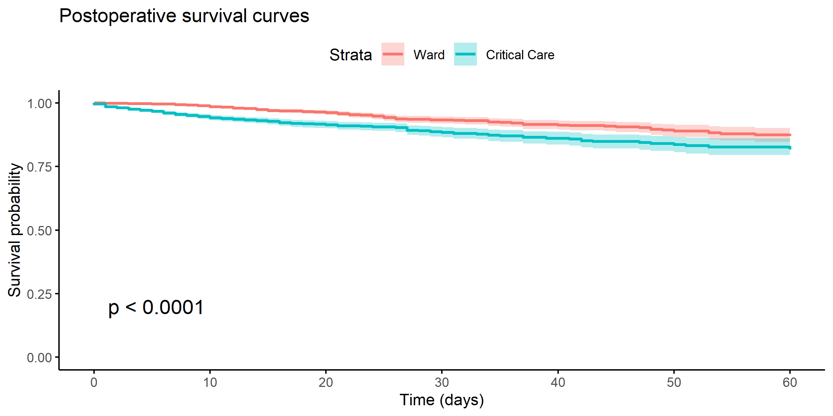

Figure 5‑15: Kaplan-Meier curves of patient survival, stratified by immediate postoperative admission to critical care versus postoperative admission to the ward. Survival was lower in the sub-group that was admitted immediately to critical care after surgery (log-rank test p <0.001).

The mortality rate in the 156 patients admitted critical care at a later date following surgery (the so-called “failure to rescue” group) was high (n = 24 [8.4%]). However, patients who were admitted to critical care immediately postoperatively, who then subsequently required readmission to critical care had a lower 30-day inpatient mortality (n = 4 [3.1%]) than those who were not initially admitted to critical care immediately postoperatively, but subsequently required critical care at a later time-point during their stay (n = 20 [12.8%], p = 0.010).

Table 5‑12: Failures to rescue. Mortality in patients subsequently admitted to critical care for treatment of complications, stratified by whether they were admitted to critical care immediately on the day of surgery.

|  |  |  |  |
| --- | --- | --- | --- |
|  | Immediate Ward Admission | Immediate Critical Care Admission | p |
| **n** | 156 | 130 |  |
| **Death within 30 days of surgery despite later critical care admission (%)** | 20 (12.8) | 4 (3.1) | 0.006 |

Tabulating the mortality rates within strata of risk as predicted using each risk tool, the majority of deaths within 30-days of surgery occurred within the small minority of patients with high predicted risk (≥5% predicted mortality) (Table 5-13).

Table 5‑13: 30-day mortality by risk strata as predicted using SORT, SRS and P-POSSUM.

|  |  |  |  |  |  |  |  |
| --- | --- | --- | --- | --- | --- | --- | --- |
|  |  | <1% | 1% to 2.4% | 2.5% to 4.9% | 5% to 9.9% | 10% to 49.9% | ≥50% |
| **SORT** | **n** | 19053 | 2863 | 1650 | 1515 | 1095 | 40 |
| **30-day deaths (%)** | 23 (0.1) | 27 (0.9) | 33 (2.0) | 87 (5.7) | 128 (11.7) | 19 (47.5) |
| **SRS** | **n** | 10012 | 6336 | 4826 | 2753 | 1991 | 298 |
| **30-day deaths (%)** | 12 (0.1) | 21 (0.3) | 47 (1.0) | 57 (2.1) | 123 (6.2) | 57 (19.1) |
| **P-POSSUM** | **n** | 12870 | 6499 | 2953 | 1772 | 1836 | 286 |
| **30-day deaths (%)** | 11 (0.1) | 24 (0.4) | 34 (1.2) | 40 (2.3) | 139 (7.6) | 69 (24.1) |

The postoperative survival of patients (unadjusted) differed across the three countries (Figure 5-16).

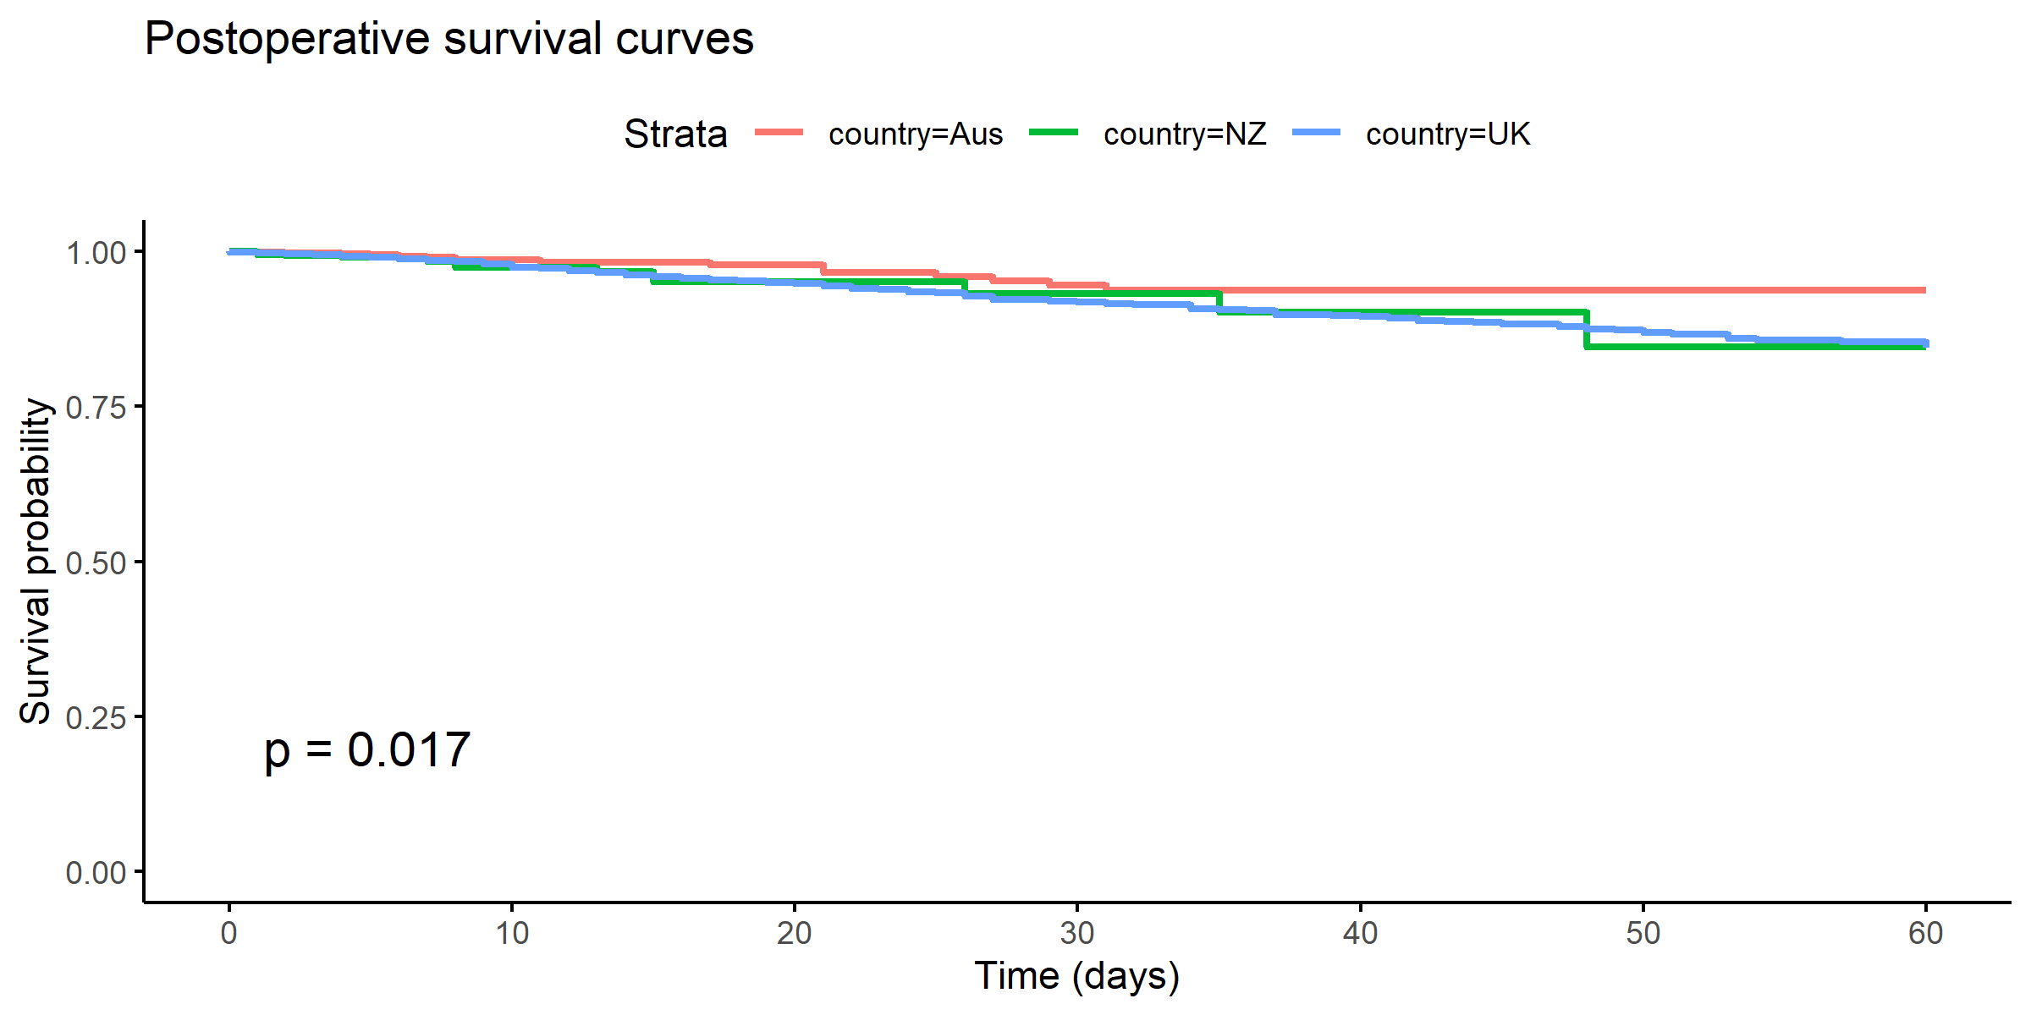

Figure 5‑16: Kaplan-Meier curves of patient survival, stratified by country. Unadjusted survival was higher in patients from Australia (log-rank test p = 0.017), which may be due to differences in case-mix or other confounding factors.

## Discussion

### Principal Findings

Patient-level data was collected in a large number of patients across multiple centres in the UK, Australia and New Zealand, representing a wide range of surgical specialties and heterogenous mix of elective and emergency cases.

In this large prospective cohort of patients undergoing inpatient surgery, the overall inpatient mortality was low (30-day mortality = 1.2%, 60-day mortality = 1.4%). The overall incidence of POMS-defined morbidity at Day 7 post-surgery was 13.9% (or 65.3% of the patients who remained in hospital on Day 7).

A minority (11.5%) of patients were admitted to critical care immediately after surgery, and a smaller proportion (1.1%) of patients were admitted to critical care later on in their hospital stay for further management. Patients who had immediate postoperative to critical care admission had higher incidences of postoperative morbidity and mortality, and longer postoperative lengths of stay than patients who were not immediately admitted. Patients who required rescue critical care at a later timepoint during their hospital stay, after not initially being admitted to critical care immediately following surgery, had higher 30-day mortality than patients who were immediately admitted to critical care after their operation.

ASA-PS I and II patients formed the majority of the cohort (69.1%). Computing preoperative predicted risks using a selection of previously-validated risk prediction tools, the proportion of patients considered “high-risk” (predicted mortality ≥5%) ranged from 10.1% to 19.2%) depending on the tool used for the calculation. However, regardless of the prediction tool used, the proportion of high-risk patients admitted to critical care immediately following surgery was consistently low — only around a third of those with ≥5% mortality as predicted using each risk tool were received immediate admission to critical care.

### Comparison with other surgical cohorts in the literature

Similar to previous studies, a small proportion of predicted high-risk patients accounted for a large proportion of the mortality in the cohort (13–15,57,58,61,153,154). While, approximately 10% of patients had a ≥5% predicted risk of death as calculated using SORT, over 70% of the deaths in the cohort came from this subgroup.

In other heterogenous international surgical cohorts, reported mortality rates vary from as low as 0.4% in the Measurement of Exercise Tolerance before Surgery (METS) study, to as high as 4.0% in the European Surgical Outcomes Study, with significant variation exhibited between countries of different income and economic development (14,15,155,156). Identifying studies in populations more similar to this cohort, the mortality rates reported in the literature showed a narrower range, perhaps more comparable to this cohort — for example, Abbott *et al* estimated a 1.1% to 2.8% in UK patients undergoing surgery between 2009 and 2014 using a large retrospective administrative dataset (10); the Determining Surgical Complications in the Overweight (DISCOVER) study reported a 2.9% 30-day mortality in a higher risk surgical population undergoing major gastrointestinal and liver surgery in the UK and Ireland (59); Gillies *et al* found a 0.8% mortality rate in Scottish surgical (excluding neurosurgery and cardiac surgery) inpatients between 2005 and 2007 (61). Therefore, mortality findings in this cohort appear to be consistent with estimates of postoperative death after surgery in other studies.

The morbidity rate found in the SNAP-2: EPICCS cohort using POMS definitions for postoperative complications (13.94%) was slightly lower than the complication rate of 16.8% reported in ISOS, but similar to that reported in METS (15,155). While mortality is unarguably important, equally important morbidity outcomes are comparatively infrequently-reported in perioperative studies, and suffer from lack of standardisation/consensus (157). Although the criteria for defining complications in this cohort are not the same as those used in ISOS and METS — the former used a list of conditions, broken down into “Infectious”, “Cardiovascular” and “Other” complications; while the latter used a list of diagnoses including non-fatal cardiac arrest, heart failure, stroke/transient ischaemic attack, respiratory failure, pneumonia, surgical site infection, deep vein thrombosis/pulmonary embolism, unexpected critical care admission or need for reoperation — they are not so drastically different from POMS definitions to render estimates reported within this chapter entirely incomparable (147,148).

Unadjusted outcomes for patients who were admitted directly to critical care after surgery in this SNAP-2: EPICCS cohort were worse than those patients who were recovered on the general surgical ward immediately postoperatively. This replicates the findings in numerous previous studies reporting poorer outcomes in patients receiving immediate postoperative critical care (14,55,56,58,59,61,158). The explanation offered in all these observational studies for the poorer outcomes in the immediate critical care admission group is the likely presence of residual confounding by indication due to strong selection bias that exists for higher-risk patients being admitted to critical care.

### Low admission rates to critical care for high-risk patients

The proportion of patients admitted immediately to critical care after surgery has previously been estimated as being as low as 0.8% in a Scottish cohort (Gillies *et al*) to as high as 37.8% in the UK and Irish DISCOVER cohort (14,15,59,61,159). The variation that exists in the literature is likely due to the differences in the cohorts studied, and geographical variations in the availability of critical care resources (57). For example, the DISCOVER cohort, where more than a third of patients studied were admitted to critical care, consisted mainly of patients undergoing major gastrointestinal and liver surgery which may represent a higher risk patient group where more protocolised care exists.

In this cohort, the proportion of high-risk patients who were admitted to critical care directly after surgery was found to be low, regardless of the tool used for mortality prediction. This finding suggests that little has changed in the last decade to identify the right patients to admit to high-intensity care postoperatively, despite the published recommendations (35–37). There may be a number of reasons for this discrepancy, which have been discussed in earlier chapters. These include the lack of capacity for critical care, clinicians not accurately identifying high-risk patients, or other factors.

Although postoperative critical care admission guidance exists in the UK, and not in Australia or New Zealand, it was interesting to find that the rates of admission to critical care for the ≥5% mortality risk group was higher in Australasia than in the UK. This may be a function of increased proportion of critical care beds in the hospitals in Australia and New Zealand, compared to the UK, a finding reported in the previous chapter. Another explanation for this finding may be that clinicians in Australasia are better at anticipating patient risks than in the UK and therefore appropriately admit high-risk patients to critical care. However, these possible explanations will need to be tested later in this thesis.

Therefore, in subsequent chapters, I will examine the accuracy of clinician risk assessments, and compare subjective risk prediction performance against the previously-validated objective risk prediction tools. I will then construct a higher-performing model for perioperative risk, which takes into account information from both subjective clinician assessment and the best-performing risk tool, in order to 1) improve on estimates of the effect of critical care on outcomes, 2) quantify the extent to which patient risk has an influence on the propensity for clinicians to recommend patients for critical care, and 3) quantify the extent to which patient risk has an influence on the propensity for patients to ultimately receive critical care after accounting for whether they actually received a clinician recommendation for critical care admission.

### Summary

In this chapter I presented the epidemiology of inpatient surgery in a representative and generalisable sample of UK, Australian and New Zealand patients. The baseline risk profiles of this large international cohort are comparable to previous heterogenous surgical cohorts in the literature. Direct critical care admission rates in this cohort have been described. In this cohort, 11.5% were admitted immediately to critical care after surgery. Admission to critical care for high-risk patients was low, regardless of the risk prediction tool used, with only around a third of patients with ≥5% predicted mortality directly admitted. Unadjusted outcomes (postoperative length of stay, morbidity and mortality) in this cohort reflect the findings of other similar published observational studies. Overall 30-day and 60-day mortality in the cohort was 1.2% and 1.4%, respectively.

Further work in the subsequent chapters of this thesis will focus on additional analyses using data from this described cohort to refine risk-adjusted outcome estimates of the effect of immediate critical care admission and estimates of the propensity for patients to receive a clinician recommendation for critical care and eventual admission to critical care.

##### PAGE BREAK

# Predicting Risk in Inpatient Surgery

National and international guidelines in perioperative care recommend that the estimation of clinical risk should guide treatment decisions during a patient’s surgical pathway (36,160). When a patient has been identified as high-risk, admission to postoperative critical care might serve to improve patient outcomes (29). Decisions to directly admit patients to critical care after surgery based on their perceived risk can have substantial impact on individual patients: either through exposing them to increased intensity of medical interventions and increased invasive monitoring with their own associated complications, or through preventing the development of deleterious complications which may impact on longer-term health and quality of life. These decisions may also have wider implications on healthcare systems: for example, critical care is a finite resource, with competition for beds between surgical and emergency medical admissions; to that end, the lack of availability of a postoperative critical care bed is a risk factor for last-minute cancellation, which brings with it adverse consequences for both patients and the healthcare providers (111). Thus, there is a need to accurately stratify patient risk, so as to make the most of limited resources and improve perioperative outcomes.

There are numerous methods available to help clinicians estimate perioperative mortality risk, including frailty indices (161,162), measures of functional capacity such as the Duke Activity Status Index and cardiopulmonary exercise testing (103,163), and dozens of risk prediction scores and models (84). Of these, the Physiological and Operative Score for the enUmeration of Mortality and Morbidity (POSSUM) and its Portsmouth variant (P-POSSUM), both developed for predicting risks in heterogenous surgical cohorts, remain among the most widely validated in international patient cohorts (144,145). Other less well-known tools such as the Surgical Risk Scale (SRS) and the Surgical Outcome Risk Tool (SORT) are also available for routine clinical use (21,143,146).

Despite the myriad of available choices, the extent to which risk prediction tools are used in routine clinical practice remains unclear. Further, there remains equipoise over which tool is most accurate, and in particular, how objective risk assessment compares with (and adds value to) subjective clinical assessment alone.

Therefore in this chapter, I performed an analysis using the patient data from SNAP-2: EPICCS that has been described in *Chapter 4*, with the following aims: 1) to describe the frequency and types of perioperative risk prediction tools used in routine practice in the United Kingdom (UK), Australia and New Zealand; 2) to externally validate and compare the performance of the P-POSSUM, SRS, SORT, ASA in the SNAP-2: EPICCS patient cohort; 3) to test the performance of subjective clinical assessment; and 4) to investigate whether risk prediction tools add value to subjective clinical assessment.

## Methods

The patient dataset from the Second Sprint National Anaesthesia Project: EPIdemiology of Critical Care provision after Surgery (SNAP-2: EPICCS) study described in *Chapter 4* was used in the analyses presented in this chapter. The full methodology of SNAP-2: EPICCS was previously reported in *Chapter 2*, but as a reminder, patients were recruited from hospitals in the UK, Australia and New Zealand via established research networks. All patients undergoing inpatient surgery (defined as a procedure requiring the care of an anaesthetist and requiring an overnight stay in hospital) during a one-week period were eligible, and patients were recruited between 21–27 March 2017 in the UK, 21–27 June 2017 in Australia, and 6–13 September 2017 in New Zealand.

### Data Variables

Patient demographic and perioperative variables were prospectively collected by clinicians providing routine clinical care at the time of surgery. Within these collected data were variables which comprise the predictor covariates for the following previously-validated risk prediction models: the American Society of Anesthesiologists Physical Status score (ASA-PS), the Portsmouth-Physiology and Operative Severity Score for the enUmeration of Mortality (P-POSSUM), Surgical Risk Scale (SRS), and Surgical Outcome Risk Tool (SORT) (142,143,145,146). Additionally, surgical and anaesthesia teams were asked preoperatively to predict their patients’ mortality risk with the following question, “*What is the estimate of the perioperative team of the risk of death within 30 days?*”; the possible responses to this question were 6 ordered categorical options (<1%, 1–2.5%, 2.6–5%, 5.1–10%, 10.1–50%, and >50% risk of 30-day mortality). Perioperative teams were then asked to record how they arrived at this estimate, whether based on clinical judgement alone, or in conjunction with one or more other formal risk assessment tools. Inpatient 30-day mortality was the primary outcome for this analysis, recorded by local clinical teams who followed-up each patient after surgery.

### Statistical Analysis

Descriptive statistics of the patients recruited, and a breakdown of the tools used by clinicians in making risk predictions are reported. Three inferential analyses were then performed: the first using the entire patient dataset, and the second and third omitting the patients in whom an objective risk assessment tool was used to predict perioperative risk (Figure 6-1, data flow diagram). For the first analysis, an external validation of the ASA-PS, P-POSSUM, SRS and SORT risk prediction tools was conducted. The second analysis, the performance of subjective clinical assessment (defined as either using clinical judgement and/or ASA-PS scoring) was compared against the best performing risk tool identified within the preceding step. In the third analysis, the added value of combining subjective clinical assessment with the best performing risk tool was evaluated, by constructing a logistic regression model with predictor variables from both sources.

#### External validation of existing risk prediction models

Predicted risks of postoperative mortality for all patients in the dataset were computed using P-POSSUM, SRS and SORT. The performance of each model for predicting mortality risk in the international patient sample was assessed on calibration and discrimination in accordance with the Transparent Reporting of a multivariable prediction model for Individual Prognosis Or Diagnosis (TRIPOD) recommendations (164). Calibration of the risk model predictions were then assessed by plotting observed mortality proportions against predicted probabilities, calculating the calibration slope, and by the Hosmer-Lemeshow goodness-of-fit test (165,166). Discrimination was assessed by calculating the area under the Receiver Operating Characteristic curve (AUROC) for each model (167). AUROC values were compared using DeLong’s test for two correlated ROC curves (168).

#### Defining and evaluating subjective clinical assessment

For the second analysis, only patients in whom subjective clinical assessment alone was used to predict the risk of 30-day mortality were included. Subjective clinical assessment was defined as either clinical judgement (as recorded on the CRF), or ASA-PS grading used alone, or in combination with each other. Subjective clinical assessment was then evaluated on calibration and discrimination. Point estimates of risk prediction were taken as the mid-point of the predicted risk intervals provided by clinicians (i.e. 0.5% for the interval <1%, 1.75% for the interval 1–2.5%, 3.75% for the interval 2.6–5%, and so on), and the proportion of observed mortality in each of these risk categories was calculated. Calibration was then assessed graphically by plotting the observed mortality proportions against the mid-points of clinician predicted risk intervals. The performance subjective clinical assessment was then compared against the performance of the best performing risk prediction model, using AUROC, the continuous net reclassification improvement statistic (NRI),[29] Brier Score and Nagelkerke’s (165).

#### Modelling combined information from subjective clinical assessments and risk prediction tools

For the third analysis, a logistic regression model was fitted with two variables: the subjective clinical assessment of risk, and the mortality prediction from the risk prediction tool, according to the following logit formula: $ln(R∕(1-R))=β_{0}+β_{1}X_{subjective}+β_{2}X_{objective}$, where $R$ is the probability of 30-day mortality, $β_{0},β_{1},β_{2}$ are the model coefficients, $X_{subjective}$ is the subjective clinical assessment (6 ordered categories, as above), and $X_{objective}$ is the risk of mortality as predicted using best performing risk prediction model. The latter was performed to investigate whether clinical assessments could be improved using the added information provided by risk models. A bootstrapped internal validation of this combined model with 1,000 repetitions was performed to obtain optimism-corrected estimates of its performance (164,170). The performance of this model was then separately compared to the performance of subjective assessment and the best performing risk model alone.

This process was then repeated with two further models fitted as above, but with the component predictor variables of the best performing risk prediction model as independent predictor variables with and without the variable for subjective clinical assessment, i.e. according to the following formula $ln(R∕(1-R))=β_{0}+β_{1}X_{objective_1}+...+β_{n}X_{objective_n}++β_{n+1}X_{subjective}$, where $β_{0},β_{1},β_{2},...,β_{n},β_{n+1}$ are the model coefficients, and $X_{objective_1},...,X_{objective_n}$ are the component predictor variables from the best performing objective model. The performance of these two further models were then compared to determine if the addition of subjective clinical assessment added value to the prediction.

A final model was then chosen from this process on the basis of clinical applicability and best performance.

#### Missing data

To predict risk using P-POSSUM, physiological data variables categorised into ranges are required (e.g. blood biochemistry, haematological tests). However, many patients deemed clinically fit for surgery routinely present to their operations without having undergone blood test investigations preoperatively (171). Therefore, in cases where physiological data were missing for P-POSSUM risk variables, normal physiological ranges were imputed. After imputing data in this way, analysis was performed on all cases bar those with missing data for the remaining variables, as the proportion of cases with missing data in the remaining variables was deemed to be low (1.08% of total cases) (172).

#### Sensitivity analyses

Three sensitivity analyses were performed. In the first, the analyses were repeated in a sub-group of high-risk patients, defined according to previously published criteria based on age, type of surgery and clinical risk factors (103). Second, the impact on subjective clinical assessment accuracy of using objective risk tools was evaluated, by computing the performance (discrimination, calibration) of subjective clinical assessment in the sub-group of patients whose risk estimates were not solely informed by clinical judgement. Third, the analyses were each repeated in the UK and Australian/NZ cohorts separately to investigate the potential for geographical influences in patient profiles and clinical practice on the results.

## Results

### Patient cohort

A full description of the patient cohort characteristics have been presented in *Chapter 4* and 5. After imputing normal range values for missing P-POSSUM physiology predictors, 26,216 (98.9%) cases had complete data for the remaining variables and were used for external validation of the P-POSSUM, SRS and SORT risk prediction models (Figure 6-1). There were 317 deaths within 30 days of surgery (1.2%). Table 6-1 summarises the characteristics for the patients included in the analyses presented in this chapter, stratified by 30-day mortality.

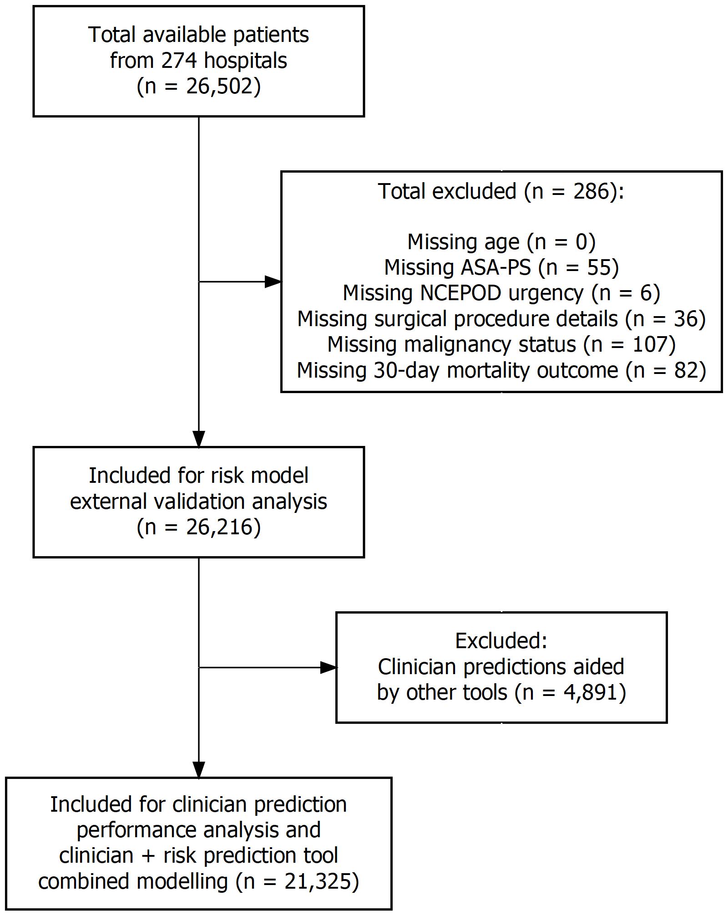

Figure 6‑1: STROBE flow diagram of patients included and excluded from this analysis.

Table 6‑1: Baseline patient demographics stratified by 30-day mortality. For surgical specialty classifications: ‘GI’ includes colorectal, upper gastrointestinal tract, bariatric and hepato-pancreato-biliary surgery, and ‘Other’ includes solid organ transplants, ophthalmic, plastic, maxillofacial/dental, ear-nose-throat, endocrine and breast surgery, as well as interventional radiology, interventional cardiology and endoscopic procedures requiring anaesthetic support.

|  |  |  |  |
| --- | --- | --- | --- |
|  | Overall | Alive at 30 days | Died within 30 days |
| **n** | 26216 | 25899 | 317 |
| **Male (%)** | 10676 (40.7) | 10486 (40.5) | 190 (59.9) |
| **Age (median [IQR])** | 57 [37, 72] | 57 [37, 71] | 76 [64, 83] |
| **Operative Urgency (%)** |  |  |  |
| Elective | 13469 (51.4) | 13437 (51.9) | 32 (10.1) |
| Expedited | 3596 (13.7) | 3555 (13.7) | 41 (12.9) |
| Urgent | 7802 (29.8) | 7645 (29.5) | 157 (49.5) |
| Immediate | 1349 ( 5.1) | 1262 ( 4.9) | 87 (27.4) |
| **ASA-PS Grade (%)** |  |  |  |
| I | 6439 (24.6) | 6435 (24.8) | 4 ( 1.3) |
| II | 11672 (44.5) | 11648 (45.0) | 24 ( 7.6) |
| III | 6696 (25.5) | 6576 (25.4) | 120 (37.9) |
| IV | 1339 ( 5.1) | 1208 ( 4.7) | 131 (41.3) |
| V | 70 ( 0.3) | 32 ( 0.1) | 38 (12.0) |
| **Surgical Severity (%)** |  |  |  |
| Minor | 2120 ( 8.1) | 2088 ( 8.1) | 32 (10.1) |
| Intermediate | 4897 (18.7) | 4850 (18.7) | 47 (14.8) |
| Major | 10507 (40.1) | 10398 (40.1) | 109 (34.4) |
| Xmajor | 5287 (20.2) | 5224 (20.2) | 63 (19.9) |
| Complex | 3405 (13.0) | 3339 (12.9) | 66 (20.8) |
| **Surgical Specialty (%)** |  |  |  |
| GI | 4472 (17.1) | 4384 (16.9) | 88 (27.8) |
| Gynaecology-Urology | 4309 (16.4) | 4297 (16.6) | 12 ( 3.8) |
| Neuro-Spine | 1208 ( 4.6) | 1181 ( 4.6) | 27 ( 8.5) |
| Obstetric | 3578 (13.7) | 3578 (13.8) | 0 ( 0.0) |
| Orthopaedic | 6772 (25.8) | 6688 (25.8) | 84 (26.5) |
| Cardiothoracic | 1033 ( 3.9) | 1015 ( 3.9) | 18 ( 5.7) |
| Vascular | 674 ( 2.6) | 645 ( 2.5) | 29 ( 9.1) |
| Other | 4163 (15.9) | 4104 (15.9) | 59 (18.6) |
| **Coronary Artery Disease (%)** | 3032 (11.6) | 2926 (11.3) | 106 (33.4) |
| **Congestive Cardiac Failure (%)** | 897 ( 3.4) | 843 ( 3.3) | 54 (17.0) |
| **Metastatic Cancer (%)** | 825 ( 3.1) | 799 ( 3.1) | 26 ( 8.2) |
| **Dementia (%)** | 676 ( 2.6) | 644 ( 2.5) | 32 (10.1) |
| **COPD (%)** | 1957 ( 7.5) | 1911 ( 7.4) | 46 (14.5) |
| **Pulmonary Fibrosis (%)** | 180 ( 0.7) | 173 ( 0.7) | 7 ( 2.2) |
| **Diabetes (%)** |  |  |  |
| Type 1 | 301 ( 1.1) | 292 ( 1.1) | 9 ( 2.8) |
| Type 2 (diet controlled) | 734 ( 2.8) | 718 ( 2.8) | 16 ( 5.0) |
| Type 2 (insulin controlled) | 850 ( 3.2) | 832 ( 3.2) | 18 ( 5.7) |
| Type 2 (non-insulin glucose lowering drug controlled) | 1647 ( 6.3) | 1599 ( 6.2) | 48 (15.1) |
| Non-diabetic | 22670 (86.5) | 22444 (86.7) | 226 (71.3) |
| **Liver Cirrhosis (%)** | 225 ( 0.9) | 207 ( 0.8) | 18 ( 5.7) |
| **Renal Disease (%)** | 381 ( 1.5) | 362 ( 1.4) | 19 ( 6.0) |
| **Postoperative Length of Stay (median [IQR])** | 2 [1, 5] | 2 [1, 5] | 7 [2, 13] |
| **SORT-predicted probability mortality risk (median [IQR])** | 0.00 [0.00, 0.01] | 0.00 [0.00, 0.01] | 0.09 [0.04, 0.21] |
| **P-POSSUM-predicted probability mortality risk (median [IQR])** | 0.01 [0.01, 0.03] | 0.01 [0.01, 0.03] | 0.18 [0.06, 0.42] |
| **SRS-predicted probability mortality risk (median [IQR])** | 0.02 [0.01, 0.04] | 0.02 [0.01, 0.04] | 0.20 [0.04, 0.36] |
| **Clinical assessment of mortality risk only (%)** | 21325 (81.3) | 21136 (81.6) | 189 (59.6) |

Multiple methods were used to estimate patient risk preoperatively (Table 6-2); however, in most cases subjective clinical assessment alone was used (n = 21,325, 81.3%).

Table 6‑2: Breakdown of information sources used by clinician in estimating 30-day mortality. Clinical teams could select one or more categories, percentages (in parentheses) therefore do not sum to 100%.

|  |  |
| --- | --- |
|  | Overall |
| **n** | 26216 |
| **Clinical Judgement (%)** | 23540 (89.8) |
| **ASA-PS Score (%)** | 9928 (37.9) |
| **Duke Activity Status Index or other activity index (%)** | 547 ( 2.1) |
| **Six-minute walk test or incremental shuttle walk test (%)** | 50 ( 0.2) |
| **Cardiopulmonary Exercise Testing (%)** | 217 ( 0.8) |
| **Formal frailty assessment (e.g. Edmonton Frail Scale) (%)** | 48 ( 0.2) |
| **Surgical Risk Scale (%)** | 340 ( 1.3) |
| **Surgical Outcome Risk Tool (%)** | 764 ( 2.9) |
| **EuroSCORE (%)** | 444 ( 1.7) |
| **POSSUM (%)** | 294 ( 1.1) |
| **P-POSSUM (%)** | 1410 ( 5.4) |
| **Surgery specific POSSUM (e.g. Vasc-POSSUM) (%)** | 193 ( 0.7) |
| **Other risk scoring system (%)** | 669 ( 2.6) |

### External validation of existing risk prediction models

SORT was the best-calibrated of the models externally validated in this analysis, however all tended to overpredict risk (Figures 6-2A to 6-2C). The Hosmer-Lemeshow test showed a significant deviation from the line of unity for all three models (p-values all <0.001 for SORT, P-POSSUM, and SRS). All models exhibited good-to-excellent discrimination (Figure 6-2D). SORT performed the best with an AUROC of 0.91 (95% confidence interval: 0.90–0.93), followed by P-POSSUM (AUROC = 0.90, 95% CI: 0.88–0.92), and SRS (AUROC = 0.85, 95% CI: 0.83–0.88). The AUROC for SORT was significantly better than SRS (p <0.001), but not P-POSSUM (p = 0.120).

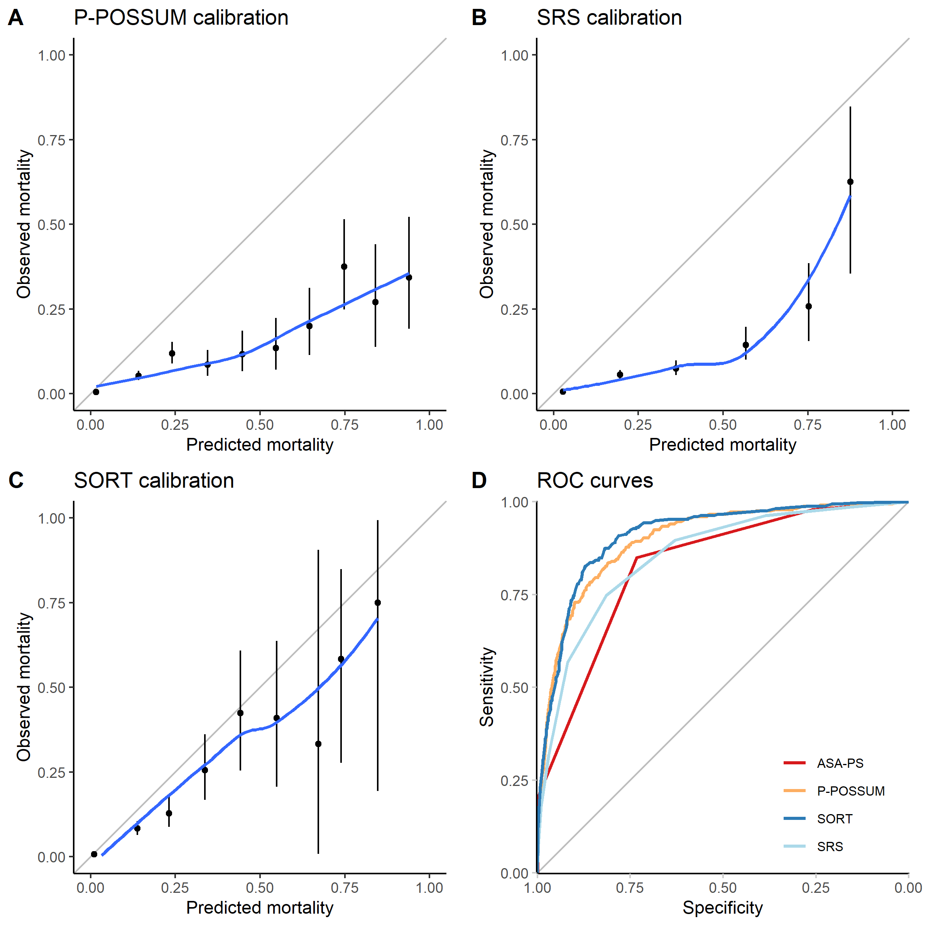

Figure 6‑2: Calibration plots for SORT (A), P-POSSUM (B), SRS (C), and Receiver Operating Characteristic (ROC) curves for the three models (D). In the calibration plots (A-C), non-parametric smoothed best-fit curves (blue) are shown along with the point-estimates for predicted vs. observed mortality (black dots) and their 95% confidence intervals (black lines) within each decile of predicted mortality. External validation of all three models were performed on the entire patient dataset.

### Subjective clinical assessment

There were 189 deaths (0.89%) within 30-days of surgery in the subset of 21325 patients who had mortality estimates based on clinical judgement and/or ASA-PS grading alone. Subjective clinical assessment tended to overpredict risk on calibration plot analysis (Figure 6-3A, Hosmer-Lemeshow test p <0.001). Subjective clinical assessment also demonstrated good discrimination (Figure 6-3B and Table 6-3, AUROC = 0.89, 95% CI: 0.87–0.92), which was not significantly different to SORT (95% CI for difference in AUROC: -0.02 to -0.01, p = 0.22). Continuous NRI analysis did not show improvement in classification when using SORT risk predictions compared to subjective clinical assessment (Table 6-3), i.e. the proportion of patients that were correctly reclassified (reclassified as higher risk and going on to die, or reclassified as lower risk and going on to survive) was not significantly different from the proportion incorrectly reclassified (reclassified as higher risk but going on to survive, or reclassified as lower risk but going on to die).

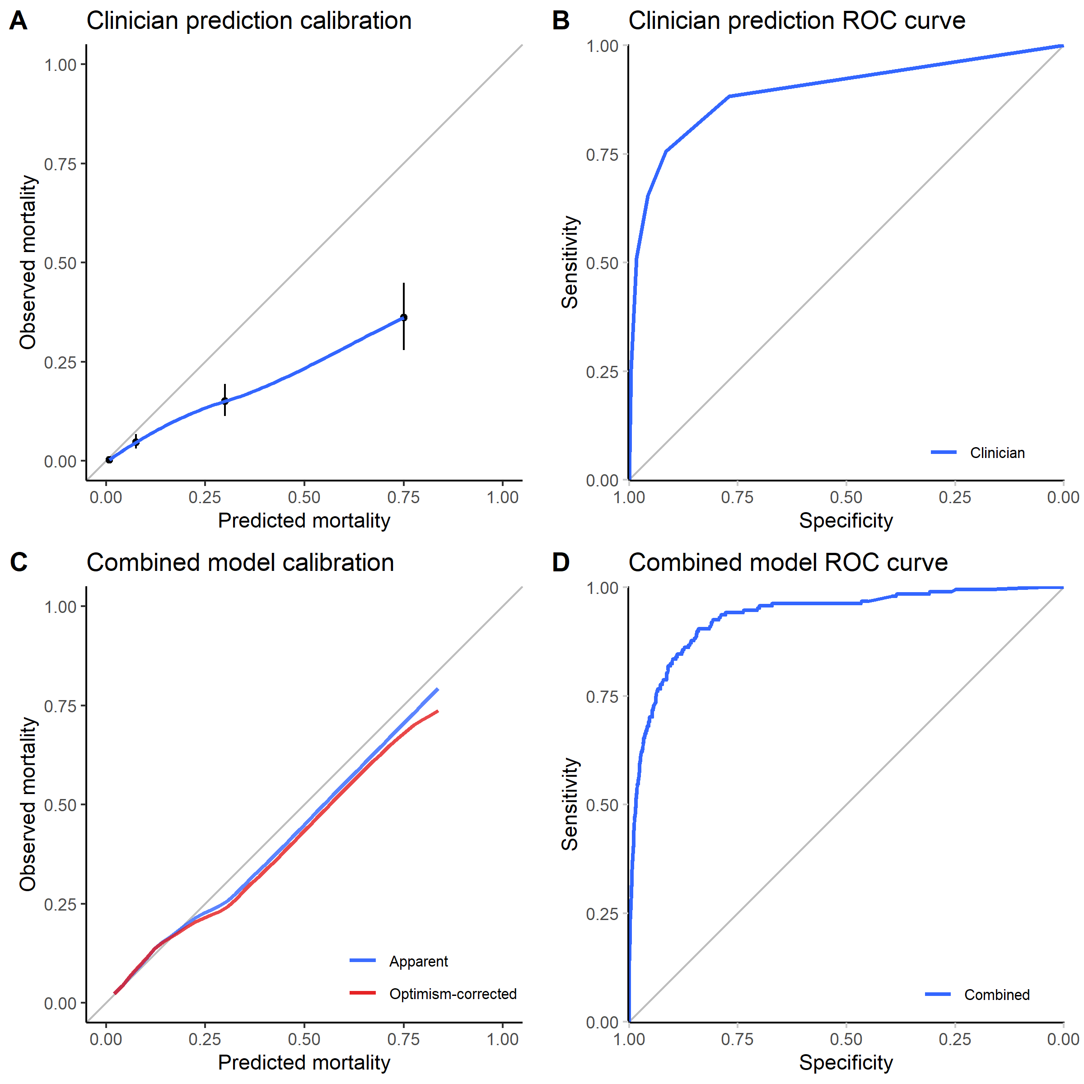

Figure 6‑3: Calibration plots and Receiver Operating Characteristic (ROC) curves for subjective Clinician Assessments (A, B) and the final chosen logistic regression model combining Clinician Assessments and component SORT variables (C, D), validated on the subset of patients in whom clinicians estimated risk based on clinical judgement alone (n = 12,802). For (A), a non-parametric smoothed best-fit curve (blue) is shown along with the point-estimates for predicted vs. observed mortality (black dots) and their 95% confidence intervals (black lines) within each range of clinician predicted mortality. For (C), the apparent (blue) and optimism-corrected (red) non-parametric smoothed calibration curves are shown, the latter was generated from 1,000 bootstrapped resamples of the dataset.

Table 6‑3: Performance metrics for Clinician Assessment versus: 1) SORT risk prediction, 2) a logistic regression model combining Clinician Assessment and SORT prediction, 3) SORT risk prediction with coefficients refitted to the current dataset (SORT-refitted), and 4) a logistic regression model combining Clinician Assessment and refitted SORT coefficients (Combined-refitted). Performance metrics were computed based on the subset of patients in whom clinician judgement alone was used to estimate risk (n = 21,325). The reported AUROC for the combined models (Combined and Combined-refitted) are the optimism-corrected value from bootstrapped internal validation. The final chosen model was Combined-refitted based on its superior performance.

|  |  |  |  |  |  |  |  |  |
| --- | --- | --- | --- | --- | --- | --- | --- | --- |
| Model | AUROC | 95% CI of AUROC | p | NRI | 95% CI of NRI | p | Brier score | R2 |
| **Clinician** | 0.894 | 0.867 to 0.922 | - | - | - | - | 0.0089 | 0.225 |
| **SORT** | 0.911 | 0.889 to 0.933 | 0.216 | 0.103 | -0.032 to 0.238 | 0.134 | 0.0081 | 0.268 |
| **Combined** | 0.929 | 0.910 to 0.948 | <0.001 | 0.131 | 0.059 to 0.204 | <0.001 | 0.0075 | 0.342 |
| **SORT-refitted** | 0.915 | 0.893 to 0.937 | 0.520 | 0.520 | 0.390 to 0.651 | <0.001 | 0.0077 | 0.324 |
| **Combined-refitted** | 0.935 | 0.915 to 0.954 | <0.001 | 0.347 | 0.228 to 0.465 | <0.001 | 0.0074 | 0.367 |

### Combining subjective and objective risk assessment

Bootstrapped internal validation yielded an optimism-corrected AUROC of 0.93 for a combined model fitted using both subjective clinical assessment and SORT predictions as independent variables, which was better than subjective assessment alone (p <0.001) and SORT alone (p = 0.020)(Table 6-3). The model calibration was better than that of SORT or subjective clinical assessment alone, as assessed visually using the optimism-corrected calibration curve. The model also resulted in significantly improved reclassification compared to subjective clinical assessment alone in continuous NRI analysis (p <0.001).

A refitted SORT model yielded an AUROC of 0.92, which was not significantly different to the original SORT model (p = 0.74) and exhibited similar calibration. The addition of subjective clinical assessment to this refitted SORT model showed that subjective assessment again improved predictions over using objective variables alone (Table 6-3). The final model chosen (Table 6-4, Combined-refitted) was the model with highest performance. The final model exhibited a Bootstrap optimism-corrected AUROC of 0.93, and was better than subjective assessment alone (p <0.001). The final model calibration was good, as assessed visually using the optimism-corrected calibration curve. Using continuous NRI analysis, the model also resulted in significantly improved reclassification compared to subjective clinical assessment alone (p <0.001), and compared to SORT alone (with refitted coefficients) (p <0.001).

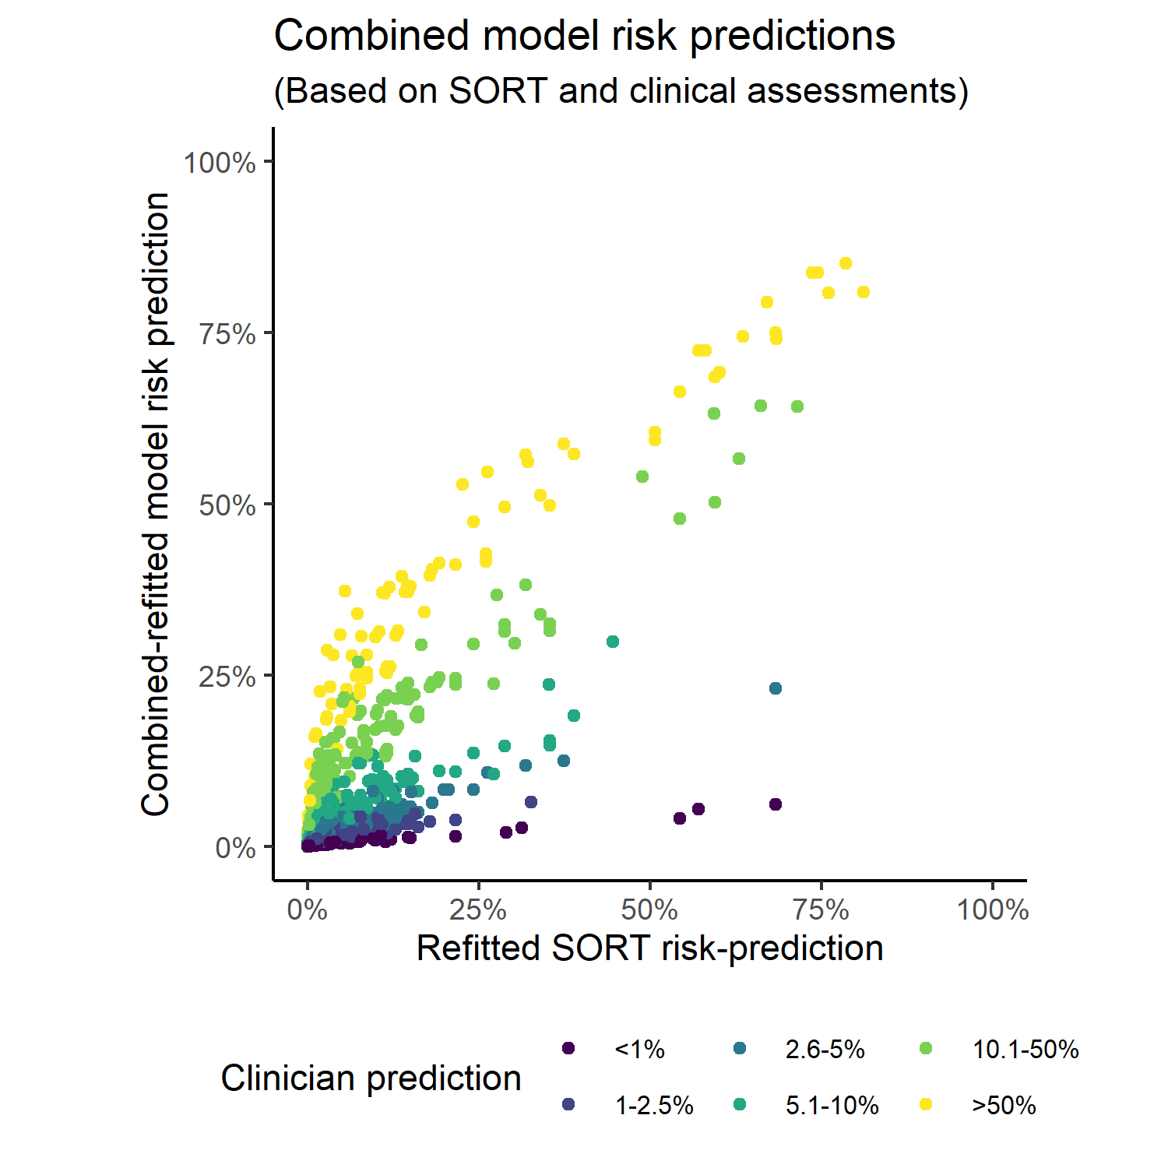

Figure 6‑4: Predicted risks from combined model, stratified by clinical assessments. The changes to risk predictions (y-axis) based on subjective clinical assessments (coloured lines) as SORT-predicted risks (x-axis) change was modelled, to illustrate the change in risk predictions if information from both are combined.

The effect of combining information from subjective clinical assessment and SORT can be demonstrated by computing the conditional probabilities of 30-day mortality using the final chosen model and plotting this against predicted mortalities using the refitted SORT model (Figure 6-4); full coefficients for the combined model are reported in Table 6-4.

Table 6‑4: Full coefficients for the risk prediction model combining subjective clinical assessment and objective risk tool information.

|  |  |  |  |  |
| --- | --- | --- | --- | --- |
| Variable | Coefficient | Std. Error | z-statistic | p |
| **Intercept** | -7.516 | 0.389 | -19.3 | <0.001 |
| **Age** |  |  |  |  |
| Age = 18 to 64 | Reference | | | |
| Age = 65 to 79 | 0.673 | 0.209 | 3.219 | 0.001 |
| Age ≥80 | 0.680 | 0.233 | 2.926 | 0.003 |
| **ASA-PS grade** |  |  |  |  |
| ASA I or II | Reference | | | |
| ASA III | 1.137 | 0.294 | 3.866 | <0.001 |
| ASA IV | 1.554 | 0.332 | 4.684 | <0.001 |
| ASA V | 3.008 | 0.478 | 6.295 | <0.001 |
| **Operative Urgency** |  |  |  |  |
| Operative Urgency = Elective | Reference | | | |
| Operative Urgency = Expedited | 0.798 | 0.313 | 2.553 | 0.011 |
| Operative Urgency = Urgent | 0.934 | 0.275 | 3.401 | <0.001 |
| Operative Urgency = Immediate | 1.649 | 0.333 | 4.955 | <0.001 |
| **High-risk surgical specialty (thoracic, gastrointestinal or vascular surgery)** | 0.389 | 0.187 | 2.076 | 0.038 |
| **Operative severity** |  |  |  |  |
| Operative severity = Minor | Reference | | | |
| Operative severity = Intermediate | 0.004 | 0.301 | 0.012 | 0.991 |
| Operative severity = Major | -0.284 | 0.281 | -1.010 | 0.313 |
| Operative severity = Xmajor | -0.539 | 0.312 | -1.729 | 0.084 |
| Operative severity = Complex | -0.586 | 0.338 | -1.736 | 0.083 |
| **Malignancy** | 0.036 | 0.251 | 0.145 | 0.885 |
| **Clinical assessment of risk** |  |  |  |  |
| Clinical assessment of risk < 1% | Reference | | | |
| Clinical assessment of risk = 1 to 2.5% | 0.974 | 0.326 | 2.987 | 0.003 |
| Clinical assessment of risk = 2.6 to 5% | 1.523 | 0.366 | 4.168 | <0.001 |
| Clinical assessment of risk = 5.1 to 10% | 2.083 | 0.355 | 5.866 | <0.001 |
| Clinical assessment of risk = 10.1 to 50% | 3.055 | 0.355 | 8.611 | <0.001 |
| Clinical assessment of risk > 50% | 3.822 | 0.392 | 9.747 | <0.001 |

### Sensitivity analyses

Three sensitivity analyses were performed to assess the robustness of our findings. Table 6-5 shows patient characteristics of the sub-cohorts used for each of the sensitivity analyses.

Table 6‑5: Sensitivity analyses. Characteristics of the patient subgroups used in all sensitivity analyses. The restricted cohort used in the first sensitivity analysis was older, had higher ASA-PS grades, higher proportions Xmajor or Complex surgery, higher incidences of comorbid disease and a higher mortality rate compared to the whole cohort of patients used in the main study analyses. The subgroup with clinical assessments made in conjunction with other tools was similar in characteristics to the whole cohort of patients used in the main analyses. The Australian and New Zealand cohort had a lower proportion of obstetric surgery (and consequently a higher proportion of males) and a higher proportion of minor/intermediate surgery, but a comparable percentage mortality.

|  |  |  |  |  |  |
| --- | --- | --- | --- | --- | --- |
|  | Overall cohort | 1: Restricted subgroup of higher risk patients | 2: Subgroup of patients with clinical assessments made in conjunction with other tools | 3: UK cohort | 3: Aus/NZ cohort |
| **n** | 26216 | 12987 | 4891 | 22789 | 3427 |
| **Male (%)** | 10676 (40.7) | 6431 (49.5) | 2407 (49.2) | 9039 (39.7) | 1637 (47.8) |
| **Age (median [IQR])** | 57 [37, 72] | 71 [61, 79] | 67 [53, 77] | 57 [37, 72] | 56 [37, 70] |
| **Operative Urgency (%)** |  |  |  |  |  |
| Elective | 13469 (51.4) | 7109 (54.7) | 2420 (49.5) | 11967 (52.5) | 1502 (43.8) |
| Expedited | 3596 (13.7) | 1899 (14.6) | 732 (15.0) | 2867 (12.6) | 729 (21.3) |
| Urgent | 7802 (29.8) | 3626 (27.9) | 1513 (30.9) | 6765 (29.7) | 1037 (30.3) |
| Immediate | 1349 ( 5.1) | 353 ( 2.7) | 226 ( 4.6) | 1190 ( 5.2) | 159 ( 4.6) |
| **ASA-PS Grade (%)** |  |  |  |  |  |
| I | 6439 (24.6) | 656 ( 5.1) | 578 (11.8) | 5794 (25.4) | 645 (18.8) |
| II | 11672 (44.5) | 6020 (46.4) | 1790 (36.6) | 10298 (45.2) | 1374 (40.1) |
| III | 6696 (25.5) | 5313 (40.9) | 1940 (39.7) | 5655 (24.8) | 1041 (30.4) |
| IV | 1339 ( 5.1) | 956 ( 7.4) | 560 (11.4) | 985 ( 4.3) | 354 (10.3) |
| V | 70 ( 0.3) | 42 ( 0.3) | 23 ( 0.5) | 57 ( 0.3) | 13 ( 0.4) |
| **Surgical Severity (%)** |  |  |  |  |  |
| Minor | 2120 ( 8.1) | 879 ( 6.8) | 250 ( 5.1) | 1749 ( 7.7) | 371 (10.8) |
| Intermediate | 4897 (18.7) | 2393 (18.4) | 653 (13.4) | 4091 (18.0) | 806 (23.5) |
| Major | 10507 (40.1) | 4042 (31.1) | 1553 (31.8) | 9241 (40.6) | 1266 (36.9) |
| Xmajor | 5287 (20.2) | 3703 (28.5) | 1186 (24.2) | 4795 (21.0) | 492 (14.4) |
| Complex | 3405 (13.0) | 1970 (15.2) | 1249 (25.5) | 2913 (12.8) | 492 (14.4) |
| **Surgical Specialty (%)** |  |  |  |  |  |
| Gastrointestinal | 4472 (17.1) | 3399 (26.2) | 1325 (27.1) | 3931 (17.3) | 541 (15.8) |
| Gynaecology-Urology | 4309 (16.4) | 2039 (15.7) | 629 (12.9) | 3886 (17.1) | 423 (12.3) |
| Neuro-Spine | 1208 ( 4.6) | 538 ( 4.1) | 180 ( 3.7) | 1002 ( 4.4) | 206 ( 6.0) |
| Obstetric | 3578 (13.7) | 0 ( 0.0) | 139 ( 2.8) | 3280 (14.4) | 298 ( 8.7) |
| Orthopaedic | 6772 (25.8) | 4262 (32.8) | 1231 (25.2) | 6053 (26.6) | 719 (21.0) |
| Cardiothoracic | 1033 ( 3.9) | 386 ( 3.0) | 609 (12.5) | 839 ( 3.7) | 194 ( 5.7) |
| Vascular | 674 ( 2.6) | 625 ( 4.8) | 224 ( 4.6) | 540 ( 2.4) | 134 ( 3.9) |
| Other | 4163 (15.9) | 1736 (13.4) | 553 (11.3) | 3252 (14.3) | 911 (26.6) |
| **Coronary Artery Disease (%)** | 3032 (11.6) | 2624 (20.2) | 1069 (21.9) | 2525 (11.1) | 507 (14.8) |
| **Congestive Cardiac Failure (%)** | 897 ( 3.4) | 751 ( 5.8) | 347 ( 7.1) | 689 ( 3.0) | 208 ( 6.1) |
| **Metastatic Cancer (%)** | 825 ( 3.1) | 622 ( 4.8) | 256 ( 5.2) | 682 ( 3.0) | 143 ( 4.2) |
| **Dementia (%)** | 676 ( 2.6) | 658 ( 5.1) | 207 ( 4.2) | 597 ( 2.6) | 79 ( 2.3) |
| **COPD (%)** | 1957 ( 7.5) | 1653 (12.7) | 583 (11.9) | 1660 ( 7.3) | 297 ( 8.7) |
| **Pulmonary Fibrosis (%)** | 180 ( 0.7) | 144 ( 1.1) | 57 ( 1.2) | 154 ( 0.7) | 26 ( 0.8) |
| **Diabetes (%)** |  |  |  |  |  |
| Type 1 | 301 ( 1.1) | 207 ( 1.6) | 48 ( 1.0) | 269 ( 1.2) | 32 ( 0.9) |
| Type 2 (diet controlled) | 734 ( 2.8) | 491 ( 3.8) | 189 ( 3.9) | 638 ( 2.8) | 96 ( 2.8) |
| Type 2 (insulin controlled) | 850 ( 3.2) | 691 ( 5.3) | 203 ( 4.2) | 645 ( 2.8) | 205 ( 6.0) |
| Type 2 (non-insulin glucose lowering drug controlled) | 1647 ( 6.3) | 1468 (11.3) | 406 ( 8.3) | 1422 ( 6.2) | 225 ( 6.6) |
| Non-diabetic | 22670 (86.5) | 10126 (78.0) | 4042 (82.7) | 19803 (86.9) | 2867 (83.7) |
| **Liver Cirrhosis (%)** | 225 ( 0.9) | 148 ( 1.1) | 62 ( 1.3) | 183 ( 0.8) | 42 ( 1.2) |
| **Renal Disease (%)** | 381 ( 1.5) | 324 ( 2.5) | 77 ( 1.6) | 284 ( 1.2) | 97 ( 2.8) |
| **Postoperative Length of Stay (median [IQR])** | 2 [1, 5] | 3 [1, 8] | 5 [2, 9] | 2 [1, 5] | 3 [1, 6] |
| **SORT-predicted probability mortality risk (median [IQR])** | 0.00 [0.00, 0.01] | 0.01 [0.00, 0.03] | 0.01 [0.00, 0.04] | 0.00 [0.00, 0.01] | 0.00 [0.00, 0.02] |
| **P-POSSUM-predicted probability mortality risk (median [IQR])** | 0.01 [0.01, 0.03] | 0.02 [0.01, 0.05] | 0.02 [0.01, 0.06] | 0.01 [0.01, 0.03] | 0.01 [0.00, 0.03] |
| **SRS-predicted probability mortality risk (median [IQR])** | 0.02 [0.01, 0.04] | 0.02 [0.01, 0.10] | 0.04 [0.02, 0.10] | 0.02 [0.01, 0.04] | 0.02 [0.01, 0.04] |
| **Inpatient deaths within 30 days (%)** | 317 ( 1.2) | 261 ( 2.0) | 128 ( 2.6) | 283 ( 1.2) | 34 ( 1.0) |

#### Sensitivity analysis 1: higher-risk patients

Applying more restrictive inclusion criteria to identify patients deemed to be “high-risk” according to criteria used in previous studies (103,173) evaluating prognostic markers yielded a sub-group of 12,987 patients in whom the 30-day mortality rate was 2.0%. Calibrations of P-POSSUM, SRS and SORT predictions were similar to the full cohort (Figure 6-5). The Hosmer-Lemeshow chi-squared goodness-of-fit test showed a significant deviation from the line of unity for all three models (p-value <0.001 for all SORT, P-POSSUM, and SRS).

All risk prediction models exhibited poorer discrimination than in the main study analysis (Figure 6-5D), however the rank order of their discrimination performance was unchanged. SORT again performed the best in this sub-group with an AUROC of 0.88 (95% confidence interval: 0.86–0.90), followed by P-POSSUM (AUROC = 0.86, 95% CI: 0.84–0.89), SRS (AUROC = 0.81, 95% CI: 0.78–0.84), and ASA-PS (AUROC = 0.75, 95% CI: 0.72–0.78).

Subjective clinical assessment in this sub-group again demonstrated a tendency to overpredict risk on calibration plot analysis (Figure 6-5E, Hosmer-Lemeshow test p <0.001). The clinician mortality predictions also demonstrated good discrimination (Figure 6-5F, AUROC = 0.85, 95% CI: 0.82–0.89) in this sub-group. The subjective assessment discrimination in this sub-group was not significantly different to the main study analysis cohort (p = 0.070).

The findings of this sensitivity analysis suggest that performance of subjective clinical assessment and all the objective risk models is poorer in a higher risk cohort. However, the relative performance of the models in comparison to each other, and in comparison, with subjective clinical assessment, was consistent with the main results.

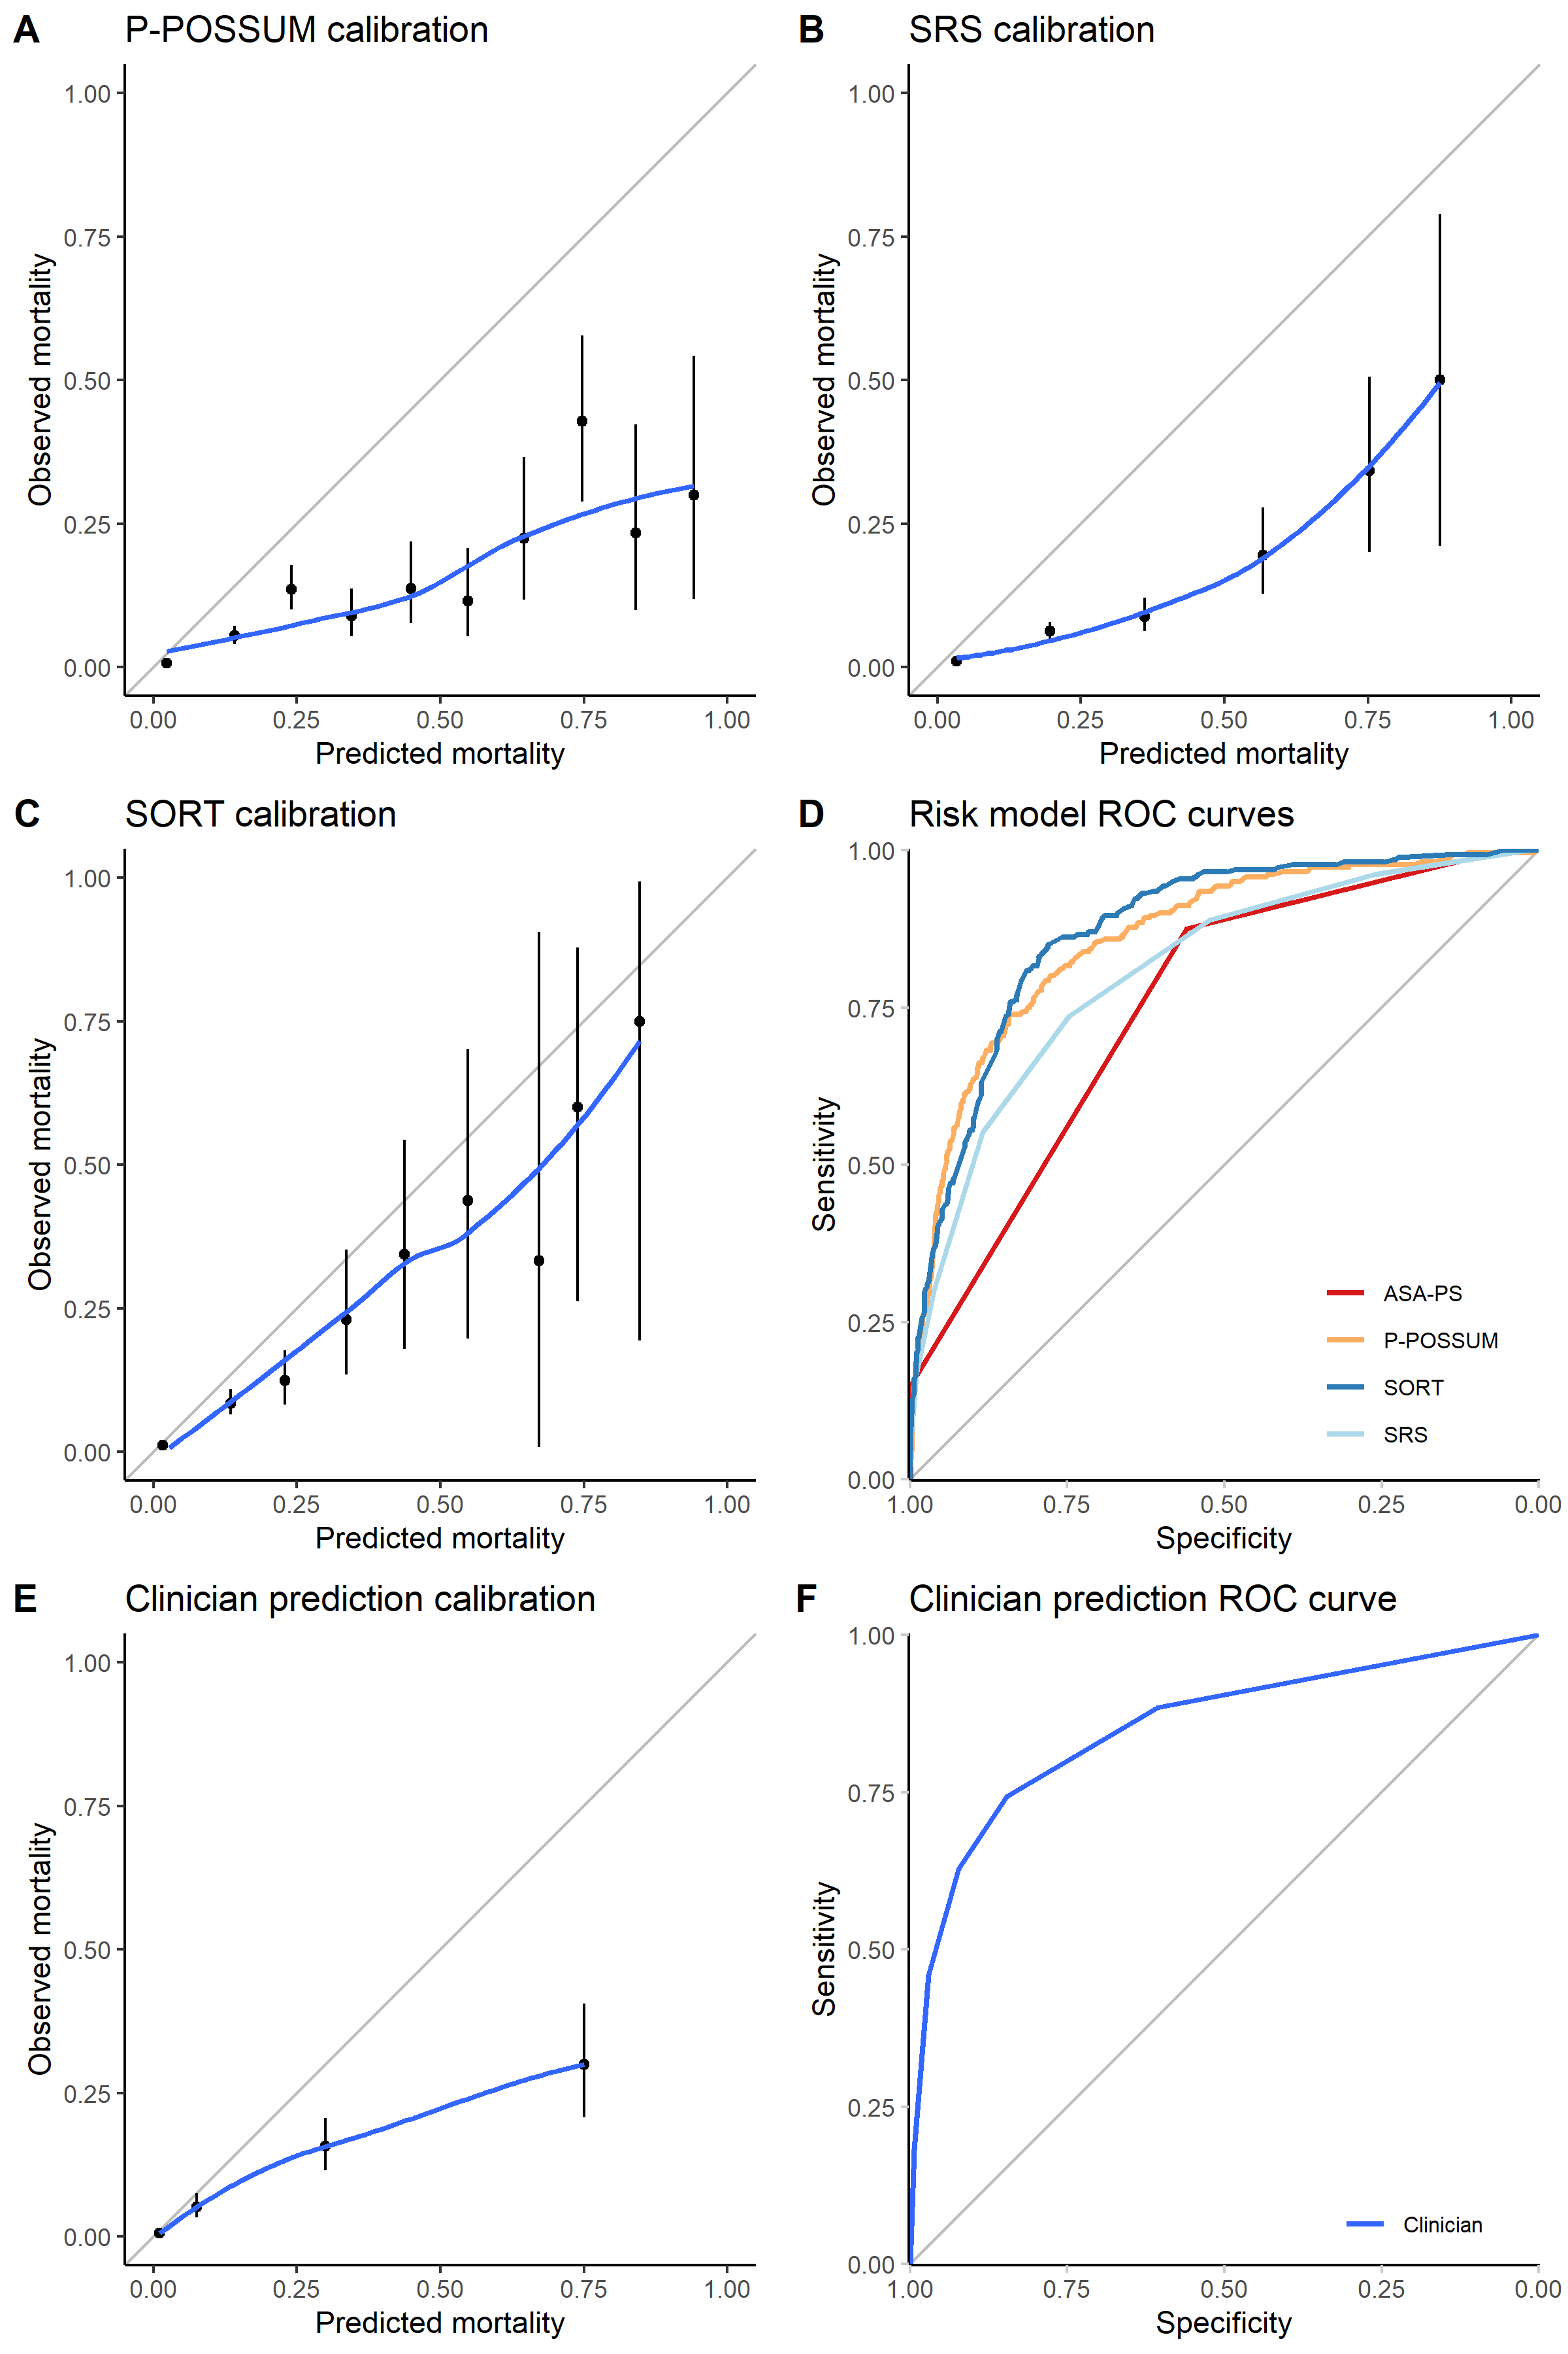

Figure 6‑5: Calibration plots for SORT (A), P-POSSUM (B), SRS (C) and clinical assessments (E), and Receiver Operating Characteristic (ROC) curves for the three models (D) and clinical assessments (F), validated in the sensitivity analysis patient subset with restricted inclusion criteria (n = 12,987). The Areas Under the ROC curves (AUROCs) for P-POSSUM, SRS, SORT and clinical assessments were 0.863, 0.811, 0.876 and 0.824 in this subgroup, respectively

#### Sensitivity analysis 2: predictions using both subjective and objective information

The second sensitivity analysis used the sub-group whose mortality estimate was based on clinical judgement in conjunction with any objective risk tool (n = 4,891). The performance of subjective clinical assessment was assessed in the sub-group of patients who received subjective risk estimates informed by other sources in addition to clinical judgement. The AUROC for subjective clinical assessment in this subgroup was 0.88 (95% CI: 0.86–0.91), which was not significantly different to the AUROC obtained for clinical assessments in the main study analysis (p = 0.550). The calibration of subjective clinical assessment in this sub-group was similar to that in the main cohort, again with a tendency to overpredict risk (Figure 6-6 for calibration plots).

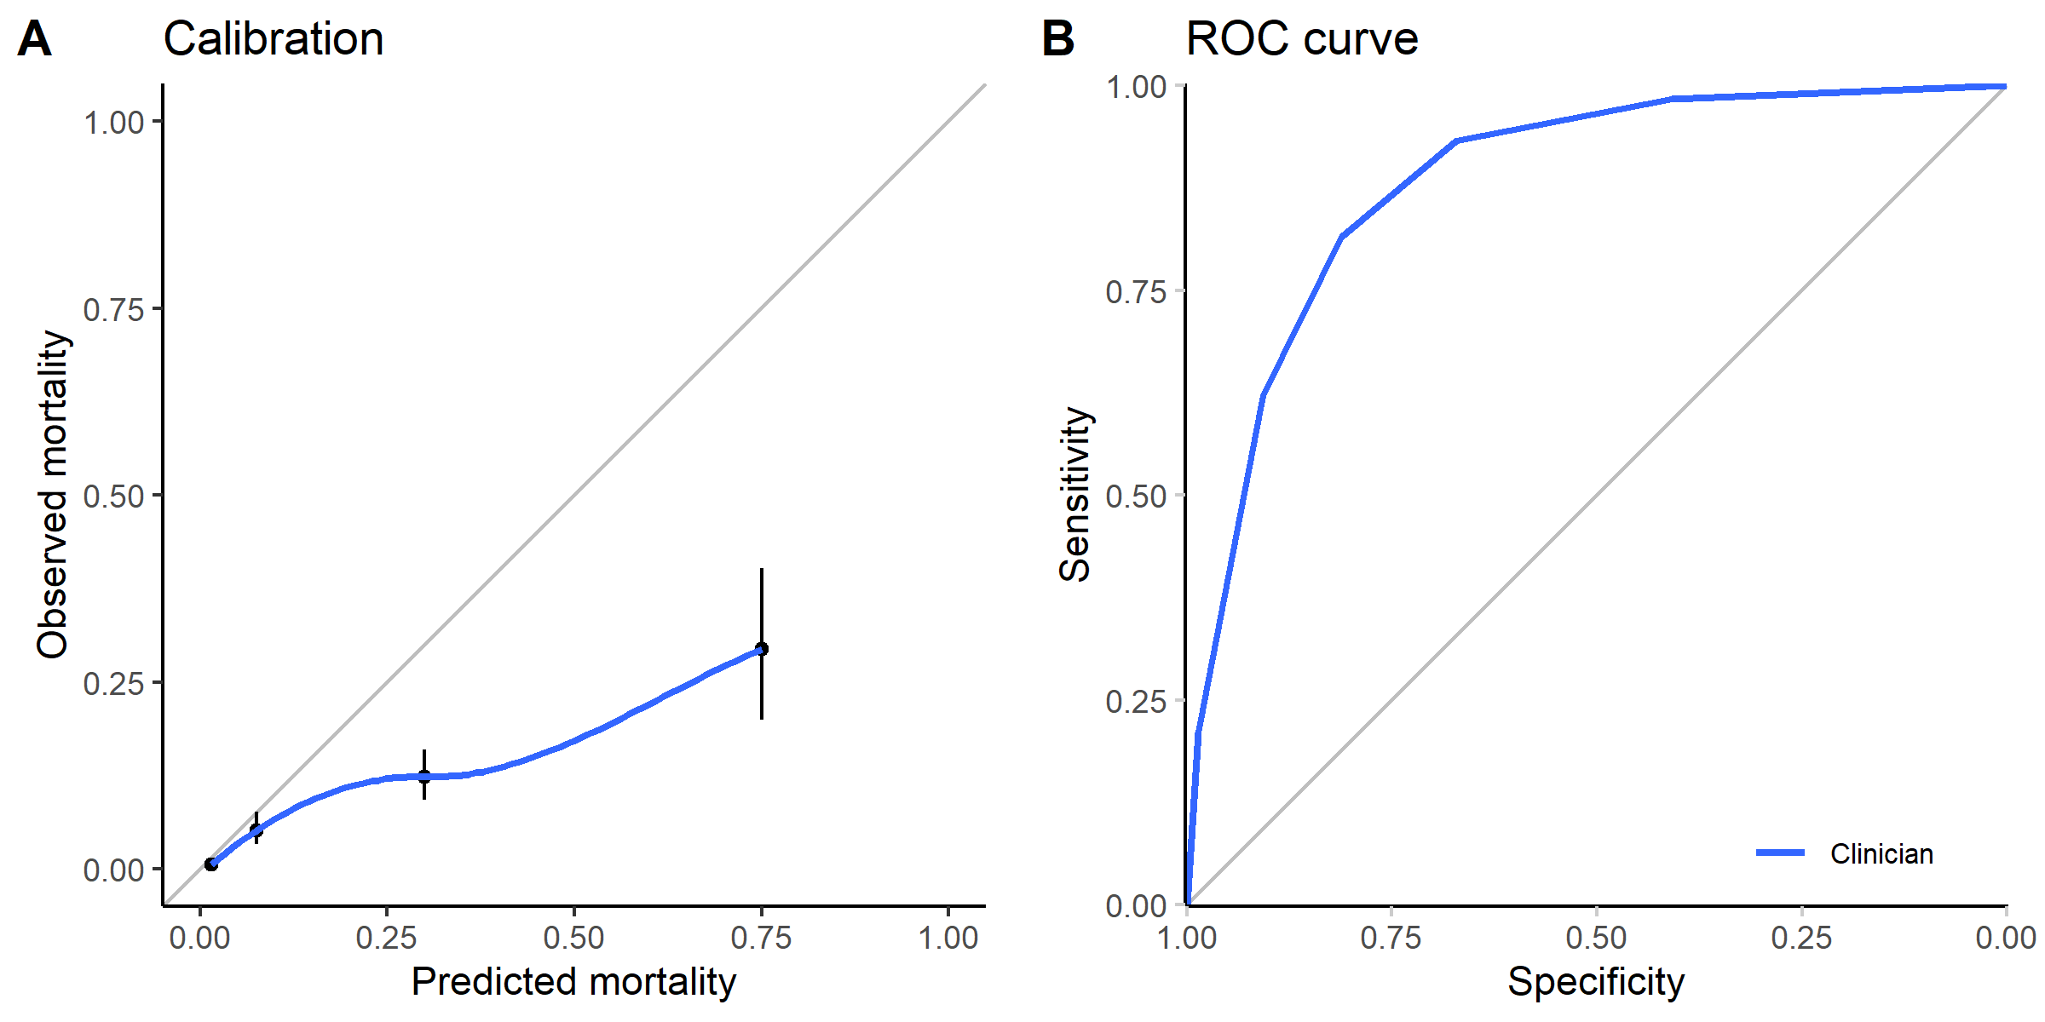

Figure 6‑6: Calibration plot (A) and Receiver Operating Characteristic (ROC) curve (B) for clinical assessments, validated in the sensitivity analysis patient subgroup where clinical assessments were made in conjunction with one or more other risk prediction tools. The Area Under the ROC curve (AUROC) for clinical assessments was 0.922 in this subgroup.

#### Sensitivity analysis 3: differences between countries

In the third sensitivity analysis, differences in performance of subjective clinical assessment and objective risk prediction tools between the UK and the Australasian cohorts were investigated. The 30-day mortality in the Australasian cohort (0.99%) was comparable to that of the UK (1.24%, p = 0.240). Visual inspection of calibration plots revealed the calibration of SORT to be worse in Australasia than the UK (Figure 6-7E and 6-7F). The AUROCs (Table 6-6) for the objective risk tools in the Australasian subset (P-POSSUM: 0.90, SRS: 0.81, and SORT: 0.88) were not significantly different to the AUROCs in the UK subset (P-POSSUM: 0.90, SRS: 0.86, and SORT: 0.91, p >0.05 for all risk tools). The calibration of subjective clinical assessment was comparable in the two geographical sub-groups (Figure 6-8) and there were also no significant differences in AUROCs (Australasia: 0.89, UK: 0.90, p = 0.810).

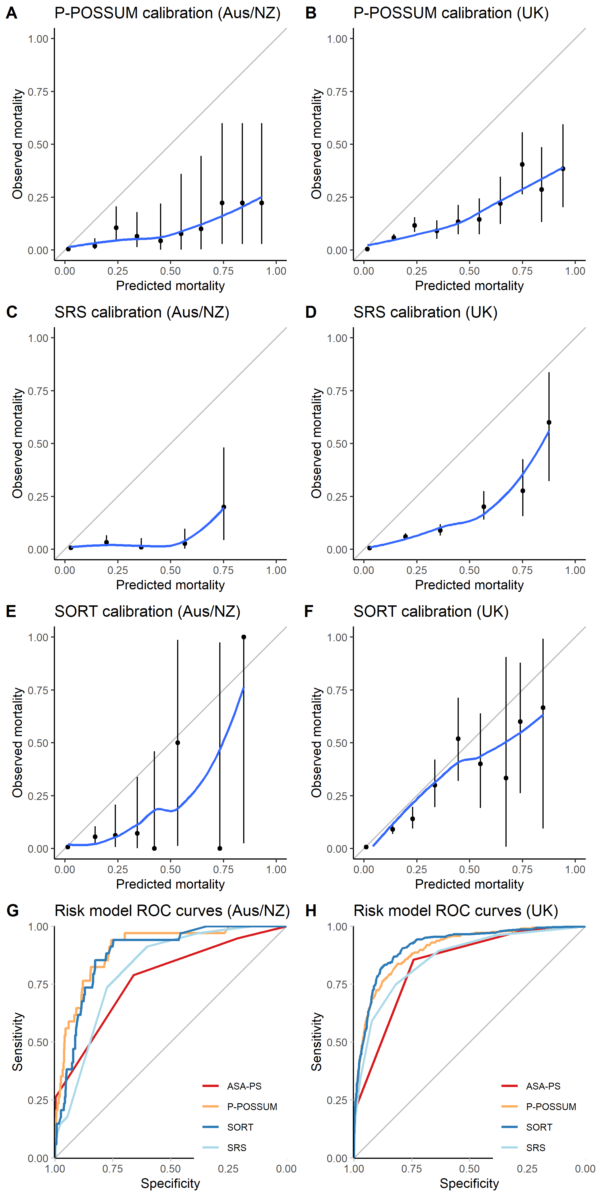

Figure 6‑7: Calibration plots (A-F) and Receiver Operating Characteristic (ROC) curves (G-H) for the objective risk prediction tools in the Australasian and UK cohorts.

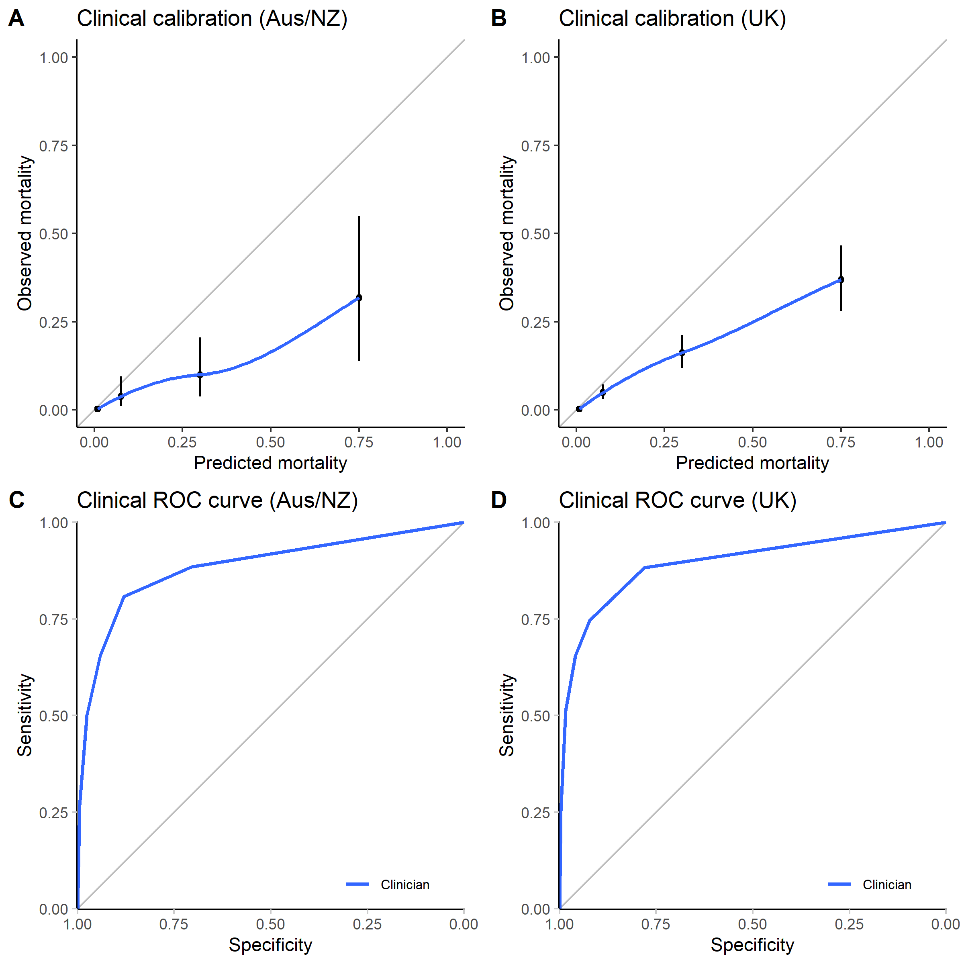

Figure 6‑8: Calibration plots (A-B) and Receiver Operating Characteristic (ROC) curves (C-D) for clinical assessments in the Australasian and UK cohorts.

Table 6‑6: AUROCs of the objective risk tools and subjective clinical assessment, compared between the UK and Australian/New Zealand data subsets. There was no significant difference in discrimination using any of the risk prediction tools or using subjective assessment when comparing their performance in the UK and Australian/New Zealand datasets.

|  |  |  |  |
| --- | --- | --- | --- |
|  | Australia/New Zealand | UK | p |
| **ASA-PS** | 0.773 | 0.837 | 0.269 |
| **P-POSSUM** | 0.901 | 0.900 | 0.963 |
| **SRS** | 0.815 | 0.860 | 0.136 |
| **SORT** | 0.881 | 0.915 | 0.179 |
| **Clinical** | 0.885 | 0.896 | 0.806 |

## Discussion

### Principal findings

In this chapter, three key findings are reported: First, despite a plethora of options for risk assessment, in over 80% of patients, subjective clinical assessment alone was used to predict 30-day mortality risk; Second, in cases where objective prediction tools were applied, the P-POSSUM or its variants were most commonly used, but were outperformed by the simpler and more recently developed SORT; Finally, the combination of subjective clinical assessment with the objective SORT resulted in a small but significant improvement in predictions over either alone.

Improved accuracy of risk prediction through the combination of subjective and objective information provides better information to the patient and therefore enhances the shared decision-making process. Beyond that, there are also important ramifications in the correct allocation of resources for high-risk patients, in particular, finite resources such as postoperative critical care beds. In this chapter, the combined model presented showed significantly better NRI performance, which can be largely attributed to the correct downgrading of patient risks — a large proportion of patients were correctly reclassified as lower risk using the combined model compared to subjective clinical assessment alone. Therefore, using an approach combining both subjective and objective risk assessment may result in fewer patients inappropriately admitted to critical care postoperatively. This is particularly important given the impact that postoperative critical care requirement can have on patients (increased risk of last-minute cancellation if no bed available) (111), and on healthcare providers (contributing to systems pressure due to competition for beds between surgical and emergency patients).

### Study limitations

I recognise there are a number of limitations to this study. First, models predicting rare events may appear optimistically accurate, as a model that identifies every patient as being low risk of mortality, in a group where the probability of death approaches 0%, would almost always appear to be correct. For this reason, I undertook the first sensitivity analysis, which evaluated the performance of the various risk assessment methods in a sub-group of patients which have been defined as high-risk in previous studies of prognostic indicators (173,174). This demonstrated that while 30-day mortality was higher and prognostic accuracy lower, the performance of the SORT and subjective clinical assessment were still good, and compared favourably with previous evaluations of more complex risk assessment methods such as functional capacity evaluation, or models including cardiac biomarkers which are not routinely available in clinical practice (173,174). Second, while it can be assumed that subjective clinical assessments were truly clinically-based judgements, because this was a pragmatic unblinded study, it was possible that unrecorded information from other sources may have subconsciously influenced these clinical assessments. For this reason, I undertook the second sensitivity analysis which refuted this possible risk. Third, due to low case numbers, one is unable to evaluate the accuracy of a variety of clinical risk prediction methods such as frailty assessment or cardiopulmonary exercise testing. However, this was not an objective of the analyses in this chapter; further, the lack of “real-world” clinical uptake of these types of measures is in itself an important finding, particularly given the substantial interest in such measures (some of which carry considerable cost) in the research literature. Finally, the cohort of patients recruited from the UK was substantially larger than the Australasian cohort. For this reason, the third sensitivity analysis was performed, which found no significant differences in mortality or predictive accuracy of the various risk assessment methods between the two geographical groups. Therefore, I anticipate the findings reported in this chapter to be generalisable to these different health systems, and propose that the model developed using a combination of subjective and objective clinical assessment should be tested in other similar (high-income) settings.

### Clinical implications and relation to existing literature

From surveying the literature, this is the first study comparing subjective clinical assessment against objective risk assessment for predicting perioperative mortality risk in a large multicentre international cohort. Research in this field is usually limited by recruitment bias, due to the predominant participation of research active centres, and the need for patient consent. For example, recent perioperative studies evaluating the accuracy of different prognostic methods include METS (174) and VISION (173) with 27% and 68% screening to recruitment rates respectively.

One way of overcoming such biases would be to study the accuracy of prognostic models using routinely collected or administrative data; however, this provides no opportunity to evaluate the accuracy of subjective clinical assessments in multiple centres. The analyses in this chapter avoided these issues through prospective data collection in an unselected cohort with an ethical waiver for patient consent. The mortality in this cohort closely matches that recorded in UK administrative data of patients undergoing major or complex (and therefore usually inpatient) surgery (10), therefore supporting the assertion that this cohort was representative of the “real-world” perioperative population. I have therefore presented generalisable information regarding the accuracy of risk assessment, which can be applied to clinical practice in the UK, Australia and New Zealand, and potentially further afield.

The METS study (174) in particular suffered from at least two further issues beyond recruitment bias, which may also have contributed to differences between their findings and those reported in this thesis. First, in their analysis the METS authors conflated clinical assessment of functional capacity with clinical assessment of mortality risk, these items are not directly analogous. There will be some patients who have poor functional capacity but high mortality risk and some with high functional capacity with low mortality risk, and thus errors in predicting functional capacity would be amplified when assessing the performance of predictions against actual mortality. Second, clinicians may be poor at judging functional capacity, but may still be good at judging mortality risk. In their study the clinicians were unable to clearly distinguish between patients with low and high estimated peak oxygen consumptions, this is different from distinguishing between patients with low and high likelihoods of dying.

Notably a large proportion of clinicians rely on clinical judgement alone when estimating risk in their patients. Despite the growing literature on CPET/functional capacity and the growing interest in perioperative CPET (110), it can be seen from these results that CPET was rarely used to estimate perioperative risk in practice. The use of objective risk tools in conjunction with clinical assessment is also cheaper, and more immediately accessible to patients and clinicians, due to the increasing ubiquity of mobile computing devices. The value of functional capacity assessment might therefore be limited to selecting patients who might benefit from specific “prehabilitation” interventions related to increasing preoperative exercise capacity (175,176).

I propose that subjective clinical assessment adds to the value of objective risk tools, by accounting for a variety of unmeasured confounders which are known to clinicians. These may include general health (e.g. unusual comorbidities, frailty, social deprivation, patient motivation and engagement) and surgical characteristics (e.g. anticipated anatomical/technical difficulties) which risk tools would not usually capture.

Currently, subjective clinical assessment is almost never incorporated into risk prediction tools for surgery. One exception is the American College of Surgeons National Surgical Quality Improvement Program (ACS NSQIP) Surgical Risk Calculator (96,177,178). In this calculator, baseline risk variable data and details of the surgical procedure are first entered onto an online form, and probabilities of a several outcomes including mortality and major complications are provided on a second screen. The clinician is then able to adjust the risk upwards if they felt the calculated risks were an underestimate. Perhaps an improved approach would be to enter clinical assessment as an additional variable at the same time as objective variables, such that a clinician’s subjective impressions of their patient’s risk is unbiased to the risk estimate presented by the calculator. Future development of the online SORT calculator could adopt this approach to provide increased accuracy in predictions (179,180).

As discussed at the start of this chapter, one of the aims of developing risk models is to direct clinical decision-making and target resources, with the intent to reduce mortality. Therefore, over time, models tend to underestimate risk for future populations, and require recalibration. It is thus unsurprising that the external model validations performed in this study detected miscalibration, particularly the older models (P-POSSUM was developed in mid-1990s and SRS in the early-2000s). Future work in this area will therefore necessitate recalibration of the combined model presented in this chapter.

### Summary

In this chapter, the performance of ASA-PS grading, P-POSSUM, SORT and SRS were evaluated in the SNAP-2: EPICCS dataset, and compared against the performance of subjective clinical assessment. Although subjective clinical assessment and all four objective risk prediction tools studied showed tendency to overpredict risk, their discrimination was comparable.

The combination of subjective and objective risk assessment could provide more accurate risk predictions than subjective clinical assessment alone. Implementation of a modified SORT model which incorporates clinical assessment should lead to improved clinical decision-making (including improved provision of information to patients contemplating surgery), and better use of limited clinical resources such as postoperative critical care for patients who are most likely to benefit.

##### PAGE BREAK

# Propensity for Admission to Critical Care After Surgery

Critical care beds are a finite resource in constrained health services and, as described in *Chapter 3*, they account for less than 5% of all inpatient hospital beds in the UK, Australia and New Zealand. A number of steps need to occur during the perioperative period in order to secure admission to critical care: typically, patients would need to be identified by the surgical or anaesthetic team as first requiring postoperative critical care admission prompting a referral so that a bed on the critical care unit is reserved (which I will refer to henceforth as a ***“perceived requirement”***), and the patient then later gets admitted once the operation finishes (referred to from this point as an ***“admission”***). Therefore, identifying patients to be admitted to critical care is an important aspect of perioperative management that facilitates the allocation of this limited resource to patients who have the greatest perceived need for critical care.

Clinicians may decide that a patient should receive critical care taking into account a range of information, including the availability of critical care beds, competition for beds from critically-ill non-surgical patients, the risk of mortality facing the patient, the type of surgery the patient is undergoing, specific patient comorbidities, specific care pathways which may exist within an institution, and so on. For example, patients undergoing cardiac surgery are routinely admitted to critical care postoperatively (67), while hepatobiliary and major gastrointestinal surgery are associated with higher rates of critical care admission (59).

As shown in *Chapter 4*, while guidelines recommend that patients with ≥5% predicted mortality should receive critical care admission, only about a third of those high-risk patients eventually end up admitted to critical care immediately after their operations; and a proportion of the patients who do get admitted to critical care are actually patients with predicted mortality risks <5% (“low-risk” patients).

A number of questions arise from this finding: 1) What are the factors which might influence clinicians to perceive a patient requires critical care admission? 2) How much does assessment of patient risk contribute to whether a patient is perceived to require critical care, compared to exogenous factors such as critical care capacity? 3) In patients who are perceived to require for critical care, what factors affect their eventual admission or non-admission? 4) Is there variation between hospitals in the likelihood of whether a patient might be perceived to require critical care, and is there variation between hospitals in the likelihood of patients then going on to be admitted to critical care?

Thus, in this chapter, I shall investigate the factors which may be associated with whether clinicians perceive a patient requires direct postoperative critical care admission post-surgery. Then, for those patients who do receive this label for **perceived requirement** for critical care admission, I shall explore the factors which may be associated with whether they later then receive critical care **admission**. I shall quantify the variation in perceived requirement for and admission to critical care between hospitals, and estimate the extent to which case-mix differences may account for any inter-hospital heterogeneity in the propensity for postoperative critical care.

## Methods

As in *Chapter 4* and *5*, patient-level data from the Second Sprint National Anaesthesia Project: EPIdemiology of Critical Care provision after Surgery (SNAP-2: EPICCS) were used in the analyses presented in this chapter. In addition, hospital-level variables from the Organisational Survey (presented in *Chapter 3*) were linked to the patient-level dataset to model higher-level effects which may be involved clinical decision-making around postoperative critical care admission. Full details of the data-acquisition for both the patient- and hospital-level variables are found in *Chapter 2*.

### Statistical analysis

Analyses using multivariable logistic regression will be presented in this chapter in two parts.

#### Part one: factors associated with recommendation for critical care

In this first part of the analyses, the factors associated with receiving label denoting a clinically perceived requirement for critical care admission were modelled. The response variable for this part was the perceived requirement for critical care — Clinicians providing routine perioperative care were asked the following question, “*Does the perioperative team think that this patient requires critical care after their operation?*” This field was answered prior to the completion of surgery and required binary (yes/no) answer. Although the case record forms were completed during surgery, clinicians were asked to answer this question as though they were predicting their patients’ outcomes before surgery began. The study documentation emphasised to all local investigators that the intention of the study was to assess how well the clinical team was able to anticipate the need for postoperative critical care before the patient met with any intraoperative complications.

Modelling for this part was performed on the whole cohort excluding patients already receiving critical care preoperatively, defined as those already receiving Level 2 or 3 care prior to arriving to the operating theatre suite. These cases were excluded because they would almost certainly need postoperative critical care if they were already in receipt of critical care preoperatively.

Fixed-effects logistic regression models were fitted with patient-level surgical risk variables, other exogenous variables unrelated to patient risk (but which could plausibly influence the decision to recommend patients for critical care, e.g. daytime vs. overnight surgery), and measures of critical care strain (availability of critical care beds) at the time of surgery as explanatory variables.

Then, mixed-effects (multilevel) logistic regression models were constructed to assess the hospital-level variables which might influence perceived critical care requirement, and to assess the inter-hospital variability in perceived requirement which might exist. For the multilevel models, variables related to structural differences between hospitals were entered into the models, and random intercepts for hospitals were used.

#### Part two: factors associated with later admission to critical care

In this second part analysis, the factors associated with eventual critical care admission were modelled, conditional on whether patients received a label for perceived requirement for critical care or not. The response variable for this part of the analysis was whether the patient was admitted directly to critical care following surgery. Similar to the first part, patients already receiving critical care prior to surgery were excluded.

As with part one, fixed-effects logistic regression models were fitted with surgical risk variables and other exogenous variables as explanatory variables, but additionally, other intraoperative variables were also included, e.g. estimated blood loss, and whether there were any unexpected critical events encountered during surgery. Following fixed-effects modelling, multilevel models with random intercepts for hospitals were again constructed to investigate the associations between hospital-level variables and critical care admission.

#### Further detail about multilevel regression modelling used in this chapter

Multilevel regression considers the fact that within the dataset, patients (level 1) are clustered within hospitals or countries (level 2). The probability of an individual patient receiving a label for requiring critical care, and the probability that a patient is then admitted to critical care after receiving such a label is made, may be statistically dependent on the hospital in which they are receiving treatment, in addition to any patient-level factors (181). Including a random intercept during modelling allows for correlated error terms for patients treated at the same hospital, therefore reducing bias in the estimates of other model coefficients (182,183). Null models with no explanatory variables but with a random-intercept for hospitals were fitted. The random-intercepts for the null models vary by hospital and indicate the level of heterogeneity that might exist between hospitals in patients receiving label for requiring critical care and/or admission. Patient-level explanatory variables were then added to the models as identified during the earlier fixed-effects regression modelling, to account for differences in patient risk case-mix between hospitals. Following this, hospital-level variables were added to investigate the which of these were influential.

The heterogeneity in perceiving a requirement for critical care and eventual critical care admission between hospitals was estimated using the Median Odds Ratio (MOR) (181,184). The MOR quantifies the variance between hospitals (level 2 variation) by transforming the random-intercept variance into an odds ratio scale to allow for comparison with other patient- and hospital-level effects (184). This approach in quantifying variance using MOR has previously been used in modelling regional variation in mortality outcomes for patients admitted to critical care after high-risk surgery (57,185).

The intermediate models fitting during the analysis will be summarised, and details of the final models chosen are reported. The final chosen models were those which best-fitted the data (lowest Akaike’s Information Criterion [AIC]), and which explained the most amount of interhospital variance (i.e. resulted in the greatest reduction of MOR from the null model).

### Data variables

Patient-level independent variables entered into the models included measures known to be associated with mortality risk, as risk is likely to influence decision-making due to the published National Confidential Enquiry into Patient Outcome and Death (NCEPOD) and Royal College of Surgeons recommendations (35,37). As the Surgical Outcome Risk Tool (SORT) was identified as best performing risk tool identified in *Chapter 5*, its component variables were used in the modelling for this chapter (146). SORT includes 6 objective variables within its model: Age; ASA-PS grade; severity of procedure (as defined using AXA-PPP codes); surgical urgency (NCEPOD classifications); whether the surgery was in a particularly high-risk specialty (thoracic, GI surgery or vascular surgery); whether the patient had active malignancy. Other patient-level risk variables modelled included presence of comorbidities (the presence of chronic cardiac, respiratory, dementia, liver or renal disease), surgical start time (defined as time of surgical incision, divided into daytime [08:00hrs to 00:00hrs] vs. overnight [00:00hrs to 08:00hrs] surgery), and surgical specialty. Age was modelled using a natural cubic spline with the number of knots selected corresponding with the lowest model AIC.

A variable measuring critical care strain was included in the modelling: this was defined as the number of empty beds (the number of physically empty beds with staffing available for these beds) recorded at two time-points during each day of the patient recruitment (08:00hrs and 20:00hrs). This measure was matched to the time of surgical incision for each case in the following manner:

* If the patient’s surgery started anytime during 08:00hrs to 20:00hrs, the critical care strain measure corresponded to the recording at the 08:00hrs timepoint that morning.
* If the patient’s surgery started between 20:00hrs to midnight, the critical care strain measure corresponded to the recording taken at the 20:00hrs timepoint that evening.
* If the patient’s surgery started from midnight to 08:00hrs, the critical care strain measure corresponded to the recording taken at the 20:00hrs timepoint of the previous day.

Hospital-level independent variables included: hospital size (as measured by the total number of hospital beds); critical care bed capacity (the proportion of critical care beds within total hospital beds); general surgical bed capacity (the proportion of general surgical ward beds within total hospital beds); presence of an emergency department; provision of tertiary services (any from a list of 16 tertiary services), and provision of enhanced care ward beds. Critical care beds were defined as Level 2 or Level 3 beds according to Intensive Care Society and Faculty of Intensive Care Medicine definitions (39,129). Enhanced care ward beds were defined as areas within the hospital with bed capacity to provide any subset of critical care interventions outside of the traditional Intensive Care or High-Dependency Unit (ICU/HDU) (81,186).

### Missing value treatment

Similar to *Chapter 5*, for patients with missing physiological values related to the risk variables used to compute P-POSSUM, normal physiological ranges were imputed. Following this imputation, cases with missing data for the remaining explanatory variables were excluded for further analysis as the proportion of cases with missing data in the remaining variables was low (0.98% of total cases) (172). Finally, patients with missing data for the response variable (whether they were recommended for critical care admission) were excluded.

## Results

After exclusion criteria were applied, 25,328 were included in part one analysis, and 2,541 were included in part two (Figure 7-1).

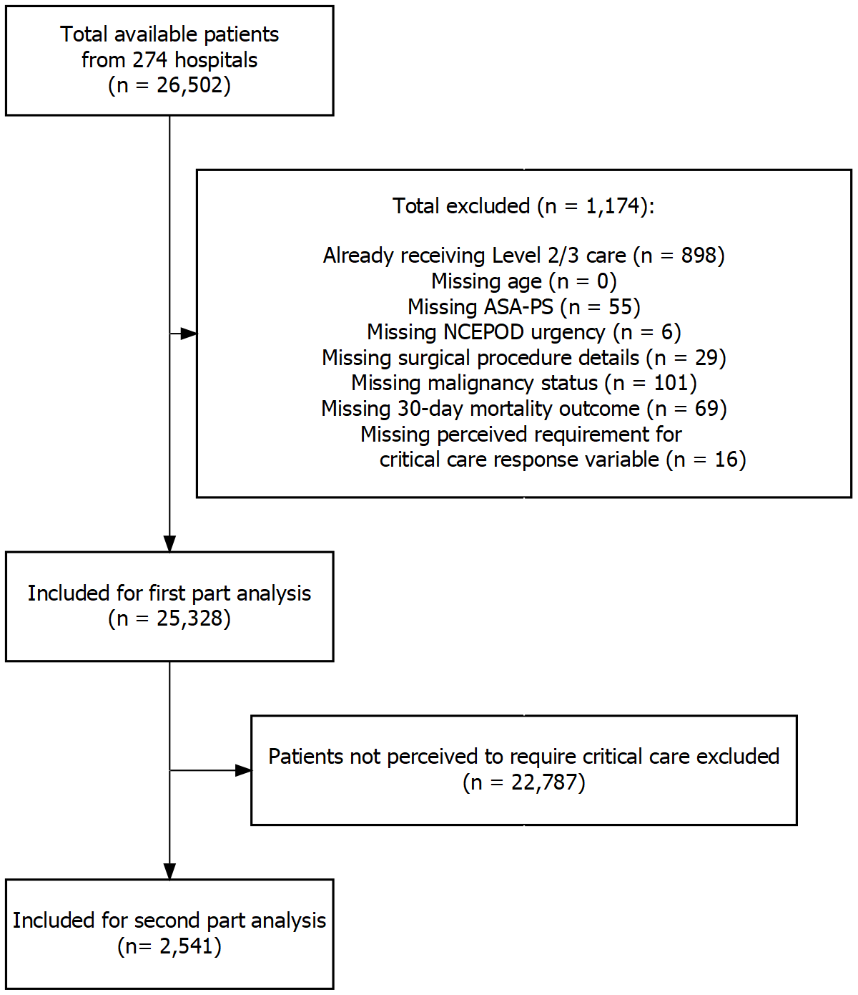

Figure 7‑1: Cases included and excluded from analysis.

### Part 1: Recommendation for critical care

A total of 2,541 patients (10.0%) were perceived to require postoperative critical care admission by the perioperative team. The patients with a perceived requirement for critical care were older, had a higher proportion of ASA-PS III and IV grades, and had an increased incidence of comorbidities (Table 7-1). Consequently, the mean predicted mortality risk in these patients was higher than those not perceived to require postoperative critical care, as computed using SORT, the combined SORT-clinical assessment model, and by subjective clinical assessment alone.

Table 7‑1: Baseline patient demographics stratified by perceived requirement for critical care admission. For surgical specialty classifications: ‘GI’ includes colorectal, upper gastrointestinal tract, bariatric and hepato-pancreato-biliary surgery, and ‘Other’ includes solid organ transplants, ophthalmic, plastic, maxillofacial/dental, ear-nose-throat, endocrine and breast surgery, as well as interventional radiology, interventional cardiology and endoscopic procedures requiring anaesthetic support.

|  |  |  |  |  |  |
| --- | --- | --- | --- | --- | --- |
|  | Overall | Missing | No perceived Requirement for Critical Care Admission | Perceived Requirement for Critical Care Admission | p |
| **N** | 25328 |  | 22787 | 2541 |  |
| **Male (%)** | 10201 (40.3) | 0.0 | 8754 (38.4) | 1447 (57.0) | <0.001 |
| **Age (median [IQR])** | 57 [37, 72] | 0.0 | 55 [36, 71] | 67 [55, 76] | <0.001 |
| **Operative Urgency (%)** |  | 0.0 |  |  | <0.001 |
| Elective | 13348 (52.7) |  | 12149 (53.3) | 1199 (47.2) |  |
| Expedited | 3489 (13.8) |  | 3016 (13.2) | 473 (18.6) |  |
| Urgent | 7370 (29.1) |  | 6679 (29.3) | 691 (27.2) |  |
| Immediate | 1121 ( 4.4) |  | 943 ( 4.1) | 178 ( 7.0) |  |
| **ASA-PS Grade (%)** |  | 0.0 |  |  | <0.001 |
| I | 6351 (25.1) |  | 6226 (27.3) | 125 ( 4.9) |  |
| II | 11492 (45.4) |  | 10833 (47.5) | 659 (25.9) |  |
| III | 6425 (25.4) |  | 5140 (22.6) | 1285 (50.6) |  |
| IV | 1040 ( 4.1) |  | 584 ( 2.6) | 456 (17.9) |  |
| V | 20 ( 0.1) |  | 4 ( 0.0) | 16 ( 0.6) |  |
| **Surgical Severity (%)** |  | 0.0 |  |  | <0.001 |
| Minor | 2014 ( 8.0) |  | 1935 ( 8.5) | 79 ( 3.1) |  |
| Intermediate | 4727 (18.7) |  | 4543 (19.9) | 184 ( 7.2) |  |
| Major | 10201 (40.3) |  | 9589 (42.1) | 612 (24.1) |  |
| Xmajor | 5150 (20.3) |  | 4698 (20.6) | 452 (17.8) |  |
| Complex | 3236 (12.8) |  | 2022 ( 8.9) | 1214 (47.8) |  |
| **Surgical Specialty (%)** |  | 0.0 |  |  | <0.001 |
| GI | 4301 (17.0) |  | 3496 (15.3) | 805 (31.7) |  |
| Gynaecology-Urology | 4249 (16.8) |  | 4058 (17.8) | 191 ( 7.5) |  |
| Neuro-Spine | 1114 ( 4.4) |  | 921 ( 4.0) | 193 ( 7.6) |  |
| Obstetrics | 3484 (13.8) |  | 3429 (15.1) | 55 ( 2.2) |  |
| Orthopaedics | 6617 (26.1) |  | 6389 (28.0) | 228 ( 9.0) |  |
| Cardiothoracic | 957 ( 3.8) |  | 324 ( 1.4) | 633 (24.9) |  |
| Vascular | 633 ( 2.5) |  | 466 ( 2.0) | 167 ( 6.6) |  |
| Other | 3968 (15.7) |  | 3701 (16.2) | 267 (10.5) |  |
| **Coronary Artery Disease (%)** | 2844 (11.2) | 0.0 | 2108 ( 9.3) | 736 (29.0) | <0.001 |
| **Congestive Cardiac Failure (%)** | 806 ( 3.2) | 0.0 | 568 ( 2.5) | 238 ( 9.4) | <0.001 |
| **Metastatic Cancer (%)** | 801 ( 3.2) | 0.0 | 591 ( 2.6) | 210 ( 8.3) | <0.001 |
| **Dementia (%)** | 641 ( 2.5) | 0.0 | 581 ( 2.5) | 60 ( 2.4) | 0.612 |
| **COPD (%)** | 1873 ( 7.4) | 0.0 | 1477 ( 6.5) | 396 (15.6) | <0.001 |
| **Pulmonary Fibrosis (%)** | 166 ( 0.7) | 0.0 | 123 ( 0.5) | 43 ( 1.7) | <0.001 |
| **Diabetes (%)** | 3363 (13.3) | 0.1 | 2847 (12.5) | 516 (20.3) | <0.001 |
| **Liver Cirrhosis (%)** | 196 ( 0.8) | 0.0 | 147 ( 0.6) | 49 ( 1.9) | <0.001 |
| **Renal Disease (%)** | 333 ( 1.3) | 0.0 | 284 ( 1.2) | 49 ( 1.9) | 0.006 |

#### Fixed-effects modelling

Models were fitted sequentially with explanatory variables added based on clinically plausibility. Intermediate models were compared using AIC to assess fit. A final explanatory model was chosen that showed the lowest AIC and that explained the data well. In the final fixed-effect model, a number of factors were found to be significantly associated with patients being perceived to require critical care (Figure 7-2).

Table 7‑2: Patient-level variable associations with the likelihood of receiving a label of perceived requirement for critical care, expressed as adjusted Odds Ratios (OR) estimated with the final fixed-effects model. Patient age was modelled using a non-linear natural spline transformation, the ORs estimated for the age terms should not be interpreted directly and have therefore been omitted from the table. The effects for age can be interpreted graphically (Figure 7-3A).

|  |  |  |  |  |
| --- | --- | --- | --- | --- |
| Variables | Odds Ratio | 95% CI Lower | 95% CI Upper | p |
| **Male** | 1.149 | 1.032 | 1.279 | 0.011 |
| **Operative Urgency** |  |  |  |  |
| Elective | Reference | | | |
| Expedited | 1.097 | 0.9396 | 1.282 | 0.241 |
| Urgent | 1.189 | 1.018 | 1.389 | 0.029 |
| Immediate | 4.597 | 3.51 | 6.021 | <0.001 |
| **ASA-PS Grade** |  |  |  |  |
| I | Reference | | | |
| II | 2.036 | 1.641 | 2.527 | <0.001 |
| III | 6.046 | 4.816 | 7.591 | <0.001 |
| IV | 17.51 | 13.16 | 23.3 | <0.001 |
| V | 64.54 | 18.45 | 225.8 | <0.001 |
| **Surgical Severity** |  |  |  |  |
| Minor | Reference | | | |
| Intermediate | 1.263 | 0.9387 | 1.701 | 0.123 |
| Major | 2.653 | 2.014 | 3.496 | <0.001 |
| Xmajor | 4.251 | 3.183 | 5.678 | <0.001 |
| Complex | 14.27 | 10.71 | 19.01 | <0.001 |
| **Malignancy** | 2.081 | 1.762 | 2.457 | <0.001 |
| **PMHX Cardiac Disease** | 1.284 | 1.118 | 1.474 | <0.001 |
| **PMHX Respiratory Disease** | 1.248 | 1.073 | 1.453 | 0.004 |
| **PMHX Dementia** | 0.727 | 0.526 | 1.004 | 0.053 |
| **PMHX Liver Disease** | 1.276 | 0.8349 | 1.951 | 0.260 |
| **PMHX Renal Disease** | 0.703 | 0.4827 | 1.023 | 0.066 |
| **Surgical Specialty** |  |  |  |  |
| GI | Reference | | | |
| Gynaecology-Urology | 0.315 | 0.262 | 0.3779 | <0.001 |
| Neuro-Spine | 0.349 | 0.2828 | 0.4299 | <0.001 |
| Obstetrics | 0.165 | 0.1169 | 0.2316 | <0.001 |
| Orthopaedics | 0.108 | 0.09006 | 0.1286 | <0.001 |
| Cardiothoracic | 2.074 | 1.691 | 2.544 | <0.001 |
| Vascular | 0.290 | 0.2272 | 0.3709 | <0.001 |
| Other | 0.443 | 0.3713 | 0.5282 | <0.001 |
| **Already inpatient (vs. admitted from home)** | 1.322 | 1.159 | 1.507 | <0.001 |
| **Daytime Surgery (vs. overnight)** | 0.760 | 0.5335 | 1.081 | 0.127 |
| **Number of Empty Beds at the Time of Surgery** | 1.045 | 1.027 | 1.064 | <0.001 |

As patient age was modelled using a natural spline transformation and the effect of continuous explanatory variables on a response variable are not easily interpreted using odds ratios when the relationship is non-linear, the effect of age was separately demonstrated using a marginal effects plot (Figure 7-3A). In this model, the likelihood of being perceived to require critical care increased as patient age increased from 18 to approximately 70 years, before then reducing at older ages.

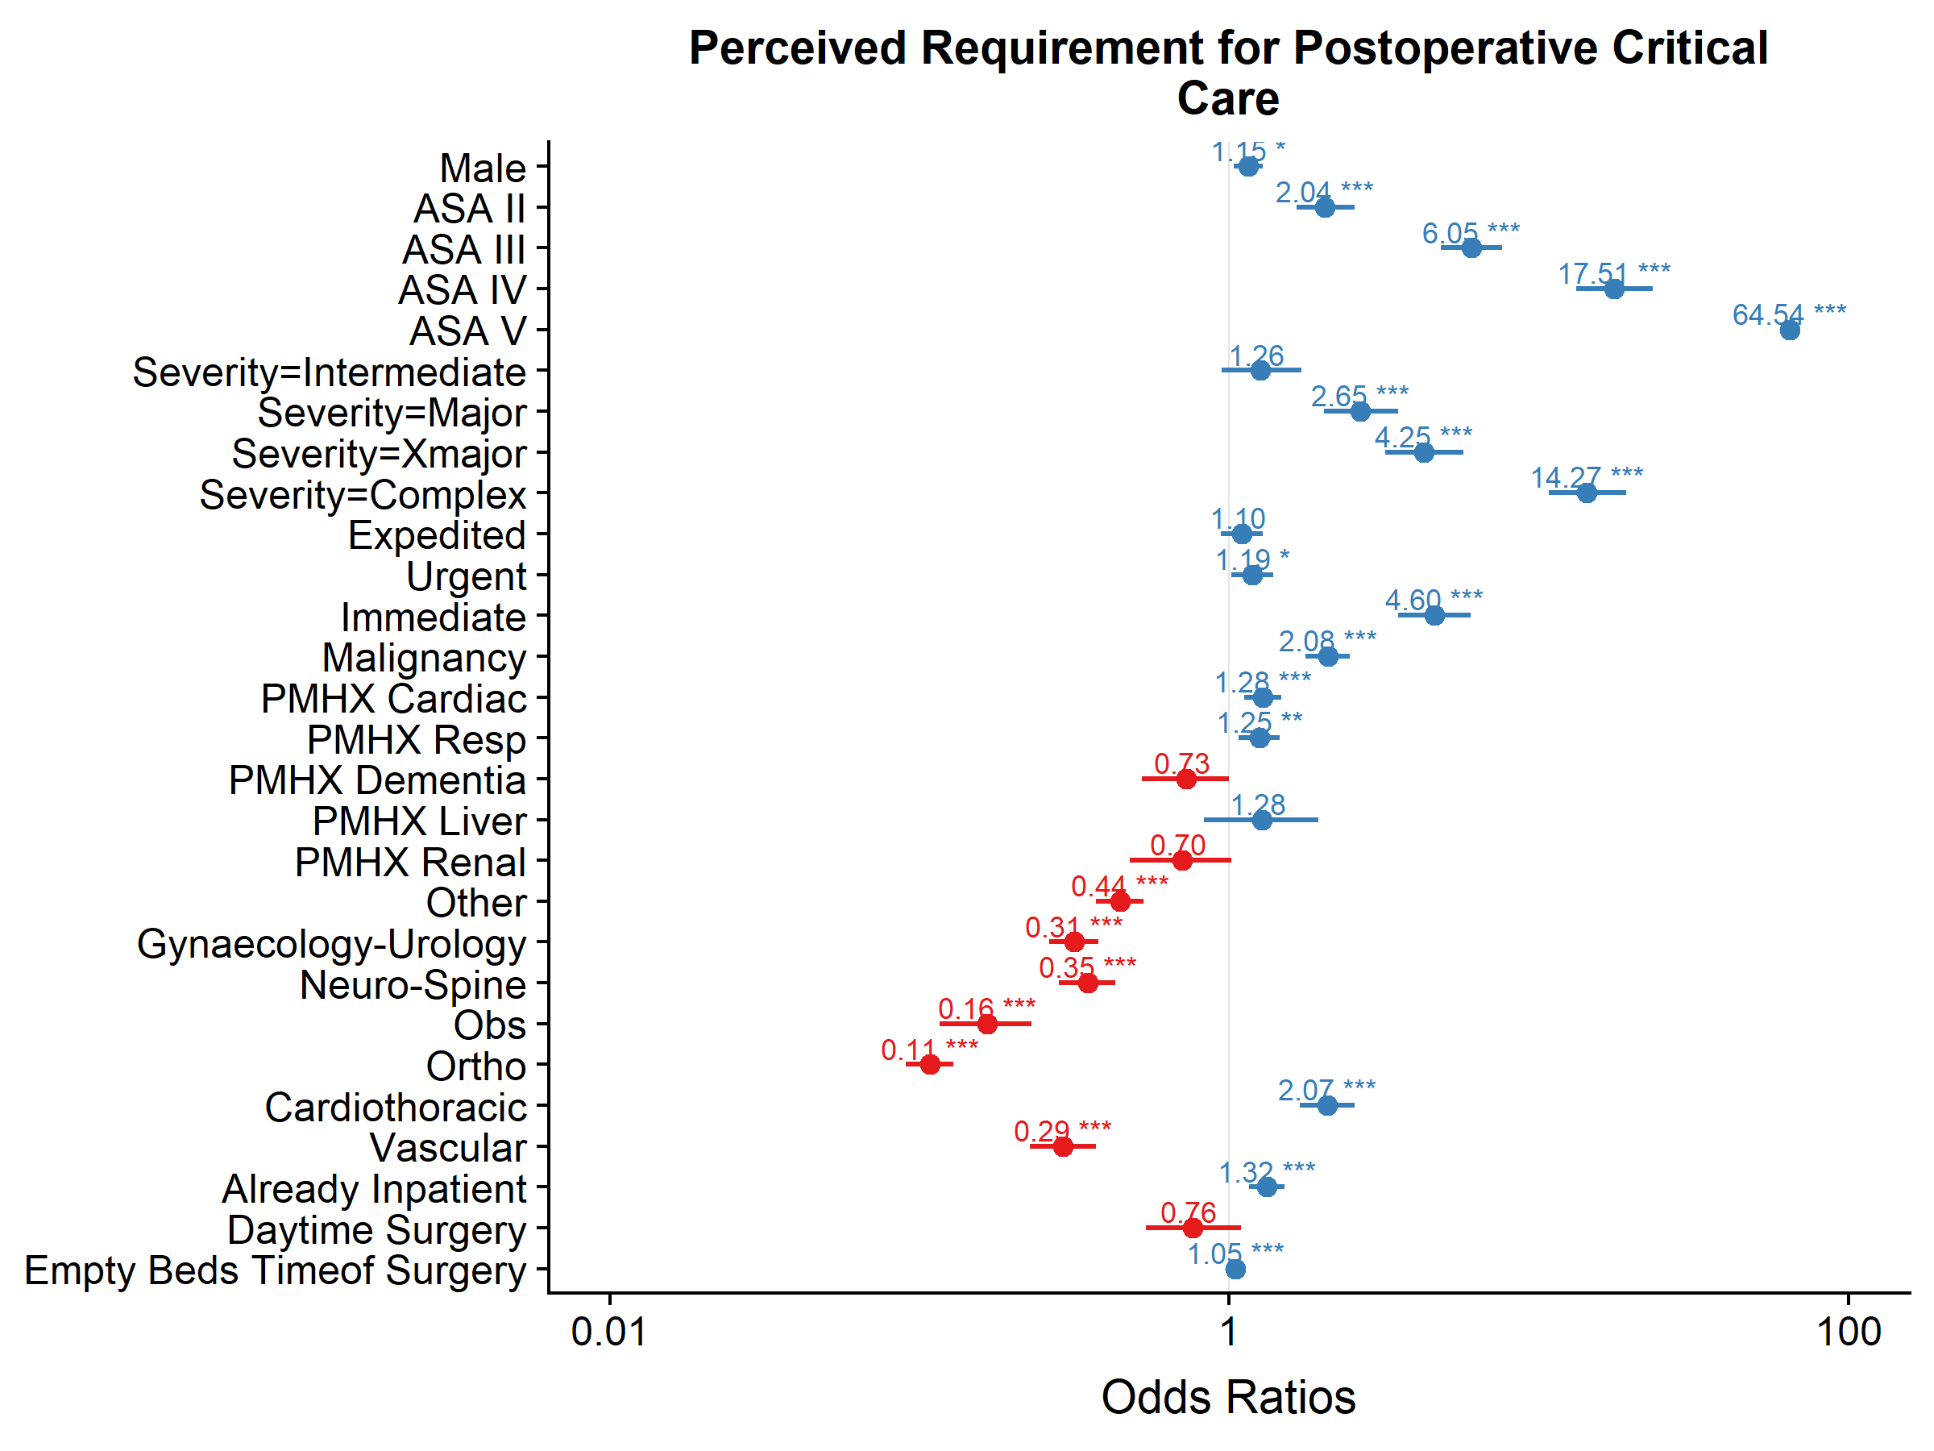

Figure 7‑2: Forest plot of adjusted odds ratios for factors associated with a perceived requirement for postoperative critical care in a fixed-effects logistic regression model. Increasing ASA-PS grades, higher surgical complexity and higher surgical urgency were associated with increased likelihoods of being perceived to require critical care. Compared to Gastrointestinal surgery, most other surgical specialties were less likely to result in perceived requirement for critical care, except Cardiothoracic surgery. For every empty critical care bed at the time of surgery, the Odds Ratio (OR) for perceived requirement was 1.05, adjusting for other patient risk factors. Age was modelled using a natural spline transformation and left out of the plot for this reason. PMHX = Past Medical History; Resp = Respiratory; Obs = Obstetric; Ortho = Orthopaedics; * p <0.05, ** p <0.01, *** p <0.001

Increasing ASA-PS grade, surgical complexity and NCEPOD-defined surgical urgency were all associated with increasing likelihood of perceived requirement for critical care The greatest effects were seen for ASA-PS III (adjusted Odds Ratio [OR] = 6.05, 95% CI: 4.82 to 7.59), ASA-PS IV (OR = 17.51, 95% CI: 13.16 to 23.3), ASA-PS V patients (OR = 64.54, 95% CI: 18.45 to 225.77), AXA-PPP complex surgical procedures (OR = 14.27, 95% CI: 10.71 to 19.01), and NCEPOD-immediate urgency (OR = 4.60, 95% CI: 3.51 to 6.02).

Compared to gastrointestinal surgery, patients undergoing cardiothoracic surgery were more likely to be perceived to require critical care (OR = 2.07, 95% CI: 1.69 to 2.54), while those undergoing procedures in other specialties were less likely to be perceived to require critical care, even after adjustment for other patient risk factors. Male patients were more likely to be perceived to require critical care after accounting for other confounders (OR = 1.15, 95% CI: 1.03 to 1.28).

Patients with active malignancy (OR = 2.08, 95% CI: 1.76 to 2.46), comorbid cardiac (OR = 1.28, 95% CI: 1.12 to 1.47) and respiratory disease (OR = 1.25, 95% CI: 1.07 to 1.45) were more likely to have a perceived requirement for critical care. In contrast, patients with comorbid dementia were less likely to be perceived to require postoperative critical care (OR = 0.73, 95% CI: 0.53 to 1.00)

Patients who were already inpatients at the time of surgery (as opposed to admitted on the day of surgery) were more likely to be perceived to require critical care (OR = 1.32, 95% CI: 1.16 to 1.51).

Although the surgical start time (daytime vs. overnight) was not significantly associated with perceived requirement for critical care, the availability of critical care beds around the time of surgical start (defined as the number of empty critical care beds) was associated with increased likelihood of being perceived to require critical care (OR = 1.05 per empty bed, 95% CI: 1.03 to 1.06). This effect was visualised graphically in Figure 7-3B.

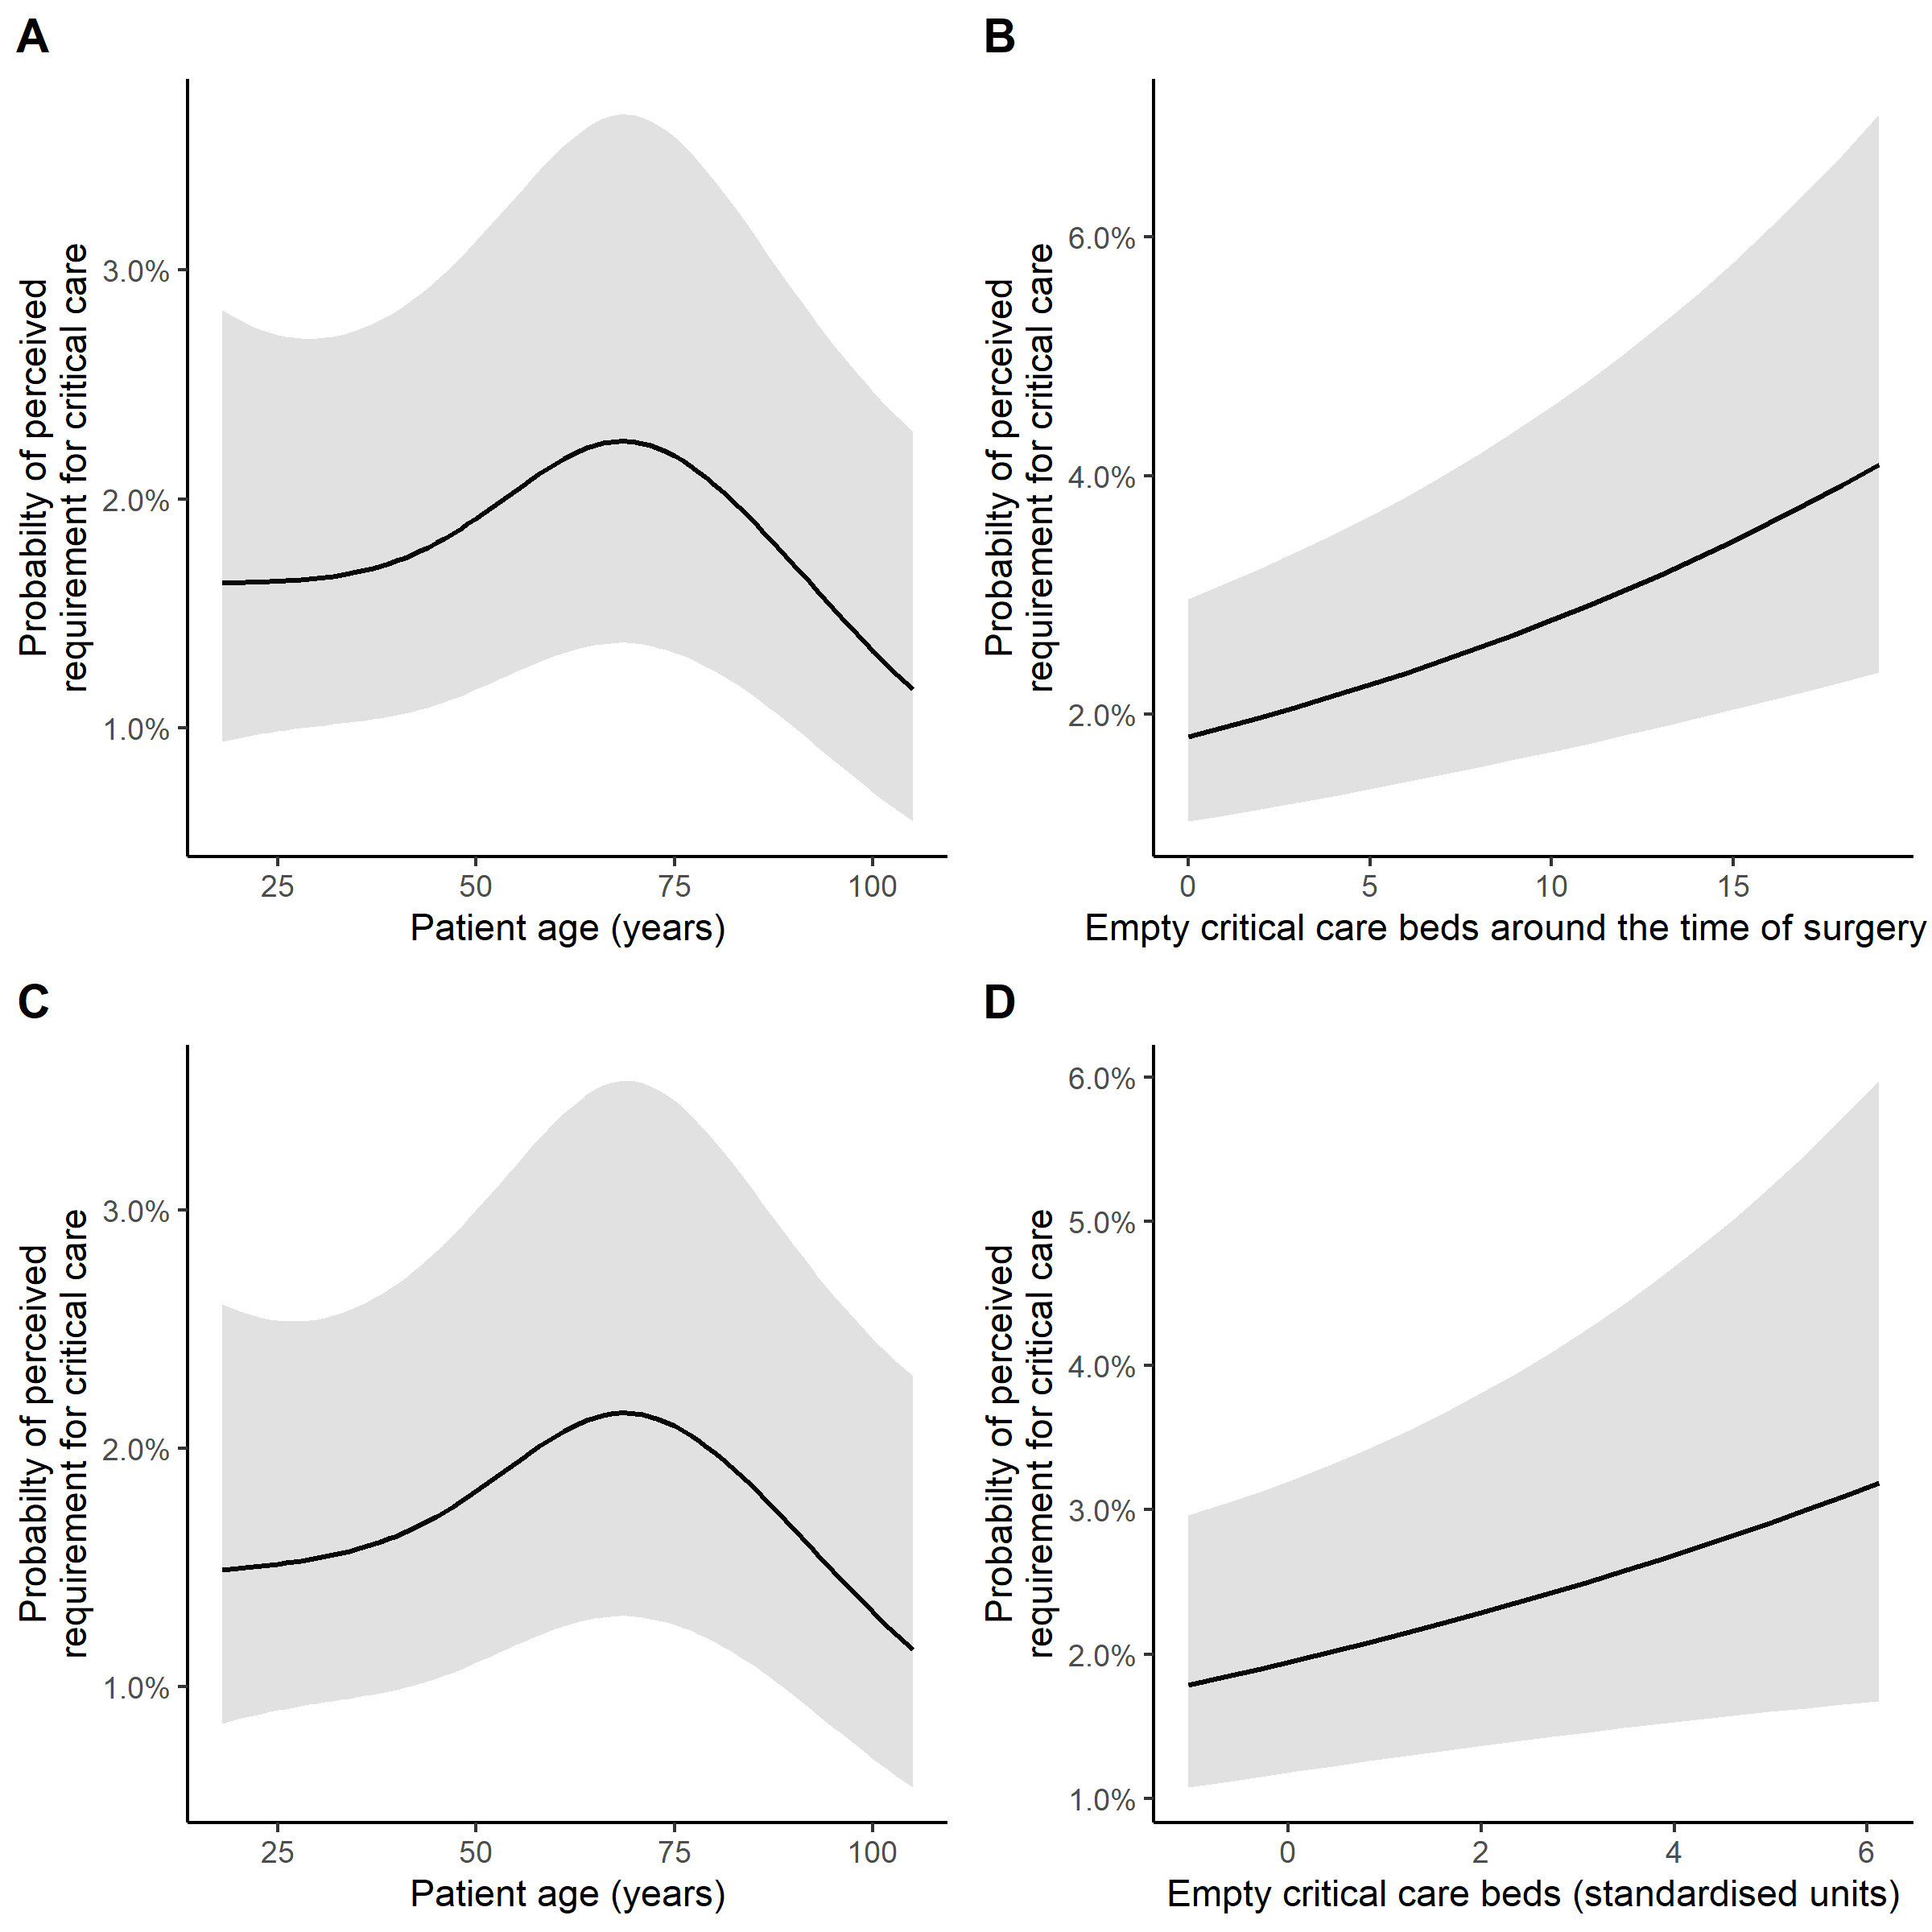

Figure 7‑3: Plots of the marginal probabilities of perceived requirement for admission to postoperative critical care against patient age (A), and against the number of empty critical care beds around the time of surgery (B) in the fixed effects model. Similar marginal effects plots are also shown for the final multilevel model, again for age (C), and for grand-mean centred empty critical care beds (D). For these marginal effects plots, other categorical variables are held constant at their reference value, while other continuous variables are held constant at their mean values.

#### Mixed-effects (Multilevel) modelling

A number of multilevel models were fitted (Table 7-3): a null model with a random intercept for hospitals but no explanatory variables (Model A); a model with a random intercept for hospitals and patient-level explanatory variables identified in fixed-effects modelling described in the previous section (Model B); and a model with a random intercept for hospitals, patient-level and hospital-level explanatory variables (Model C).

The model with a random intercept for hospitals (Model A) demonstrated that there was substantial inter-hospital variation in the perceived requirement of patients for postoperative critical care (Median Odds Ratio [MOR] = 2.22). The addition of patient-level fixed-effects variables (Model B) reduced the MOR to 1.68. In this model, adjusting for differences in case-mix between hospitals using the fixed-effects identified in the previous section appeared to explain some of the inter-hospital variation in perceived requirement for critical care.

Table 7‑3: Summary of the multilevel logistic regression models fitted in the first part of analysis in this chapter. MOR = Median Odds Ratio; AIC = Akaike’s Information Criterion.

|  |  |  |  |  |  |
| --- | --- | --- | --- | --- | --- |
| Model name | Terms | Description | MOR | AIC | Interpretation |
| Model A | No fixed terms + random intercept for hospitals only | Assesses whether there is clustering in the data by sites, i.e. is there variation in the likelihood of being perceived to require critical care depending on the hospital where surgery is conducted. | 2.22 | 15661.15 | The variance of the random intercept for hospitals when transformed into an Odds Ratio scale was 2.22, suggesting there was substantial inter-hospital variation in the likelihood for perceived requirement for postoperative critical care. |
| Model B | Patient-level fixed-effects explanatory variables + random intercept | Adjusts for differences in patient case-mix that might account for differences between hospitals in the likelihood of being perceived to require critical care. | 1.68 | 10258.23 | The addition of patient-level variables improved the model fit significantly compared to Model A, and explained some of the inter-hospital variation as the MOR reduced to 1.68. |
| Model C | Patient-level and hospital-level fixed-effects explanatory variables + random intercept | Estimates the hospital-level effects which are associated with the likelihood of being referred to critical care. | 1.58 | 10229.26 | The addition of hospital-level variables improved the model fit significantly compared to Model B, and explained some of the inter-hospital variation as it reduced MOR. |

Adding hospital-level fixed-effects variables to the model (Model C), further reduced the MOR to 1.58, suggesting that hospital-level differences explained a further proportion of the inter-hospital variation, above and beyond patient case-mix differences. However, a substantial amount of inter-hospital variation remained unexplained by the model. The MOR of 1.58 was comparable to the adjusted ORs for comorbid liver cirrhosis (OR = 1.25) or comorbid respiratory disease (OR = 1.22).

Patients were more likely to be perceived to require critical care if they underwent surgery in hospitals with higher proportions of critical care beds (adjusted OR = 1.12, 95% CI: 1.01 to 1.23 for every standard deviation increase in percentage of critical care beds). An interaction between predicted mortality risk and critical care bed proportions was tested during model construction but this was not found to be significant and therefore not retained in the final model.

Patients undergoing surgery in hospitals with an emergency department were approximately half as likely to have a perceived requirement for critical care (adjusted OR = 0.51, 95% CI: 0.37 to 0.69) than patients operated on in hospitals without an emergency department.

The following hospital-level factors were not significantly associated with whether patients received a perceived requirement for critical care: whether surgery was performed in hospitals with high-acuity beds (as described in *Chapter 3*), the size of hospital (as measured by number of hospital beds), proportion of general surgical ward beds, tertiary status of the hospital and whether the patient was operated on overnight. The final mixed-effects model (Model C), including both fixed- and random-effects is visualised in a Forest Plot (Figure 7-4)

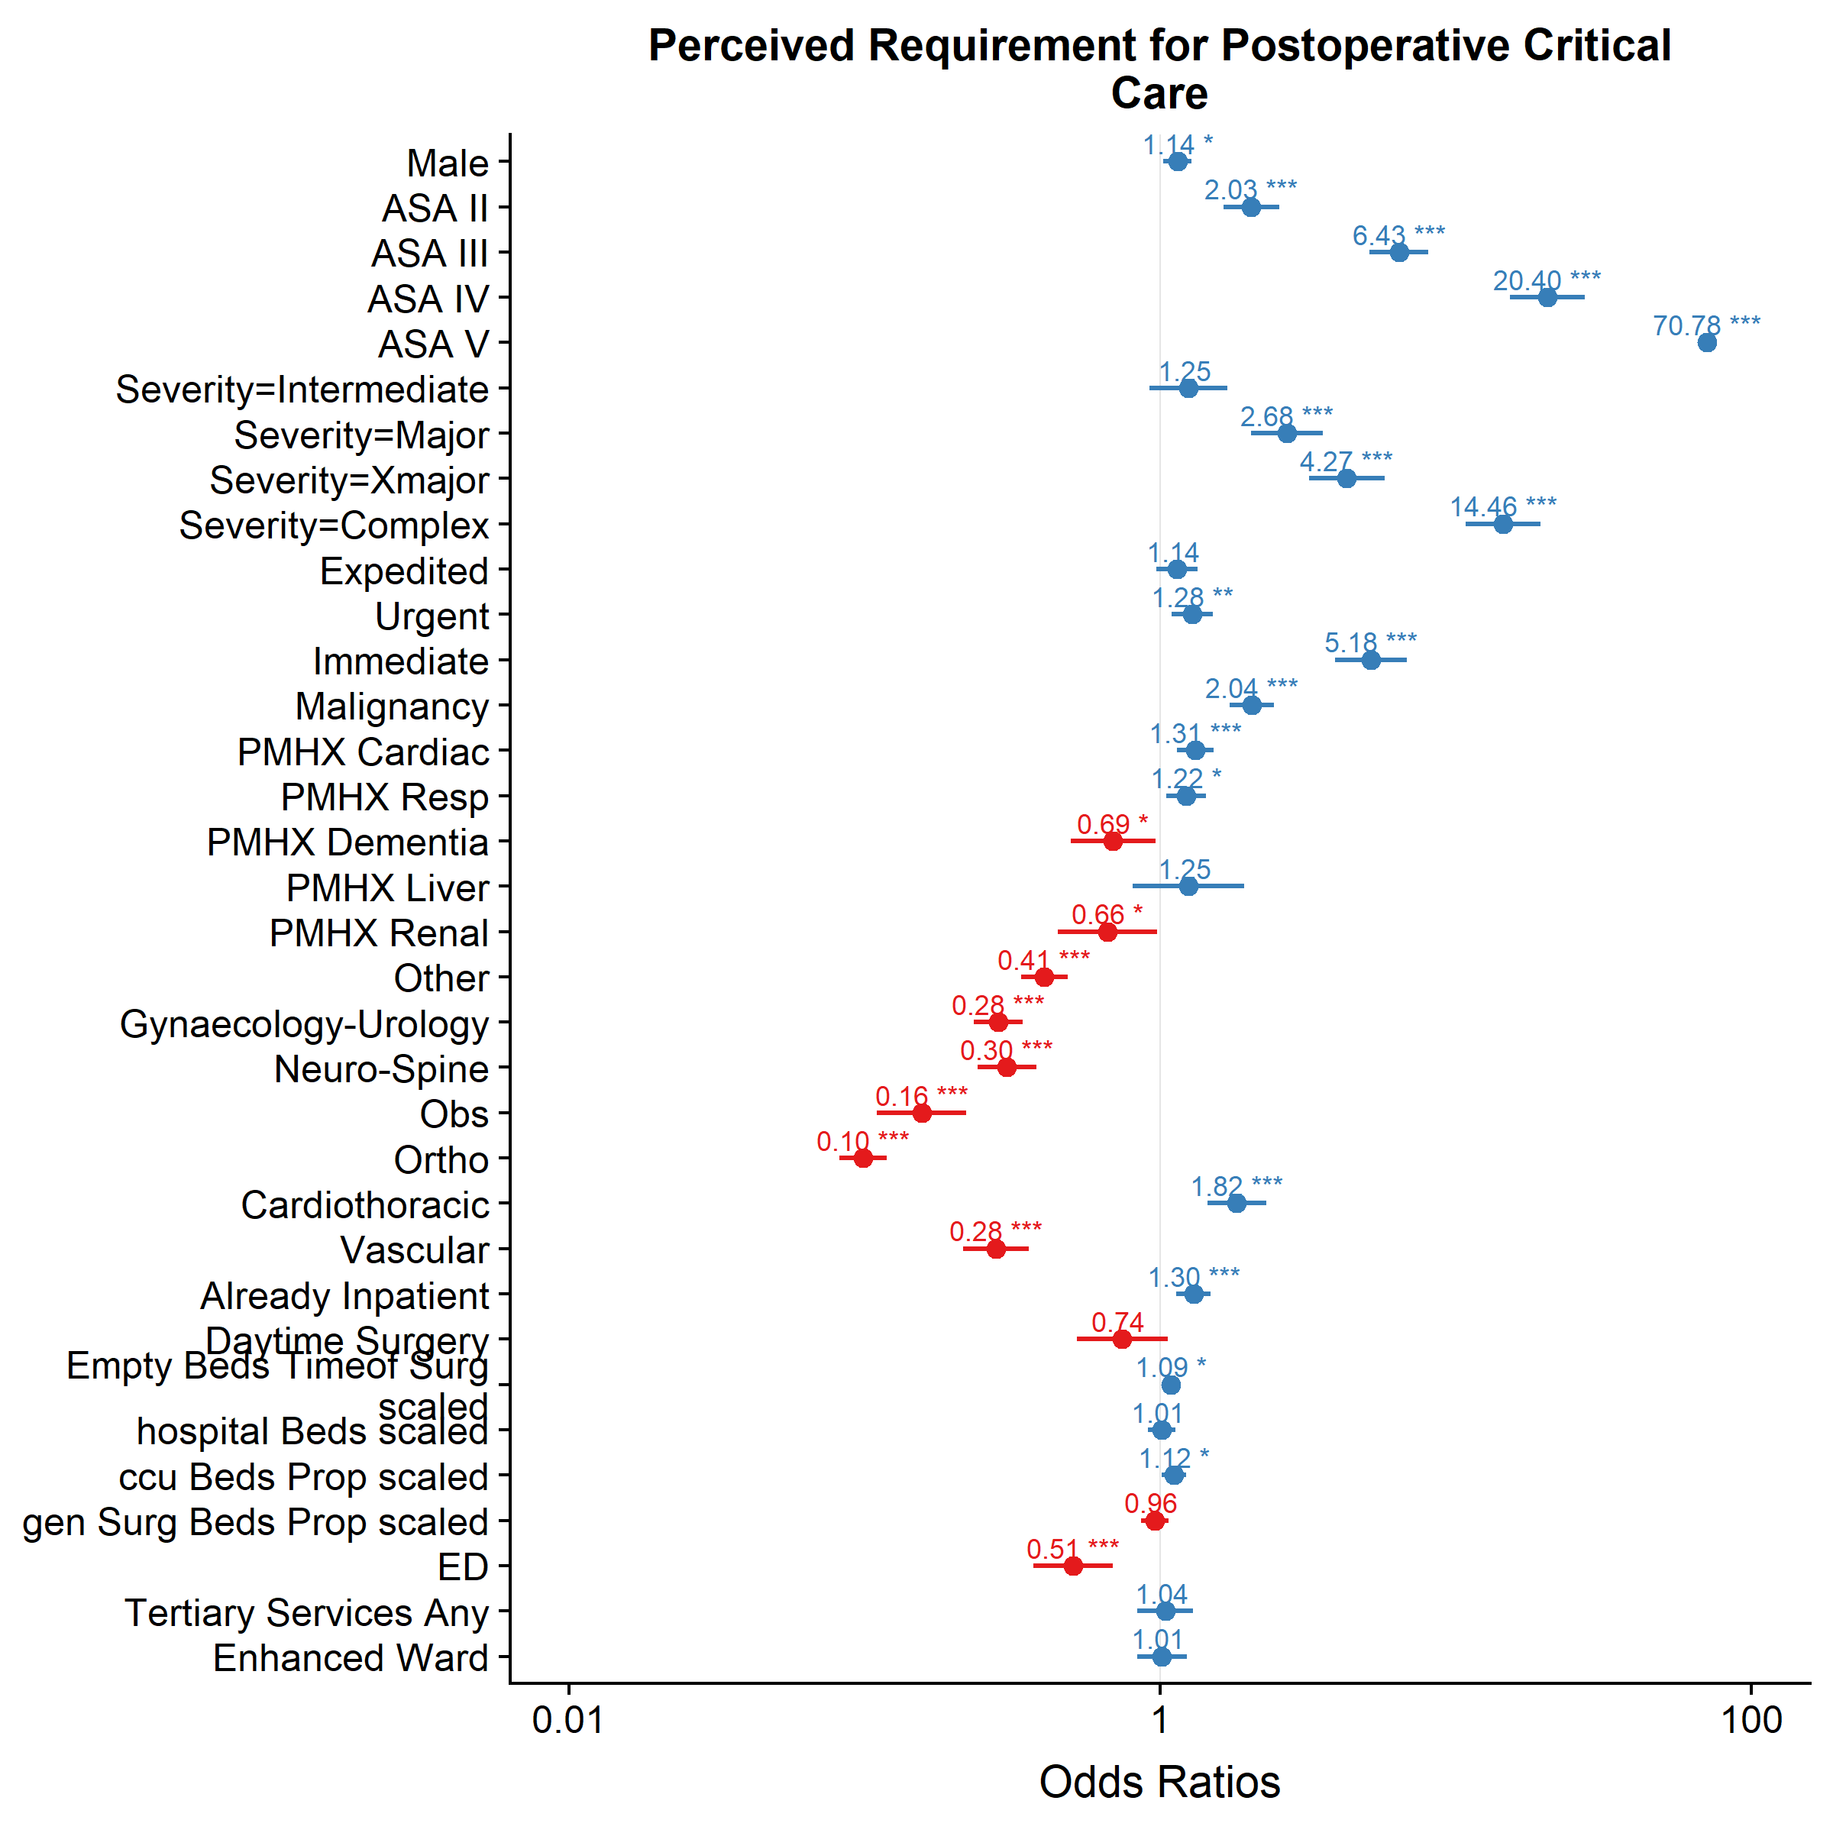

Figure 7‑4: Forest plot of adjusted odds ratios for factors associated with a perceived requirement for postoperative critical care in the final mixed-effects logistic regression model. Similar to the fixed-effects only model, increasing ASA-PS grades, higher surgical complexity and higher surgical urgency were associated with increased likelihoods of perceived requirement for critical care. Again, compared to Gastrointestinal surgery, most other surgical specialties were also less likely to result in perceived requirement for critical care, except Cardiothoracic surgery. For every standard deviation increase in empty critical care beds at the time of surgery, the Odds Ratio (OR) for perceived requirement was 1.09, adjusting for other patient risk factors and hospital-level factors. Hospitals with a higher percentage of critical care beds as a proportion of total hospital beds were more likely to have patients perceived to require critical care (adjusted OR = 1.12). Hospitals with Emergency Departments (EDs) were almost half as likely to have patients perceived to require critical care. Age was modelled using a natural spline transformation and left out of the plot for this reason. PMHX = Past Medical History; Resp = Respiratory; Obs = Obstetric; Ortho = Orthopaedics; * p <0.05, ** p <0.01, *** p <0.001.

The relationship between age and perceived requirement for critical care remained the same in the multilevel model (Figure 7-3C), the likelihood of receiving a recommendation for critical care again increased as patient age increased from 18 to approximately 70 years, then reducing at older ages.

### Part 2: Eventual admission to critical care

Of the 2,541 patients who had a perceived requirement for postoperative critical care admission, 1,925 (75.8%) were later admitted to critical care immediately following surgery. The baseline characteristics of this patient subgroup are summarised in Table 7-4. In contrast, of the 22,787 patients who were not perceived to require critical care admission, only a small number 544 (2.4%) were later admitted to critical care immediately following surgery.

Clinicians were asked during surgery why patients were perceived to require critical care, and 35.4% cited that patients were high-risk based on preoperative risk stratification, while 52.8% cited that critical care admission was routine for the type of operation the patient was undergoing. In the remainder, free-text responses were analysed and categorised. Other reasons cited for referral to critical care included anticipated intraoperative bleeding or haemodynamic instability (2.1%), patient frailty or multimorbidity (1.7%), anticipated increased postoperative monitoring needs (1.5%), anticipated postoperative airway or respiratory complications (1.0%), or high procedural complexity (1.1%).

Unexpected intraoperative events or complications were reported in 11.5% of the patients receiving a recommendation for critical care, and a small number of these (n = 9) were cited as free-text reasons for critical care referral.

Patients who were not perceived to require critical care formed a group of patients within the cohort, and the characteristics of these patients are summarised in Table 7-5, stratified by whether they were actually later admitted to critical care.

Table 7‑4: Baseline demographics for patients who were perceived to require critical care admission included in the second analysis, stratified by whether they actually then were admitted to critical care after surgery. For surgical specialty classifications: ‘GI’ includes colorectal, upper gastrointestinal tract, bariatric and hepato-pancreato-biliary surgery, and ‘Other’ includes solid organ transplants, ophthalmic, plastic, maxillofacial/dental, ear-nose-throat, endocrine and breast surgery, as well as interventional radiology, interventional cardiology and endoscopic procedures requiring anaesthetic support.

|  |  |  |  |  |  |
| --- | --- | --- | --- | --- | --- |
|  | Overall | Missing | Not Admitted to Critical Care Despite Perceived Requirement | Perceived Requirement for and Admitted to Critical Care | p |
| **n** | 2541 |  | 612 | 1925 |  |
| **Male (%)** | 0.57 (0.50) | 0.0 | 0.52 (0.50) | 0.59 (0.49) | 0.004 |
| **Age (median [IQR])** | 67 [55, 76] | 0.0 | 67 [51, 77] | 67 [56, 75] | 0.417 |
| **Operative Urgency (%)** |  | 0.0 |  |  | 0.006 |
| Elective | 1199 (47.2) |  | 267 (43.6) | 930 (48.3) |  |
| Expedited | 473 (18.6) |  | 101 (16.5) | 371 (19.3) |  |
| Urgent | 691 (27.2) |  | 199 (32.5) | 491 (25.5) |  |
| Immediate | 178 ( 7.0) |  | 45 ( 7.4) | 133 ( 6.9) |  |
| **ASA-PS Grade (%)** |  | 0.0 |  |  | <0.001 |
| I | 125 ( 4.9) |  | 52 ( 8.5) | 73 ( 3.8) |  |
| II | 659 (25.9) |  | 149 (24.3) | 509 (26.4) |  |
| III | 1285 (50.6) |  | 308 (50.3) | 975 (50.6) |  |
| IV | 456 (17.9) |  | 101 (16.5) | 354 (18.4) |  |
| V | 16 ( 0.6) |  | 2 ( 0.3) | 14 ( 0.7) |  |
| **Surgical Severity (%)** |  | 0.0 |  |  | <0.001 |
| Minor | 79 ( 3.1) |  | 27 ( 4.4) | 51 ( 2.6) |  |
| Intermediate | 184 ( 7.2) |  | 71 (11.6) | 113 ( 5.9) |  |
| Major | 612 (24.1) |  | 175 (28.6) | 434 (22.5) |  |
| Xmajor | 452 (17.8) |  | 116 (19.0) | 336 (17.5) |  |
| Complex | 1214 (47.8) |  | 223 (36.4) | 991 (51.5) |  |
| **Surgical Specialty (%)** |  | 0.1 |  |  | <0.001 |
| GI | 805 (31.7) |  | 159 (26.0) | 643 (33.4) |  |
| Gynaecology-Urology | 191 ( 7.5) |  | 56 ( 9.2) | 135 ( 7.0) |  |
| Neuro-Spine | 193 ( 7.6) |  | 56 ( 9.2) | 137 ( 7.1) |  |
| Obstetrics | 55 ( 2.2) |  | 35 ( 5.7) | 20 ( 1.0) |  |
| Orthopaedics | 228 ( 9.0) |  | 106 (17.3) | 122 ( 6.3) |  |
| Cardiothoracic | 633 (24.9) |  | 82 (13.4) | 551 (28.6) |  |
| Vascular | 167 ( 6.6) |  | 39 ( 6.4) | 128 ( 6.7) |  |
| Other | 267 (10.5) |  | 78 (12.8) | 188 ( 9.8) |  |
| **Coronary Artery Disease (%)** | 736 (29.0) | 0.0 | 157 (25.7) | 578 (30.0) | 0.043 |
| **Congestive Cardiac Failure (%)** | 238 ( 9.4) | 0.0 | 64 (10.5) | 173 ( 9.0) | 0.315 |
| **Metastatic Cancer (%)** | 210 ( 8.3) | 0.0 | 51 ( 8.3) | 158 ( 8.2) | 0.989 |
| **Dementia (%)** | 60 ( 2.4) | 0.0 | 32 ( 5.2) | 28 ( 1.5) | <0.001 |
| **COPD (%)** | 396 (15.6) | 0.0 | 94 (15.4) | 301 (15.6) | 0.916 |
| **Pulmonary Fibrosis (%)** | 43 ( 1.7) | 0.1 | 12 ( 2.0) | 31 ( 1.6) | 0.688 |
| **Diabetes (%)** | 516 (20.3) | 0.0 | 129 (21.1) | 387 (20.1) | 0.647 |
| **Liver Cirrhosis (%)** | 49 ( 1.9) | 0.0 | 4 ( 0.7) | 45 ( 2.3) | 0.014 |
| **Renal Disease (%)** | 49 ( 1.9) | 0.0 | 8 ( 1.3) | 41 ( 2.1) | 0.262 |

Table 7‑5: Baseline demographics for patients did not have a perceived requirement for critical care admission, stratified by whether they were later admitted to critical care after surgery. For surgical specialty classifications: ‘GI’ includes colorectal, upper gastrointestinal tract, bariatric and hepato-pancreato-biliary surgery, and ‘Other’ includes solid organ transplants, ophthalmic, plastic, maxillofacial/dental, ear-nose-throat, endocrine and breast surgery, as well as interventional radiology, interventional cardiology and endoscopic procedures requiring anaesthetic support.

|  |  |  |  |  |  |
| --- | --- | --- | --- | --- | --- |
|  | Overall | Missing | Neither Perceived to Require nor Admitted to Critical Care | Perceived requirement for yet Not Admitted to Critical Care | p |
| **n** | 22787 |  | 22165 | 544 |  |
| **Male (%)** | 0.38 (0.49) | 0.0 | 0.38 (0.49) | 0.52 (0.50) | <0.001 |
| **Age (median [IQR])** | 55 [36, 71] | 0.0 | 55 [35, 71] | 64 [47, 74] | <0.001 |
| **Operative Urgency (%)** |  | 0.0 |  |  | 0.023 |
| Elective | 12149 (53.3) |  | 11793 (53.2) | 321 (59.0) |  |
| Expedited | 3016 (13.2) |  | 2926 (13.2) | 74 (13.6) |  |
| Urgent | 6679 (29.3) |  | 6525 (29.4) | 130 (23.9) |  |
| Immediate | 943 ( 4.1) |  | 921 ( 4.2) | 19 ( 3.5) |  |
| **ASA-PS Grade (%)** |  | 0.0 |  |  | <0.001 |
| I | 6226 (27.3) |  | 6120 (27.6) | 83 (15.3) |  |
| II | 10833 (47.5) |  | 10584 (47.8) | 209 (38.4) |  |
| III | 5140 (22.6) |  | 4910 (22.2) | 215 (39.5) |  |
| IV | 584 ( 2.6) |  | 548 ( 2.5) | 36 ( 6.6) |  |
| V | 4 ( 0.0) |  | 3 ( 0.0) | 1 ( 0.2) |  |
| **Surgical Severity (%)** |  | 0.0 |  |  | <0.001 |
| Minor | 1935 ( 8.5) |  | 1879 ( 8.5) | 36 ( 6.6) |  |
| Intermediate | 4543 (19.9) |  | 4445 (20.1) | 73 (13.4) |  |
| Major | 9589 (42.1) |  | 9387 (42.4) | 177 (32.5) |  |
| Xmajor | 4698 (20.6) |  | 4575 (20.6) | 115 (21.1) |  |
| Complex | 2022 ( 8.9) |  | 1879 ( 8.5) | 143 (26.3) |  |
| **Surgical Specialty (%)** |  | 0.0 |  |  | <0.001 |
| GI | 3496 (15.3) |  | 3354 (15.1) | 124 (22.8) |  |
| Gynaecology-Urology | 4058 (17.8) |  | 3968 (17.9) | 79 (14.5) |  |
| Neuro-Spine | 921 ( 4.0) |  | 864 ( 3.9) | 57 (10.5) |  |
| Obstetrics | 3429 (15.1) |  | 3384 (15.3) | 34 ( 6.2) |  |
| Orthopaedics | 6389 (28.0) |  | 6275 (28.3) | 103 (18.9) |  |
| Cardiothoracic | 324 ( 1.4) |  | 273 ( 1.2) | 51 ( 9.4) |  |
| Vascular | 466 ( 2.0) |  | 441 ( 2.0) | 22 ( 4.0) |  |
| Other | 3701 (16.2) |  | 3603 (16.3) | 74 (13.6) |  |
| **Coronary Artery Disease (%)** | 2108 ( 9.3) | 0.0 | 2013 ( 9.1) | 85 (15.6) | <0.001 |
| **Congestive Cardiac Failure (%)** | 568 ( 2.5) | 0.0 | 539 ( 2.4) | 28 ( 5.1) | <0.001 |
| **Metastatic Cancer (%)** | 591 ( 2.6) | 0.0 | 555 ( 2.5) | 34 ( 6.2) | <0.001 |
| **Dementia (%)** | 581 ( 2.5) | 0.0 | 570 ( 2.6) | 11 ( 2.0) | 0.506 |
| **COPD (%)** | 1477 ( 6.5) | 0.0 | 1406 ( 6.3) | 62 (11.4) | <0.001 |
| **Pulmonary Fibrosis (%)** | 123 ( 0.5) | 0.0 | 115 ( 0.5) | 8 ( 1.5) | 0.007 |
| **Diabetes (%)** | 2847 (12.5) | 0.1 | 2757 (12.4) | 82 (15.1) | 0.078 |
| **Liver Cirrhosis (%)** | 147 ( 0.6) | 0.0 | 140 ( 0.6) | 6 ( 1.1) | 0.277 |
| **Renal Disease (%)** | 284 ( 1.2) | 0.0 | 277 ( 1.2) | 7 ( 1.3) | 1.000 |

#### 

#### Fixed-effects modelling

Similar to the part one analysis, fixed-effects models were fitted sequentially with explanatory variables added based on clinically plausibility. The same models were fitted separately on the subgroups of patients perceived to require and perceived not to require critical care on the response variable of immediate critical care admission (Figure 7-5). In addition to the baseline preoperative patient-level variables modelled in part one, variables accounting for unexpected intraoperative critical events and large volume haemorrhage were added to the models in this section.

Patients experiencing unexpected intraoperative critical events were more likely to be admitted to critical care, both in patients with a perceived requirement for critical care (adjusted OR = 1.52, 95% CI: 1.07 to 2.15) and in patients who were perceived not to require critical care (OR = 3.16, 95% CI: 2.4 to 4.15). Similarly, large volume intraoperative blood loss of greater than 1L was associated with critical care admission (OR for those with perceived requirement for critical care = 2.29, 95% CI: 1.47 to 3.58; OR for those perceived not requiring critical care = 4.24, 95% CI: 2.82 to 6.37). The presence of comorbid liver was associated with increased likelihood of critical care admission, in patients perceived to require critical care. While comorbid dementia was again associated with reduced likelihood of admission to critical care in patients with perceived requirement for critical care. The patterns of association between surgical specialty reflected the findings in part one, with obstetric, orthopaedic, and gynaecology/urology procedures less likely to be admitted to critical care, regardless of whether patients had a perceived requirement for critical care or not.

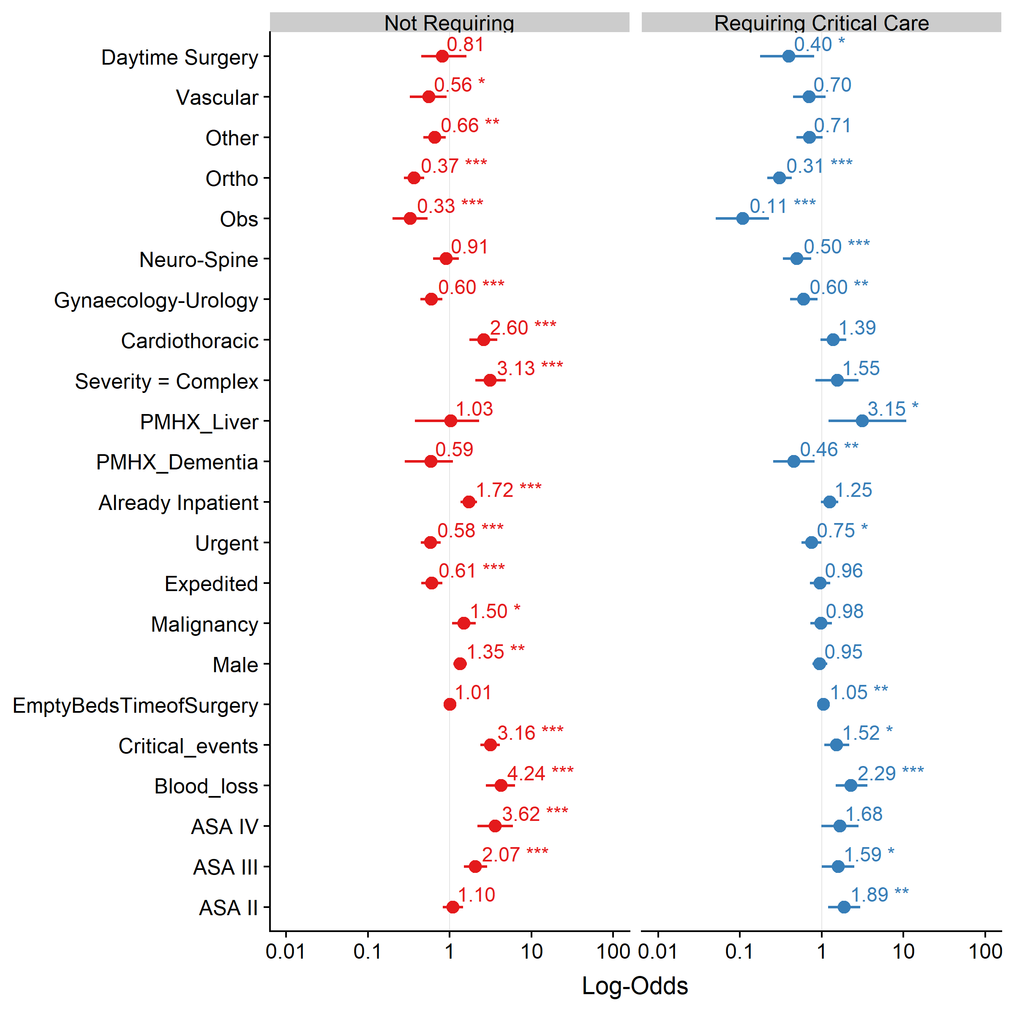

Figure 7‑5: Forest plots of adjusted odds ratios for factors associated with admission to critical care in both patients who were perceived to require and perceived not to require critical care in the fixed-effects logistic regression models. For ease of interpretation, due to the large number of variables, variables with no significant effects for either subgroup of patients have been removed from the plot. Age was modelled using a natural spline transformation and left out of the plot for this reason. PMHX = Past Medical History; Obs = Obstetric; Ortho = Orthopaedics; * p <0.05, ** p <0.01, *** p <0.001.

The patients who were later admitted despite not being perceived to require critical care were more likely to be male, more likely to be ASA-PS III or higher, and more likely to be undergoing Xmajor or Complex surgery. Age was again modelled with a natural spline transformation and better appreciated with a marginal plot (Figure 7-6).

Patients with a perceived requirement for critical care were increasingly likely to be admitted as more empty critical care beds were available around the time of surgery.

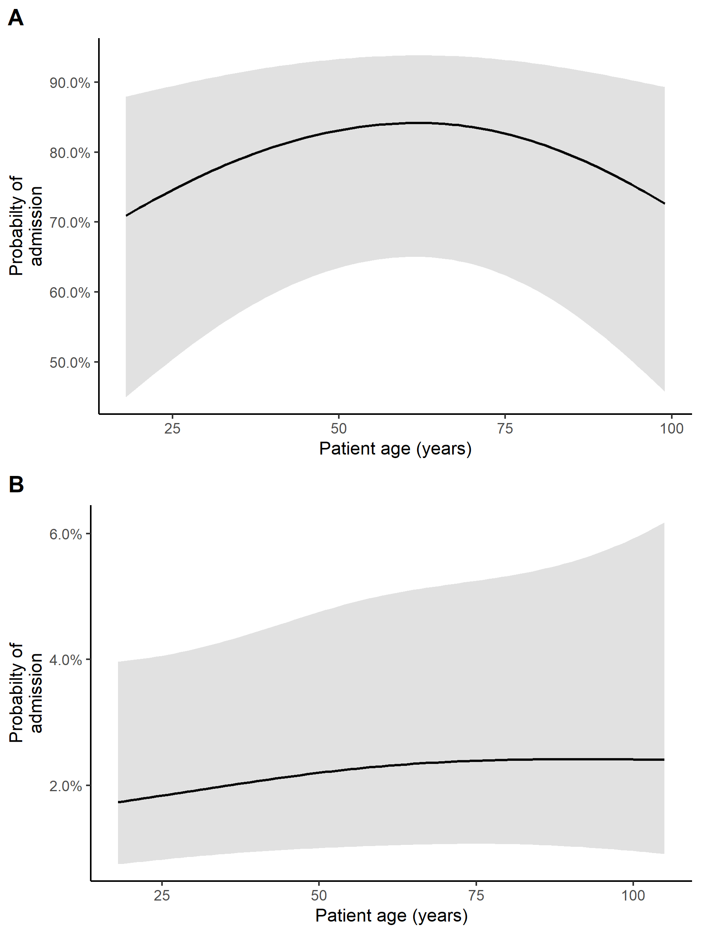

Figure 7‑6: Plots of the marginal effects age on admission to postoperative critical care in patients who were perceived to require critical care (A), and in patients who were perceived to not require critical care recommendation (B). For these marginal effects plots, other categorical variables are held constant at their reference value, while other continuous variables are held constant at their mean values.

#### Mixed-effects (Multilevel) modelling

A number of multilevel models were again constructed (Table 7-6) to investigate the hospital-level factors which influence eventual critical care admission within the subsets of patients perceived to require (Models D to F) and perceived not to require critical care (Models G to I), and quantify the inter-hospital variability in critical care admission.

Table 7‑6: Summary of the multilevel logistic regression models fitted in the second part of analysis in this chapter. Final model chosen is in **bold**. MOR = Median Odds Ratio; AIC = Akaike’s Information Criterion.

|  |  |  |  |  |  |  |
| --- | --- | --- | --- | --- | --- | --- |
| Model name | Terms | Dataset | Description | MOR | AIC | Interpretation |
| Model D | No fixed terms + random intercept for hospitals only | Patients with **perceived requirement** for critical care | Assesses whether there is clustering in the data by sites, i.e. is there inter-hospital variation in the likelihood of being admitted to in patients perceived to require critical care. | 3.15 | 2539.59 | The variance of the random intercept for hospitals when transformed into an Odds Ratio scale was 3.15, suggesting there was substantial inter-hospital variation in the likelihood for patients being admitted postoperative critical care. |
| Model E | Patient-level fixed-effects explanatory variables + random intercept | Patients with **perceived requirement** for critical care | Adjusts for differences in patient case-mix that might account for differences between hospitals in the likelihood of being admitted to critical care after having a perceived requirement for critical care. | 3.21 | 2280.27 | Introduction of patient-level variables improved model fit (reduced AIC compared to Model D) but did not explain any of the inter-hospital variation in admissions to critical care after patients were perceived to require critical care (the MOR was not reduced compared to Model D). |
| **Model F** | **Patient-level and hospital-level fixed-effects explanatory variables + random intercept** | **Patients with perceived requirement for critical care** | **Estimates the hospital-level effects which are associated with the likelihood of being admitted to critical care.** | **3.15** | **2285.59** | **Introduction of hospital-level variables did not explain any of the inter-hospital variation in admissions to critical care after patients were perceived to require critical care, nor improve the model fit compared to Model E.** |
| Model G | No fixed terms + random intercept for hospitals only | Patients **perceived not to require** critical care | Assesses whether there is clustering in the data by sites, i.e. is there inter-hospital variation in the likelihood of being admitted despite not being perceived to require critical care. | 3.74 | 4065.07 | The variance of the random intercept for hospitals when transformed into an Odds Ratio scale was 3.74, suggesting there was substantial inter-hospital variation in the likelihood for patients being admitted postoperative critical care. |
| Model H | Patient-level fixed-effects explanatory variables + random intercept | Patients **perceived not to require** critical care | Adjusts for differences in patient case-mix that might account for differences between hospitals in the likelihood of being admitted to critical care after being perceived to require critical care. | 3.89 | 3414.92 | Introduction of patient-level variables improved model fit (reduced AIC compared to Model G) but did not explain any of the inter-hospital variation in admissions to critical care after patients were perceived not to require (the MOR was not reduced compared to Model D). |
| **Model I** | **Patient-level and hospital-level fixed-effects explanatory variables + random intercept** | **Patients perceived not to require critical care** | **Estimates the hospital-level effects which are associated with the likelihood of being admitted to critical care.** | **3.75** | **3413.13** | **Introduction of hospital-level variables did not explain any of the inter-hospital variation in admissions to critical care after patients were perceived not to require critical care, nor improve the model fit compared to Model H.** |

In the final chosen models (Figure 7-7), critical care bed availability (measured by empty beds at the time of surgery and the number of critical care beds as a proportion of total hospital beds) were not significantly associated with the likelihood of critical care admission, both in patients perceived to require and perceived not to require critical care. Patients operated on in hospitals with emergency departments were again less likely to be admitted in those perceived not to require critical care (adjusted OR = 0.37, 95% CI: 0.16 to 0.85).

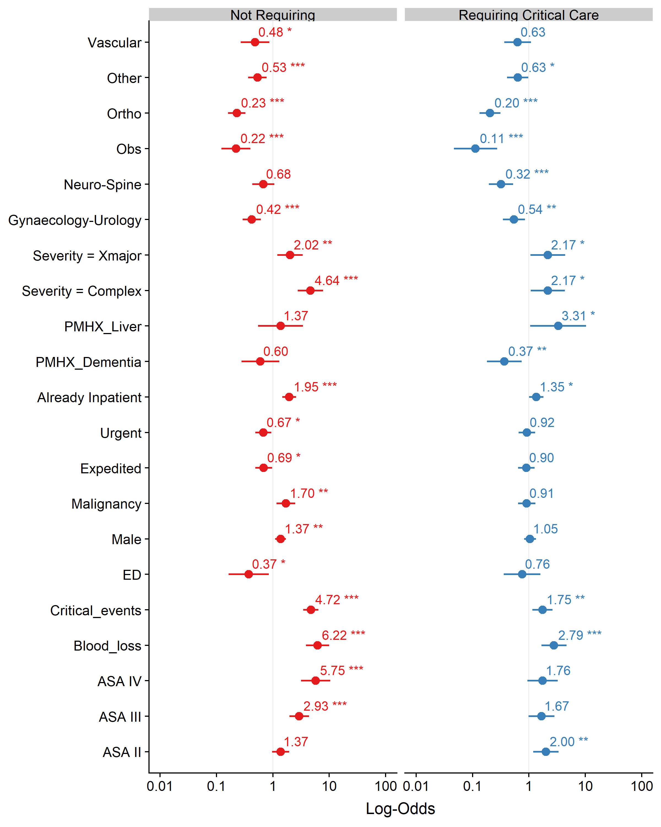

Figure 7‑7: Forest plots of adjusted odds ratios for factors associated with admission to postoperative critical care in the final multilevel logistic regression models. For ease of interpretation, due to the large number of variables modelled, variables with no significant effects for either subgroup of patients have been removed from the plot. Age was modelled using a natural spline transformation and left out of the plot for this reason. PMHX = Past Medical History; Obs = Obstetric; Ortho = Orthopaedics; * p <0.05, ** p <0.01, *** p <0.001.

## Discussion

### Key Findings

In this chapter, the postoperative critical care admission pathway was broken down into 1) being perceived to require admission followed by 2) later admission to critical care. Using fixed-effects and mixed-effects logistic regression modelling, the relationship between patient-level and hospital-level factors, and the likelihood of patients being perceived to require and eventually being admitted to critical care were investigated. The independent effects of different risk variables on clinical decision-making were estimated.

First, increased age was non-linearly associated with increased likelihood of being perceived to require critical care, with its marginal effect increasing between 18 to 69 years, plateauing around 70 years and then declining. Other variables known to be associated with increased risk of mortality were positively associated with perception of requirement for critical care, such as increasing ASA-PS grade, increasing surgical complexity and urgency.

Second, increased availability of critical care beds — both around the time of surgery (measured using the number of empty but staffed critical care beds) and more generally on a hospital-level (measured using the percentage of critical care beds as a proportion of the total number of beds in a hospital) — was significantly associated with a perceived requirement for critical care. However, the effect of critical care bed availability on perceived requirement was small compared to the effects of patient mortality-risk variables.

Third, the presence of an emergency department at the hospital where patients undergo their surgery was negatively associated with perceived critical care requirement, but not with later critical care admission. While the addition of hospital-level variables explained some of the inter-hospital variation seen for both perceived requirement for and admission to critical care, substantial variation remains unexplained by the constructed models.

Fourth, patients undergoing cardiothoracic surgery were much more likely to be perceived to require critical care compared to gastrointestinal surgery, but other surgical specialties were much less likely to have a perceived requirement, despite adjusting for other risk variables.

Finally, intraoperative episodes such as large volume blood loss and unexpected critical events were associated with critical care admission in patients with a perceived requirement for critical care, and patient-level mortality-risk variables were much less influential in their effects on admission once patients were already perceived to require critical care.

### Interpretation

Whether to admit a patient to critical care after their surgical procedure is a complex decision that clinicians must make, after considering a wide range of factors. Individual patient mortality risk has a large estimated effect on the decision-making process, with higher risk patients (increased ASA-PS grades, more complex surgery, higher surgical urgency, and those with cardiorespiratory comorbidities) being more likely to have a perceived requirement for admission to critical care. However, certain patient characteristics may discourage clinicians from deciding that their patients should receive critical care, such as comorbid dementia, and increasing age beyond 70 years-old.

While the availability of resources should ideally not influence clinical decision-making and patients should be assigned treatment based on clinical need, this analysis shows that the increased availability of empty critical care beds has a small but significant association with clinicians perceptions for requiring critical care for individual patients. The magnitude of this effect is greatly outweighed by the effect-sizes detected for the risk variables in the model, but nonetheless one can infer that there is a subtle effect of exogenous influences on clinical decision-making at play here. This effect is further confirmed by the finding that patients undergoing surgery in hospitals with a higher proportions of critical care beds were also more likely to be perceived to require critical care.

After adjustment for baseline factors related to mortality risk such as ASA-PS grade, age, surgical severity and urgency, etc., there was a marked difference in the likelihood for having a perceived requirement for critical care depending on which surgical specialty the patient was being treated by. Compared to gastrointestinal surgery patients, cardiothoracic patients were more than twice as likely to be perceived to require critical care, while orthopaedic, obstetric, gynaecology and urology patients were less than half as likely. Patients of a similar risk profile are therefore not regarded as requiring critical care to a similar extent, and the reasons for this could be multiple.

First, clinical pathways have evolved in cardiothoracic surgery which mandate the ring-fenced provision of Level 2 or 3 facilities for postoperative recovery (67,68). The 2016 Guidance for the Provision of Anaesthesia Services (GPAS) for cardiothoracic patients states, *“The nature of cardiac surgery demands that all patients should be cared for post-operatively in a unit that conforms to the standards of general level 3 and 2 intensive care facilities.”* Similarly, the Getting It Right First Time Programme National Specialty Report for Cardiothoracic Surgery, published in 2018, recommended that, *“All cardiac surgery and many thoracic surgery patients initially recover on an Intensive Treatment Unit (ITU) after their operation.”*

Second, certain specialties may not perceive there to be any benefit from critical care admission for their patients. For example, patients undergoing orthopaedic surgery typically undergo early intensive physical rehabilitation in order to decrease length of stay, postoperative complications and costs, and increases function and quality of life (187). Intensive care and high-dependency care in contrast is associated with exposure to hospital-acquired infections, reduced access to early mobilisation, oversedation, sleep deprivation, stress, and delirium, all of which conflict with postoperative orthopaedic rehabilitation goals (62).

Third, certain specialties may not be historically or culturally primed to recommend critical care to their patients after surgery, because of entrenched behaviours that govern their clinical practice (188), or because of a lack of familiarity with critical care within their surgical specialty training (189). There might therefore be higher thresholds to critical care referral that exist for patients undergoing procedures in these specialties, regardless of whether or not they are appropriate.

Fourth, other unmeasured confounders not modelled within this analysis might contribute to the risk profile assessment of the patients within certain specialties, above and beyond factors such as ASA-PS grade, age and so on. The presence of certain specific rare diagnoses might be highly influential in determining whether a patient would be perceived to require critical care for some surgical specialties, more so than the factors considered. For example, a diagnosis of eclampsia (population risk of 2.7 cases per 10,000 live births) is highly predictive of critical care admission (190).

Undergoing surgery in a hospital with an emergency department (ED) was found to be associated with reduced likelihood of perceived critical care requirement. This finding was consistent with earlier published findings using data from SNAP-2: EPICCS that patients were approximately four times as likely to suffer on-the-day surgical cancellations if their procedure was scheduled in a hospital with an ED (111). The proposed mechanism for this finding is that medical patients presenting via ED to hospital compete for the same pool of critical care beds with surgical patients, thus increasing the threshold for patients to be allocated critical care.

Once the clinical team perceived a requirement for critical care, the majority of patients would subsequently receive admission. However, within this group, patients with increasing age beyond 70 years, with comorbid dementia, and undergoing surgery under surgical specialties are less likely to be admitted, while those with intraoperative critical events and high-volume blood loss were more likely to be admitted. The effects of critical care bed availability no longer appear to be as influential once the decision that the patient needed critical care was made. In contrast, patients who were not perceived to require critical care were subsequently also much less likely to then later be admitted to critical care, and within this second group, intraoperative complications appeared to have a much larger influence in eventual admission.

The MOR for the multilevel models presented in this analysis demonstrated that a substantial amount of unexplained variance persisted despite the patient-level and hospital-level variables considered. The inter-hospital variations when quantified using MOR (e.g. 1.58 for Model C in Table 7-3) are of an order of magnitude larger than some comorbidities such as cardiac (OR = 1.31) or respiratory (OR = 1.22) disease. In other words, for two similar patients presenting to two different hospitals, their likelihood of being perceived to require critical care or being admitted to critical care could vary as much as two otherwise similar patients, one with comorbid ischaemic heart disease and the other without, presenting to the same hospital for the same type of surgery.

This study therefore highlights that there may be other factors which may be influential in decision-making and admission which have not been considered within this chapter that warrant further investigation, both at a patient level and at an institutional level. Some of these factors may be related to inter-hospital differences in clinician behaviour, culture, logistics and patient pathways which may not be easily captured in a quantitative observational study. Further investigation into the other factors which may influence clinical decision-making around postoperative critical care is thus needed to understand why differences in critical care resource allocation occurs.

### Study limitations

In this analysis, the decisions that clinicians take have been simplified into binary response variables, but this may be a crude model of clinical decision-making. In reality, a clinician may have more than two options for managing a high-risk patient, beyond simply determining their discharge destination. Furthermore, decisions are often arrived at through consultation with the wider multidisciplinary team in conjunction with the patient. A patient may state a preference for or against critical care admission, due to previous experience, or treatment may be for palliative reasons, all these were factors not captured within the data variables modelled. Clinical teams may consider cancellation or postponement of surgery for the highest-risk elective patients until critical care beds are available, in which case their data would not have been sampled within this dataset. Alternative management on the general ward with critical care outreach support may be an acceptable pathway in some hospitals, and there may thus be a spectrum of intensity in the amount of postoperative surveillance available in certain institutions.

The response variable of perceived requirement for critical care used in the part one analysis was filled in around the time of surgery, and although anaesthetists were asked to complete the field as though they were deciding preoperatively whether the patient would require critical care once the procedure was finished, there was no way of policing whether the response to this was influenced by intraoperative findings. The CRFs could have been completed at any time whilst the patient was undergoing surgery, including intraoperatively or during the immediate postoperative period. This could introduce additional information that biased responses about anticipated risks, for example if there were intraoperative complications with haemorrhage or haemodynamic instability, an otherwise low risk patient which would not have been perceived to require critical care might have had their recorded perceived requirement for critical care variable changed by the anaesthetic team retrospectively. However, there is evidence from the data that if this did happen, it did not have a substantial effect on the study findings, as the odds ratios for intraoperative critical events and blood loss were lower for the subgroup with perceived requirement for critical care than for the subgroup without.

### Clinical implications

Although clinicians largely base their decisions about who needs to be admitted for critical care postoperatively on the risk profiles of their patients, exogenous factors such as the availability of critical care beds — both on the day of surgery, and more broadly as a function of institutional capacity — exert a subtle influence. Similarly, risky patients may be more or less likely to have a perceived requirement for critical care if they underwent surgery at an institution with more or less critical care beds in general, or at a time coinciding with more or less empty beds. Furthermore, similarly risky patients from particular surgical specialties may be more or less likely to be perceived to require critical care, based largely on specialty-specific factors, which may not have strong clinical merit. For example, a 65 year-old patient with exertional angina undergoing coronary artery bypass grafting is much more likely to be perceived to require and then to receive critical care admission than another patient of similar age and similar baseline risks undergoing surgery of a different specialty, all other factors being equal, even though the predicted risk of mortality in either patient may be similar.

Clinicians should therefore be mindful of their reasons for and against deciding a patient needs critical care when faced with an individual presenting in front of them for surgery. They should also be cognizant of biases which influence their decision-making about resource allocation, especially when the treatments allocated may affect patient outcomes.

### Summary

Patients with increased risk factors for postoperative mortality are more likely to have a perceived requirement for critical care, and although critical care bed availability has a significant influence, the effects of patient risk factors and surgical specialties on clinical decision-making about postoperative critical care admission are larger. Although a number of factors have been identified which are influential in being perceived to require and eventually being admitted to critical care, a substantial amount of residual unexplained inter-institutional variance still exists that has not been accounted for within these analyses.

##### PAGE BREAK

# Conclusions and future directions

## Summary of the thesis

Critical care is a complex medical intervention and admission to critical care following surgery is a component of the postoperative recovery pathway. The fundamental differences in structures and processes in critical care allow the delivery of higher levels of nursing and medical monitoring and therapies compared to general ward care, but consequently critical care is more costly, and its availability is limited.

The scarcity of critical care beds, deficits in the accuracy of identifying patient risk, and equipoise over the efficacy of postoperative critical care have all been cited as reasons for the apparent misallocation of critical care resources seen in previous studies.

In this thesis, I presented findings from the Second Sprint National Anaesthesia Project: EPIdemiology of Critical Care Provision (SNAP-2: EPICCS) study to (1) investigate the availability of postoperative critical care resources in the UK, Australia and New Zealand; (2) describe the risk profile and outcomes of patients undergoing inpatient surgery in these countries, and the proportions of patients admitted to critical care following their surgery; (3) assess how accurate clinicians are at evaluating patient mortality risk comparing their accuracy to available objective risk tools; and finally, (4) explore the factors which affect clinical decision-making around postoperative critical care.

### Epidemiology of inpatient surgery and critical care admission

Patients who underwent surgery recruited to the SNAP-2: EPICCS cohort are likely to be a representative sample of the general population of surgical patients due to the non-consenting study methodology adopted. Using the data collected from this patient sample, the wider population of patients undergoing surgery could therefore be described. Patients undergoing a range of different surgical procedures, with differing surgical complexity and urgency were included in the cohort. The majority (more than two-thirds) of patients were either ASA-PS I or II patients, and the predicted mortality risks of the patients were low in general.

Approximately one in nine patients were admitted to critical care immediately after surgery, with the majority of them being planned admissions. About one out every 100 patients was admitted to critical care on a later date after surgery for treatment of complications. Only about a third of patients with mortality risks ≥5% (predicted with P-POSSUM, SORT, or SRS) received immediate critical care admission. This finding was consistent across the three countries contributing data.

Postoperative mortality on the whole is low, the in-hospital mortality in this cohort was 1.2% at 30 days, and 1.4% at 60 days. Patients who were admitted to critical care immediately after surgery had higher mortality and morbidity rates, however the mortality rate for patients who were admitted to critical care later on during their hospital stay was higher still.

The median postoperative length of stay in hospital overall was 2 days, but lengths of stay generally varied according to surgical specialty, and were longer in patients admitted to critical care immediately after surgery (median 7 days). Approximately one in seven patients who underwent surgery with a planned overnight stay remained in hospital seven days following their procedure with some form of morbidity (as defined by POMS). Around two-thirds of patients who remained in hospital seven days after their surgery were found to suffer from POMS-defined morbidity. The incidence of POMS-defined morbidity was higher in patients who were directly admitted postoperatively to critical care (approximately 43%) than patients who were not directly admitted (approximately 10%).

The research questions introduced in *Chapter 1* will be revisited in the following sections to summarise the findings of this thesis.

### What is the availability of critical care, including high-acuity care areas?

Approximately 3% of all hospital beds in the UK, Australia and New Zealand are designated ICU or HDU beds, however notable differences in availability of postoperative critical care exist between the three country. UK hospitals had a lower median proportion of critical care beds compared to their counterparts in Australasia (2.7% in the UK vs 3.7% in Australia and 3.5% in New Zealand). When expressed in per capita terms, the UK had an estimated 9.3 critical care beds per 100,000 population, which was comparable to the estimate for New Zealand (9.1 beds per 100,000 population), while the estimate for Australia was higher (14.1 beds per 100,000 population) both other countries. These estimates update historical estimates from the literature, and demonstrate a trend of increasing per capita availability of critical care in these countries over approximately the last decade.

Approximately a third of hospitals in all three countries reported the use of high-acuity care areas which admitted higher-risk post-surgical patients unsuitable for the ward. On average, these high-acuity areas were small 4-bedded units with nursing ratios of one nurse to two patients. They were able to provide a heterogenous mix of postoperative monitoring and treatment modalities including continuous observations, invasive blood pressure monitoring, vasoactive infusions, etc.; almost half of them were managed by surgeons with no input from anaesthesia or intensive care specialists. Larger hospitals providing tertiary service were more likely to report using such high-acuity beds, suggesting that they are being used to augment the critical care capacity in hospitals where intensive care or high-dependency unit (ICU/HDU) bed capacity may be insufficient to support the volume of surgical activity.

When high-acuity areas and critical care beds are considered in total, the critical care capacity to support postoperative patient recovery is potentially increased.

### How do clinicians estimate postoperative risk, and how accurate are currently available prediction tools?

Patients undergoing surgery should ideally be risk-assessed prior to surgery, and although a number of objective risk tools are available for routine clinical use, the vast majority (over 80%) of clinicians used only subjective clinical assessment (either individual clinical judgement and/or ASA-PS grading) in estimating their patients’ mortality risks preoperatively.

When externally validating three objective risk tools (P-POSSUM, SORT and SRS) using the SNAP-2: EPICCS dataset, all three models showed good-to-excellent discrimination, with the best performing model, SORT, having an Area under the Receiver Operating Characteristic curve (AUROC) of 0.91. However, in terms of calibration, the objective risk tools all appeared to overestimate the probability of 30-day mortality, especially at the highest extremes of risk.

In comparison, subjective clinical assessment appeared to discriminate high-risk from low-risk patient similarly well as the best-performing objective tool, with an AUROC of 0.89. Clinicians were also similarly overestimating risk when calibration curves were plotted.

A model incorporating information from both subjective clinical assessment and objective risk tools showed improved discrimination and calibration compared to subjective clinician assessments alone, suggesting that clinicians’ subjective risk assessments may be further improved by combining information from objective risk tools. In addition to discrimination and calibration, combining information from both sources also results in improved predictions based on continuous net reclassification index, and decision curve analyses, suggesting that improved predictions have real-world clinical implications. A final model was presented which incorporated subjective clinical assessment and SORT variables performed the best out of all the models assessed and may play a role in clinical care in the future.

Taken together, there is little evidence to support the hypothesis that poor clinical risk assessment is a reason for poor identification of patients to refer to critical care admission, as the discrimination was high for all risk models (both subjective and objective), and the overestimation of risk identified in calibration analysis should result in more patients referred to critical care, not less.

### How do clinicians decide which patients to admit for postoperative critical care and what factors are influential?

Around one in ten patients had a perceived requirement for critical care admission by the perioperative team. These patients were more likely to be older, and have higher ASA-PS grades, and increased comorbidities. Substantial inter-hospital variation existed in the likelihood of patients being perceived to require critical care admission, and this variation persisted even after patient- and hospital-level variables were accounted for.

Fixed-effects and mixed-effects logistic regression models showed that the factors which were most strongly associated with a critical care referral were high ASA-PS grades, higher complexity surgery, and emergency surgery. Increased critical care capacity, both in terms of day-to-day variation (expressed as the number of empty beds around the time of surgery), and general availability of critical care (expressed as a proportion of total hospital beds), were significantly associated with increased likelihood of recommendation, although the magnitude of this association was small in comparison with other factors. The likelihood of being recommended critical care admission was also strongly associated with surgical specialty — some specialties, such as orthopaedics and obstetrics, were highly unlikely to recommend critical care after accounting for patient risk factors compared with gastrointestinal surgery.

Once patients received a critical care recommendation, around three-quarters would then go on to be admitted to critical care, while only around 2% of those who did not receive a recommendation would be admitted. Unexpected intraoperative critical events and large volume blood loss were both associated with increased admission, for both patients recommended and not recommended critical care. Critical care bed capacity was not significantly associated with admission after critical care recommendation and other factors were considered. Substantial inter-hospital variation existed in the likelihood of admission despite accounting for other variables in the mixed-effects models.

## Other decisions around the time of surgery — whether to cancel

Much of the focus within this thesis has been predicated on the assumption that clinicians are limited to making a single dichotomous decision when faced with a high-risk patient, i.e. whether to admit the patient postoperatively to critical care or not. However, during the course of conducting this research, it became apparent from interactions with collaborators that there might be more complex decisions that could be made. Whether to cancel or delay surgery in the face of insufficient critical care capacity was often cited as an alternative option. Therefore, a planned analysis of SNAP-2: EPICCS data limited to UK hospitals was conducted looking at the incidences and reasons for on-the-day surgical cancellations (111).

In this analysis, approximately 10% of the UK patients who underwent surgery in SNAP-2: EPICCS reported a previous cancellation, while approximately 14% of patients who presented when the study was being conducted did not proceed with surgery on the day. Non-clinical reasons, predominantly inadequate bed capacity, accounted for a large proportion of previous cancellations. Independent risk factors for cancellation due to inadequate bed capacity included requirement for postoperative critical care (Odds Ratio [OR]: 2.92; 95% confidence interval [CI]: 2.12–4.02) and the presence of an emergency department in the treating hospital (OR:4.18; 95% CI: 2.22–7.89). Findings from this analysis attracted substantial media attention, including from general news outlets (191–195), and are likely to add weight to the policy discussions surrounding service planning in the future.

When combined with the other findings presented within this thesis, results from this analysis on surgical cancellations suggest that beyond information about patient-level risk factors, exogenous contextual factors like critical care availability and overall bed capacity exert an important effect on clinicians making decisions about their patients in the perioperative period.

## Outstanding questions and future directions

SNAP-2: EPICCS was a wide-ranging and ambitious observational study and its scope exceeded that of this PhD thesis. Research questions which remain that it may help to provide answers to include:

1. How effective is postoperative critical care on patient outcomes after surgery?
2. What are the perceptions of clinicians towards critical care?
3. What are the long-term outcomes following surgery in both patients admitted and not admitted to critical care?

These outstanding questions will require long-term mortality outcomes to be obtained via linkage with administrative Hospital Episode Statistics and Office of National Statistics data in the future. Data linkage is currently underway and will constitute ensuing work beyond this PhD. Furthermore, within the programme of SNAP-2: EPICCS, data on clinician perceptions towards postoperative critical care were collected alongside the organisational survey and patient cohort studies, and will be reported elsewhere. The analyses of these residual components of SNAP-2: EPICCS will be conducted according to previously published analysis plans (72).

However, beyond the confines of observational research, the fundamental question of the effectiveness of critical care on postoperative outcomes may require the conduct of randomised controlled studies to completely remove the effects of confounding by indication, even with causal inference techniques like propensity score analysis and instrumental variable analysis. In this thesis, particularly in *Chapter 7*, we see that clinician perception of requirement for critical care is predictive of whether patients eventually get admitted. Three-quarters of the patients who were perceived to require critical care in the SNAP-2: EPICCS patient cohort ultimately received admission. This suggests that the clinician’s opinions on whether patients should receive critical care are a strong confounder that may not be entirely adjusted for by statistical means. I personally believe that there is sufficient equipoise over the benefits of critical care, especially in the intermediate risk groups of between 5% and 10% predicted mortality, that it would be ethical to conduct such a randomised study in the future.

In this thesis, I have provided evidence for the increased accuracy that could be achieved through the combination of subjective and objective risk assessment information in determining an individual patient’s risk. Future experimental studies using this combined approach to risk prediction to guide clinical interventions would likely be useful. With increased availability of cheap and accessible computing devices, clinical decision support aids may allow clinicians to augment their subjective opinions and arrive at better clinical decisions. There is observational evidence from the National Emergency Laparotomy Audit (NELA), that increased documentation of predicted patient mortality risks has been associated with increased consultant anaesthetist and surgeon presence during high-risk emergency surgery, and may also be correlated with improved national mortality outcomes over time (22,86,88,196,197). It may very well be that through the routine use of combined risk prediction, more patients receive the correct intervention for them.

Therefore, future randomised studies in this area may involve using a combined risk prediction approach to estimate patient mortality risks preoperatively, to identify patients in the intermediate risk group for which the benefits of critical care are less certain, and then to randomise them to receive critical care or enhanced care or ward-level care.

As critical care is expensive and resources are finite, there is a need for future health economic studies examining the cost effectiveness of managing postoperative patients in ICU/HDU as compared to admitting them onto general ward or enhanced care/high-acuity beds instead. With the imminent arrival of consensus definitions and regulations for enhanced care beds (81–83), more clarity surrounding the use of such facilities to manage high-risk patients will emerge, which will allow health economic analysis to become feasible.

There is a growing literature surrounding the phenomenon of Post-Intensive Care Unit Syndrome, i.e. the long-term symptoms and signs associated with survivors of critical illness (198). Much of this literature is related to the patients who have prolonged stays on ICU, with medical diagnoses and prolonged organ support. While the postoperative stays on critical care seen in the SNAP-2: EPICCS cohort were short (median 2 days, with an upper quartile of 5 days), a small proportion of patients would have had long stays on critical care, who might warrant future study using qualitative methods. It would be interesting to patients to guide their expectations about whether a small risk of developing clinically significant critical care complications is a worthwhile price to pay for the intended benefits of undergoing high-risk surgery. This would align closely with the recommendation issued by the Choosing Wisely UK Anaesthesia and Intensive Care Medicine that, *“All patients considering an operation should have shared decision-making consultations to discuss their individual chance of benefit or harm and to identify their personal preference”* (199).

Finally, in this thesis I have identified a small but significant effect of clinical resource availability affecting clinical decision-making. Clinician perceptions of the requirement for critical care, although largely influenced by patient risk factors, were subtly associated with the availability of critical care beds, both at the time of surgery and more generally within the institution as a proportion of overall hospital beds. Cancellations were also more likely to occur when there are competing demands for critical care beds. These findings should be used to prompt a more general discussion about healthcare resourcing and rationing going forward. With an increasingly frail and ageing world population (11,161,200), and increasing burden of surgery into the future (10), more patients are likely to suffer complications from surgery. Frail older patients are more likely than younger, fitter patients to suffer from postoperative morbidity and mortality, but are less likely over the age of 75 to be admitted to critical care. As a society with finite means, we must discuss whether this is equitable. Policy makers must address this issue going forward.

## Conclusion

In this thesis, I have described current availability of postoperative critical care in the UK, Australia and New Zealand, and further identified and characterised the presence of high-acuity/enhanced care beds which may be used for high-risk patients recovering after surgery when formal critical care bed capacity may be insufficient.

The risk profile of patients undergoing inpatient surgery in these three nations has been reported, and the accuracy of subjective clinician assessment of risk has been investigated, and compared with existing objective risk assessment tools. Only about a third of patients at high-risk of mortality following surgery, as defined using a range of predictive tools, are admitted to critical care, which is a lower proportion than is expected. The discrimination of clinicians’ subjective assessments is comparable with the best performing objective risk tools, and clinician assessments are overly pessimistic. However, when information from both subjective risk assessment is combined with information from objective risk tools, the accuracy of predictions can be improved. In the combined predictive model reported, risk predictions are both statistically and clinically significant.

Finally, I described the factors which are strongly correlated with postoperative patients with a perceived requirement for and eventual admission to critical care. Although the availability of critical care beds has a marginal effect on decisions clinicians refer patients for critical care, this effect is small in comparison to patient risk factors for mortality, such as age, ASA-PS grade and the nature of the surgical insult. Once accounting for the perceived requirement for critical care, capacity is no longer significantly associated with eventual admission, and other factors such as intraoperative critical events and blood loss are more strongly correlated.

##### PAGE BREAK

# Personal Reflections

In conducting this programme of research work, I have personally learned a great deal, and the experiences I have gained during this PhD will likely deeply influence my future academic and clinical work. Project managing a large multicentre study with multiple stakeholders has been both difficult and rewarding. Negotiating the ethics and fulfilling the necessary governance requirements of conducting research without patient consent has been challenging.

## Seeking help and sharing early

The biggest lesson I have taken away from this process is that perfection is the enemy of good.[30] Academics often delay the public unveiling of their work or sharing it with others for fear of criticism and ridicule, striving instead to improve upon it in isolation. They think they can avoid failure and mistakes by identifying flaws within their work before other people find them first. However, this obsessive way of working only allows them to see the flaws that are visible from their own perspectives, delays the dissemination of knowledge and confines horizons. Instead, turning early work out brings views from other angles which would not have been possible in solitude. During the PhD, there have been many documents and manuscripts which I have had to prepare in order to conduct my research, and I have always regretted not seeking help early and sharing early drafts, to iteratively improve upon my work.

Collaboration with people of diverse skillsets has helped to fill gaps in my own skills, and managing a large group of researchers and clinicians during this PhD has broadened my access to people with wider knowledge than my own. There were many times when I needed to complete a task outside of my existing knowledge base, and seeking expertise from others was crucial in overcoming personal hurdles I faced. This is something that I will take with me back into clinical practice and continue doing in my research career.

## Understanding other’s motivations and personal incentives

During the course of conducting the research I realised that different stakeholders and individuals have slightly different needs and agendas, and the alignment of agendas is necessary to complete the project at hand. For the patient undergoing surgery, they might want to receive good clinical care to maximise their outcomes. For the clinicians delivering their care to the patient, they might want to perform their work with minimal interruption and go home on time, whilst focusing on the quality of care they deliver. For research and development staff at the hospital, they might want to ensure that the studies they are supporting are conducted efficiently with minimal deviation from protocol. For the funders of research, they might want to ensure that research outputs are published and disseminated widely and on time.

Spending some effort to understand the underlying motivations of each person taking part in the study, in whatever role they might have, is important. I have learned that seeking empathy with those around me helps to get the best from people.

## Understanding myself

Much of the work I have done during this PhD has relied on being organised and keeping track of different timelines. While being an anaesthetist was good training for this, the timelines in anaesthesia are shorter and the feedback from actions are generally more immediate: surgery never takes more than a few hours to finish, and most physiological changes react quickly to an intravenous drug bolus. In research, timelines can stretch out to weeks, months and years. I have learned that I do not like keeping multiple unfinished strands going simultaneously, and that I crave task completion in order to achieve a sense of closure.

Furthermore, I have enjoyed the autonomy that I have had over my time during this period of research. The feeling of being able to plan the project and control what I do during the day will help guide my future decisions about which projects I take on, and which projects I might choose to pass up.

Lastly, there have been periods in the PhD when I have been sitting in front of a computer or a stack of printed papers for a whole day without much human interaction. These have been the hardest parts of the research process, and I have come to realise that I enjoy social interaction and the happiest moments in research have been those where I have had the opportunity to share experiences with patients, colleagues and mentors. Finding a career role where I can participate in research discussions and facilitate other people’s research ideas, as well as my own, is a direction I hope to take.

##### PAGE BREAK

# Appendices

## Appendix 1: Organisational survey questions

Survey questions for the Organisational Survey described in *Chapters 2* and *3* were made available to lead investigators at each site. Respondents were given the opportunity to either respond via a web browser interface using an online survey tool, or respond via email through direct annotation of the paper survey form.

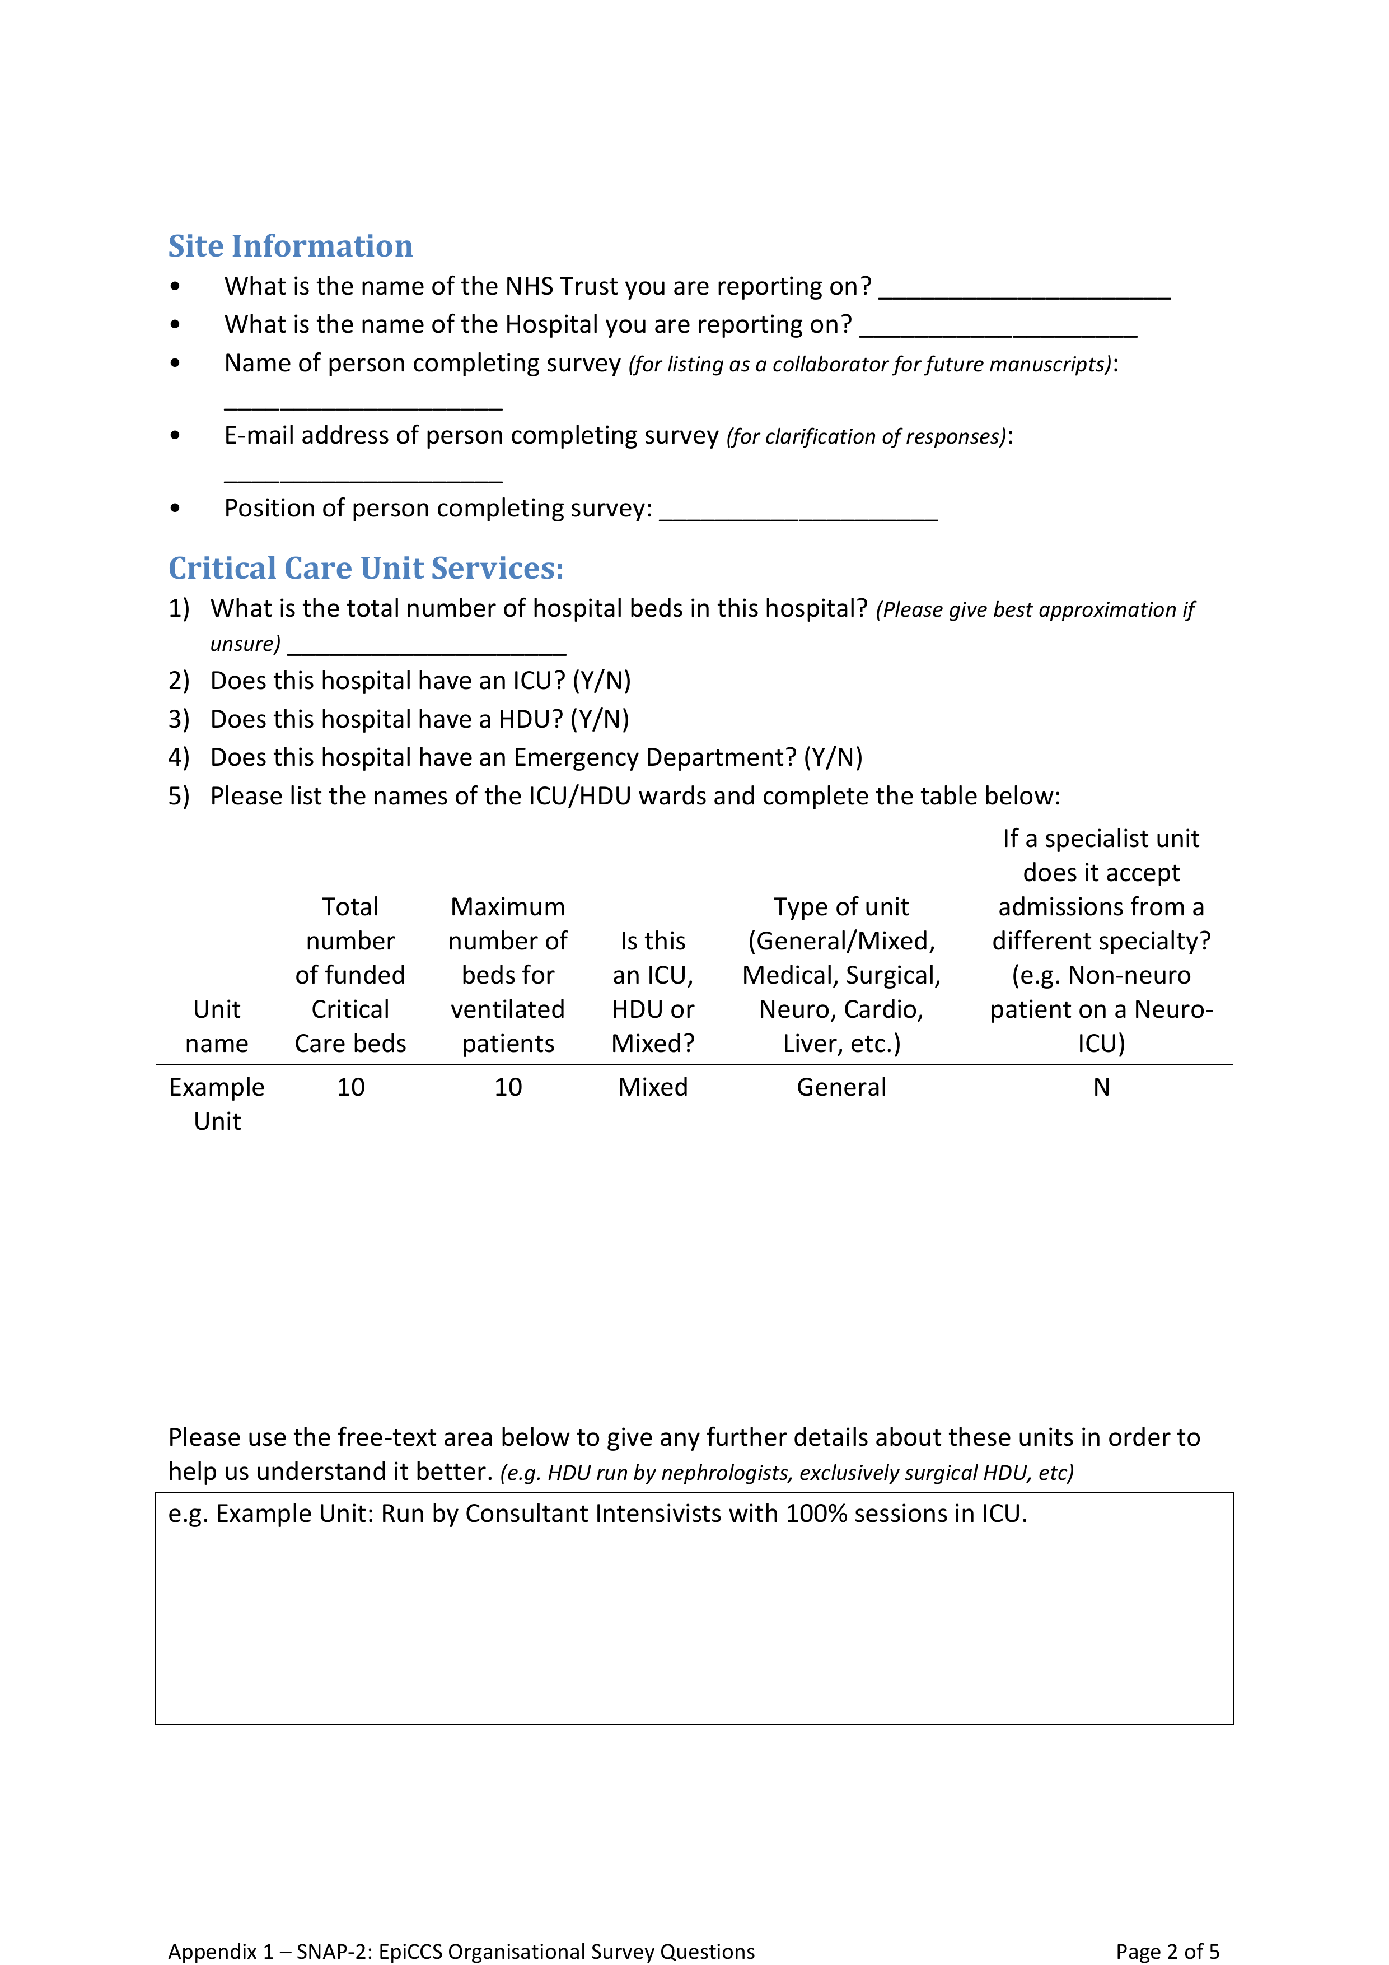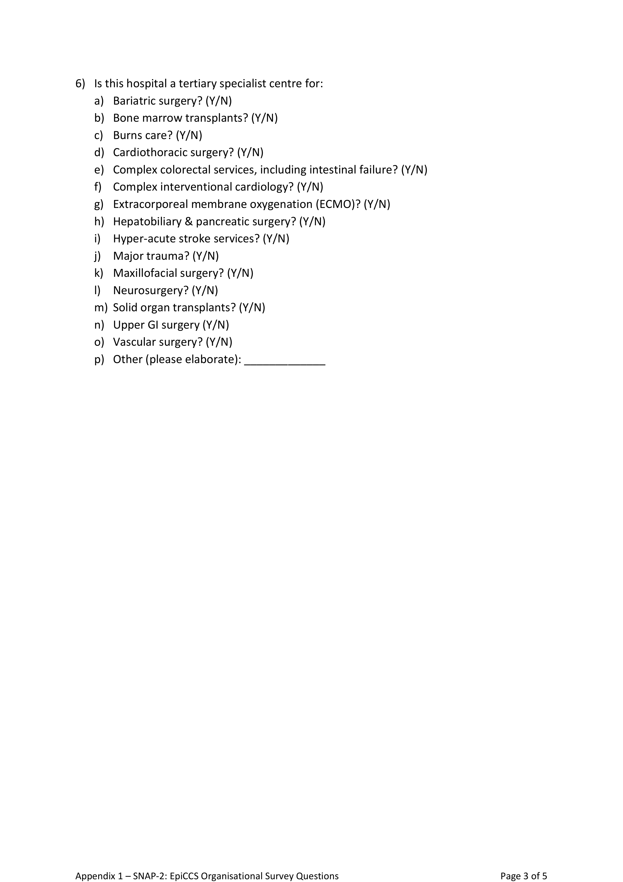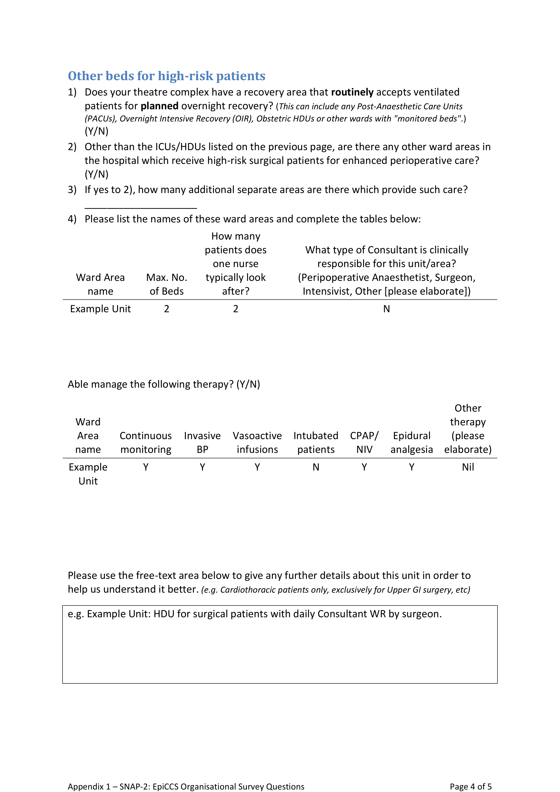

##### PAGE BREAK

## Appendix 2: Patient study CRF

The UK versions of the Case Record Forms (CRFs) for the patient study are presented here with help text annotations alongside in the right margin. Clinical anaesthetists would complete these CRFs on paper perioperatively and local investigators would later upload the data onto the online webtool. Minor changes were made to the CRFs to facilitate data collection in Australia and New Zealand.

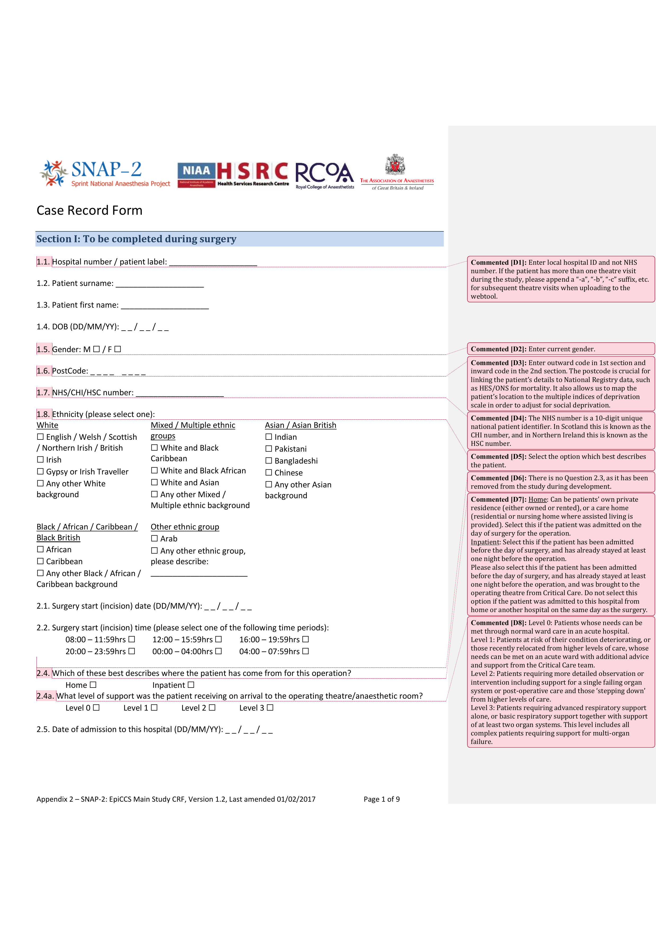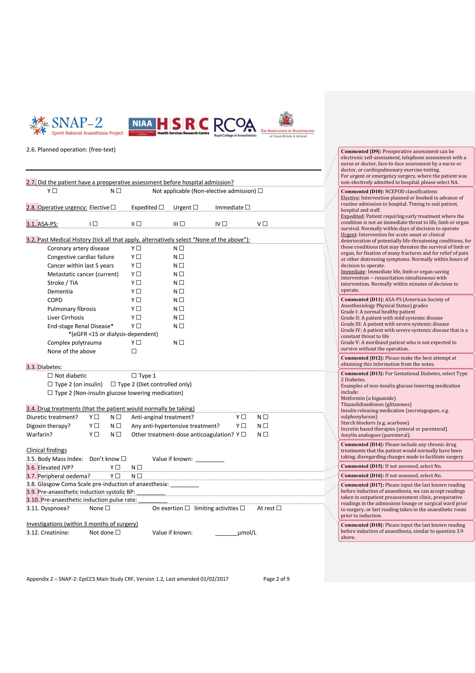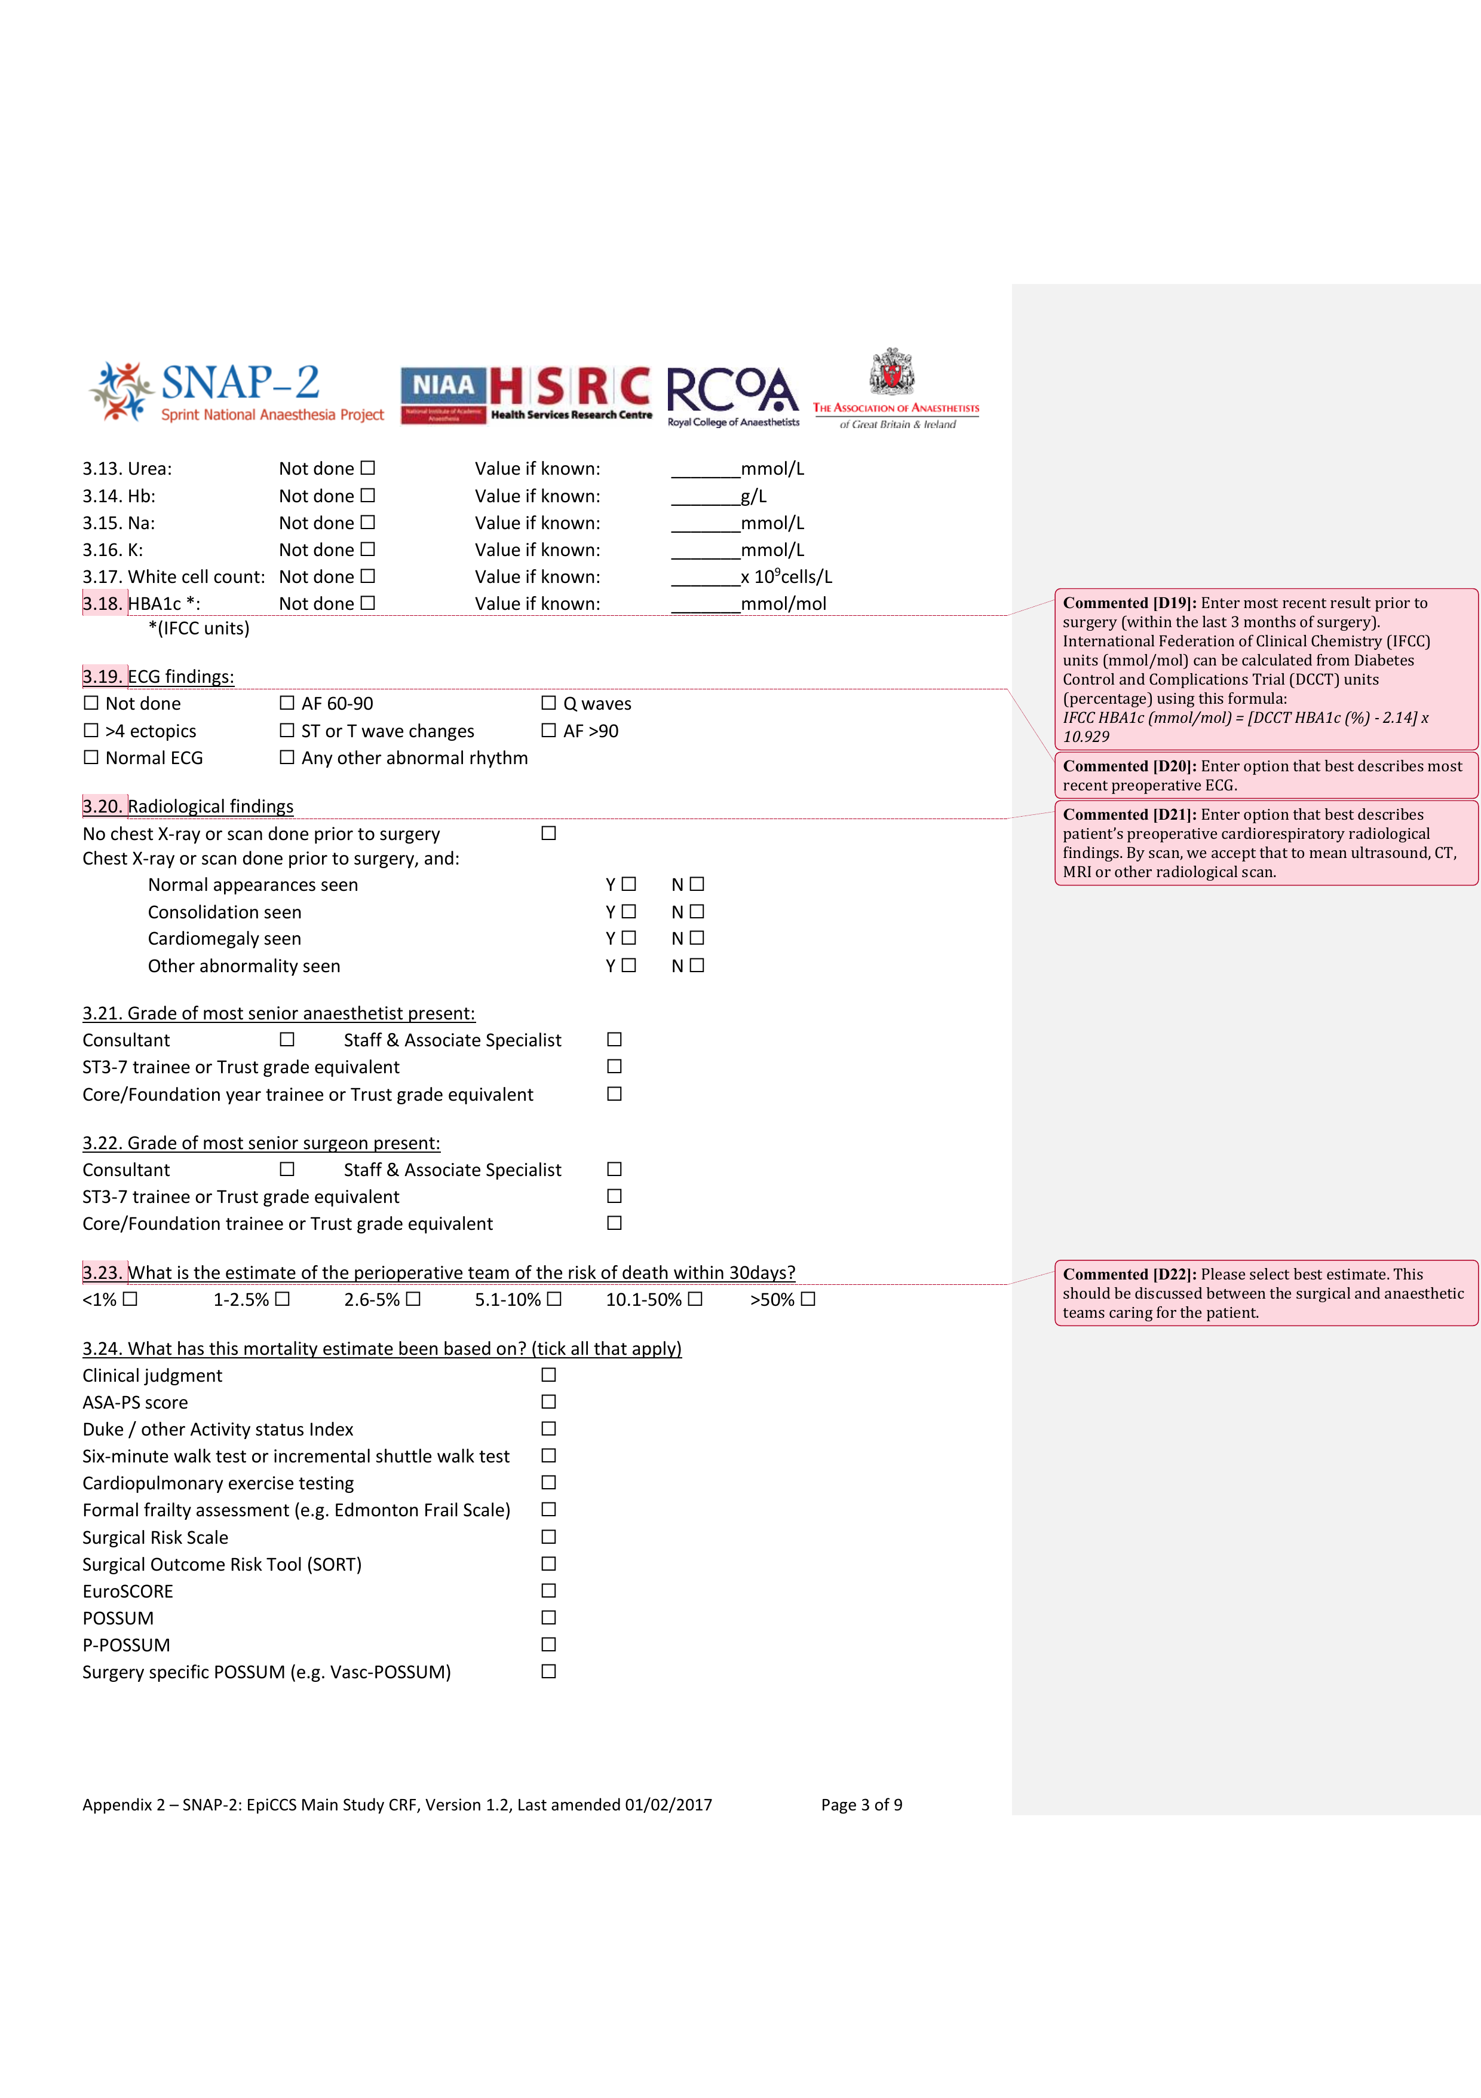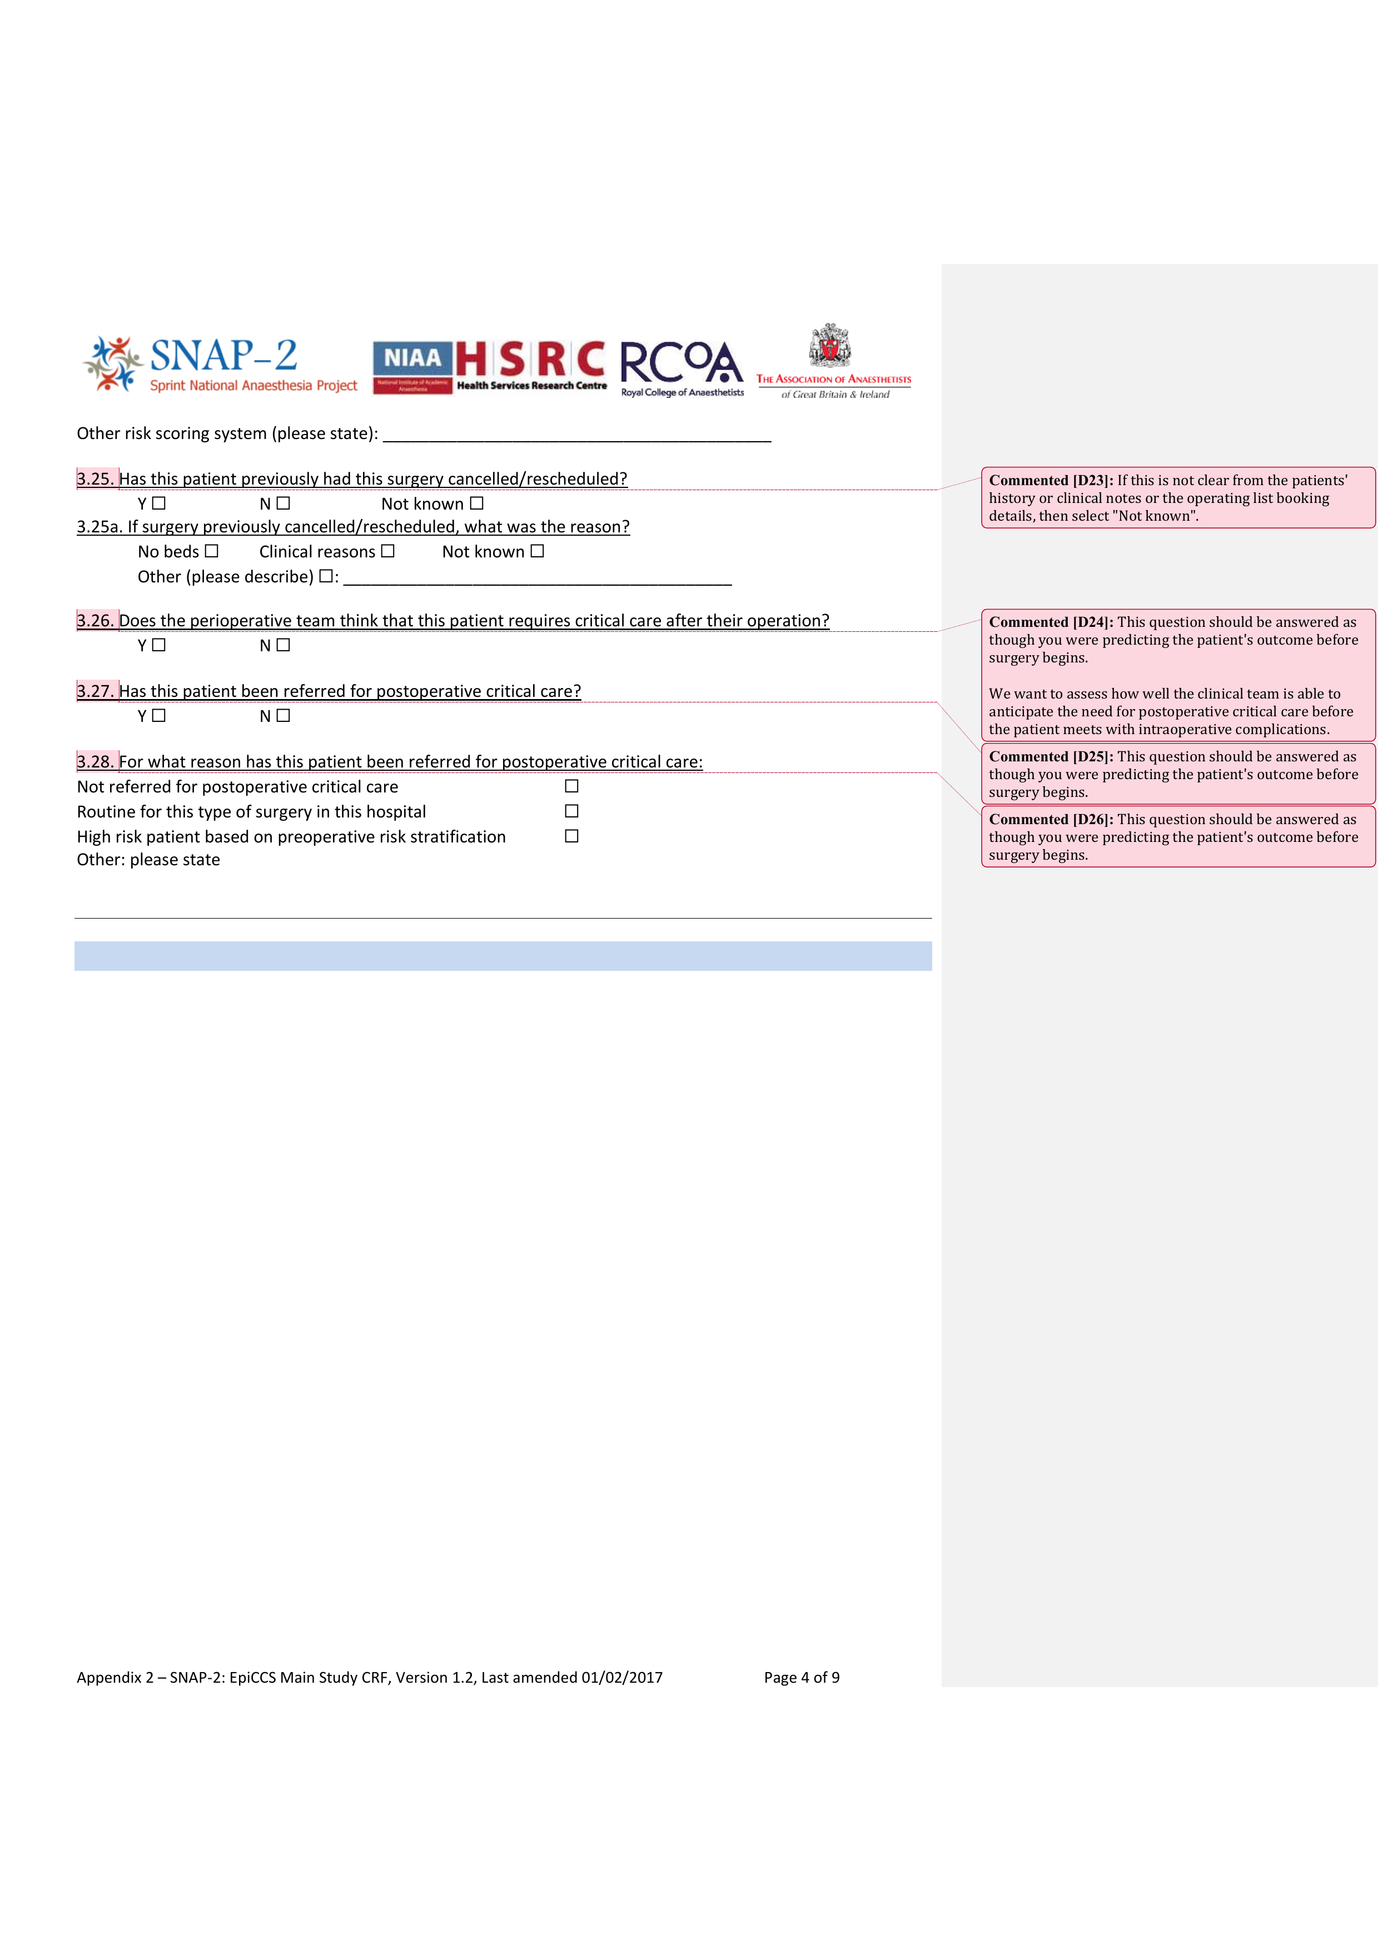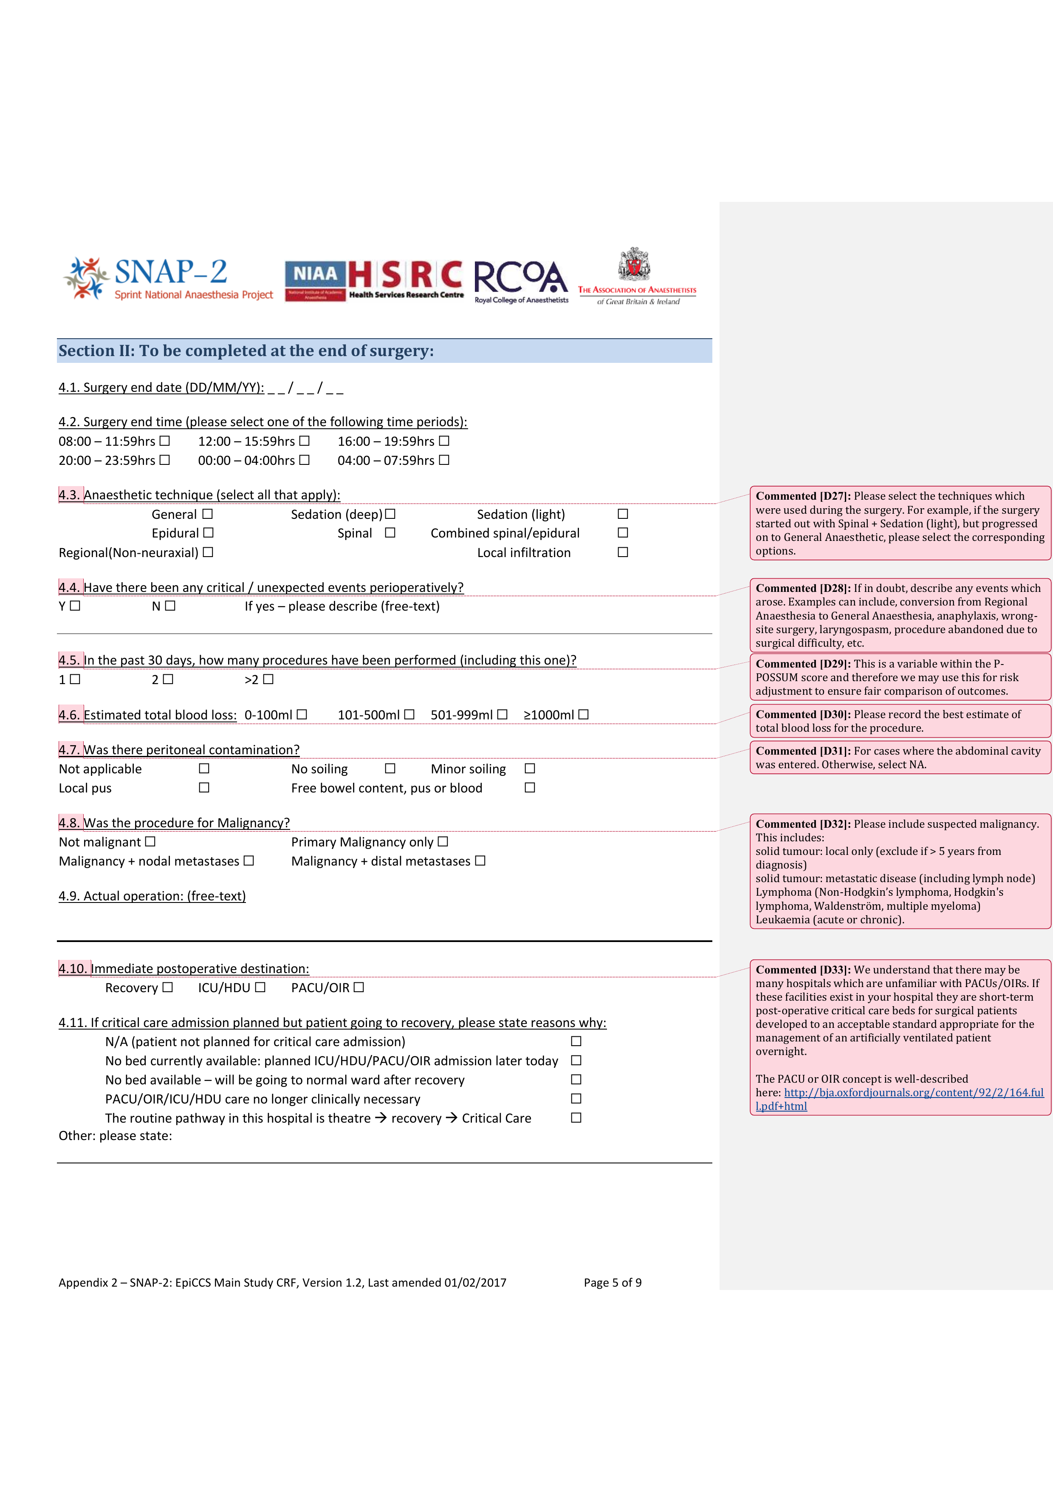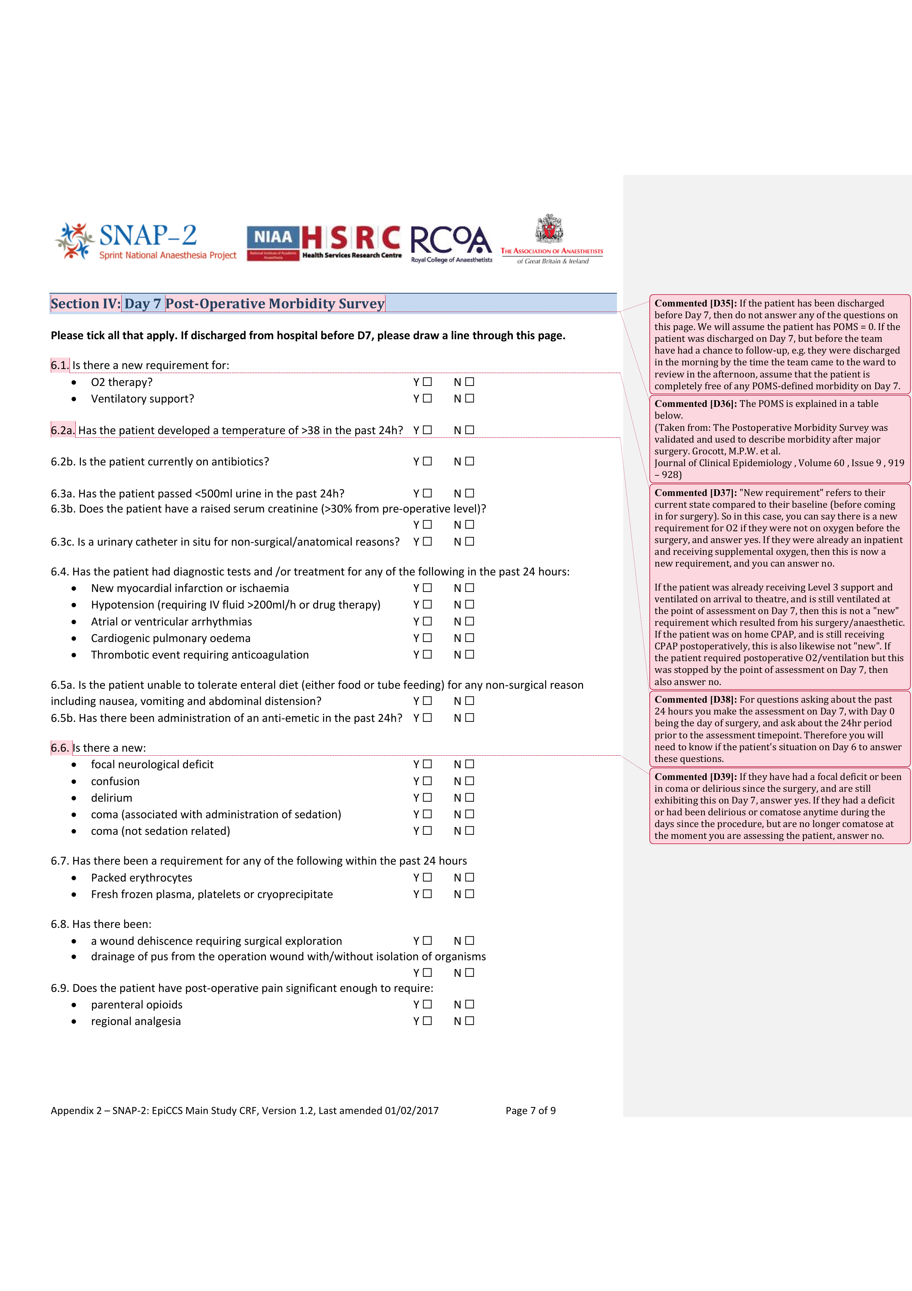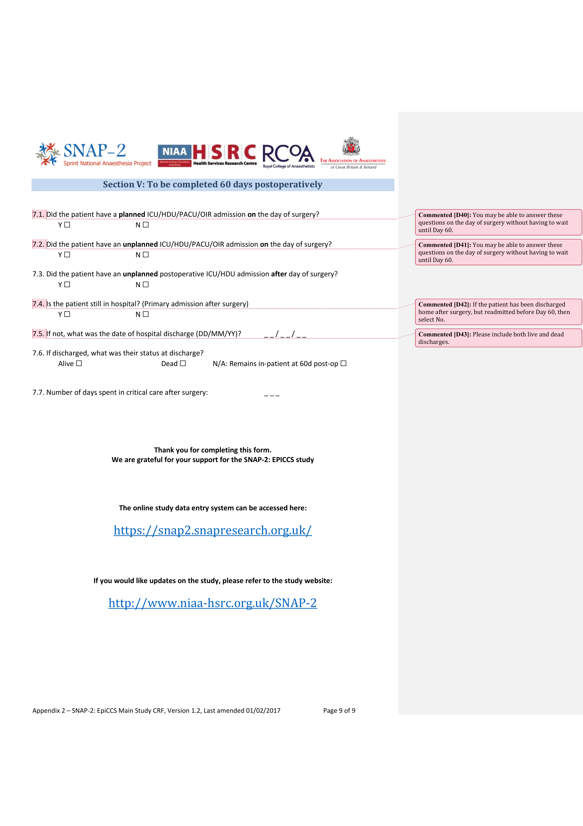

##### PAGE BREAK

## Appendix 3: Critical care occupancy CRF

The UK versions of the Case Record Forms (CRFs) for the collecting the critical care occupancy data during the patient study are presented here with help text annotations alongside in the right margin. Investigators would complete these CRFs on paper at two timepoints during each day of patient recruitment and then would later upload the data onto the online webtool. Minor changes were made to the CRFs to facilitate data collection in Australia and New Zealand.

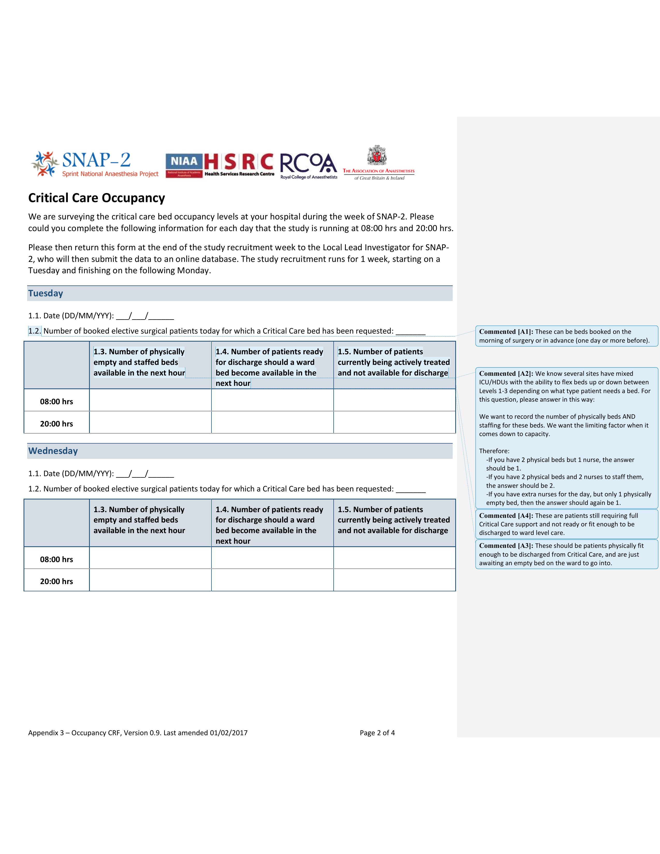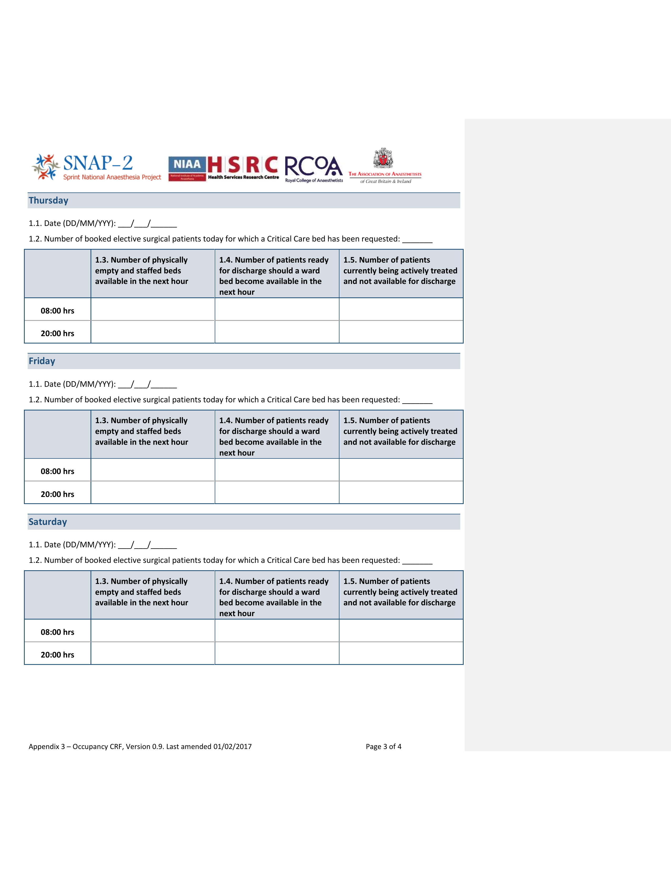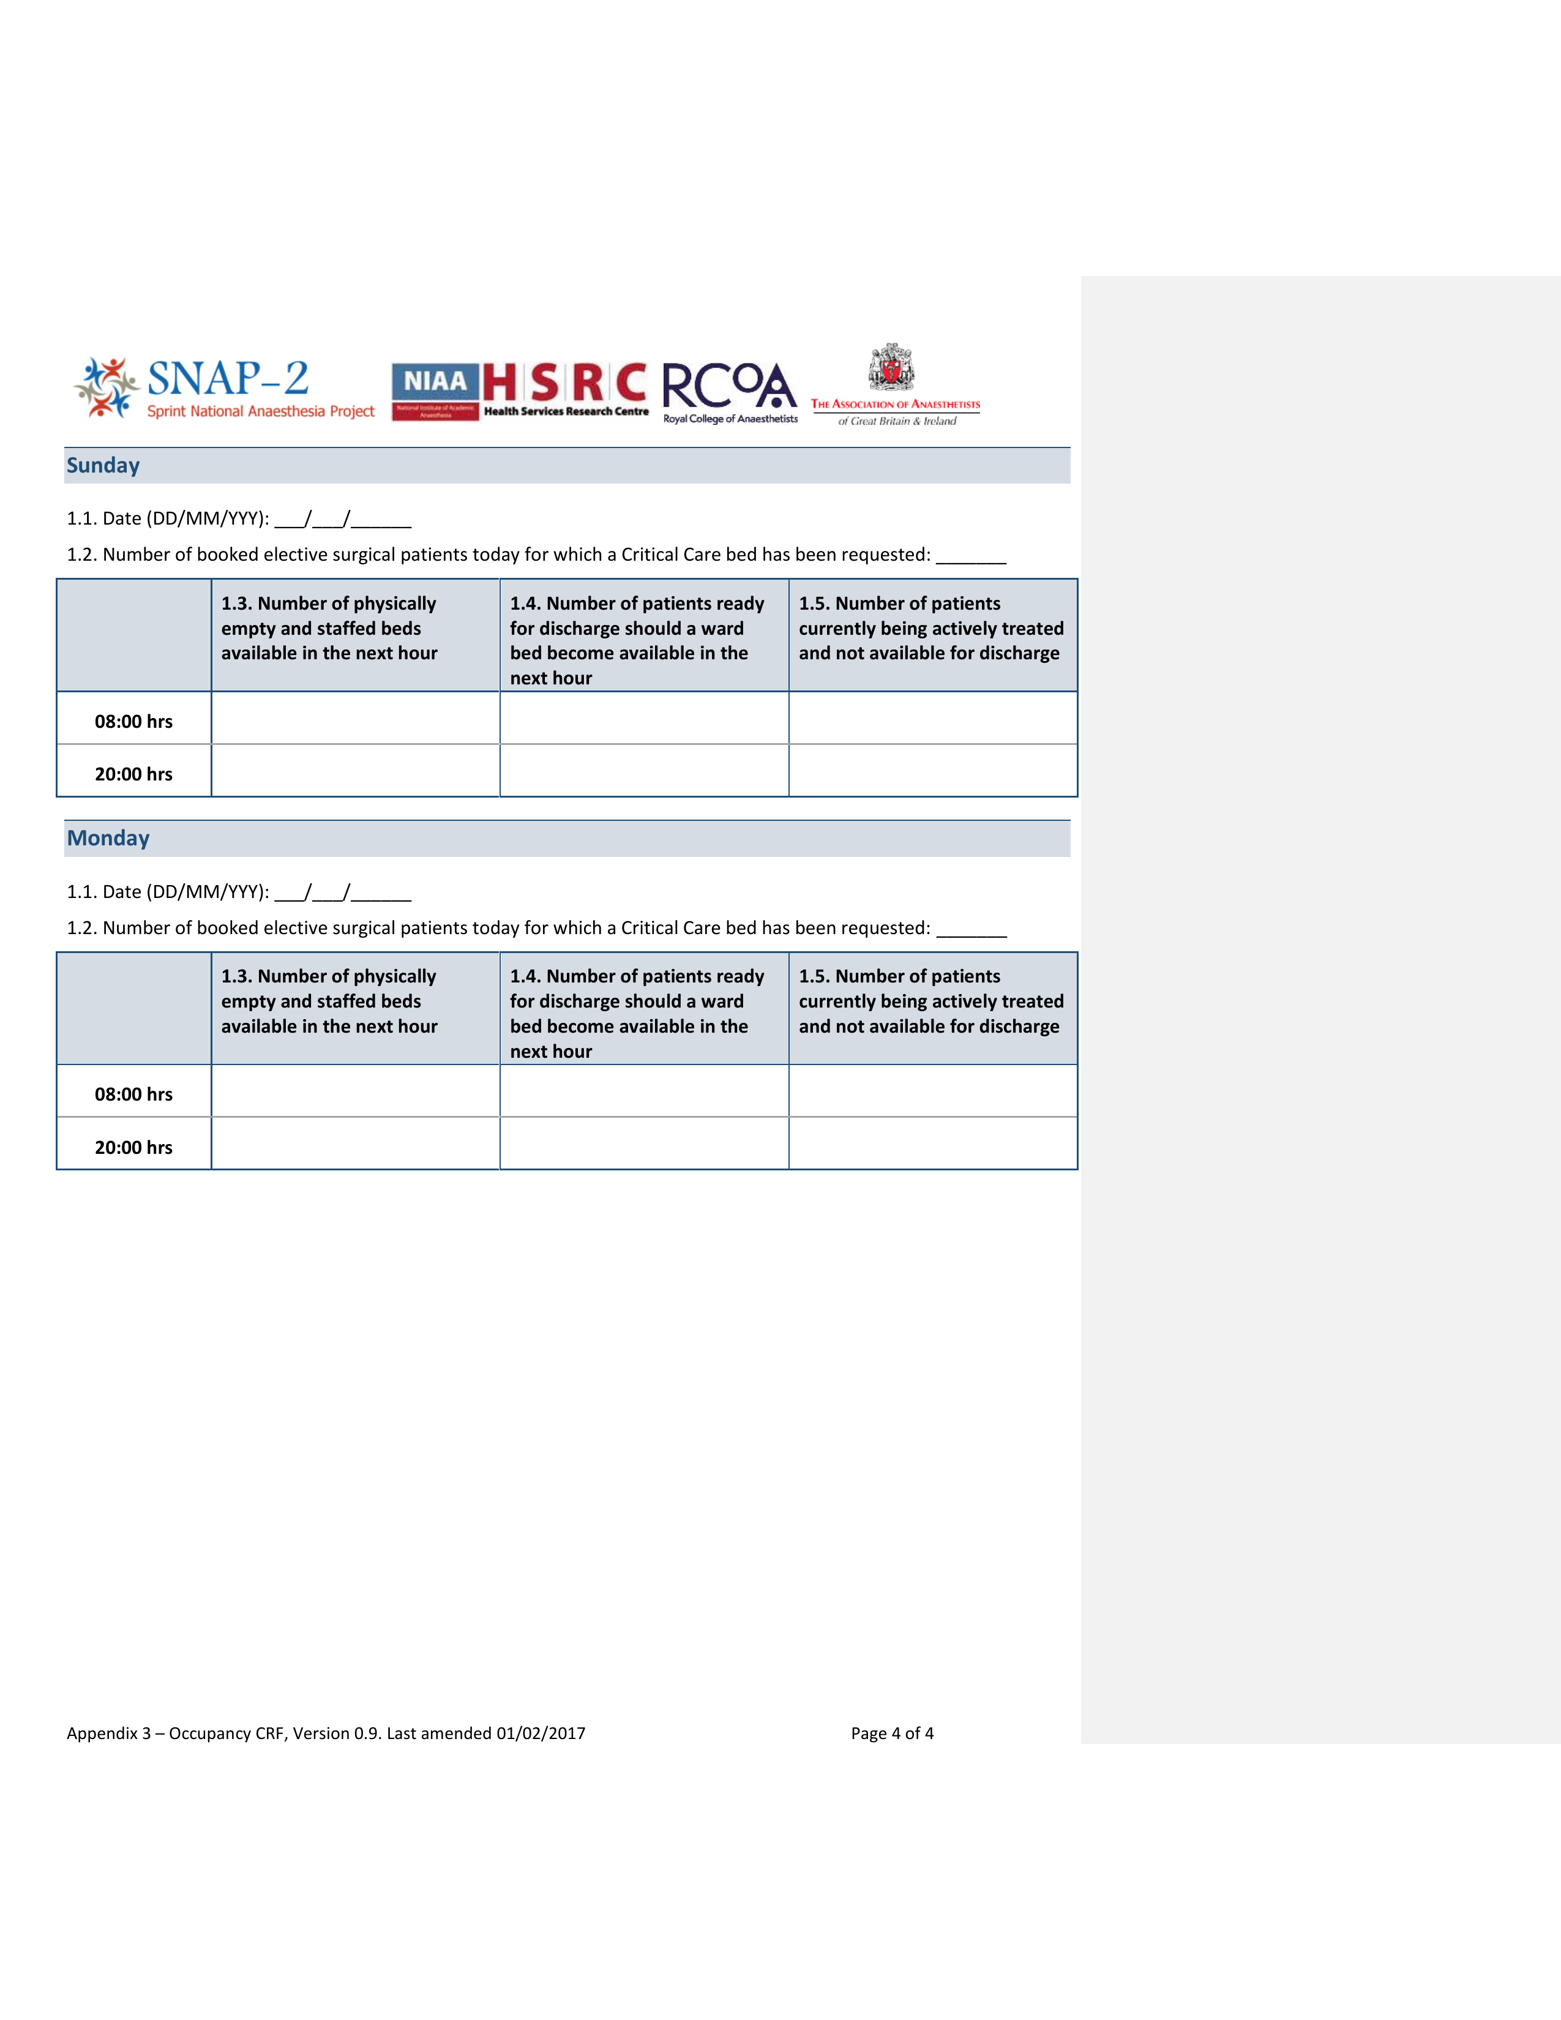

##### PAGE BREAK

## Appendix 4: Sample size considerations for the patient cohort study

A power analysis was performed by Dr Mizan Khondoker (consulting statistician) to establish the sample size for the inpatient surgery cohort (Table 10-1). A statistical power of 80% and significance of 0.05 (one-tailed) were assumed. Minimum sample sizes were estimated to detect effect sizes for the intervention of postoperative critical care on a primary outcome of day 7 POMS, which is a planned future study in SNAP-2: EPICCS, beyond the scope of this thesis. Calculations were performed using Stata/IC 12.1 (StataCorp, College Station, Texas, USA).

There were no realistic estimates available in the literature to suggest the potential effect of critical care admission on reducing postoperative morbidity. However, using previous studies to guide the allocation proportions and estimates of baseline morbidity (116,147,148), calculations were performed based on an assumed morbidity rate of 30% on day 7 inpatients who were admitted postoperatively to the general ward and an assumed 15% relative risk reduction for patients electively admitted to critical care. The following other assumptions were also taken: an allocation ratio of 1:10 (critical care vs. ward care) (13,14,35), R-squared (multiple correlation between the exposure and other covariates) = 10%, and a dropout rate of 1%. The calculated minimum sample size (n) required was 8,177. A number of other calculations were also performed with varying assumptions for the morbidity rates ranging from 15% to 30% and varying effect sizes (relative risk reductions ranging from 5% to 20%). The sampsi Stata command was used for these calculations (with separate adjustments for confounding and dropout).

Table 10‑1: Minimum sample sizes assuming morbidity rate = 15% to 30% (with 5% intervals) in the general ward, and 5%, 10%, 15% and 20% reduction in the group of patients referred to critical care. Calculations assume an allocation ratio 1:10 (critical care vs. ward), R-squared (multiple correlation between the exposure and other covariates) = 10 % and a dropout rate of 1%. Final sample size target chosen highlighted in **bold**.

|  |  |  |  |
| --- | --- | --- | --- |
| Proportion in general ward (p1) | % reduction in ICU | Proportion in ICU (p2) | Minimum sample size (n) required |
| 0.15 | 5% | 0.143 | 212,898 |
| 0.15 | 10% | 0.135 | 45,004 |
| 0.15 | 15% | 0.128 | 20,350 |
| 0.15 | 20% | 0.120 | 10,594 |
| 0.20 | 5% | 0.190 | 130,967 |
| 0.20 | 10% | 0.180 | 31,906 |
| 0.20 | 15% | 0.170 | 13,801 |
| 0.20 | 20% | 0.160 | 7,535 |
| 0.25 | 5% | 0.238 | 106,954 |
| 0.25 | 10% | 0.225 | 24,050 |
| 0.25 | 15% | 0.213 | 10,730 |
| 0.25 | 20% | 0.200 | 5,710 |
| 0.30 | 5% | 0.285 | 76,824 |
| 0.30 | 10% | 0.270 | 18,820 |
| **0.30** | **15%** | **0.255** | **8,177** |
| 0.30 | 20% | 0.240 | 4,489 |

##### A 1% drop-out rate was included in calculations in order to account for the risk that in some cases, missing data variables may be present, either due to data-linkage issues or loss to follow-up. In 1 week, based on data from the SNAP-1 study (113), it was estimated that SNAP-2: EPICCS would be able to recruit >12,000 patients. PAGE BREAK

## Appendix 5: Poisson Models for case ascertainment and capture

### Data quality assurance

Quality assurance of the data to be used in study analyses is important for confidence in the outputs that arise in the study.

There are 2 major obstacles to data quality in the study which were anticipated:

1. Incomplete case capture
2. Incomplete/missing data variables from individual patient records

#### Incomplete case capture

For patient level data, in order to ascertain whether some sites may have inappropriately excluded a significant number of cases, Poisson regression models were constructed with the number of inpatient surgical cases expected for each site as the response variable. A number of models were constructed, and a final Poisson model was chosen with the following predictor variables: total inpatient bed numbers, whether the hospital has a critical care unit and whether the hospital offers any tertiary services. Figure 10-1 shows a scatterplot of the number of inpatient surgical cases captured at each site against the number of inpatient beds, demonstrating a strong positive correlation between both variables (Pearson’s r = 0.78), additionally, the figure also illustrates the tendency for hospitals with critical care units to be larger (more hospital beds) and have a higher number of cases.

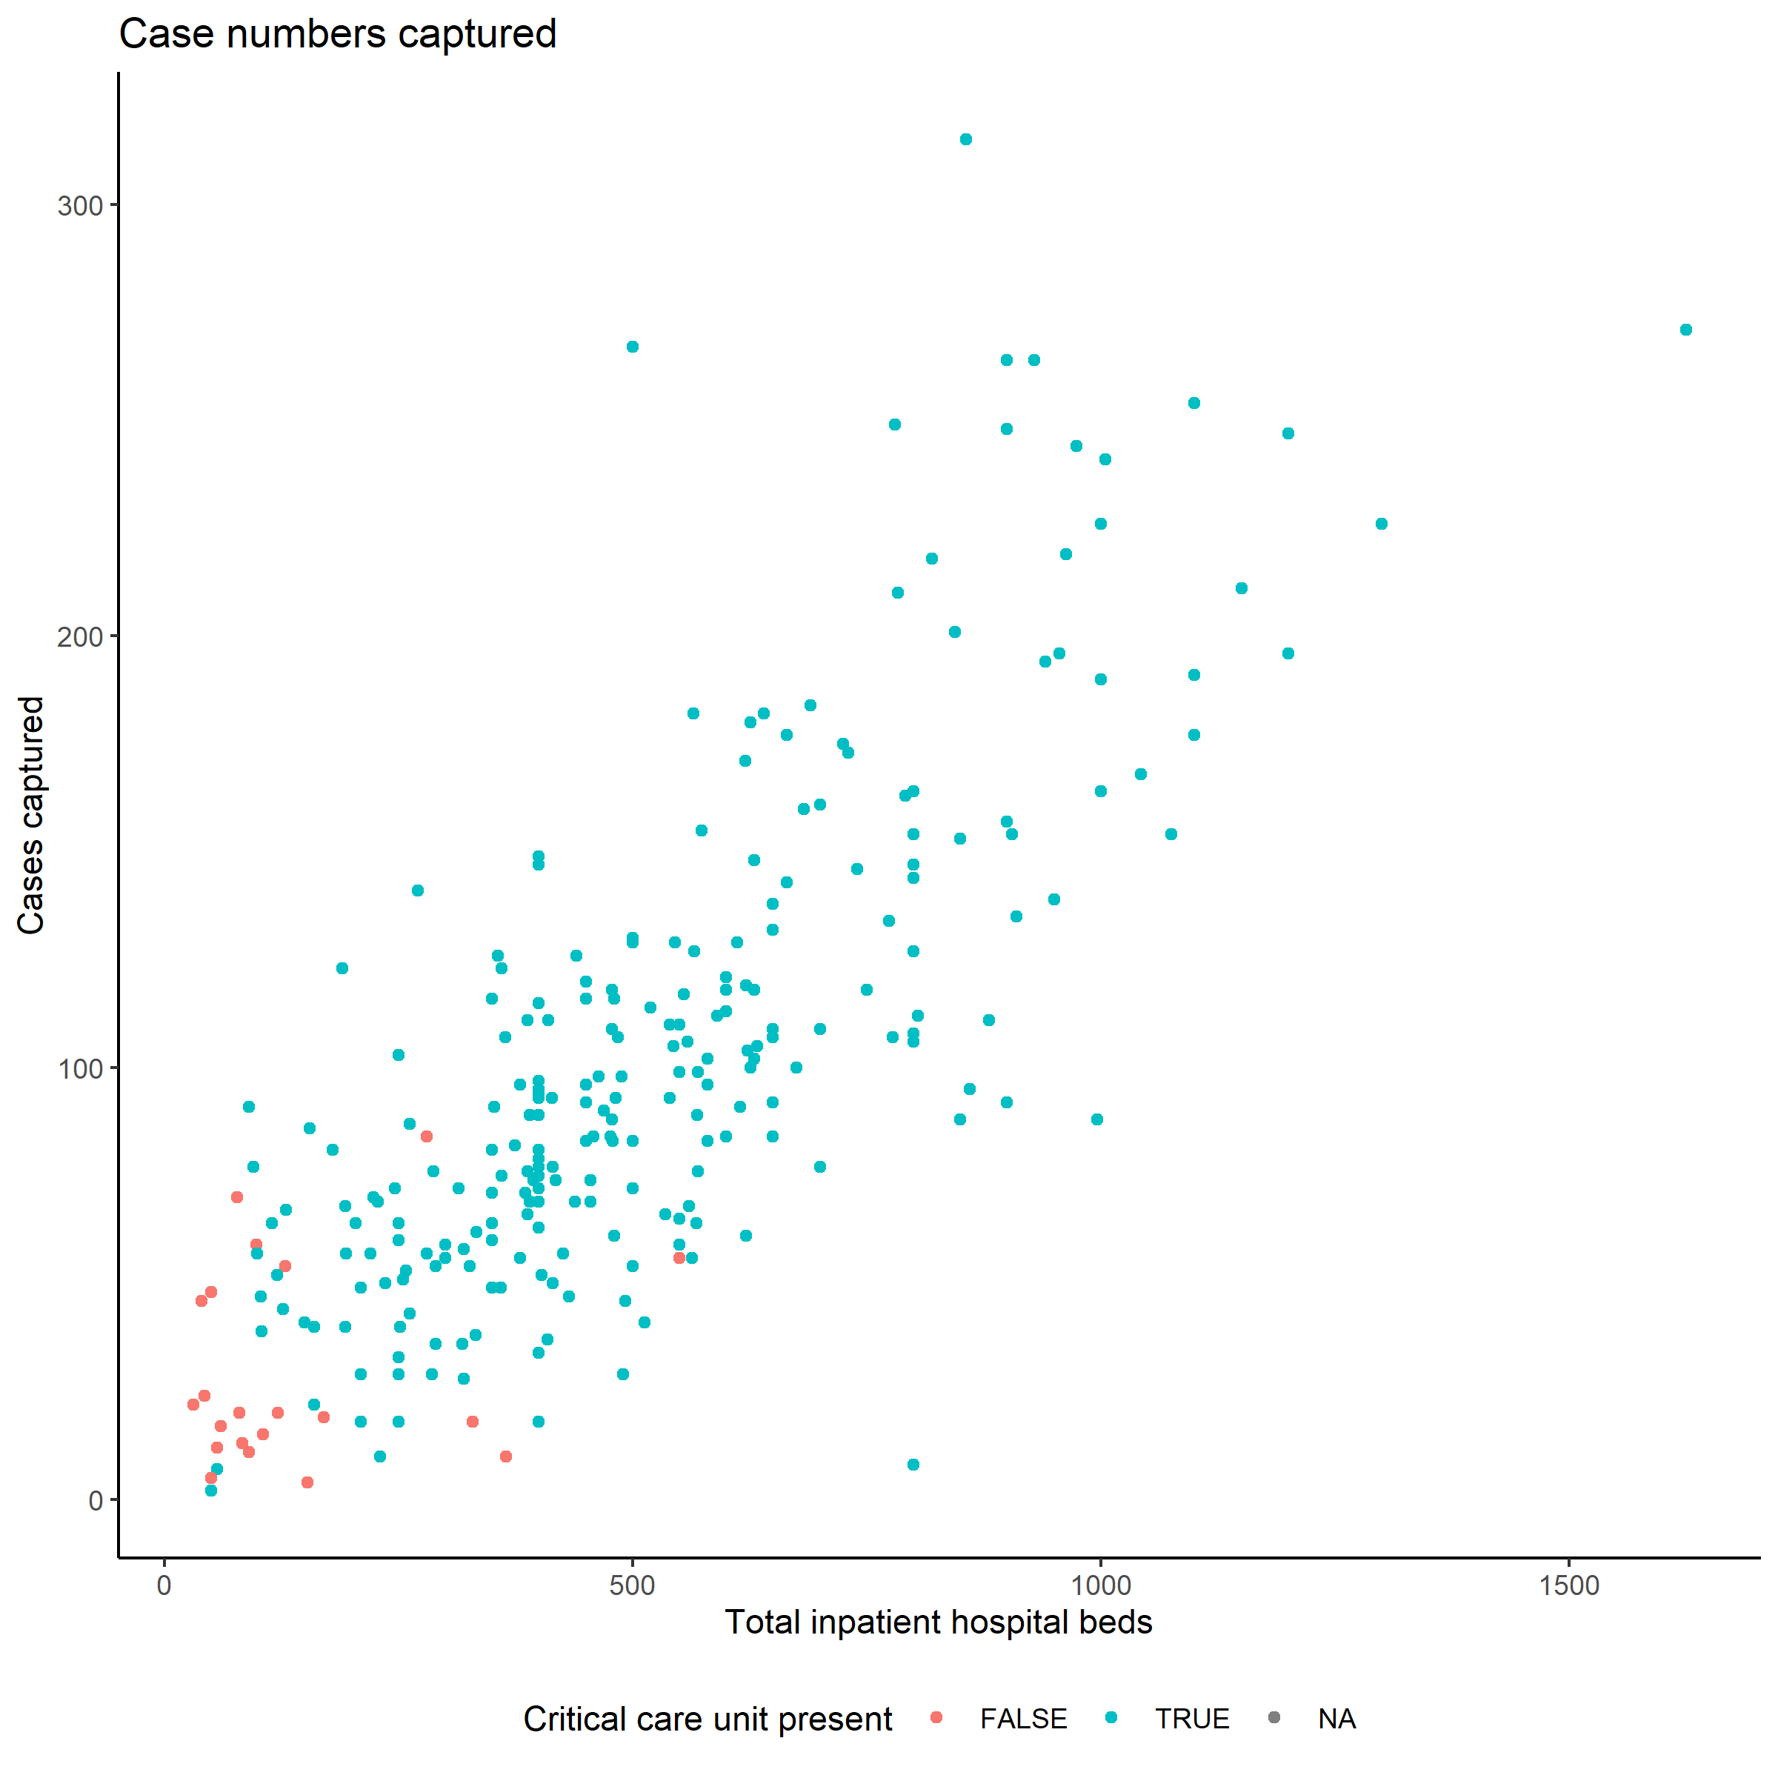

Figure 10‑1: Total number of cases captured by hospital.

In addition to the Poisson modelling used to identify sites which potentially under-reported data, on each day of the study, Principal Investigators (PIs) at each participating site also completed a survey which assessed qualitatively how well their site managed to capture all possible cases which fulfilled the study inclusion/exclusion criteria. A single question was asked for each study day: “Apart from patients who opted out, what proportion of eligible patients do you think your site missed during data collection for the main study today?”

Possible responses to this question were categorical:

1. None. We captured every last one.
2. We might have missed a couple.
3. We definitely missed a few.
4. We missed a significant minority.
5. We missed more than half.

This qualitative survey was used in conjunction with the Poisson models to identify sites with particular problems capturing fata, and both were used to initiate a dialogue with PIs to clarify problems with case capture during the study.

Using our final Poisson model, an expected (predicted) total number of cases captured at each site for the week was then computed. The prediction residual (actual case numbers subtracted from expected case numbers as calculated by the model) for each site, and the standard deviation of these residuals, was subsequently calculated. Sites with actual case numbers which fell outside of 2 standard deviations of the residual were then identified as potential outliers. Three hospitals were identified as being potential outliers through this process.

Each of these three sites were then contacted to discuss their case capture rates and identify why and whether cases may have been missed from data collection. Qualitative surveys on the completeness of case capture (completed by the local collaborators for each day of the study) were then cross-checked for these two sites. These steps identified 2 sites which either stated that they had “missed more than half” of the possible cases that could have been included in the study in the majority of the 7 study recruitment days (Figure 10-2), and which also reported significantly lower cases than was expected in the statistical model.

The data submitted from these 2 sites were therefore considered lower-quality. However, the total number of cases contributed by these 2 sites was low (total n = 157) and only accounted for only a small proportion of the total dataset (0.36%).

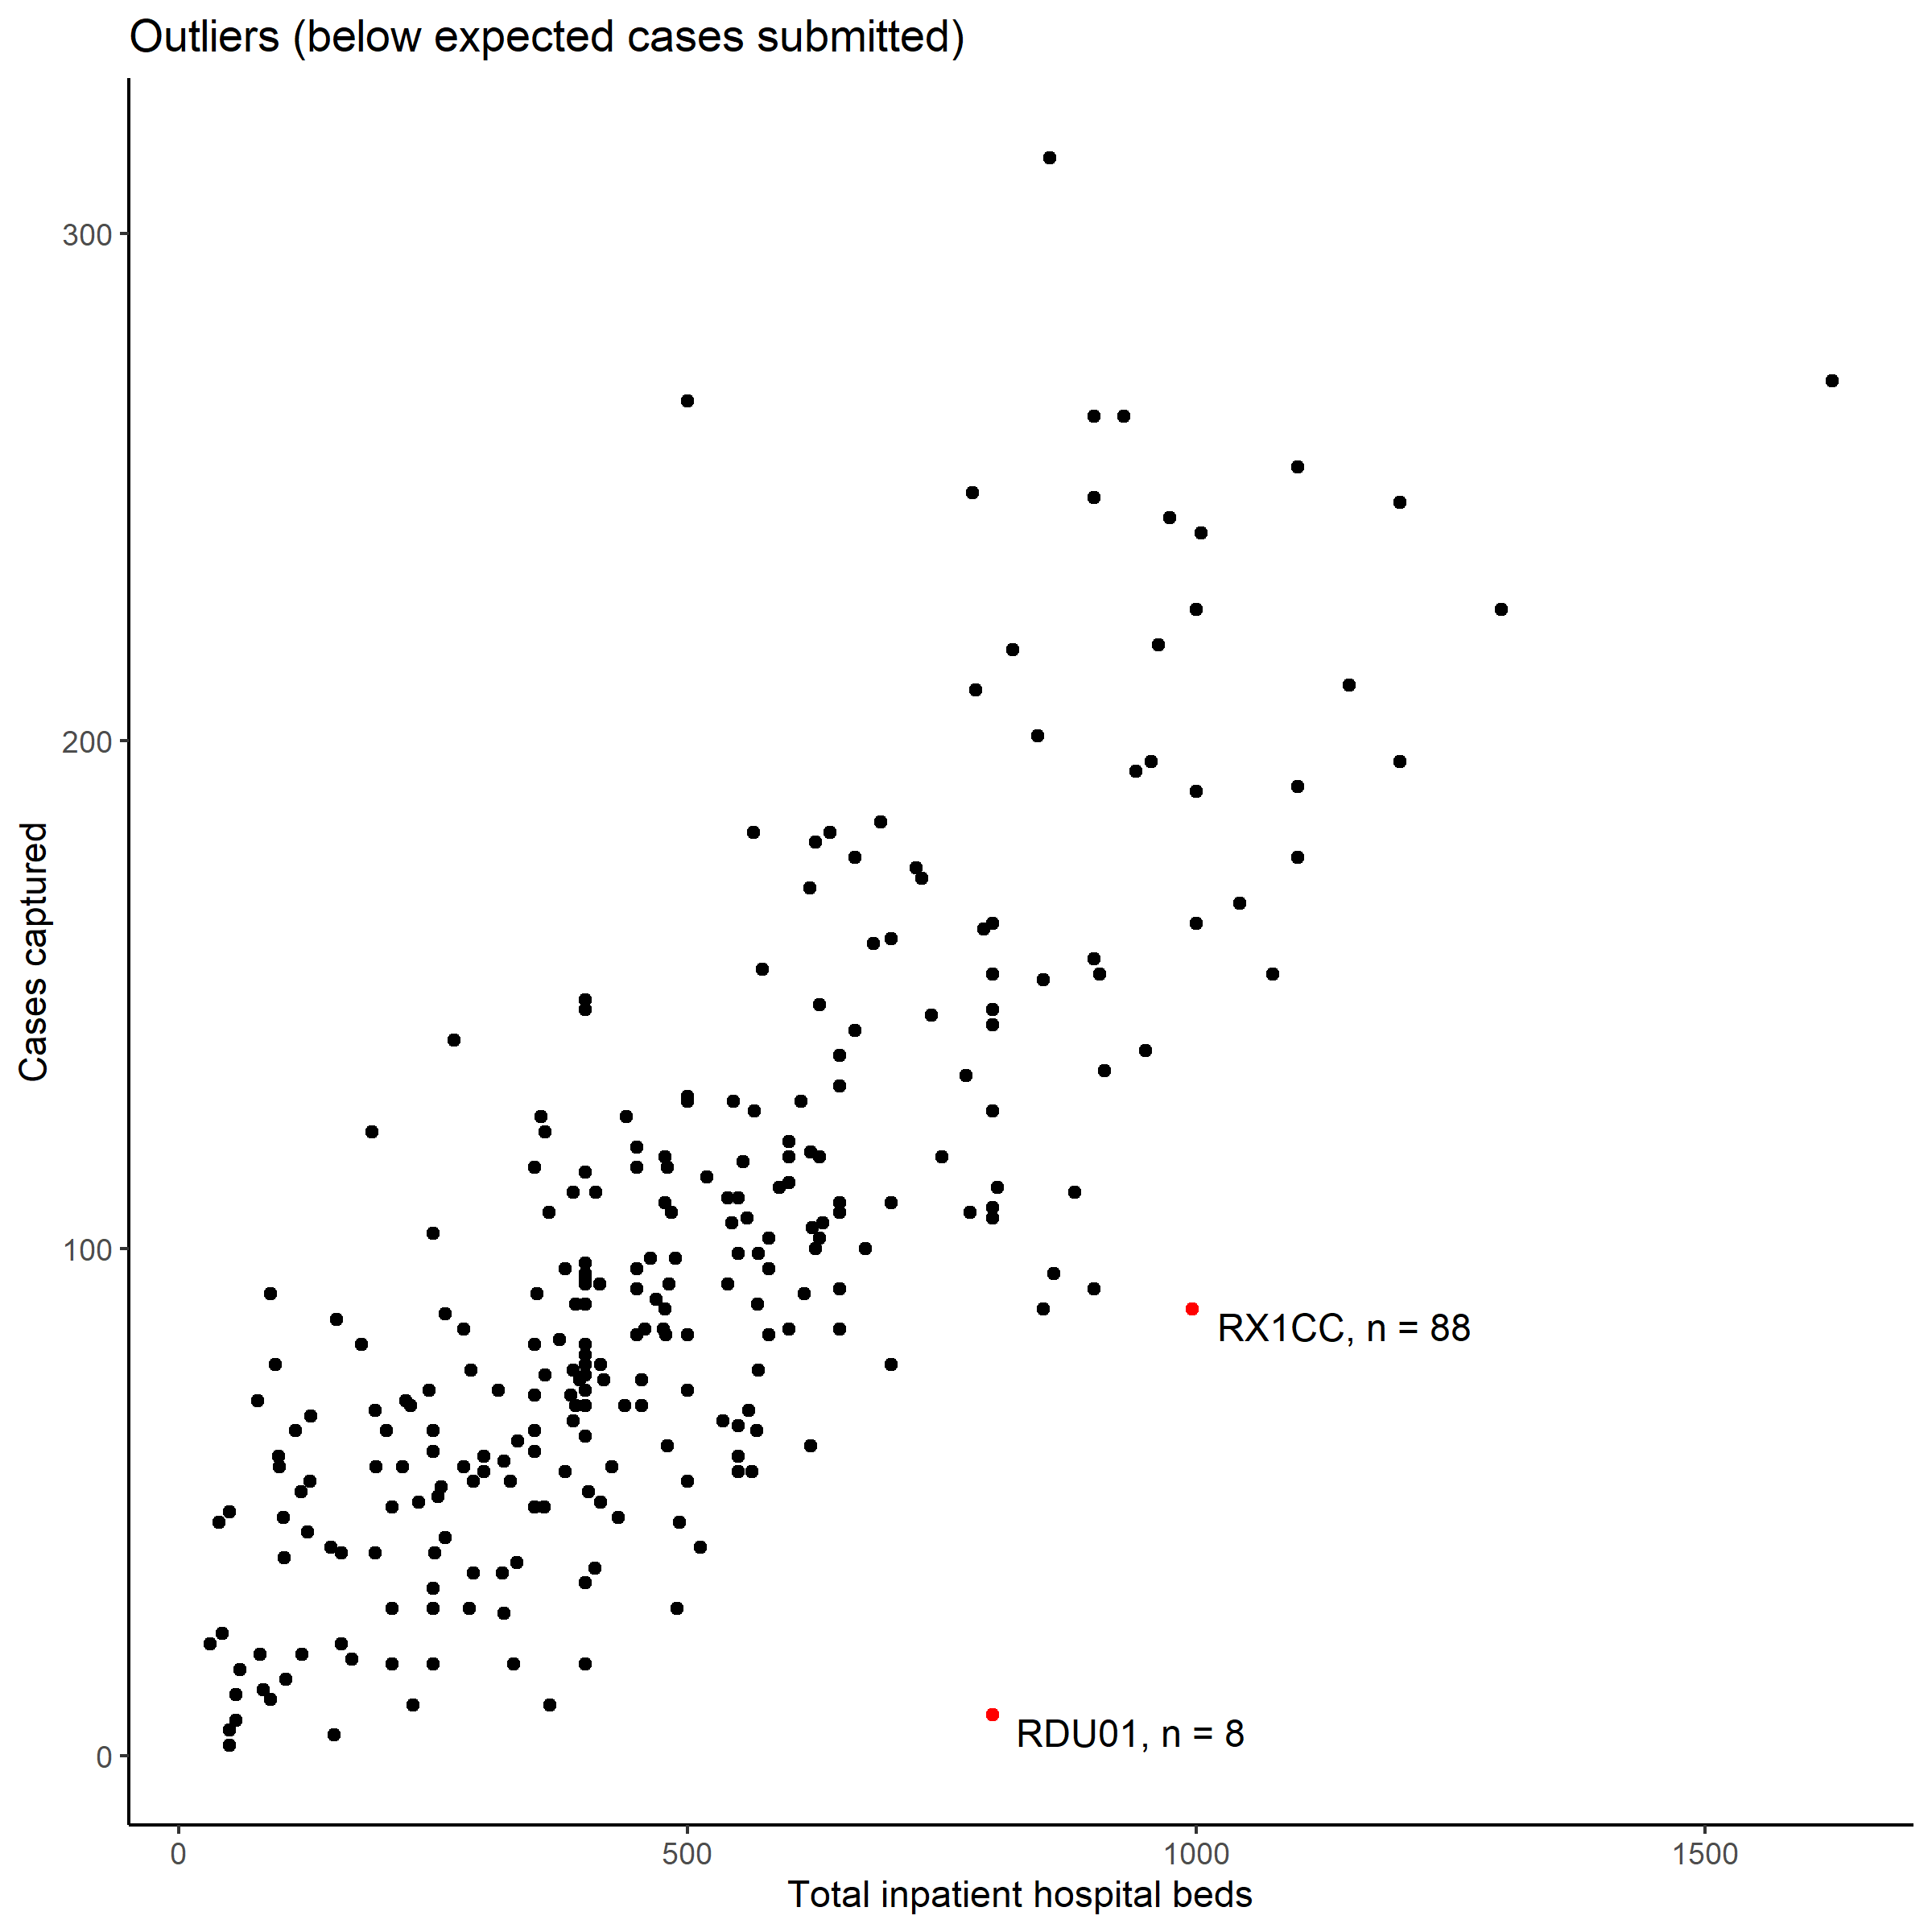

Figure 10‑2: Site codes, and number of cases of the 3 sites (in red) identified as significant outliers reporting fewer than expected cases.

### Missingness of data variables

A total of 168 variables were collected for each surgical case. Each variable was examined separately for missingness. Overall, 94.1% of cases had complete data recorded (no inappropriately missing values). Some variables were not considered absolutely necessary minimum requirements, for example not all patients undergoing surgery have routine blood tests or radiological imaging taken prior to surgery, so cases without data recorded for these variables were considered appropriately missing. Individual data variables characteristics and missingness are available in the *Appendix 6*.

##### PAGE BREAK

## 

## Appendix 6: Patient-level data variables and proportion of missing values

A description of each variable from the entire SNAP-2: EPICCS dataset is presented here. Only variables collected from the CRF will be presented (i.e. no transformed or computed variables are included in this Appendix). Fields containing personal identifiable information (e.g. names, absolute dates including dates of birth and dates of surgery, etc) are not presented. Names of hospitals have been removed as they could be used indirectly to link to patients and individual hospital performance.

Data Frame Summary  
patients_clean  
Dimensions: 26502 x 133  
Duplicates: 1

|  |  |  |  |
| --- | --- | --- | --- |
| Variable Name [datatype] | Stats / Values | Frequencies (% of Valid) | Missing |
| **SiteCode [character]** | 1. AUK 2. G405H 3. ALF 4. ROYB 5. S314H [ 269 others ] | 315 ( 1.2%) 271 ( 1.0%) 267 ( 1.0%) 264 ( 1.0%) 264 ( 1.0%) 25121 (94.8%) | 0 (0%) |
| **S01Gender [factor]** | 1. F 2. M | 15688 (59.2%) 10813 (40.8%) | 1 (0%) |
| **S01Age [integer]** | Mean (sd) : 55.2 (19.9) min < med < max: 18 < 57 < 105 IQR (CV) : 35 (0.4) | 87 distinct values | 0 (0%) |
| **S02TimeOfSurgeryStartIncision [integer]** | Mean (sd) : 10.7 (3.7) min < med < max: 0 < 12 < 20 IQR (CV) : 4 (0.3) | 6 distinct values | 22 (0.08%) |
| **S02PatientOrigin [factor]** | 1. H 2. I | 15659 (59.1%) 10838 (40.9%) | 5 (0.02%) |
| **S02LevelOfSupport [integer]** | Mean (sd) : 0.3 (0.6) min < med < max: 0 < 0 < 3 IQR (CV) : 0 (2) | 0 : 19962 (75.4%) 1 : 5617 (21.2%) 2 : 480 ( 1.8%) 3 : 418 ( 1.6%) | 25 (0.09%) |
| **S02PreopLOS [integer]** | Mean (sd) : 1.6 (15.9) min < med < max: 0 < 0 < 2193 IQR (CV) : 1 (9.8) | 99 distinct values | 15 (0.06%) |
| **S02PlannedProcedureMainGroup [character]** | 1. 13 2. 9 3. 15 4. 10 5. 11 [ 11 others ] | 6830 (25.8%) 4567 (17.2%) 3605 (13.6%) 2359 ( 8.9%) 2049 ( 7.7%) 7068 (26.7%) | 24 (0.09%) |
| **S02PlannedProcedureSubGroup [character]** | 1. 15-1 2. 13-19 3. 13-23 4. 11-1 5. 9-4 [ 129 others ] | 3605 (13.6%) 1739 ( 6.6%) 1590 ( 6.0%) 1418 ( 5.4%) 1332 ( 5.0%) 16793 (63.4%) | 25 (0.09%) |
| **S02PlannedProcedure [character]** | 1. 15-1-3-Maj 2. 13-23-32-X 3. 13-19-12-X 4. 9-6-21-Xma 5. 13-19-22-X [ 1357 others ] | 3036 (11.5%) 940 ( 3.6%) 598 ( 2.3%) 523 ( 2.0%) 446 ( 1.7%) 20910 (79.0%) | 49 (0.18%) |
| **S02PreoperativeAssessmentBeforeHospitalAdmission [factor]** | 1. N 2. Y | 5910 (30.7%) 13333 (69.3%) | 7259 (27.39%) |
| **S02OperativeUrgency [factor]** | 1. Ele 2. Exp 3. I 4. U | 13564 (51.2%) 3645 (13.8%) 1366 ( 5.2%) 7912 (29.9%) | 15 (0.06%) |
| **S03AsaPsClass [factor]** | 1. I 2. II 3. III 4. IV 5. V | 6483 (24.5%) 11747 (44.4%) 6774 (25.6%) 1370 ( 5.2%) 73 ( 0.3%) | 55 (0.21%) |
| **S03PastMedicalHistoryCoronaryArteryDisease [factor]** | 1. N 2. Y | 23394 (88.4%) 3075 (11.6%) | 33 (0.12%) |
| **S03PastMedicalHistoryCongestiveCardiacFailure [factor]** | 1. N 2. Y | 25553 (96.5%) 912 ( 3.4%) | 37 (0.14%) |
| **S03PastMedicalHistoryCancerLast5Yrs [factor]** | 1. N 2. Y | 23217 (87.7%) 3252 (12.3%) | 33 (0.12%) |
| **S03PastMedicalHistoryMetastaticCancerCurrent [factor]** | 1. N 2. Y | 25631 (96.9%) 835 ( 3.1%) | 36 (0.14%) |
| **S03PastMedicalHistoryStrokeTIA [factor]** | 1. N 2. Y | 25115 (94.9%) 1350 ( 5.1%) | 37 (0.14%) |
| **S03PastMedicalHistoryDementia [factor]** | 1. N 2. Y | 25772 (97.4%) 692 ( 2.6%) | 38 (0.14%) |
| **S03PastMedicalHistoryCOPD [factor]** | 1. N 2. Y | 24474 (92.5%) 1991 ( 7.5%) | 37 (0.14%) |
| **S03PastMedicalHistoryPulmonaryFibrosis [factor]** | 1. N 2. Y | 26283 (99.3%) 181 ( 0.7%) | 38 (0.14%) |
| **S03PastMedicalHistoryLiverCirrhosis [factor]** | 1. N 2. Y | 26233 (99.1%) 231 ( 0.9%) | 38 (0.14%) |
| **S03PastMedicalHistoryRenalDisease [factor]** | 1. N 2. Y | 26080 (98.6%) 383 ( 1.4%) | 39 (0.15%) |
| **S03PastMedicalHistoryComplexPolytrauma [factor]** | 1. N 2. Y | 26266 (99.2%) 198 ( 0.8%) | 38 (0.14%) |
| **S03PastMedicalHistoryNone [integer]** | Min : 1 Mean : 1.3 Max : 2 | 1 : 17218 (65.7%) 2 : 8995 (34.3%) | 289 (1.09%) |
| **S03Diabetes [factor]** | 1. 1 2. 2D 3. 2I 4. 2O 5. N | 306 ( 1.2%) 744 ( 2.8%) 859 ( 3.2%) 1672 ( 6.3%) 22879 (86.5%) | 42 (0.16%) |
| **S03DrugTreatmentDiureticTreatment [factor]** | 1. N 2. Y | 23936 (90.5%) 2498 ( 9.4%) | 68 (0.26%) |
| **S03DrugTreatmentAntiAnginal [factor]** | 1. N 2. Y | 24735 (93.6%) 1691 ( 6.4%) | 76 (0.29%) |
| **S03DrugTreatmentDigoxinTherapy [factor]** | 1. N 2. Y | 26073 (98.7%) 356 ( 1.4%) | 73 (0.28%) |
| **S03DrugTreatmentAntiHypertensive [factor]** | 1. N 2. Y | 18063 (68.3%) 8363 (31.6%) | 76 (0.29%) |
| **S03DrugTreatmentWarfarin [factor]** | 1. N 2. Y | 25282 (95.7%) 1143 ( 4.3%) | 77 (0.29%) |
| **S03DrugTreatmentOther [factor]** | 1. N 2. Y | 24828 (94.0%) 1593 ( 6.0%) | 81 (0.31%) |
| **S03BodyMassIndexBmi [numeric]** | Mean (sd) : 29.2 (7) min < med < max: 12 < 28 < 100 IQR (CV) : 9 (0.2) | 391 distinct values | 10425 (39.34%) |
| **S03ElevatedJugularVenousPressureJvp [factor]** | 1. N 2. Y | 26144 (99.0%) 264 ( 1.0%) | 94 (0.35%) |
| **S03PeripheralOedema [factor]** | 1. N 2. Y | 25173 (95.3%) 1233 ( 4.7%) | 96 (0.36%) |
| **S03GlasgowComaScaleGcsPreInductionOfAnaesthesia [integer]** | Mean (sd) : 14.8 (1.1) min < med < max: 3 < 15 < 15 IQR (CV) : 0 (0.1) | 13 distinct values | 113 (0.43%) |
| **S03SystolicBloodPressureBpAtPreAssessment [integer]** | Mean (sd) : 138.7 (23.1) min < med < max: 0 < 137 < 267 IQR (CV) : 30 (0.2) | 175 distinct values | 336 (1.27%) |
| **S03PulseRateAtPreoperativeAssessment [integer]** | Mean (sd) : 80.6 (16.5) min < med < max: 0 < 80 < 188 IQR (CV) : 20 (0.2) | 129 distinct values | 362 (1.37%) |
| **S03Dyspnoea [factor]** | 1. AR 2. L 3. Non 4. OME | 334 ( 1.3%) 1426 ( 5.4%) 21144 (80.2%) 3446 (13.1%) | 152 (0.57%) |
| **S03Creatinine [integer]** | Mean (sd) : 86.2 (68.3) min < med < max: 20 < 73 < 999 IQR (CV) : 28 (0.8) | 493 distinct values | 5488 (20.71%) |
| **S03Urea [numeric]** | Mean (sd) : 7 (8) min < med < max: 0.7 < 5.3 < 99 IQR (CV) : 2.9 (1.1) | 360 distinct values | 7333 (27.67%) |
| **S03Hb [integer]** | Mean (sd) : 129.3 (18.9) min < med < max: 14 < 131 < 203 IQR (CV) : 24 (0.1) | 150 distinct values | 2800 (10.57%) |
| **S03Na [integer]** | Mean (sd) : 138.7 (3.6) min < med < max: 100 < 139 < 171 IQR (CV) : 4 (0) | 58 distinct values | 5534 (20.88%) |
| **S03K [numeric]** | Mean (sd) : 4.3 (0.5) min < med < max: 2.1 < 4.3 < 7.9 IQR (CV) : 0.6 (0.1) | 52 distinct values | 5781 (21.81%) |
| **S03WhiteCellCountWcc [numeric]** | Mean (sd) : 9.8 (6.9) min < med < max: 0.1 < 8.4 < 211 IQR (CV) : 4.5 (0.7) | 404 distinct values | 3537 (13.35%) |
| **S03HBA1c [numeric]** | Mean (sd) : 51.8 (18.9) min < med < max: 7.3 < 48 < 187 IQR (CV) : 22 (0.4) | 156 distinct values | 24554 (92.65%) |
| **S03EcgFindings [factor]** | 1. 4E 2. AF>90 3. AF6090 4. ND 5. NOR [ 3 others ] | 205 ( 0.8%) 243 ( 0.9%) 840 ( 3.2%) 11129 (42.1%) 10900 (41.2%) 3130 (11.8%) | 55 (0.21%) |
| **S03RadiologicalFindings [factor]** | 1. N 2. Y | 22318 (84.3%) 4149 (15.7%) | 35 (0.13%) |
| **S03RadiologicalFindingsNormal [factor]** | 1. N 2. Y | 1935 (48.4%) 2065 (51.6%) | 22502 (84.91%) |
| **S03RadiologicalFindingsConsolidation [factor]** | 1. N 2. Y | 1635 (84.3%) 304 (15.7%) | 24563 (92.68%) |
| **S03RadiologicalFindingsCardiomegaly [factor]** | 1. N 2. Y | 1592 (82.1%) 348 (17.9%) | 24562 (92.68%) |
| **S03RadiologicalFindingsOtherAbnormality [factor]** | 1. N 2. Y | 508 (26.0%) 1445 (74.0%) | 24549 (92.63%) |
| **S03GradeOfMostSeniorAnaesthetistPresent [factor]** | 1. AS 2. CFT 3. Con 4. FEL 5. JR [ 2 others ] | 2977 (11.3%) 576 ( 2.2%) 19758 (74.7%) 270 ( 1.0%) 116 ( 0.4%) 2762 (10.4%) | 43 (0.16%) |
| **S03GradeOfMostSeniorSurgeonPresent [factor]** | 1. AS 2. CFT 3. Con 4. FEL 5. JR [ 2 others ] | 2063 ( 7.8%) 60 ( 0.2%) 20012 (75.6%) 281 ( 1.1%) 140 ( 0.5%) 3902 (14.8%) | 44 (0.17%) |
| **S03PerioperativeTeamOfTheRiskOfDeathWithin30Days [factor]** | 1. G50 2. L1 3. L10 4. L2 5. L50 6. L6 | 227 ( 0.9%) 18180 (69.8%) 1034 ( 4.0%) 4316 (16.6%) 733 ( 2.8%) 1546 ( 5.9%) | 466 (1.76%) |
| **S03MortalityEstimateClinicalJudgment [logical]** | 1. FALSE 2. TRUE | 2747 (10.4%) 23750 (89.6%) | 5 (0.02%) |
| **S03MortalityEstimateASAPSScore [logical]** | 1. FALSE 2. TRUE | 16487 (62.2%) 10010 (37.8%) | 5 (0.02%) |
| **S03MortalityEstimateDukeOtherActivityStatusIndex [logical]** | 1. FALSE 2. TRUE | 25943 (97.9%) 554 ( 2.1%) | 5 (0.02%) |
| **S03MortalityEstimateWalkTest [logical]** | 1. FALSE 2. TRUE | 26447 (99.8%) 50 ( 0.2%) | 5 (0.02%) |
| **S03MortalityEstimateCardiopulmonaryExerciseTesting [logical]** | 1. FALSE 2. TRUE | 26278 (99.2%) 219 ( 0.8%) | 5 (0.02%) |
| **S03MortalityEstimateFrailtyAssessment [logical]** | 1. FALSE 2. TRUE | 26447 (99.8%) 50 ( 0.2%) | 5 (0.02%) |
| **S03MortalityEstimateSurgicalRiskScale [logical]** | 1. FALSE 2. TRUE | 26153 (98.7%) 344 ( 1.3%) | 5 (0.02%) |
| **S03MortalityEstimateSurgicalOutcomeRiskTool [logical]** | 1. FALSE 2. TRUE | 25728 (97.1%) 769 ( 2.9%) | 5 (0.02%) |
| **S03MortalityEstimateEuroSCORE [logical]** | 1. FALSE 2. TRUE | 26045 (98.3%) 452 ( 1.7%) | 5 (0.02%) |
| **S03MortalityEstimatePOSSUM [logical]** | 1. FALSE 2. TRUE | 26199 (98.9%) 298 ( 1.1%) | 5 (0.02%) |
| **S03MortalityEstimatePPOSSUM [logical]** | 1. FALSE 2. TRUE | 25069 (94.6%) 1428 ( 5.4%) | 5 (0.02%) |
| **S03MortalityEstimateSurgeryPPOSSUM [logical]** | 1. FALSE 2. TRUE | 26301 (99.3%) 196 ( 0.7%) | 5 (0.02%) |
| **S03MortalityEstimateOther [logical]** | 1. FALSE 2. TRUE | 25822 (97.5%) 675 ( 2.5%) | 5 (0.02%) |
| **S03MortalityEstimateOtherDetails [character]** | 1. Nottingham 2. NHFS 3. NSQIP 4. Nottingham 5. NOTTINGHAM [ 443 others ] | 33 ( 4.9%) 24 ( 3.6%) 23 ( 3.4%) 20 ( 3.0%) 16 ( 2.4%) 559 (82.8%) | 25827 (97.45%) |
| **S03PreviouslyHadThisSurgeryCancelledRescheduled [factor]** | 1. N 2. NK 3. Y | 22413 (84.7%) 1874 ( 7.1%) 2188 ( 8.3%) | 27 (0.1%) |
| **S03PreviouslyHadThisSurgeryCancelledRescheduledReason [factor]** | 1. CR 2. NB 3. NK 4. O | 675 (30.0%) 520 (23.1%) 315 (14.0%) 739 (32.9%) | 24253 (91.51%) |
| **S03PreviouslyHadThisSurgeryCancelledRescheduledReasonOther [character]** | 1. Ran out of 2. Lack of ti 3. lack of th 4. No time 5. Chest infe [ 631 others ] | 9 ( 1.2%) 6 ( 0.8%) 5 ( 0.7%) 5 ( 0.7%) 4 ( 0.5%) 715 (96.1%) | 25758 (97.19%) |
| **S03PatientRequiresCriticalCareAfterTheirOperation [factor]** | 1. N 2. Y | 23263 (87.9%) 3199 (12.1%) | 40 (0.15%) |
| **S03ReferredForPostoperativeCriticalCare [factor]** | 1. N 2. Y | 23170 (87.6%) 3293 (12.4%) | 39 (0.15%) |
| **S03ReasonReferredForPostoperativeCriticalCare [factor]** | 1. HR 2. NR 3. O 4. R | 1257 ( 4.8%) 23159 (87.5%) 481 ( 1.8%) 1558 ( 5.9%) | 47 (0.18%) |
| **S03ReasonReferredForPostoperativeCriticalCareOtherDetails [character]** | 1. already IT 2. Epidural c 3. Already an 4. Already in 5. Already on [ 456 others ] | 4 ( 0.8%) 4 ( 0.8%) 2 ( 0.4%) 2 ( 0.4%) 2 ( 0.4%) 466 (97.1%) | 26022 (98.19%) |
| **S04SurgeryEndTimePeriods [integer]** | Mean (sd) : 12 (4.1) min < med < max: 0 < 12 < 20 IQR (CV) : 8 (0.3) | 6 distinct values | 155 (0.58%) |
| **S04AnaestheticTechniqueGeneral [logical]** | 1. FALSE 2. TRUE | 7181 (27.1%) 19295 (72.9%) | 26 (0.1%) |
| **S04AnaestheticTechniqueSedationDeep [logical]** | 1. FALSE 2. TRUE | 25846 (97.6%) 630 ( 2.4%) | 26 (0.1%) |
| **S04AnaestheticTechniqueSedationLight [logical]** | 1. FALSE 2. TRUE | 25013 (94.5%) 1463 ( 5.5%) | 26 (0.1%) |
| **S04AnaestheticTechniqueEpidural [logical]** | 1. FALSE 2. TRUE | 25143 (95.0%) 1333 ( 5.0%) | 26 (0.1%) |
| **S04AnaestheticTechniqueSpinal [logical]** | 1. FALSE 2. TRUE | 20046 (75.7%) 6430 (24.3%) | 26 (0.1%) |
| **S04AnaestheticTechniqueSpinalEpidural [logical]** | 1. FALSE 2. TRUE | 26156 (98.8%) 320 ( 1.2%) | 26 (0.1%) |
| **S04AnaestheticTechniqueRegional [logical]** | 1. FALSE 2. TRUE | 24150 (91.2%) 2326 ( 8.8%) | 26 (0.1%) |
| **S04AnaestheticTechniqueLocalInfiltration [logical]** | 1. FALSE 2. TRUE | 23987 (90.6%) 2489 ( 9.4%) | 26 (0.1%) |
| **S04CriticalUnexpectedEventsPerioperatively [factor]** | 1. N 2. Y | 24978 (94.8%) 1375 ( 5.2%) | 149 (0.56%) |
| **S04CriticalUnexpectedEventsPerioperativelyYesDetails [character]** | 1. Hypotensio 2. Bleeding 3. Bronchospa 4. hypotensio 5. bleeding [ 1289 others ] | 10 ( 0.7%) 8 ( 0.6%) 6 ( 0.4%) 6 ( 0.4%) 4 ( 0.3%) 1339 (97.5%) | 25129 (94.82%) |
| **S04ProcedureCount [factor]** | 1. 2 2. 1 3. 2 4. GT2 | 15 ( 0.1%) 23570 (89.4%) 1507 ( 5.7%) 1281 ( 4.9%) | 129 (0.49%) |
| **S04BloodLoss [integer]** | Mean (sd) : 105.2 (212) min < med < max: 0 < 0 < 1000 IQR (CV) : 101 (2) | 0 : 14406 (55.0%) 101 : 9005 (34.4%) 501 : 1881 ( 7.2%) 1000 : 903 ( 3.4%) | 307 (1.16%) |
| **S04PeritonealContamination [factor]** | 1. FBC 2. LP 3. MS 4. NS | 347 ( 6.3%) 315 ( 5.7%) 404 ( 7.4%) 4422 (80.6%) | 21014 (79.29%) |
| **S04Malignancy [factor]** | 1. MDM 2. MNM 3. NM 4. PM | 385 ( 1.5%) 559 ( 2.1%) 22899 (86.8%) 2546 ( 9.6%) | 113 (0.43%) |
| **S04PlannedOperationPerformed [factor]** | 1. N 2. PA 3. Y | 857 ( 3.3%) 65 ( 0.2%) 25196 (96.5%) | 384 (1.45%) |
| **S04ActualOperationPerformedMainGroup [character]** | 1. 9 2. 13 3. 15 4. 11 5. 10 [ 11 others ] | 414 (36.3%) 141 (12.4%) 131 (11.5%) 118 (10.3%) 116 (10.2%) 221 (19.4%) | 25361 (95.69%) |
| **S04ActualOperationPerformedSubGroup [character]** | 1. 9-4 2. 15-1 3. 11-1 4. 9-6 5. 9-3 [ 81 others ] | 150 (13.2%) 126 (11.1%) 89 ( 7.8%) 66 ( 5.8%) 59 ( 5.2%) 644 (56.8%) | 25368 (95.72%) |
| **S04ActualOperationPerformed [character]** | 1. 15-1-3-Maj 2. 9-4-1-Maj 3. 9-4-16-Xma 4. 10-3-16-Ma 5. 11-1-24-Ma [ 364 others ] | 97 ( 8.7%) 46 ( 4.1%) 31 ( 2.8%) 19 ( 1.7%) 19 ( 1.7%) 906 (81.0%) | 25384 (95.78%) |
| **S04ImmediatePostoperativeDestination [factor]** | 1. ICU 2. PAC 3. R | 1852 ( 7.0%) 391 ( 1.5%) 24157 (91.5%) | 102 (0.38%) |
| **S04CriticalCareToRecoveryReasonsWhy [factor]** | 1. NBA 2. NBC 3. O 4. PAC 5. Rou | 62 ( 3.1%) 172 ( 8.7%) 237 (12.0%) 146 ( 7.4%) 1350 (68.6%) | 24535 (92.58%) |
| **S04CriticalCareToRecoveryReasonsWhyOtherDetails [character]** | 1. Not answer 2. not stated 3. blank on c 4. Theatre - 5. Not stated [ 186 others ] | 11 ( 4.7%) 9 ( 3.8%) 8 ( 3.4%) 6 ( 2.5%) 4 ( 1.7%) 198 (83.9%) | 26266 (99.11%) |
| **S05PatientStillAliveAndInHospital [factor]** | 1. N 2. Y | 21134 (79.9%) 5306 (20.1%) | 62 (0.23%) |
| **S05StatusAtDischarge [factor]** | 1. A 2. D 3. NK 4. PT | 20805 (98.4%) 171 ( 0.8%) 57 ( 0.3%) 120 ( 0.6%) | 5349 (20.18%) |
| **S05PatientReturnedToTheirPreoperativeLevelOfMobility [factor]** | 1. N 2. NK 3. Y | 3153 (57.2%) 1215 (22.0%) 1146 (20.8%) | 20988 (79.19%) |
| **S05NonClinicalReasonForRemainingInHospital [factor]** | 1. N 2. Y | 5031 (92.6%) 400 ( 7.4%) | 21071 (79.51%) |
| **S05O2Therapy [factor]** | 1. N 2. Y | 25636 (97.0%) 793 ( 3.0%) | 73 (0.28%) |
| **S05VentilatorySupport [factor]** | 1. N 2. Y | 26222 (99.2%) 207 ( 0.8%) | 73 (0.28%) |
| **S05TemperatureOfGreaterThan38DegreesInPast24Hrs [factor]** | 1. N 2. Y | 26034 (98.5%) 392 ( 1.5%) | 76 (0.29%) |
| **S05CurrentlyOnAntibiotics [factor]** | 1. N 2. Y | 24230 (91.7%) 2196 ( 8.3%) | 76 (0.29%) |
| **S05PassedLessThan500MlUrineInThePast24Hrs [factor]** | 1. N 2. Y | 25615 (97.0%) 789 ( 3.0%) | 98 (0.37%) |
| **S05RaisedSerumCreatinineGreaterThan30PercentFromPreoperativeLevel [factor]** | 1. N 2. Y | 26104 (98.8%) 319 ( 1.2%) | 79 (0.3%) |
| **S05UrinaryCatheterInSituForNonSurgicalAnatomicalReasons [factor]** | 1. N 2. Y | 25526 (96.6%) 898 ( 3.4%) | 78 (0.29%) |
| **S05Test24HrsNewMyocardialInfarctionOrIschaemia [factor]** | 1. N 2. Y | 26370 (99.8%) 57 ( 0.2%) | 75 (0.28%) |
| **S05Test24HrsHypotensionRequiringIvFluidGreaterThan200MlHrOrDrugTherapy [factor]** | 1. N 2. Y | 26203 (99.2%) 223 ( 0.8%) | 76 (0.29%) |
| **S05Test24HrsAtrialOrVentricularArrhythmias [factor]** | 1. N 2. Y | 26217 (99.2%) 210 ( 0.8%) | 75 (0.28%) |
| **S05Test24HrsCardiogenicPulmonaryOedema [factor]** | 1. N 2. Y | 26356 (99.7%) 71 ( 0.3%) | 75 (0.28%) |
| **S05Test24HrsThromboticEventRequiringAnticoagulation [factor]** | 1. N 2. Y | 26357 (99.7%) 70 ( 0.3%) | 75 (0.28%) |
| **S05UnableToTolerateEnteralDietForNonSurgicalReason [factor]** | 1. N 2. Y | 25944 (98.2%) 483 ( 1.8%) | 75 (0.28%) |
| **S05AdministrationOfAnAntiEmeticInThePast24Hrs [factor]** | 1. N 2. Y | 25728 (97.4%) 694 ( 2.6%) | 80 (0.3%) |
| **S05FocalNeurologicalDeficit [factor]** | 1. N 2. Y | 26291 (99.5%) 136 ( 0.5%) | 75 (0.28%) |
| **S05Confusion [factor]** | 1. N 2. Y | 26083 (98.7%) 344 ( 1.3%) | 75 (0.28%) |
| **S05Delirium [factor]** | 1. N 2. Y | 26201 (99.1%) 226 ( 0.9%) | 75 (0.28%) |
| **S05ComaAssociatedWithAdministrationOfSedation [factor]** | 1. N 2. Y | 26313 (99.6%) 114 ( 0.4%) | 75 (0.28%) |
| **S05ComaNotSedationRelated [factor]** | 1. N 2. Y | 26389 (99.9%) 38 ( 0.1%) | 75 (0.28%) |
| **S05PackedErythrocytes [factor]** | 1. N 2. Y | 26261 (99.4%) 167 ( 0.6%) | 74 (0.28%) |
| **S05FreshFrozenPlasmaPlateletsOrCryoprecipitate [factor]** | 1. N 2. Y | 26399 (99.9%) 30 ( 0.1%) | 73 (0.28%) |
| **S05AWoundDehiscenceRequiringSurgicalExploration [factor]** | 1. N 2. Y | 26280 (99.5%) 145 ( 0.5%) | 77 (0.29%) |
| **S05DrainageOfPusFromTheOperationWound [factor]** | 1. N 2. Y | 26119 (98.8%) 308 ( 1.2%) | 75 (0.28%) |
| **S05ParenteralOpioids [factor]** | 1. N 2. Y | 25629 (97.0%) 796 ( 3.0%) | 77 (0.29%) |
| **S05RegionalAnalgesia [factor]** | 1. N 2. Y | 26270 (99.4%) 153 ( 0.6%) | 79 (0.3%) |
| **S07PlannedDayOfSurgeryIcuHduPacuAdmission [factor]** | 1. N 2. Y | 23593 (89.6%) 2734 (10.4%) | 175 (0.66%) |
| **S07UnplannedDayOfSurgeryIcuHduPacuAdmission [factor]** | 1. N 2. Y | 26007 (98.8%) 320 ( 1.2%) | 175 (0.66%) |
| **S07UnplannedPostoperativeIcuHduAdmissionAfterDayOfSurgery [factor]** | 1. N 2. Y | 26032 (98.9%) 293 ( 1.1%) | 177 (0.67%) |
| **S07StillInHospitalPrimaryAdmissionAfterSurgery [factor]** | 1. N 2. Y | 25982 (98.7%) 343 ( 1.3%) | 177 (0.67%) |
| **S07StatusAtDischarge [factor]** | 1. A 2. D | 25591 (98.6%) 368 ( 1.4%) | 543 (2.05%) |
| **S07NumberOfDaysSpentInCriticalCareAfterSurgery [integer]** | Mean (sd) : 0.6 (3.1) min < med < max: 0 < 0 < 121 IQR (CV) : 0 (5.4) | 54 distinct values | 189 (0.71%) |

##### PAGE BREAK

## Appendix 7: AXA-PPP procedure codes

The reference manual for AXA-PPP Healthcare Specialist Procedure Codes classifies procedures on an ordinal scale of complexity of surgery ranging from Minor to Complex (151). This scale has previously been used in the literature to distinguish between simple surgery, likely to cause minimal physiological insults to the patient, from more complex procedures which subject patients to greater stresses (146,152). The codes classify over 2000 procedures with some examples below.

A full list of procedures can be found on AXA-PPP Healthcare website, <https://online.axappphealthcare.co.uk/SpecialistForms/SpecialistCode.mvc/Print?source=contracted> (last accessed: 01/10/2019).

|  |  |
| --- | --- |
| AXA-PPP Severity codes | Example procedures |
| **Minor** | Dilation of stricture of rectum; change of cast under general anaesthetic. |
| **Intermediate** | Laparoscopic repair of incisional or ventral hernia requiring mesh; closed reduction of fracture of short bone (including cast or percutaneous K-wires). |
| **Major** | Laparoscopic appendicectomy; closed reduction of fracture of long bone with external fixation (excluding fixation by cast or percutaneous K-wires). |
| **Xmajor** | Right hemicolectomy; locked intramedullary nailing of fractured long bone. |
| **Complex** | Total excision of colon and ileorectal anastomosis; revision of uncemented or cemented total hip replacement without adjunctive procedures. |

##### PAGE BREAK

## Appendix 8: Computing environment used in the analyses

For all statistical analyses in this thesis, R version 3.5.2 (2018-12-20) (R Foundation for Statistical Computing, Vienna, Austria) was used. The following details the computing environment used to perform the analyses, along with the external packages and version numbers.

**R version 3.5.2 (2018-12-20)**

**Platform:** x86_64-w64-mingw32/x64 (64-bit)

**locale:** *LC_COLLATE=English_United Kingdom.1252*, *LC_CTYPE=English_United Kingdom.1252*, *LC_MONETARY=English_United Kingdom.1252*, *LC_NUMERIC=C* and *LC_TIME=English_United Kingdom.1252*

**attached base packages:** *splines*, *stats*, *graphics*, *grDevices*, *utils*, *datasets*, *methods* and *base*

**other attached packages:** *pdftools(v.1.8)*, *summarytools(v.0.9.4)*, *ggalluvial(v.0.10.0)*, *lme4(v.1.1-18-1)*, *Matrix(v.1.2-15)*, *sjmisc(v.2.8.1)*, *ggeffects(v.0.11.0)*, *nricens(v.1.6)*, *survminer(v.0.4.3)*, *ggpubr(v.0.1.8)*, *magrittr(v.1.5)*, *cowplot(v.0.9.3)*, *ggridges(v.0.5.0)*, *PredictABEL(v.1.2-2)*, *PBSmodelling(v.2.68.6)*, *epitools(v.0.5-10)*, *ROCR(v.1.0-7)*, *gplots(v.3.0.1)*, *caret(v.6.0-80)*, *rms(v.5.1-2)*, *SparseM(v.1.77)*, *Hmisc(v.4.1-1)*, *Formula(v.1.2-3)*, *survival(v.2.42-6)*, *lattice(v.0.20-38)*, *pROC(v.1.12.1)*, *fuzzyjoin(v.0.1.4)*, *readxl(v.1.3.1)*, *sjlabelled(v.1.1.0)*, *sjPlot(v.2.6.0)*, *labelled(v.1.1.0)*, *tableone(v.0.9.3)*, *powerAnalysis(v.0.2.1)*, *knitr(v.1.25)*, *pander(v.0.6.2)*, *rsvg(v.1.3)*, *DiagrammeRsvg(v.0.1)*, *DiagrammeR(v.0.9.2)*, *ggrepel(v.0.8.0)*, *forcats(v.0.5.0)*, *stringr(v.1.4.0)*, *dplyr(v.0.8.5)*, *purrr(v.0.3.3)*, *readr(v.1.3.1)*, *tidyr(v.1.0.2)*, *tibble(v.2.1.3)*, *ggplot2(v.3.3.0)* and *tidyverse(v.1.3.0)*

**loaded via a namespace (and not attached):** *estimability(v.1.3)*, *ModelMetrics(v.1.2.0)*, *coda(v.0.19-1)*, *acepack(v.1.4.1)*, *multcomp(v.1.4-8)*, *Rook(v.1.1-1)*, *data.table(v.1.12.8)*, *rpart(v.4.1-13)*, *RCurl(v.1.95-4.11)*, *generics(v.0.0.2)*, *TH.data(v.1.0-9)*, *polspline(v.1.1.13)*, *xml2(v.1.2.4)*, *lubridate(v.1.7.4)*, *assertthat(v.0.2.0)*, *viridis(v.0.5.1)*, *gower(v.0.1.2)*, *xfun(v.0.10)*, *hms(v.0.5.3)*, *bayesplot(v.1.6.0)*, *evaluate(v.0.14)*, *DEoptimR(v.1.0-8)*, *caTools(v.1.17.1.1)*, *dbplyr(v.1.4.2)*, *km.ci(v.0.5-2)*, *igraph(v.1.2.2)*, *DBI(v.1.0.0)*, *htmlwidgets(v.1.5.1)*, *reshape(v.0.8.7)*, *stringdist(v.0.9.5.1)*, *ddalpha(v.1.3.4)*, *stats4(v.3.5.2)*, *ellipsis(v.0.3.0)*, *backports(v.1.1.2)*, *V8(v.1.5)*, *insight(v.0.4.1)*, *survey(v.3.33-2)*, *rapportools(v.1.0)*, *influenceR(v.0.1.0)*, *pwr(v.1.2-2)*, *vctrs(v.0.2.3)*, *quantreg(v.5.36)*, *abind(v.1.4-5)*, *withr(v.2.1.2)*, *pryr(v.0.1.4)*, *sfsmisc(v.1.1-2)*, *robustbase(v.0.93-2)*, *checkmate(v.1.8.5)*, *emmeans(v.1.2.3)*, *mnormt(v.1.5-5)*, *cluster(v.2.0.7-1)*, *crayon(v.1.3.4)*, *recipes(v.0.1.3)*, *pkgconfig(v.2.0.2)*, *labeling(v.0.3)*, *nlme(v.3.1-137)*, *nnet(v.7.3-12)*, *rlang(v.0.4.5)*, *lifecycle(v.0.2.0)*, *pls(v.2.7-0)*, *MatrixModels(v.0.4-1)*, *sandwich(v.2.5-0)*, *downloader(v.0.4)*, *rgexf(v.0.15.3)*, *PresenceAbsence(v.1.1.9)*, *modelr(v.0.1.6)*, *cellranger(v.1.1.0)*, *tcltk(v.3.5.2)*, *matrixStats(v.0.54.0)*, *KMsurv(v.0.1-5)*, *zoo(v.1.8-3)*, *reprex(v.0.3.0)*, *base64enc(v.0.1-3)*, *png(v.0.1-7)*, *viridisLite(v.0.3.0)*, *bitops(v.1.0-6)*, *KernSmooth(v.2.23-15)*, *visNetwork(v.2.0.4)*, *DRR(v.0.0.3)*, *coin(v.1.2-2)*, *brew(v.1.0-6)*, *arm(v.1.10-1)*, *scales(v.1.1.0)*, *plyr(v.1.8.6)*, *gdata(v.2.18.0)*, *compiler(v.3.5.2)*, *RColorBrewer(v.1.1-2)*, *dimRed(v.0.1.0)*, *snakecase(v.0.9.2)*, *cli(v.1.1.0)*, *TMB(v.1.7.15)*, *htmlTable(v.1.12)*, *magic(v.1.5-8)*, *MASS(v.7.3-51.1)*, *mgcv(v.1.8-26)*, *tidyselect(v.0.2.5)*, *stringi(v.1.1.7)*, *highr(v.0.7)*, *yaml(v.2.2.0)*, *latticeExtra(v.0.6-28)*, *survMisc(v.0.5.5)*, *grid(v.3.5.2)*, *tools(v.3.5.2)*, *parallel(v.3.5.2)*, *rstudioapi(v.0.11)*, *foreach(v.1.4.4)*, *foreign(v.0.8-71)*, *gridExtra(v.2.3)*, *prodlim(v.2018.04.18)*, *farver(v.2.0.3)*, *digest(v.0.6.25)*, *lava(v.1.6.3)*, *cmprsk(v.2.2-7)*, *Rcpp(v.1.0.1)*, *broom(v.0.5.5)*, *httr(v.1.4.1)*, *generalhoslem(v.1.3.2)*, *psych(v.1.8.4)*, *kernlab(v.0.9-27)*, *sjstats(v.0.17.0)*, *colorspace(v.1.3-2)*, *rvest(v.0.3.5)*, *XML(v.3.98-1.16)*, *fs(v.1.3.2)*, *CVST(v.0.2-2)*, *RcppRoll(v.0.3.0)*, *xtable(v.1.8-3)*, *jsonlite(v.1.6.1)*, *nloptr(v.1.0.4)*, *geometry(v.0.3-6)*, *timeDate(v.3043.102)*, *modeltools(v.0.2-22)*, *ipred(v.0.9-7)*, *R6(v.2.2.2)*, *pillar(v.1.4.3)*, *htmltools(v.0.4.0)*, *prediction(v.0.3.6)*, *glue(v.1.4.0)*, *minqa(v.1.2.4)*, *english(v.1.2-3)*, *class(v.7.3-14)*, *codetools(v.0.2-15)*, *mvtnorm(v.1.0-8)*, *curl(v.4.3)*, *gtools(v.3.8.1)*, *magick(v.2.2)*, *glmmTMB(v.0.2.2.0)*, *rmarkdown(v.1.16)*, *munsell(v.0.5.0)*, *e1071(v.1.7-0)*, *iterators(v.1.0.10)*, *haven(v.2.2.0)*, *reshape2(v.1.4.3)* and *gtable(v.0.2.0)*

##### PAGE BREAK

## Appendix 9: Publications Associated With This Thesis

### Chapter 2 & Chapter 4

* Moonesinghe SR, **Wong DJN**, Farmer L, Shawyer R, Myles PS, Harris SK. SNAP-2 EPICCS: the second Sprint National Anaesthesia Project—EPIdemiology of Critical Care after Surgery: protocol for an international observational cohort study. BMJ Open. 2017 Sep 1;7(9):e017690.
* **Wong DJN**, Moonesinghe SR. The 2nd Sprint National Anaesthesia Project: Epidemiology of Critical Care provision after Surgery. Bulletin of The Royal College of Anaesthetists. 2016 Jan;(95):18–9.
* **Wong DJN**, Moonesinghe SR. SNAP-2: Epidemiology of Critical Care provision after Surgery (EPICCS) Coming to Your Hospital Soon! Bulletin of The Royal College of Anaesthetists. 2017 Mar;(102):18–9.

### Chapter 3

* **Wong D**, Bedford J, Chazapis M, Farmer L, Saunders D, Harris S, et al. Postoperative critical care facilities in the UK: not as simple as 1-2-3. In: Abstracts of the AAGBI WSM London [Internet]. London, UK: Anaesthesia; 2018 [cited 2018 Feb 20]. p. 71. Available from: <http://doi.wiley.com/10.1111/anae.14192>
* **Wong DJN**, Popham S, Wilson AM, Barneto LM, Lindsay HA, Farmer L, et al. Postoperative critical care and high-acuity care provision in the United Kingdom, Australia, and New Zealand. British Journal of Anaesthesia. 2019 Apr 1;122(4):460–9.

### Chapter 5

* **Wong DJN**, Harris SK, Moonesinghe SR. Cancelled operations: a 7-day cohort study of planned adult inpatient surgery in 245 UK National Health Service hospitals. British Journal of Anaesthesia. 2018 Oct 1;121(4):730–8.

### Chapter 6

* **Wong DJN**, Sahni A, Bedford JR, Harris SK, Moonesinghe SR. Man vs machine: how good are clinicians at predicting perioperative risk? In: Abstracts from the BJA Research Forum, May 2018 [Internet]. London, UK: British Journal of Anaesthesia; 2018 [cited 2018 Sep 11]. p. e28–9. Available from: <https://bjanaesthesia.org/article/S0007-0912(18)30428-8/fulltext>

##### PAGE BREAK

# References

1. Snow SJ. Blessed days of anaesthesia: How anaesthetics changed the world. Oxford: Oxford University Press; 2008.

2. Cohen E. The modulated scream: Pain in late medieval culture. Chicago: University of Chicago Press; 2010.

3. Nuland SB. The doctors’ plague: Germs, childbed fever, and the strange story of Ignác Semmelweis. New York: W. W. Norton; 2003.

4. Burney F, Hemlow J. Selected letters and journals. Oxford: Oxford University Press; 1987. (Oxford letters & memoirs).

5. Herr HW. “Cutting for the stone”: The ancient art of lithotomy. BJU International. 2008;101(10):1214–6.

6. Phil Gyford. Bladder and kidney stones (The Diary of Samuel Pepys). The Diary of Samuel Pepys. https://www.pepysdiary.com/encyclopedia/346/;

7. Zumstein V, Betschart P, Abt D, Schmid H-P, Panje CM, Putora PM. Surgical management of urolithiasis a systematic analysis of available guidelines. BMC Urology. 2018 Dec;18(1).

8. Rose J, Weiser TG, Hider P, Wilson L, Gruen RL, Bickler SW. Estimated need for surgery worldwide based on prevalence of diseases: A modelling strategy for the WHO Global Health Estimate. The Lancet Global Health. 2015;3:S13–20.

9. The Royal College of Anaesthetists. Perioperative Medicine - The Pathway to Better Surgical Care. The Royal College of Anaesthetists; 2015.

10. Abbott TEF, Fowler AJ, Dobbs TD, Harrison EM, Gillies MA, Pearse RM. Frequency of surgical treatment and related hospital procedures in the UK: A national ecological study using hospital episode statistics. British Journal of Anaesthesia. 2017 Aug;119(2):249–57.

11. Fowler AJ, Abbott TEF, Prowle J, Pearse RM. Age of patients undergoing surgery. British Journal of Surgery. 2019 May;bjs.11148.

12. Weiser TG, Regenbogen SE, Thompson KD, Haynes AB, Lipsitz SR, Berry WR, et al. An estimation of the global volume of surgery: A modelling strategy based on available data. The Lancet. 2008;372(9633):139–44.

13. Pearse RM, Harrison DA, James P, Watson D, Hinds C, Rhodes A, et al. Identification and characterisation of the high-risk surgical population in the United Kingdom. Critical Care. 2006;10(3):R81.

14. Pearse RM, Moreno RP, Bauer P, Pelosi P, Metnitz P, Spies C, et al. Mortality after surgery in Europe: A 7 day cohort study. The Lancet. 2012;380(9847):1059–65.

15. The International Surgical Outcomes Study group. Global patient outcomes after elective surgery: Prospective cohort study in 27 low-, middle- and high-income countries. British Journal of Anaesthesia. 2016 Nov;117(5):601–9.

16. Desborough JP. The stress response to trauma and surgery. British Journal of Anaesthesia. 2000 Jul;85(1):109–17.

17. Burton D, Nicholson G, Hall G. Endocrine and metabolic response to surgery. Continuing Education in Anaesthesia, Critical Care & Pain. 2004 Jan;4(5):144–7.

18. Finnerty CC, Mabvuure NT, Ali A, Kozar RA, Herndon DN. The Surgically Induced Stress Response. JPEN Journal of parenteral and enteral nutrition. 2013 Sep;37(5 0):21S–9S.

19. Peck TE, Hill SA, Williams M. Pharmacology for anaesthesia and intensive care. Cambridge: Cambridge University Press; 2008.

20. Parr SM. Induction of anaesthesia (Chapter 2). In: Smith T, Pinnock C, Lin T, editors. Fundamentals of anaesthesia. 3rd ed. Cambridge: Cambridge University Press; 2009. pp. 25–43.

21. Marufu TC, White SM, Griffiths R, Moonesinghe SR, Moppett IK. Prediction of 30-day mortality after hip fracture surgery by the Nottingham Hip Fracture Score and the Surgical Outcome Risk Tool. Anaesthesia. 2016 May;71(5):515–21.

22. NELA Project Team. Third Patient Report of the National Emergency Laparotomy Audit. London, UK: Royal College of Anaesthetists; 2017.

23. Cook T, Woodall N, Frerk C. Major complications of airway management in the UK: Results of the Fourth National Audit Project of the Royal College of Anaesthetists and the Difficult Airway Society. Part 1: Anaesthesia. British Journal of Anaesthesia. 2011 May;106(5):617–31.

24. Cook T, Counsell D, Wildsmith J. Major complications of central neuraxial block: Report on the Third National Audit Project of the Royal College of Anaesthetists. British Journal of Anaesthesia. 2009 Feb;102(2):179–90.

25. Jenkins K, Baker AB. Consent and anaesthetic risk. Anaesthesia. 2003 Oct;58(10):962–84.

26. Adams AM, Smith AF. Risk perception and communication: Recent developments and implications for anaesthesia. Anaesthesia. 2001;56(8):745–55.

27. Arbous MS, Grobbee DE, Van Kleef JW, De Lange JJ, Spoormans HHaJM, Touw P, et al. Mortality associated with anaesthesia: A qualitative analysis to identify risk factors. Anaesthesia. 2001 Dec;56(12):1141–53.

28. Li G, Warner M, Lang BH, Huang L, Sun LS. Epidemiology of Anesthesia-related Mortality in the United States, 19992005. Anesthesiology. 2009 Apr;110(4):759–65.

29. Khuri SF, Henderson WG, DePalma RG, Mosca C, Healey NA, Kumbhani DJ, et al. Determinants of long-term survival after major surgery and the adverse effect of postoperative complications. Annals of Surgery. 2005 Sep;242(3):326–341; discussion 341–3.

30. Miller TE, Mythen M. Successful recovery after major surgery: Moving beyond length of stay. Perioperative Medicine. 2014;3:4.

31. Paton F, Chambers D, Wilson P, Eastwood A, Craig D, Fox D, et al. Effectiveness and implementation of enhanced recovery after surgery programmes: A rapid evidence synthesis. BMJ Open. 2014 Jul;4(7):e005015.

32. Ljungqvist O, Scott M, Fearon KC. Enhanced Recovery After Surgery: A Review. JAMA Surgery. 2017 Mar;152(3):292–8.

33. The Royal College of Anaesthetists. Guidelines for the Provision of Anaesthetic Services (GPAS) 2017. London: The Royal College of Anaesthetists; 2017 Mar.

34. Bougeard A-M, Brent A, Swart M, Snowden C. A survey of UK peri-operative medicine: Pre-operative care. Anaesthesia. 2017 Aug;72(8):1010–5.

35. Findlay GP, Goodwin APL, Protopapa K, Smith NCE, Mason M. Knowing the Risk: A review of the peri-operative care of surgical patients. National Confidential Enquiry into Patient Outcome and Death (NCEPOD); 2011.

36. Anderson I, Eddleston J, Grocott M, Lees N, Lobo D, Loftus I, et al. The Higher Risk General Surgical Patient: Towards improved care for a forgotten group. The Royal College of Surgeons of England and Department of Health; 2011.

37. Lees NP, Peden CJ, Dhesi JK, Quiney N, Lockwood S, Symons NRA, et al. The High-Risk General Surgical Patient: Raising the Standard. The Royal College of Surgeons of England; 2018.

38. NHS Digital. NHS Critical Care Minimum Data Set version 3.10. NHS Digital; 2005.

39. Intensive Care Society. Levels of Critical Care for Adult Patients. Intensive Care Society; 2009.

40. Masterson G, Baudouin S. Guidelines for the Provision of Intensive Care Services. Faculty of Intensive Care Medicine & Intensive Care Society; 2015.

41. Wunsch H, Angus DC, Harrison DA, Collange O, Fowler R, Hoste EAJ, et al. Variation in critical care services across North America and Western Europe. Critical care medicine. 2008 Oct;36(10):2787–93, e1–9.

42. Rhodes A, Moreno RP, Chiche J-D. ICU structures and organization: Putting together all the pieces of a very complex puzzle. Intensive Care Medicine. 2011 Sep;37(10):1569.

43. Rhodes A, Ferdinande P, Flaatten H, Guidet B, Metnitz PG, Moreno RP. The variability of critical care bed numbers in Europe. Intensive Care Medicine. 2012 Oct;38(10):1647–53.

44. Minimum Standards for Intensive Care Units. College of Intensive Care Medicine of Australia and New Zealand; 2011.

45. Guidelines on Standards for High Dependency Units for Training in Intensive Care Medicine. College of Intensive Care Medicine of Australia and New Zealand; 2013.

46. Valentin A, Ferdinande P, ESICM Working Group on Quality Improvement. Recommendations on basic requirements for intensive care units: Structural and organizational aspects. Intensive Care Medicine. 2011 Sep;37(10):1575.

47. Craig P, Dieppe P, Macintyre S, Michie S, Nazareth I, Petticrew M. Developing and evaluating complex interventions: The new Medical Research Council guidance. BMJ. 2008 Sep;337:a1655.

48. Pearl J. Causality: Models, reasoning, and inference. Cambridge: Cambridge University Press; 2000.

49. Pearl J, Glymour M, Jewell NP. Causal inference in statistics: A primer. Chichester, West Sussex: Wiley; 2016.

50. Donabedian A. Evaluating the quality of medical care. The Milbank Memorial Fund Quarterly. 1966 Jul;44(3):Suppl:166–206.

51. Ayanian JZ, Markel H. Donabedian’s Lasting Framework for Health Care Quality. New England Journal of Medicine. 2016 Jul;375(3):205–7.

52. Pearse R, Dawson D, Fawcett J, Rhodes A, Grounds RM, Bennett ED. Early goal-directed therapy after major surgery reduces complications and duration of hospital stay. A randomised, controlled trial [ISRCTN38797445]. Critical Care (London, England). 2005;9(6):R687–693.

53. Hamilton MA, Cecconi M, Rhodes A. A systematic review and meta-analysis on the use of preemptive hemodynamic intervention to improve postoperative outcomes in moderate and high-risk surgical patients. Anesthesia and Analgesia. 2011 Jun;112(6):1392–402.

54. Harris S, Singer M, Sanderson C, Grieve R, Harrison D, Rowan K. Impact on mortality of prompt admission to critical care for deteriorating ward patients: An instrumental variable analysis using critical care bed strain. Intensive Care Medicine. 2018 May;44(5):606–15.

55. Symons NRA, Moorthy K, Almoudaris AM, Bottle A, Aylin P, Vincent CA, et al. Mortality in high-risk emergency general surgical admissions. British Journal of Surgery. 2013;100(10):1318–25.

56. Vester-Andersen M, Lundstrøm LH, Møller MH, Waldau T, Rosenberg J, Møller AM. Mortality and postoperative care pathways after emergency gastrointestinal surgery in 2904 patients: A population-based cohort study. British Journal of Anaesthesia. 2014 May;112(5):860–70.

57. Gillies MA, Power GS, Harrison DA, Fleming A, Cook B, Walsh TS, et al. Regional variation in critical care provision and outcome after high-risk surgery. Intensive Care Medicine. 2015 Jul;41(10):1809–16.

58. Kahan BC, Koulenti D, Arvaniti K, Beavis V, Campbell D, Chan M, et al. Critical care admission following elective surgery was not associated with survival benefit: Prospective analysis of data from 27 countries. Intensive Care Medicine. 2017 Apr;1–9.

59. McLean K, Glasbey J, Borakati A, Brooks T, Chang H, Choi S, et al. Critical care usage after major gastrointestinal and liver surgery: A prospective, multicentre observational study. British Journal of Anaesthesia. 2019 Jan;122(1):42–50.

60. Thevathasan T, Copeland CC, Long DR, Patrocínio MD, Friedrich S, Grabitz SD, et al. The Impact of Postoperative Intensive Care Unit Admission on Postoperative Hospital Length of Stay and Costs: A Prespecified Propensity-Matched Cohort Study. Anesthesia & Analgesia. 2019 Mar;Publish Ahead of Print.

61. Gillies MA, Harrison EM, Pearse RM, Garrioch S, Haddow C, Smyth L, et al. Intensive care utilization and outcomes after high-risk surgery in Scotland: A population-based cohort study. British Journal of Anaesthesia. 2017 Jan;118(1):123–31.

62. Taccone P, Langer T, Grasselli G. Do we really need postoperative ICU management after elective surgery? No, not any more! Intensive Care Medicine. 2017 May;

63. Sobol JB, Wunsch H. Triage of high-risk surgical patients for intensive care. Critical Care. 2011 Mar;15:217.

64. Schweizer A, Khatchatourian G, Höhn L, Spiliopoulos A, Romand J, Licker M. Opening of a new postanesthesia care unit: Impact on critical care utilization and complications following major vascular and thoracic surgery. Journal of Clinical Anesthesia. 2002 Nov;14(7):486–93.

65. Ghaffar S, Pearse RM, Gillies MA. ICU admission after surgery: Who benefits? Current Opinion in Critical Care. 2017 Oct;23(5):424–9.

66. Ahmad T, Bouwman RA, Grigoras I, Aldecoa C, Hofer C, Hoeft A, et al. Use of failure-to-rescue to identify international variation in postoperative care in low-, middle- and high-income countries: A 7-day cohort study of elective surgery. British Journal of Anaesthesia. 2017;

67. Smith D. Guidance on the Provision of Cardiac and Thoracic Anaesthesia Services 2016 (Chapter 18). In: Guidelines for the Provision of Anaesthesia Services (GPAS). London: Royal College of Anaesthetists; 2016.

68. Richens D. Getting It Right First Time: Cardiothoracic Surgery National Specialty Report. 2018.

69. Simchen EM, Sprung CL, Galai N, Zitser-Gurevich YM, Bar-Lavi Y, Levi L, et al. Survival of critically ill patients hospitalized in and out of intensive care. Critical Care Medicine. 2007 Feb;35(2):449–57.

70. Fan E, Needham DM. Deciding who to admit to a critical care unit. British Medical Journal. 2007 Dec;335(7630):1103–4.

71. Gruppo di Studio ad Hoc della Commissione di Bioetica della SIAARTI. SIAARTI guidelines for admission to and discharge from Intensive Care Units and for limitation of treatment in intensive care. Minerva Anestesiologica. 2003 Mar;69(3):101–11, 111–8.

72. Moonesinghe SR, Wong DJN, Farmer L, Shawyer R, Myles PS, Harris SK. SNAP-2 EPICCS: The second Sprint National Anaesthesia ProjectEPIdemiology of Critical Care after Surgery: Protocol for an international observational cohort study. BMJ Open. 2017 Sep;7(9):e017690.

73. Wong DJN, Moonesinghe SR. The 2nd Sprint National Anaesthesia Project: Epidemiology of Critical Care provision after Surgery. Bulletin of The Royal College of Anaesthetists. 2016 Jan;(95):18–9.

74. Wong DJN, Moonesinghe SR. SNAP-2: Epidemiology of Critical Care provision after Surgery (EPICCS) Coming to Your Hospital Soon! Bulletin of The Royal College of Anaesthetists. 2017 Mar;(102):18–9.

75. Abu Al-Saad N, Skedgel C, Nortje J. Principles of resource allocation in critical care. BJA Education. 2017 Dec;17(12):390–5.

76. 2017-18 National Schedule of Reference Costs. NHS Improvement; 2018.

77. Ridley S, Morris S. Cost effectiveness of adult intensive care in the UK. Anaesthesia. 2007 Jun;62(6):547–54.

78. Halpern NA, Pastores SM. Critical care medicine in the United States 20002005: An analysis of bed numbers, occupancy rates, payer mix, and costs. Critical Care Medicine. 2010 Jan;38(1):65–71.

79. Tan SS, Bakker J, Hoogendoorn ME, Kapila A, Martin J, Pezzi A, et al. Direct Cost Analysis of Intensive Care Unit Stay in Four European Countries: Applying a Standardized Costing Methodology. Value in Health. 2012 Jan;15(1):81–6.

80. Adhikari NK, Fowler RA, Bhagwanjee S, Rubenfeld GD. Critical care and the global burden of critical illness in adults. The Lancet. 2010;376(9749):1339–46.

81. Batchelor A, Pittard A, Ripley A, Waeland D, Waldmann C. Critical Futures: A Report on the First Wave Survey. The Faculty of Intensive Care Medicine; 2017.

82. FICM & RCP (London) Enhanced Care Working Parties. Consultation Document on Enhanced Care: Guidance on Service Development in Acute Care. Faculty of Intensive Care Medicine & Royal College of Physicians London; 2019.

83. Faculty of Intensive Care Medicine. Seeking your views on Enhanced Care. Faculty of Intensive Care Medicine. https://www.ficm.ac.uk/news-events-education/news/seeking-your-views-enhanced-care; 2019.

84. Moonesinghe SR, Mythen MG, Das P, Rowan KM, Grocott MPW. Risk stratification tools for predicting morbidity and mortality in adult patients undergoing major surgery: Qualitative systematic review. Anesthesiology. 2013 Oct;119(4):959–81.

85. Moonesinghe SR. Individualised surgical outcomes: Please look the other way. Postgraduate Medical Journal. 2013 Dec;89(1058):677–8.

86. NELA Project Team. The First Patient Report of the National Emergency Laparotomy Audit. London, UK: Royal College of Anaesthetists; 2015 Jun.

87. PQIP Project Team. Perioperative Quality Improvement Programme Annual Report 2017-18. London: Royal College of Anaesthetists; 2018 Apr.

88. NELA Project Team. Fourth Patient Report of the National Emergency Laparotomy Audit. London, UK: Royal College of Anaesthetists; 2018.

89. Pettigrew RA, Hill GL. Indicators of surgical risk and clinical judgement. British Journal of Surgery. 1986;73(1):47–51.

90. Pettigrew RA, Burns HJ, Carter DC. Evaluating surgical risk: The importance of technical factors in determining outcome. British Journal of Surgery. 1987 Sep;74(9):791–4.

91. Pons JMV, Borras JM, Espinas JA, Moreno V, Cardona M, Granados A. Subjective versus statistical model assessment of mortality risk in open heart surgical procedures. The Annals of Thoracic Surgery. 1999 Mar;67(3):635–40.

92. Markus PM, Martell J, Leister I, Horstmann O, Brinker J, Becker H. Predicting postoperative morbidity by clinical assessment. British Journal of Surgery. 2005;92(1):101–6.

93. Woodfield JC, Pettigrew RA, Plank LD, Landmann M, van Rij AM. Accuracy of the Surgeons’ Clinical Prediction of Perioperative Complications Using a Visual Analog Scale. World Journal of Surgery. 2007 Aug;31(10):1912.

94. Cohen ME, Bilimoria KY, Ko CY, Richards K, Hall BL. Effect of subjective preoperative variables on risk-adjusted assessment of hospital morbidity and mortality. Annals of Surgery. 2009 Apr;249(4):682–9.

95. Karliczek A, Harlaar NJ, Zeebregts CJ, Wiggers T, Baas PC, van Dam GM. Surgeons lack predictive accuracy for anastomotic leakage in gastrointestinal surgery. International Journal of Colorectal Disease. 2009 May;24(5):569–76.

96. Bilimoria KY, Liu Y, Paruch JL, Zhou L, Kmiecik TE, Ko CY, et al. Development and Evaluation of the Universal ACS NSQIP Surgical Risk Calculator: A Decision Aid and Informed Consent Tool for Patients and Surgeons. Journal of the American College of Surgeons. 2013 Nov;217(5):833–842.e3.

97. Pommerening MJ, Goodman MD, Holcomb JB, Wade CE, Fox EE, Del Junco DJ, et al. Clinical gestalt and the prediction of massive transfusion after trauma. Injury. 2015 May;46(5):807–13.

98. Cowger J, Shah P, Stulak J, Maltais S, Aaronson KD, Kirklin JK, et al. INTERMACS profiles and modifiers: Heterogeneity of patient classification and the impact of modifiers on predicting patient outcome. The Journal of Heart and Lung Transplantation: The Official Publication of the International Society for Heart Transplantation. 2016 Apr;35(4):440–8.

99. Buchlak QD, Yanamadala V, Leveque J-C, Edwards A, Nold K, Sethi R. The Seattle spine score: Predicting 30-day complication risk in adult spinal deformity surgery. Journal of Clinical Neuroscience: Official Journal of the Neurosurgical Society of Australasia. 2017 Sep;43:247–55.

100. Wang X, Hu Y, Zhao B, Su Y. Predictive validity of the ACS-NSQIP surgical risk calculator in geriatric patients undergoing lumbar surgery. Medicine. 2017 Oct;96(43).

101. Woodfield JC, Sagar PM, Thekkinkattil DK, Gogu P, Plank LD, Burke D. Accuracy of the Surgeons’ Clinical Prediction of Postoperative Major Complications Using a Visual Analog Scale. Medical Decision Making. 2017 Jan;37(1):101–12.

102. Kwan KYH, Lam TC, Choi HCW, Koh HY, Cheung KMC. Prediction of survival in patients with symptomatic spinal metastases: Comparison between the Tokuhashi score and expert oncologists. Surgical Oncology. 2018 Mar;27(1):7–10.

103. Wijeysundera DN, Pearse RM, Shulman MA, Abbott TEF, Torres E, Ambosta A, et al. Assessment of functional capacity before major non-cardiac surgery: An international, prospective cohort study. The Lancet. 2018 Jul;391(10140):2631–40.

104. Pons JM, Granados A, Espinas JA, Borras JM, Martin I, Moreno V. Assessing open heart surgery mortality in Catalonia (Spain) through a predictive risk model. European Journal of Cardiothoracic Surgery. 1997 Mar;11(3):415–23.

105. Wildman MJ, Sanderson CFB, Groves J, Reeves BC, Ayres JG, Harrison D, et al. Survival and quality of life for patients with COPD or asthma admitted to intensive care in a UK multicentre cohort: The COPD and Asthma Outcome Study (CAOS). Thorax. 2009 Feb;64(2):128–32.

106. Wildman MJ, Sanderson C, Groves J, Reeves BC, Ayres J, Harrison D, et al. Predicting mortality for patients with exacerbations of COPD and Asthma in the COPD and Asthma Outcome Study (CAOS). QJM: An International Journal of Medicine. 2009 Jun;102(6):389–99.

107. Brabrand M, Hallas J, Knudsen T. Nurses and Physicians in a Medical Admission Unit Can Accurately Predict Mortality of Acutely Admitted Patients: A Prospective Cohort Study. PLOS ONE. 2014 Jul;9(7):e101739.

108. Azadeh-Fard N, Ghaffarzadegan N, Camelio JA. Can a Patient’s In-Hospital Length of Stay and Mortality Be Explained by Early-Risk Assessments? PLOS ONE. 2016 Sep;11(9):e0162976.

109. Moonesinghe SR, Bashford T, Wagstaff D. Implementing risk calculators: Time for the Trojan Horse? British Journal of Anaesthesia. 2018 Dec;121(6):1192–6.

110. Reeves T, Bates S, Sharp T, Richardson K, Bali S, Plumb J, et al. Cardiopulmonary exercise testing (CPET) in the United Kingdom a national survey of the structure, conduct, interpretation and funding. Perioperative Medicine. 2018 Jan;7.

111. Wong DJN, Harris SK, Moonesinghe SR. Cancelled operations: A 7-day cohort study of planned adult inpatient surgery in 245 UK National Health Service hospitals. British Journal of Anaesthesia. 2018 Oct;121(4):730–8.

112. Wong DJN, Popham S, Wilson AM, Barneto LM, Lindsay HA, Farmer L, et al. Postoperative critical care and high-acuity care provision in the United Kingdom, Australia, and New Zealand. British Journal of Anaesthesia. 2019 Apr;122(4):460–9.

113. Walker EMK, Bell M, Cook TM, Grocott MPW, Moonesinghe SR, for the SNAP-1 investigator group. Patient reported outcome of adult perioperative anaesthesia in the United Kingdom: A cross-sectional observational study. British Journal of Anaesthesia. 2016 Dec;117(6):758–66.

114. NIAA HSRC. The Next 5 Years: Strategy 2017-2022. 2017.

115. NIHR Clinical Research Network. Eligibility Criteria for NIHR Clinical Research Network Support. 2017.

116. Moonesinghe SR, Harris S, Mythen MG, Rowan KM, Haddad FS, Emberton M, et al. Survival after postoperative morbidity: A longitudinal observational cohort study. British Journal of Anaesthesia. 2014 Jan;113(6):977–84.

117. Brown BB. Delphi Process: A Methodology Used for the Elicitation of Opinions of Experts. Santa Monica, CA, USA: RAND Corporation; 1968.

118. The Royal College of Anaesthetists. The Lay Committee. https://www.rcoa.ac.uk/laycom; 2017.

119. Organisation for Economic Co-operation and Development (OECD). Hospital beds (indicator). OECD Health Statistics. 2018;

120. Akaike H. A new look at the statistical model identification. IEEE Transactions on Automatic Control. 1974 Dec;19(6):716–23.

121. Australian Institute of Health and Welfare. MyHospitals Data. Australian Institute of Health and Welfare; 2017.

122. NHS Confederation. NHS statistics, facts and figures. http://www.nhsconfed.org/confed18; 2017.

123. NHS England. Cancelled Elective Operations. https://www.england.nhs.uk/statistics/statistical-work-areas/cancelled-elective-operations/; 2018.

124. NHS Scotland. Organisations - Scotland’s Health on the Web. Scottish Health on the Web. http://www.scot.nhs.uk; 2017.

125. NHS Wales. NHS Wales | Hospitals. http://www.wales.nhs.uk/ourservices/directory/Hospitals; 2006.

126. Scottish Intensive Care Society Audit Group. Audit of Critical Care in Scotland 2017 Reporting on 2016. 2017.

127. ANZICS Centre for Outcome and Resource Evaluation Adult Patient Database (APD) Activity Report 2016-2017. Australian and New Zealand Intensive Care Society; 2017.

128. Organisation for Economic Co-operation and Development (OECD). Health spending (indicator). OECD Health Statistics. 2018;

129. Core Standards for Intensive Care Units. Faculty of Intensive Care Medicine & Intensive Care Society; 2013.

130. Drennan K, Hart GK, Hicks P. Intensive Care Resources & Activity: Australia and New Zealand 2006/2007. Australian and New Zealand Intensive Care Society; 2008.

131. Martin JM, Hart GK, Hicks P. A unique snapshot of intensive care resources in Australia and New Zealand. Anaesthesia and Intensive Care. 2010 Jan;38(1):149–58.

132. Australian Institute of Health and Welfare. Admitted patient care 2016-17: Australian hospital statistics. Canberra, Australia; 2018. Report No.: 84. Cat. no. HSE 201.

133. Weiser TG, Haynes AB, Molina G, Lipsitz SR, Esquivel MM, Uribe-Leitz T, et al. Estimate of the global volume of surgery in 2012: An assessment supporting improved health outcomes. The Lancet. 2015 Apr;385:S11.

134. Whiteley S, Macartney I, Mark J, Barratt HS, Binks R. Guidelines for the transport of the critically ill adult (3rd Edition 2011). London: Intensive Care Society; 2011.

135. Barratt H, Harrison DA, Rowan KM, Raine R. Effect of non-clinical inter-hospital critical care unit to unit transfer of critically ill patients: A propensity-matched cohort analysis. Critical Care. 2012 Oct;16(5):R179.

136. Collins TC, Daley J, Henderson WH, Khuri SF. Risk Factors for Prolonged Length of Stay After Major Elective Surgery. Annals of Surgery. 1999 Aug;230(2):251.

137. Bennett-Guerrero E, Hyam JA, Shaefi S, Prytherch DR, Sutton GL, Weaver PC, et al. Comparison of P-POSSUM risk-adjusted mortality rates after surgery between patients in the USA and the UK. British Journal of Surgery. 2003 Dec;90(12):1593–8.

138. Donati A, Ruzzi M, Adrario E, Pelaia P, Coluzzi F, Gabbanelli V, et al. A new and feasible model for predicting operative risk. British Journal of Anaesthesia. 2004 Jan;93(3):393–9.

139. Ahmed J, Lim M, Khan S, McNaught C, MacFie J. Predictors of length of stay in patients having elective colorectal surgery within an enhanced recovery protocol. International Journal of Surgery. 2010 Jan;8(8):628–32.

140. Kelly M, Sharp L, Dwane F, Kelleher T, Comber H. Factors predicting hospital length-of-stay and readmission after colorectal resection: A population-based study of elective and emergency admissions. BMC Health Services Research. 2012 Mar;12:77.

141. Krell RW, Girotti ME, Dimick JB. Extended length of stay after surgery: Complications, inefficient practice, or sick patients? JAMA Surgery. 2014 Aug;149(8):815–20.

142. Cullen DJ, Apolone G, Greenfield S, Guadagnoli E, Cleary P. ASA Physical Status and age predict morbidity after three surgical procedures. Annals of Surgery. 1994 Jul;220(1):3–9.

143. Sutton R, Bann S, Brooks M, Sarin S. The surgical risk scale as an improved tool for risk-adjusted analysis in comparative surgical audit. British Journal of Surgery. 2002 Jun;89(6):763–8.

144. Copeland GP, Jones D, Walters M. POSSUM: A scoring system for surgical audit. British Journal of Surgery. 1991 Mar;78(3):355–60.

145. Prytherch DR, Whiteley MS, Higgins B, Weaver PC, Prout WG, Powell SJ. POSSUM and Portsmouth POSSUM for predicting mortality. British Journal of Surgery. 1998 Sep;85(9):1217–20.

146. Protopapa KL, Simpson JC, Smith NCE, Moonesinghe SR. Development and validation of the Surgical Outcome Risk Tool (SORT). British Journal of Surgery. 2014 Dec;101(13):1774–83.

147. Bennett-Guerrero E, Welsby I, Dunn TJ, Young LR, Wahl TA, Diers TL, et al. The Use of a Postoperative Morbidity Survey to Evaluate Patients with Prolonged Hospitalization After Routine, Moderate-Risk, Elective Surgery: Anesthesia & Analgesia. 1999 Aug;89(2):514–9.

148. Grocott MPW, Browne JP, Van der Meulen J, Matejowsky C, Mutch M, Hamilton MA, et al. The Postoperative Morbidity Survey was validated and used to describe morbidity after major surgery. Journal of Clinical Epidemiology. 2007 Sep;60(9):919–28.

149. Davies SJ, Francis J, Dilley J, Wilson RJT, Howell SJ, Allgar V. Measuring outcomes after major abdominal surgery during hospitalization: Reliability and validity of the Postoperative Morbidity Survey. Perioperative Medicine. 2013;2:1.

150. Healthcare Quality Improvement Partnership. A-Z of National Clinical Audits. HQIP. https://www.hqip.org.uk/a-z-of-nca/; 2018.

151. AXA PPP healthcare: Specialist Procedure Codes. https://online.axappphealthcare.co.uk/SpecialistForms/SpecialistCode.mvc/Print?source=contracted; 2016.

152. Wong DJN, Oliver CM, Moonesinghe SR. Predicting postoperative morbidity in adult elective surgical patients using the Surgical Outcome Risk Tool (SORT). British Journal of Anaesthesia. 2017;119(1):95–105.

153. Jhanji S, Thomas B, Ely A, Watson D, Hinds CJ, Pearse RM. Mortality and utilisation of critical care resources amongst high-risk surgical patients in a large NHS trust*. Anaesthesia. 2008 Jul;63(7):695–700.

154. Pearse RM, Holt PJE, Grocott MPW. Managing perioperative risk in patients undergoing elective non-cardiac surgery. British Medical Journal. 2011 Oct;343:d5759.

155. Wijeysundera DN. Predicting outcomes: Is there utility in risk scores? Canadian Journal of Anesthesia. 2016 Feb;63(2):148–58.

156. Smith T, Li X, Nylander W, Gunnar W. Thirty-Day Postoperative Mortality Risk Estimates and 1-Year Survival in Veterans Health Administration Surgery Patients. JAMA Surgery. 2016 May;151(5):417–22.

157. Myles PS, Grocott MPW, Boney O, Moonesinghe SR, Group on behalf of the C-S, Myles P, et al. Standardizing end points in perioperative trials: Towards a core and extended outcome set. British Journal of Anaesthesia. 2016 Jan;116(5):586–9.

158. Wunsch H, Gershengorn HB, Cooke CR, Guerra C, Angus DC, Rowe JW, et al. Use of Intensive Care Services for Medicare Beneficiaries Undergoing Major Surgical Procedures. Anesthesiology. 2016 Apr;124(4):899–907.

159. Jerath A, Laupacis A, Austin PC, Wunsch H, Wijeysundera DN. Intensive care utilization following major noncardiac surgical procedures in Ontario, Canada: A population-based study. Intensive Care Medicine. 2018 Jul;

160. Fleisher LA, Fleischmann KE, Auerbach AD, Barnason SA, Beckman JA, Bozkurt B, et al. 2014 ACC/AHA Guideline on Perioperative Cardiovascular Evaluation and Management of Patients Undergoing Noncardiac Surgery: A Report of the American College of Cardiology/American Heart Association Task Force on Practice Guidelines. Journal of the American College of Cardiology. 2014 Dec;64(22):e77–e137.

161. Partridge JSL, Harari D, Dhesi JK. Frailty in the older surgical patient: A review. Age and Ageing. 2012 Mar;41(2):142–7.

162. McGuckin DG, Mufti S, Turner DJ, Bond C, Moonesinghe SR. The association of peri-operative scores, including frailty, with outcomes after unscheduled surgery. Anaesthesia. 2018 Jul;73(7):819–24.

163. Moran J, Wilson F, Guinan E, McCormick P, Hussey J, Moriarty J. Role of cardiopulmonary exercise testing as a risk-assessment method in patients undergoing intra-abdominal surgery: A systematic review. British Journal of Anaesthesia. 2016 Feb;116(2):177–91.

164. Moons KG, Altman DG, Reitsma JB, Ioannidis JP, Macaskill P, Steyerberg EW, et al. Transparent Reporting of a multivariable prediction model for Individual Prognosis Or Diagnosis (TRIPOD): Explanation and Elaboration. Annals of Internal Medicine. 2015 Jan;162(1):W1.

165. Steyerberg EW, Vickers AJ, Cook NR, Gerds T, Gonen M, Obuchowski N, et al. Assessing the performance of prediction models: A framework for some traditional and novel measures. Epidemiology. 2010 Jan;21(1):128–38.

166. Hosmer DW, Hosmer T, Le Cessie S, Lemeshow S. A comparison of goodness-of-fit tests for the logistic regression model. Statistics in Medicine. 1997 May;16(9):965–80.

167. Swets JA. Measuring the accuracy of diagnostic systems. Science. 1988 Jun;240(4857):1285–93.

168. DeLong ER, DeLong DM, Clarke-Pearson DL. Comparing the Areas under Two or More Correlated Receiver Operating Characteristic Curves: A Nonparametric Approach. Biometrics. 1988;44(3):837–45.

169. Pencina MJ, D’Agostino RB, D’Agostino RB, Vasan RS. Evaluating the added predictive ability of a new marker: From area under the ROC curve to reclassification and beyond. Statistics in Medicine. 2008 Jan;27(2):157–172; discussion 207–12.

170. Harrell F. Regression Modeling Strategies - With Applications to Linear Models, Logistic Regression, and Survival Analysis. Springer; 2001.

171. NICE. Routine preoperative tests for elective surgery (NICE guideline NG45). National Institute for Health and Care Excellence (NICE); 2016.

172. Graham JW. Analysis of Missing Data. In: Missing Data. New York, NY: Springer New York; 2012. pp. 47–69.

173. Abbott TEF, Pearse RM, Archbold RA, Ahmad T, Niebrzegowska E, Wragg A, et al. A Prospective International Multicentre Cohort Study of Intraoperative Heart Rate and Systolic Blood Pressure and Myocardial Injury After Noncardiac Surgery: Results of the VISION Study. Anesthesia and Analgesia. 2018 Jun;126(6):1936–45.

174. Wijeysundera DN, Pearse RM, Shulman MA, Abbott TEF, Torres E, Croal BL, et al. Measurement of Exercise Tolerance before Surgery (METS) study: A protocol for an international multicentre prospective cohort study of cardiopulmonary exercise testing prior to major non-cardiac surgery. BMJ Open. 2016 Mar;6(3):e010359.

175. West MA, Loughney L, Lythgoe D, Barben CP, Sripadam R, Kemp GJ, et al. Effect of prehabilitation on objectively measured physical fitness after neoadjuvant treatment in preoperative rectal cancer patients: A blinded interventional pilot study. British Journal of Anaesthesia. 2015 Feb;114(2):244–51.

176. Richardson K, Levett DZH, Jack S, Grocott MPW. Fit for surgery? Perspectives on preoperative exercise testing and training. British Journal of Anaesthesia. 2017 Dec;119(suppl_1):i34–43.

177. American College of Surgeons. ACS Risk Calculator. https://riskcalculator.facs.org/RiskCalculator/; 2018.

178. Mitka M. Data-Based Risk Calculators Becoming More Sophisticated - and More Popular. JAMA. 2009 Aug;302(7):730–1.

179. NCEPOD, SOuRCe. Surgical Outcome Risk Tool (SORT). http://www.sortsurgery.com/SORT_home; 2015.

180. NCEPOD Surgical Outcome Risk Tool. Cranworth Medical. 2016.

181. Merlo J, Chaix B, Ohlsson H, Beckman A, Johnell K, Hjerpe P, et al. A brief conceptual tutorial of multilevel analysis in social epidemiology: Using measures of clustering in multilevel logistic regression to investigate contextual phenomena. Journal of Epidemiology and Community Health. 2006 Apr;60(4):290–7.

182. Gelman A, Hill J. Data analysis using regression and multilevel/hierarchical models. New York, USA: Cambridge University Press; 2007.

183. Garson GD. Hierarchical linear modeling: Guide and applications. London, UK: Sage; 2013.

184. Larsen K, Merlo J. Appropriate Assessment of Neighborhood Effects on Individual Health: Integrating Random and Fixed Effects in Multilevel Logistic Regression. American Journal of Epidemiology. 2005 Jan;161(1):81–8.

185. Oliver CM, Bassett MG, Poulton TE, Anderson ID, Murray DM, Grocott MP, et al. Organisational factors and mortality after an emergency laparotomy: Multilevel analysis of 39 903 National Emergency Laparotomy Audit patients. British Journal of Anaesthesia. 2018 Dec;121(6):1346–56.

186. Wong D, Bedford J, Chazapis M, Farmer L, Saunders D, Harris S, et al. Postoperative critical care facilities in the UK: Not as simple as 1-2-3. In: Abstracts of the AAGBI WSM London. London, UK: Anaesthesia; p. 71.

187. Briggs T. Getting It Right First Time: A national review of adult elective orthopaedic services in England. NHS Improvement (NHSI) Operational Productivity Directorate; 2015.

188. Robertson R, Jochelson K. Interventions that change clinician behaviour: Mapping the literature. National Institute of Clinical Excellence (NICE). 2006;

189. Wheatly S. Maternal critical care: What’s in a name? International Journal of Obstetric Anesthesia. 2010 Oct;19(4):353–5.

190. Knight M. Eclampsia in the United Kingdom 2005. BJOG: An International Journal of Obstetrics & Gynaecology. 2007 Jul;114(9):1072–8.

191. Triggle N. Many operations ’cancelled on the day’. BBC News. 2018 Sep;

192. One in seven NHS operations “cancelled or postponed”. ITV News. https://www.itv.com/news/2018-09-07/one-in-seven-nhs-operations-cancelled-or-postponed/; 2018.

193. Denis Campbell. NHS cancels 14% of operations at last minute, research finds. The Guardian. 2018 Sep;

194. Alex Matthews-King. One in seven major operations in UK cancelled on day of surgery, data shows. The Independent. 2018 Sep;

195. Torjesen I. One in seven operations cancelled on day of surgery, study finds. British Medical Journal. 2018 Sep;362:k3767.

196. NELA Project Team. The Second Patient Report of the National Emergency Laparotomy Audit. London, UK: Royal College of Anaesthetists; 2016.

197. Eugene N, Oliver CM, Bassett MG, Poulton TE, Kuryba A, Johnston C, et al. Development and internal validation of a novel risk adjustment model for adult patients undergoing emergency laparotomy surgery: The National Emergency Laparotomy Audit risk model. British Journal of Anaesthesia. 2018 Oct;121(4):739–48.

198. Jensen JF, Thomsen T, Overgaard D, Bestle MH, Christensen D, Egerod I. Impact of follow-up consultations for ICU survivors on post-ICU syndrome: A systematic review and meta-analysis. Intensive Care Medicine. 2015 May;41(5):763–75.

199. Santhirapala R, Fleisher LA, Grocott MPW. Choosing Wisely: Just because we can, does it mean we should? British Journal of Anaesthesia. 2019 Mar;122(3):306–10.

200. Kinsella K, Phillips DR. Global Aging: The Challenge of Success. Population Bulletin. 2005;60(1).

201. Ben-Shahar T. The Pursuit of Perfect: How to Stop Chasing Perfection and Start Living a Richer, Happier Life. McGraw Hill Professional; 2009.

1. Urinary tract stone removal (from the Greek *litho-*, meaning *relating to a stone*; and *-tomy*, meaning *cutting*). In medieval period, lithomies would have involved an incision in the perineum, approaching the bladder inferolaterally. The recovery time with this procedure was one to three months, and some patients were left with permanent fistulae. Unsurprisingly, mortality rates were high in this era before asepsis and anaesthesia, estimated at between 10% and 30% (5).
2. In an entry from 26 March 1664, Pepys wrote, *“This being my solemn feast for my cutting of the stone, it being now, blessed be God! this day six years since the time; and I bless God I do in all respects find myself free from that disease or any signs of it, more than that upon the least cold I continue to have pain in making water, by gathering of wind and growing costive, till which be removed I am at no ease, but without that I am very well. One evil more I have, which is that upon the least squeeze almost my cods begin to swell and come to great pain, which is very strange and troublesome to me, though upon the speedy applying of a poultice it goes down again, and in two days I am well again.”*(6)
3. Perioperative medicine is a newly evolving medical specialty concerned with the delivery of healthcare for patients undergoing surgery in the secondary care setting and closely involving anaesthetic services. It refers to the integration of multidisciplinary care by surgeons, physicians, anaesthetists and allied healthcare professionals from time that surgery is contemplated, until the patient has undergone full recovery following their operation.
4. Examples of complications directly attributable to anaesthesia include: 1) airway-related complications (estimated at 46 complications per million general anaesthetics, including death or brain damage due to inadequate oxygenation at a rate of 6.6 per million general anaesthetics) (23); 2) complications from spinal or epidural anaesthesia (estimated incidences of paraplegia or death 0.7–1.8 per 100,000 central neuraxial blocks) (24); 3) other complications such as myocardial ischaemia events (500 per 10,000), pulmonary aspiration and respiratory infections (3 per 10,000), anaphylaxis to drugs (1 per 10,000), damage to teeth (2 per 10,000), postoperative nausea and vomiting (2,500 per 10,000), postoperative delirium (1,400 per 10,000) and so on (25). This list is of course not exhaustive. To contrast these values with everyday risks: the annual risk of death from smoking 10 cigarettes per day is estimated at 1 in 200 and the annual risk of death from a road traffic accident is approximately 1 in 8,000 (26).
5. This pathway has been clearly illustrated in an animated short film commissioned by the Royal College of Anaesthetists as an information resource for patients and healthcare providers. It follows the journey of a hypothetical patient, Doug, who undergoes surgery to remove a bowel tumour and experiences some complications after his operation. The film can be seen here: <https://youtu.be/BA6ZUsf5jdo>.
6. Graphical models were pioneered by Judea Pearl, Professor of Computer Science at the University of California in Los Angeles (48,49). Using a graphical model, variables (nodes/vertices) are linked by arrows (edges), indicating a possible causal effect between linked variables, in the direction of the arrow. Relationships between variables can therefore be visually inspected and paths between variables would indicate the presence or absence of a causal relationship. When a variable is omitted in a graphical model, or where a link is not drawn between variables, an explicit assumption is stated about the system.
7. Avedis Donabedian, a Professor of Public Health at the University of Michigan, proposed a system for evaluating healthcare quality using a *Structure-Process-Outcome* model, where *Structure*—the settings and organisations where healthcare takes place—and *Process*—the activities of healthcare delivery—can affect patient *Outcome*—the end result healthcare received. This model was first published in a conference paper he wrote in 1966 (50). Donabedian’s conceptual framework is now regarded as a cornerstone in the evaluation of healthcare systems and structures, and has been influential in the assessment of small clinics, hospitals and nursing homes at a micro-level, and entire public health systems and networks at a macro-level (51).
8. While this is generally accepted in the literature as evidence that patients requiring critical care are not appropriately allocated, looking back retrospectively at whether the patient received critical care immediately following surgery, after already knowing that the patient has already died, introduces hindsight bias in the process. A better approach would be to prospectively determine who should receive critical care based on anticipated (predicted) risks. This will be the approach adopted in this thesis, and will be examined in later chapters.
9. ISOS also further showed that 5,270 (11.8%) of their cohort who were not immediately admitted to critical care after their surgery, later went on to develop complications, and of these 365 (6.9%) later required admission to critical care for rescue treatment.
10. Prices adjusted for consumer price inflation using the Bank of England Inflation Calculator (available from <https://www.bankofengland.co.uk/monetary-policy/inflation/inflation-calculator>).
11. Published data tables from Pearse *et al* (2012), and Rhodes *et al* (2012) were scraped, and values for criticial care capacity per 100,000 population and percentage of EuSOS study patients admitted immediately to critical care after their operation were linked by country name (14,43). A simple linear regression of percentage of patients admitted to critical care postoperatively (dependent variable $y$) against critical care capacity (independent variable $x$) was performed. A linear model: $y=0.368x+2.407$ was obtained with an $R^{2}$ = 0.289, p-value for $x$ = 0.002.
12. The search was performed in the PubMed database using the terms *(“perioperative”[All Fields] OR “preoperative”[All Fields] OR “surgery”[All Fields] OR “operation”[All Fields] OR “operative”[All Fields]) AND (“complication”[All Fields] OR “mortality”[All Fields] OR “Postoperative Complications”[Mesh]) AND (“risk”[All Fields] OR “predict”[All Fields] OR “risk prediction”[All Fields] OR “evaluation”[All Fields] OR “assessment”[All Fields] OR “stratification”[All Fields] OR “Risk Assessment”[MeSH Terms]) AND (“subjective”[All Fields] OR “clinical”[All Fields]) AND (“performance”[All Fields] OR “accuracy”[All Fields] OR “discrimination”[All Fields] OR “calibration”[All Fields])*. The search was restricted to English-language articles reporting relevant studies in adult perioperative patients published before between 24 December 2008 and 20 December 2018. I supplemented the PubMed database search with hand-searches of reference lists from relevant reviews and practice guidelines. Two thousand seven hundred and forty-four abstracts were screened and 15 published studies were found that are included in this introduction chapter.
13. Further research questions which SNAP-2: EPICCS was initially designed to answer, related to the third hypothesis (i.e. whether postoperative critical care improves outcomes), are beyond the scope of this thesis, but may form the basis for future postdoctoral research which I will discuss in Chapter 8.
14. The previous project in the programme, the First Sprint National Anaesthesia Project (SNAP-1), was a two-day cross-sectional observational study of patient reported outcomes after anaesthesia (113). Although SNAP-1 and SNAP-2 share similar names, and utilise similar study support and infrastructure through the NIAA HSRC to collect data, both look at different aspects of perioperative anaesthesia care and seek to answer different scientific questions.
15. The QuARCs are active and engaged anaesthetists who serve as the NIAA HSRC’s contact points in the hospitals they work for facilitating national audits, quality improvement projects, and multi-centre research. This network was established in 2013, and has representation in almost all UK NHS hospitals (<https://www.niaa-hsrc.org.uk/QUARCs>). Further details of the QuARC network is discussed later in this chapter.
16. The National Institute of Health Research Clinical Research Network (NIHR CRN) provides *“infrastructure support for the initiation and delivery of high quality research which benefits patients and the NHS, including relevant research in public health and social care”* (115) The support provided includes access to Network-funded research delivery staff at individual NHS sites participating in studies, e.g. research nurses and administrative staff.
17. The following is a list of 16 tertiary services which were sought in the survey. This list is based on specialised services commissioned by NHS England which have been grouped into six National Programmes of Care (<https://www.england.nhs.uk/commissioning/spec-services/npc-crg/>): Bariatric surgery; Bone marrow transplants; Burns care; Cardiothoracic surgery; Complex colorectal services, including intestinal failure; Complex interventional cardiology; Extracorporeal membrane oxygenation (ECMO); Hepatobiliary & pancreatic surgery; Hyper-acute stroke services; Major trauma; Maxillofacial surgery; Neurosurgery; Complex orthopaedic surgery; Solid organ transplants; Upper GI surgery; Vascular surgery.
18. These were defined as any other ward areas in the hospital other than the ICU/HDU which receive high-risk surgical patients for enhanced perioperative care, for one or more interventions normally associated with critical care, such as continuous monitoring, invasive blood pressure monitoring, vasoactive infusions, invasive ventilation, continuous positive airway pressure or non-invasive ventilation, epidural analgesia, or other specialist therapies.
19. Patients with respiratory failure requiring invasive mechanical ventilatory support via an endotracheal tube or tracheostomy are considered patients requiring the highest level of critical care (Level 3 Intensive Care)(39). The number of beds designated as available for ventilated patients (i.e. able to deliver mechanical ventilation) was therefore taken to be a surrogate measure of the number of Level 3 ICU beds available on the unit.
20. The QuARCs are active and engaged anaesthetists who serve as the NIAA HSRC’s contact points in the hospitals they work for facilitating national audits, quality improvement projects, and multi-centre research. This network was established in 2013, and has representation in almost all UK NHS hospitals (<https://www.niaa-hsrc.org.uk/QUARCs>). Further details of the QuARC network is discussed later in this chapter.
21. Denominator data for UK hospitals and NHS Trusts was obtained from published sources maintained by NHS organisations (122–125).
22. ICNARC manage the Case Mix Programme (CMP), a national audit of patients admitted to critical care in England, Wales and Northern Ireland. <https://www.icnarc.org/Our-Audit/Audits/Cmp/About>
23. CHKS are a UK-based provider of software for healthcare intelligence and quality improvement analytics. <http://www.chks.co.uk/>
24. The reference manual for AXA-PPP Healthcare Specialist Procedure Codes classifies procedures on an ordinal scale of complexity of surgery ranging from Minor to Complex (151). This scale has previously been used in the literature to distinguish between simple surgery, likely to cause minimal physiological insults to the patient, from more complex procedures which subject patients to greater stresses (146,152). Some example procedures and their associated severity codes can be found in *Appendix 6*.
25. When calculating preoperative predicted mortality risks as above in Table 5-2, some blood test result values were required in order to compute the physiological score component of P-POSSUM. For patients whose blood results were not available, I imputed normal range values instead. P-POSSUM converts continuous result variables into categorical ranges and then assigns a severity score based on the degree to which the results deviate away from normal. Blood investigations are often not ordered for patients with low clinician-anticipated risk, and therefore it is a common assumption to make that blood results would likely have been normal, had they been ordered for these patients.
26. As the final inpatient follow-up timepoint was 60-days post-surgery, the lengths of stay for patients who remained in hospital on Day 60 were winsorised to 60 days. The number of patients who were still inpatient beyond Day 60 was small (n = 351 [1.3%]).
27. “Other” surgery includes the following specialties: breast and endocrine surgery, ear-nose-throat (ENT), maxillofacial and dental surgery, ophthalmic surgery, plastic surgery, and transplant surgery. Within this category procedures which required anaesthetic support, but not necessarily performed by a surgeon, such as interventional cardiology, endoscopic and interventional radiology procedures were also included.
28. This used definitions I have previously published, that mapped POMS morbidity domains against Clavien-Dindo definitions of postoperative complications (152). Patients with higher-grades of postoperative morbidity could be identified from the cohort. Higher-grade morbidities include Clavien-Dindo Grade 2 or above, i.e. any deviation from the normal postoperative course requiring pharmacological treatment or surgical, endoscopic, and radiological interventions (excluding antiemetics, antipyretics, analgesics, diuretics, electrolytes, and physiotherapy). Based on this, temperature >38°C in the last 24 hours, having a urinary catheter in situ, being unable to tolerate an enteral diet, vomiting or abdominal distension, or use of anti-emetics, and new pain significant enough to require parenteral opioids or regional analgesia, were all considered Clavien-Dindo Grade 1 complications, and the rest of the POMS morbidities were considered Grade 2 or higher.
29. The NRI quantifies the proportion of individuals whose predictions improve in accuracy (positive reclassification) subtracted by the proportion whose predictions worsened in accuracy (negative reclassification), when using one prediction model versus another (169). An NRI >0 indicates an overall improvement, <0 an overall deterioration, and zero no difference in prediction accuracy.
30. This is an aphorism commonly attributed to Voltaire, who paraphrased an Italian proverb in his *Dictionnaire philosophique (Philosophical Dictionary)*, published in 1770. However, this concept has also been proposed by other philosophers, including Confucius and Aristotle (201).